**Muteeb's_Portfolio**

Home | Work | Blog | Contact

Home

Hello World ! I am Muteeb Haider and I am a Programmer

About Me

Hello! My name is Muteeb Haider, and I'm currently pursuing a Bachelor's degree in Computer Science at Eötvös Loránd University (ELTE) in Budapest, Hungary. Originally from Pakistan, I bring a diverse perspective and a passion for technology to my academic and professional pursuits.

My journey in the field of computer science began with my exceptional performance in both my Intermediate (Inter) and Matriculation (Matric) exams in Pakistan, where I achieved top grades with an A+. These early academic successes ignited my curiosity and enthusiasm for exploring the world of programming, algorithms, and software development.As a student at ELTE, I am actively engaged in honing my skills in various areas of computer science, including but not limited to software engineering, data structures, algorithms, and web development. I am particularly fascinated by the intersection of technology and creativity, and I constantly seek opportunities to apply my technical knowledge to real-world problems while embracing innovative solutions.

Beyond academics, I am an avid learner and a proactive member of the tech community. I enjoy participating in hackathons, coding competitions, and workshops, where I collaborate with peers to solve challenges and expand my skill set. Additionally, I am passionate about sharing my knowledge and experiences with others, whether through mentoring fellow students or contributing to online forums and open-source projects.

Outside of the tech world, I am an advocate for cultural exchange and diversity, cherishing the experiences and perspectives gained from living and studying in different countries. In my free time, I enjoy exploring Budapest's vibrant culture, trying out new cuisines, and immersing myself in various creative endeavors.I am excited about the possibilities that lie ahead in my journey as a computer science student and future professional. With a blend of academic excellence, hands-on experience, and a global mindset, I am committed to making meaningful contributions to the ever-evolving field of technology.Thank you for visiting my portfolio website, and feel free to connect with me to discuss collaboration opportunities, projects, or simply to share ideas. Let's create something incredible together!

**My Education**

|  |  |  |  |
| --- | --- | --- | --- |
| Degree | Year | Institute | Grade |
| BSc Computer Science | 2023-2026 | ELTE,Budapest,Hungary | 4.3 |
| Intermediate | 2020-2022 | Gov’t graduate college,Skp,Pk | A+ |
| Matriclation | 2018-2020 | BMMS,Sheikhupura,Pakistan | A+ |



[This Photo](https://freepngimg.com/png/72894-art-instagram-government-reigate-restaurant-vishwakarma-engineering) by Unknown Author is licensed under [CC BY-NC](https://creativecommons.org/licenses/by-nc/3.0/)



[This Photo](https://freepngimg.com/png/77079-logo-whatsapp-computer-icons-free-hq-image) by Unknown Author is licensed under [CC BY-NC](https://creativecommons.org/licenses/by-nc/3.0/)

All rights reserved 2024-2028.Muteeb Haider(AGBW8L@inf.elte.hu)

Home | Work | Blog | Contact

# **WORK**

Here are my some projects to show

**Tic Tac Toe**

Tic-tac-toe is a simple game that is played on a 3x3 grid. The game is usually played with two players, using X and O as the two different markers. The player using X starts the game and then players take turns placing their markers on the grid. The goal of the game is to get three of your markers in a row horizontally, vertically or diagonally before your opponent does. If all of the spaces on the grid are filled and

## Ship Shooter

A ship shooter game is a type of game in which the player controls a ship and must defend it against enemy ships or other obstacles while attempting to destroy them. The game is typically set in a science fiction or fantasy setting. In a ship shooter game, the player's ship is equipped with various weapons and abilities, such as lasers, missiles, and shields. The player will move the ship in different directions and use the weapons to destroy enemy ships and other obstacles

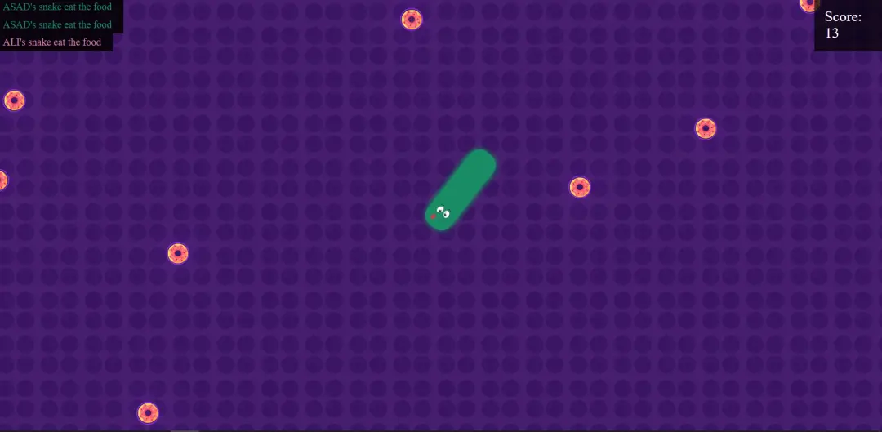

## Multiplayer Snake

A multiplayer snake game io is a type of online multiplayer game that is based on the classic Snake game, but with multiple players competing against each other in real-time. The game is played on a shared board and players control a snake that moves around the board trying to consume food and grow longer. The objective of the game is to be the last snake standing by avoiding crashing into other players' snakes, the walls, and own tail.

## WORD GUESS

A word guess game is a type of game where players try to guess a hidden word or phrase by suggesting letters or words. The game is played in various ways, but typically one player is the "computer" and chooses a word or phrase, while the player take turns trying to guess the word or phrase by suggesting letters. The computer responds with a message indicating which letters in the word or phrase are correct and in the correct position, and which letters are correct but in the wrong position.



[This Photo](https://freepngimg.com/png/72894-art-instagram-government-reigate-restaurant-vishwakarma-engineering) by Unknown Author is licensed under [CC BY-NC](https://creativecommons.org/licenses/by-nc/3.0/)



[This Photo](https://freepngimg.com/png/77079-logo-whatsapp-computer-icons-free-hq-image) by Unknown Author is licensed under [CC BY-NC](https://creativecommons.org/licenses/by-nc/3.0/)

All rights reserved 2024-2028.Muteeb Haider(AGBW8L@inf.elte.hu)

Home | Work | Blog | Contact

BLOG

# BEST NICHE OF WEB DEVELOPMENT SERVICES FOR SELLING ON FIVERRWED Mar 2024

[Fiverr](https://www.fiverr.com/) is a popular online marketplace where you can find freelancers for various services. In this blog, we will explore how to find the best gig on Fiverr for web development services.



## What is Gig?

A gig is a service offered by a freelancer on Fiverr. It can be anything from designing a logo to developing a website. You can find gigs for almost any type of service on Fiverr.

https://youtu.be/wKAYfGXk15o?si=lT7XB_lZWZlpaR1o

Gigs are categorized into different categories, such as Graphics & Design, Digital Marketing, Writing & Translation, Video & Animation, Music & Audio, Programming & Tech, Business, and Lifestyle.

## How you can earn money from Fiverr?

You can earn money from Fiverr by offering your services as a freelancer. You can create a gig for any service you want to offer and set your price. When someone orders your gig, you will get paid for the work you do. You have need to create a gig that has large search volume and huge amoumt of buyers so you can get rank and earn more money. You have need to select a niche that has large search volume and huge amoumt of buyers so you can get rank and earn more money.

## Best Niche of Web Development

To select any niche you have need to do some research. You have need to select a niche that has large search volume and huge amoumt of buyers so you can get rank and earn more money. You have need to select a niche that has large search volume. You can use Google Analytics or any other keyword tool to check the volume of that niche.

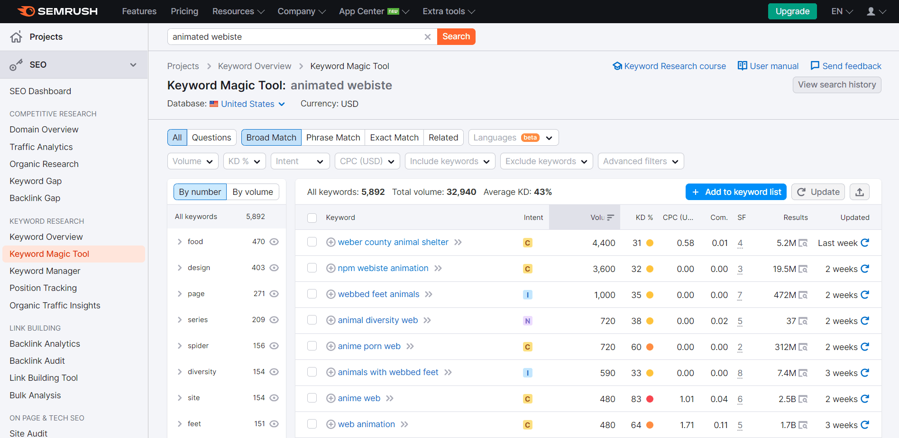

After too much researching and analysis I found that [**Animated Landing Page**](https://www.google.com/search?q=animated+landing+page) is the best niche for web development services. You can create a gig for Animated Landing Page and earn money from Fiverr. More in demand is that 3d landing page becasue it is more attractive and eye catching.

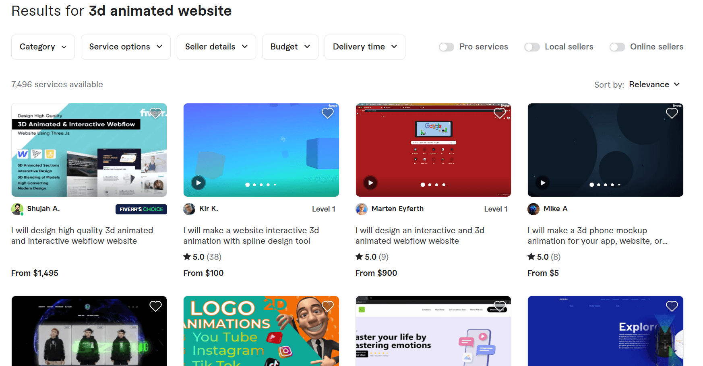

## Conclusion

In this blog, we have explored how to find the best gig on Fiverr for web development services. We have also discussed how you can earn money from Fiverr by offering your services as a freelancer. You can create a gig for any service you want to offer and set your price. When someone orders your gig, you will get paid for the work you do.



[This Photo](https://freepngimg.com/png/72894-art-instagram-government-reigate-restaurant-vishwakarma-engineering) by Unknown Author is licensed under [CC BY-NC](https://creativecommons.org/licenses/by-nc/3.0/)



[This Photo](https://freepngimg.com/png/77079-logo-whatsapp-computer-icons-free-hq-image) by Unknown Author is licensed under [CC BY-NC](https://creativecommons.org/licenses/by-nc/3.0/)

All rights reserved 2024-2028.Muteeb Haider([AGBW8L@inf.elte.hu](mailto:AGBW8L@inf.elte.hu))

Home | Work | Blog | Contact

# Contact

You can contact me through my email or whatsapp no. I am here for full time work with you. You can use any freelancing app or direct hire me. Contact me for more details. Please get in touch.

# I am here for Work



[This Photo](https://freepngimg.com/png/72894-art-instagram-government-reigate-restaurant-vishwakarma-engineering) by Unknown Author is licensed under [CC BY-NC](https://creativecommons.org/licenses/by-nc/3.0/)



[This Photo](https://freepngimg.com/png/77079-logo-whatsapp-computer-icons-free-hq-image) by Unknown Author is licensed under [CC BY-NC](https://creativecommons.org/licenses/by-nc/3.0/)

All rights reserved 2024-2028.Muteeb Haider(AGBW8L@inf.elte.hu)