VAHAN SYSTEM OVERVIEW REPORT

Overall architecture
The administration interface saves filter profiles and schedules. FastAPI prepares cases, checks worker readiness and UI Health, and maintains a durable PostgreSQL task queue. Available Playwright workers claim cases through the API, operate VAHAN Public Report in Chromium, and return results for validation and SQL commit. The dashboard receives status and data updates through API polling and Socket.IO.
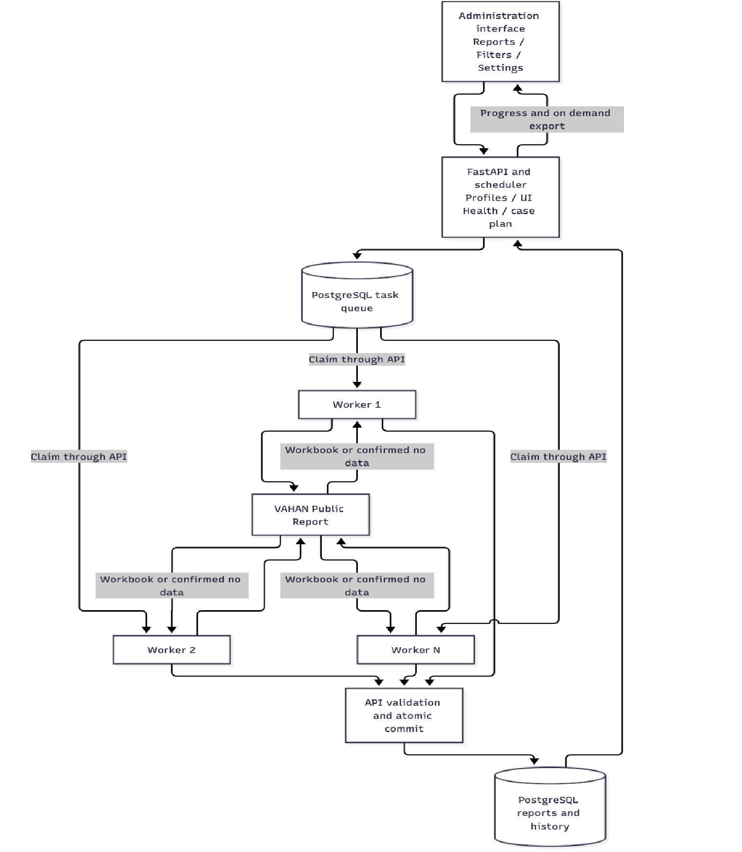
Figure 1. Current architecture. Editable Mermaid source.
Current scope. Once, daily and monthly schedules, editable filter profiles, and concurrent workers are implemented. Redis is absent from the current Compose stack. CAPTCHA processing runs inside each worker; there is no shared external CAPTCHA service. Monthly recurrence schedules an annual Maker / Month Wise report, rather than introducing a separate monthly-only report type.
Review basis. Source reviewed on branch ocr at commit 30e4429. Read-only checks at approximately 16:52 Vietnam time found the API, Web, PostgreSQL and four runner containers healthy; API readiness reported PostgreSQL storage and queue. These checks establish service availability, not acceptance of a complete VAHAN collection run.

1 Data collection process
An administrator defines the collection scope in a saved filter profile. The current report format is Calendar Year / Maker / Month Wise, with one reporting year per run. The scheduler resolves live VAHAN options and converts valid combinations into cases, subject to the profile limit of up to 3,000 cases.
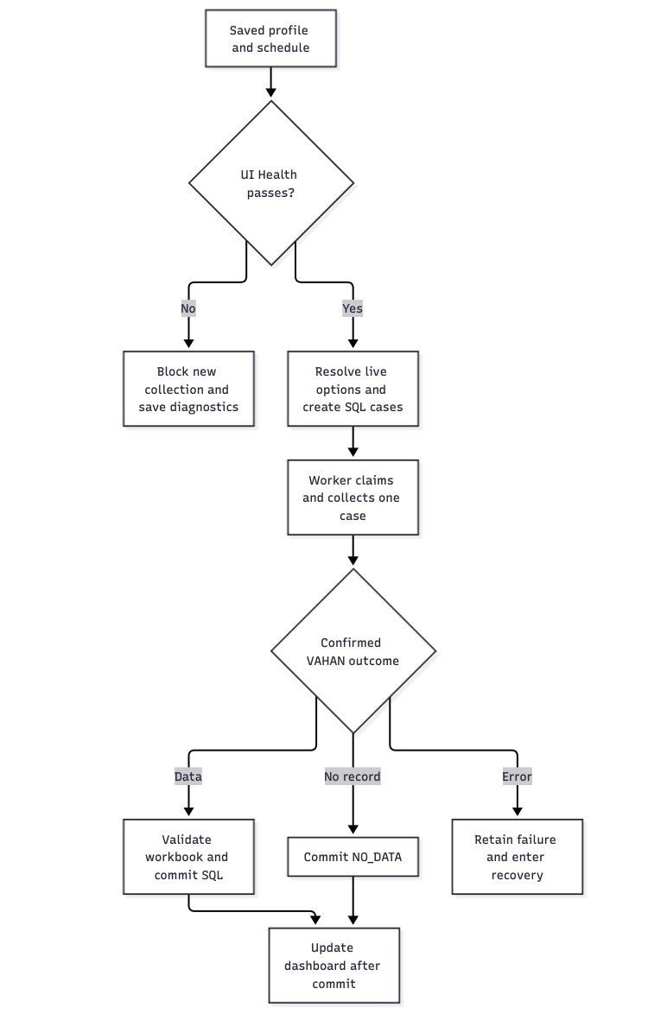
Figure 2. Data collection process. Editable Mermaid source.
Step | Current behavior | User outcome
Define scope | Choose year and vehicle/geographic filters; save a profile revision and preview its cases. | A repeatable reporting scope with a visible case limit.
Prepare run | Check ready workers and the VAHAN form before loading live options and building the queue. | Incompatible page changes block new collection.
Collect data | Each worker fills dependent filters, verifies their actual values and submits one assigned case. | Status and progress are associated with the correct case.
Import data | Download the full source workbook; read every worksheet and validate Maker, year and office context. | Accepted values become available after transaction commit.
Confirm no data | Save NO_DATA only after a confirmed VAHAN norecord result. | An empty result stays separate from a timeout or execution error.
Step | Current behavior | User outcome
Recover errors | Retain failed cases and their causes for checkpoint retries and the final recovery pass. | Successful and valid no-data cases do not need to be repeated.
The OTHERS group supplied by VAHAN remains OTHERS; the system does not assign it to a specific manufacturer. A worker being online, or a schedule finishing, does not by itself establish complete State/RTO coverage. Coverage must be compared with the cases expected from the selected profile.

2 Administration interface functions
The current interface has three main areas. Exported Reports is the default page. Administrators also access Filters and Settings; ordinary members access Exported Reports. The separate Create Report page and the standalone worker monitor are no longer part of the current navigation.

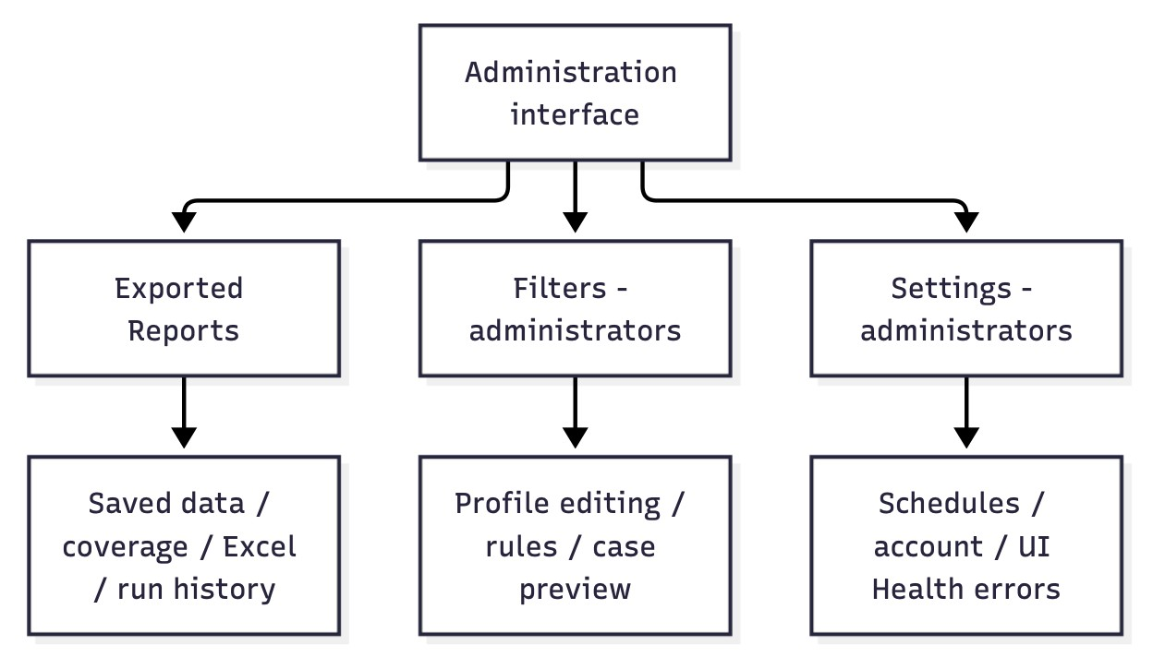
Figure 3. Administration interface functions. Editable Mermaid source.
Function | Actions and information shown | User benefit
Filter profiles | Edit report year and vehicle/geographic filters; save revisions, include/exclude rules and preview cases. | Reuse and review the exact collection scope.
Schedule collection | Choose profile, year, time zone, start and Once / Every day / Every month recurrence. | Run collection without keeping the dashboard open.
Control a run | Pause new assignments, wait for active saves, change the concurrency limit and continue the same queue. | Resume unfinished work while retaining committed results.
Monitor progress | View processed/total cases, status, cases/min and current system activity. | See progress and the reason for waiting.
Review failures | Open Failed cases, review attempt history and copy failures or diagnostics. | Investigate cases that recovery has not resolved.
Run history | Review sessions, filters, outcomes and timestamps; hide/delete eligible sessions and restore them. | Trace earlier runs while keeping report data.
Exported Reports | Select dataset/year, search State or RTO, browse 12 monthly values and export Excel. | Reuse data already committed to SQL.
Data coverage | View coverage and the last saved report timestamp in GMT+7. | Identify missing scope and recent saves.
Function | Actions and information shown | User benefit
Account management | View account, change password and log out; admins manage users and roles. | Control access to reports and administration.
UI Health errors | Display unresolved blocking page errors with affected workers and copyable diagnostics. | Support repairs before new work is assigned.
The schedule form uses Show form / Hide form. Account and detailed diagnostics open in dialogs. Healthy UI Health checks hide the error section. Schedule cards currently show processing speed; remaining time and estimated finish are not rendered in the current interface.

Filter configuration and case selection
The filter editor is now an existing feature, rather than the proposed extension described in the old report. It supports named profiles with revisions, a report year, fixed values or iteration over available values, include/exclude lists, and combination rules. Geographic and vehicle dependencies are resolved from VAHAN options.
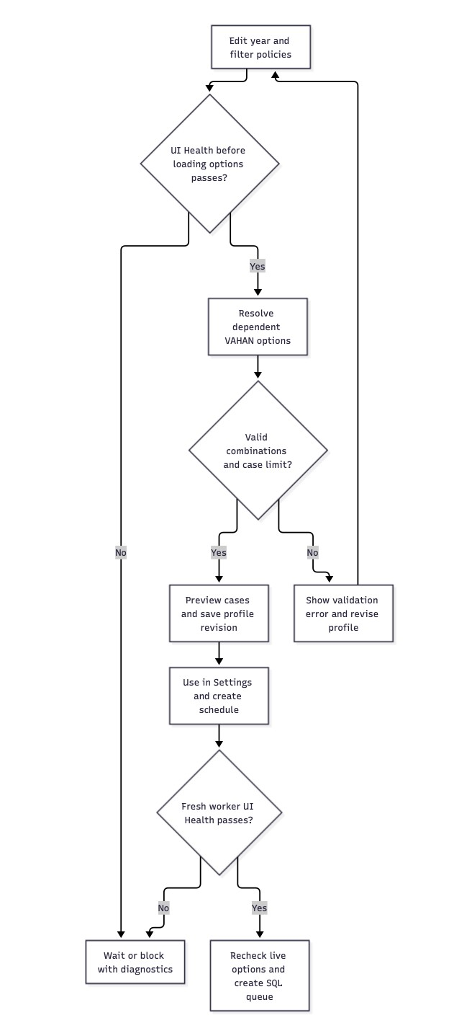
Figure 4. Filter configuration and case selection. Editable Mermaid source.
Configuration | Current scope
Report format | Calendar Year; Y axis Maker; X axis Month Wise. The editor does not support arbitrary report axes or custom date-range reports.
Geography | State region / Delhi NCR, State and RTO, including dependent State → RTO options.
Vehicle classification | Category group, sub-category, class, EV type, fuel, Active / Archive and emission.
Additional filters | Maker, status, owner type, vehicle type and fitness, where supported by the source form.
Selection policy | Fixed selections or iteration; include/exclude values; require/exclude combination rules.
Case limit | A profile may specify 1–3,000 cases. Actual combinations depend on live options and profile constraints.
A schedule retains the selected profile definition and revision. Later edits to the profile do not silently alter an existing schedule; create a new schedule to use the new revision. Existing queue cases retain the filters recorded at creation.
The old manual choices Run all, Run one RTO and Start from selected RTO are not current standalone screen actions. To limit collection, define the desired State/RTO scope in a profile and schedule that profile. Continuing an existing run resumes its saved queue.
Review point. Validate a sample profile against live VAHAN options, compare preview and queued cases, and confirm that a stale or incompatible source option produces an explicit error rather than a report under unintended filters.

3 Report data and reconciliation
The main report table stores January–December values for each filter dataset, reporting year, State, RTO and Maker. Accounts share the report dataset; run ownership and activity remain traceable. Filter datasets prevent different vehicle/report scopes from being merged as though they were equivalent.
The system distinguishes a blank month from a reported zero, retains OTHERS, and records the source observation time and value history. Repeated submission of the same committed job is acknowledged without adding another report. For normal collection, a newer observation may replace an existing monthly value while retaining the previous value and provenance. Older or unsupported conflicting values remain visible for review. This replaces the old report’s statement that ordinary imports never update non-empty cells.
A confirmed no-data result is stored separately from an execution failure. The data save, import history, final job status and worker release belong to the same SQL transaction. The dashboard reports success after that commit.

4 Operations monitoring and access control
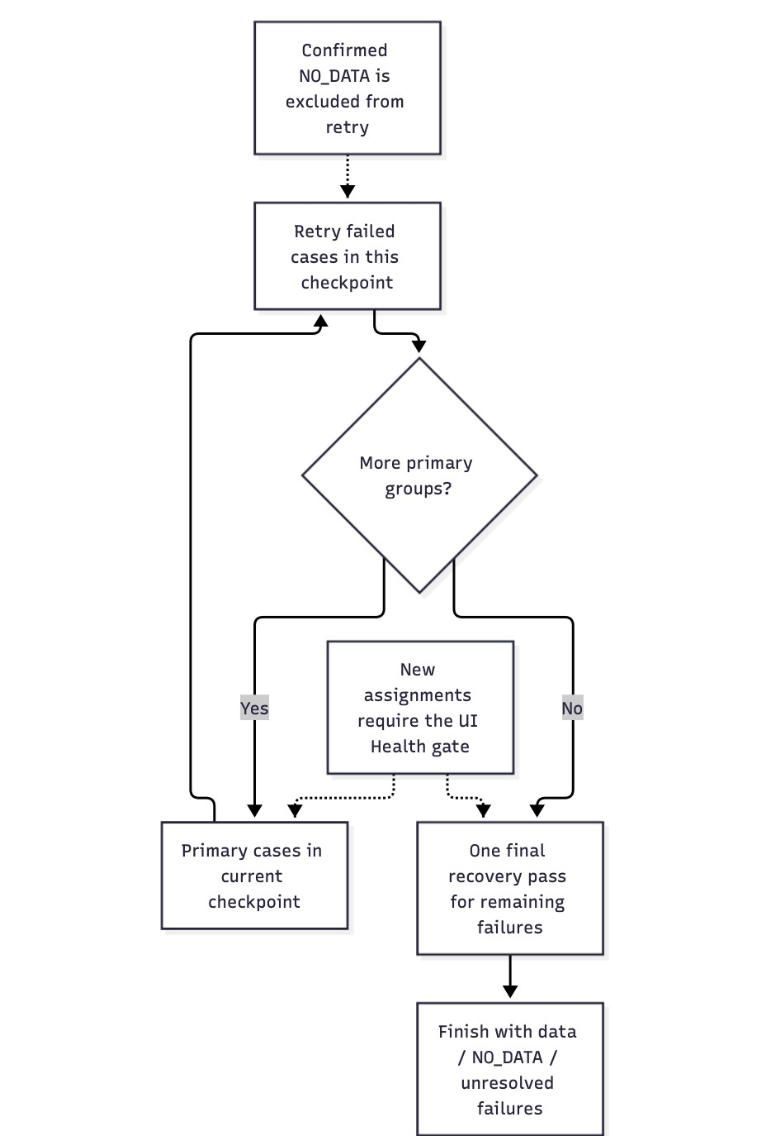
Figure 5. Checkpoint retries and final recovery. Editable Mermaid source.
Area | Current support
Checkpoint recovery | Groups contain at least 10 cases and expand to the configured concurrency. Each ordinary case has the initial attempt, checkpoint retry and final recovery opportunity; failures do not retry indefinitely.
Pause and resume | Pause blocks new claims and lets active cases save. Continue run rechecks the worker pool and resumes the same SQL session.
Monitoring | Schedule cards show progress and cases/min. System activity and Worker details explain the current stage, recent updates and errors.
Network recovery | Server connectivity checks pause interrupted collection; two healthy probes permit automatic recovery of network-paused runs. Keep paused retains a manual pause.
Access control | Admin controls profiles, schedules and users. Members view Exported Reports. Account changes and roles are enforced through backend authentication.
Reloading the dashboard does not create another dispatch loop. SQL checkpoints retain progress and retry phases across interruption. Delay warnings identify work requiring attention; they are not proof that a worker has hung.

5 Scheduled collection and multiple workers
Scheduled collection and multiple workers are implemented in the current release. A schedule can run once, daily or monthly. Vietnam time (UTC+07:00) is the default; India time (UTC+05:30) is also supported. A monthly repeat uses the selected local day and falls back to month-end when necessary. Recurrence determines when the annual report profile is collected; it does not change the report format.
The API owns scheduling and case preparation. It saves the profile snapshot, resolves options, records cases in PostgreSQL and binds successful UI Health evidence. Ready workers poll the API and atomically claim queued cases. Additional workers can join an existing run after readiness and UI Health checks. Redis and a separate queue publisher are not required by the current architecture.
Control | Current behavior
Worker instances | Compose replicates one runner service. The launcher assesses local CPU/RAM and may preserve existing replicas; deployment configuration can override the count.
Parallel tasks | A positive concurrency limit controls active work in SQL. It is independent of the number of runner containers and has no fixed 10-worker validation cap in the current schedule model.
Available capacity | The run uses currently connected, eligible workers up to its concurrency limit. Setting 8 parallel tasks while only 4 workers are ready does not create another 4 containers.
Enable or disable | Enable schedule / Disable future runs controls later starts; disabling does not itself stop an active run.
Pause and continue | Pause run stops new claims and waits for active saves. While paused, choose a new task limit and Continue run with the same cases.
Delete schedule | Deletion is restricted during active transitions. It removes the schedule and remaining queue while retaining report sessions, jobs and collected report values.
Service interruption | A saved checkpoint allows restart recovery. An overdue one-time schedule can start when services return; repeating schedules do not replay every missed occurrence.
The API, PostgreSQL and browser workers must remain running. Closing the dashboard is supported. Stopping the host or Docker stops processing until services return. The stack is currently a single-host deployment, without a built-in high-availability service layer.
The read-only snapshot found four healthy runner containers. This is a deployment observation at the time of review, not a throughput benchmark or confirmation of the configured concurrency for every schedule. Collection rate and coverage still depend on VAHAN response times, validation, source options and host resources.

6 Delivery scope and evaluation criteria
The current delivery provides editable profiles, scheduled collection, a PostgreSQL queue, concurrent browser workers, saved annual report data, Excel export, run recovery and administration. UI Health is integrated into preparation and task eligibility, with blocking diagnostics in Settings. Several statements in the old report therefore move from planned expansion to current implementation.
Capability | Current assessment | Evaluation needed
Profiles and case preparation | Implemented in the editor, API and SQL repositories. | Check dependent options, preview counts and exact queued filters.
Schedules and workers | Once/daily/monthly schedules and SQL concurrency are implemented. | Run at the chosen time and verify effective parallelism and repeat behavior.
PostgreSQL queue | Workers claim directly from SQL; Redis is absent from Compose. | Verify concurrent claims, interruption recovery and absence of duplicate saved results.
Report integrity | Full-workbook parsing, strict validation and atomic commit are implemented. | Compare source monthly values, SQL data and exported workbook.
Recovery and UI Health | Checkpoint/final retry, pause/resume, network guard and DOM gate are implemented. | Inject controlled failures and confirm correct blocking and recovery.
ETA | Current cards render progress and cases/min; remaining/finish estimates are not displayed. | Agree the display requirement and validate it on real runs if added.
Maker Update | GLOBAL / DISCOVER / REFRESH storage and API paths exist; a complete current UI/orchestration flow was not established. | Do not accept end-to-end selective refresh until the full flow is demonstrated.
Service availability | Read-only checks found  API/Web/PostgreSQL and four runners healthy. | Service health alone does not prove a complete collection run or data coverage.
Acceptance should use one agreed profile and reporting year. Preserve the previewed case list, record the selected concurrency and time zone, then reconcile every expected case with its final outcome: with data, confirmed no data, unresolved failure or cancellation. Compare representative source values with SQL and the opened Excel export.
A finished schedule with unresolved failures is not equivalent to complete data coverage. The reviewer should approve the collected scope and residual error list explicitly. No new VAHAN job, schedule, failure simulation or account change was performed to prepare this document; the functional evaluations above remain acceptance tasks.

7 Database and data lifecycle
PostgreSQL is the durable record for accounts, profiles, schedules, sessions, queue tasks, jobs, monthly report values and history. A worker can finish a data case only after the API confirms that its workbook has been accepted and committed. Confirmed no-data history and terminal job status are also committed together.
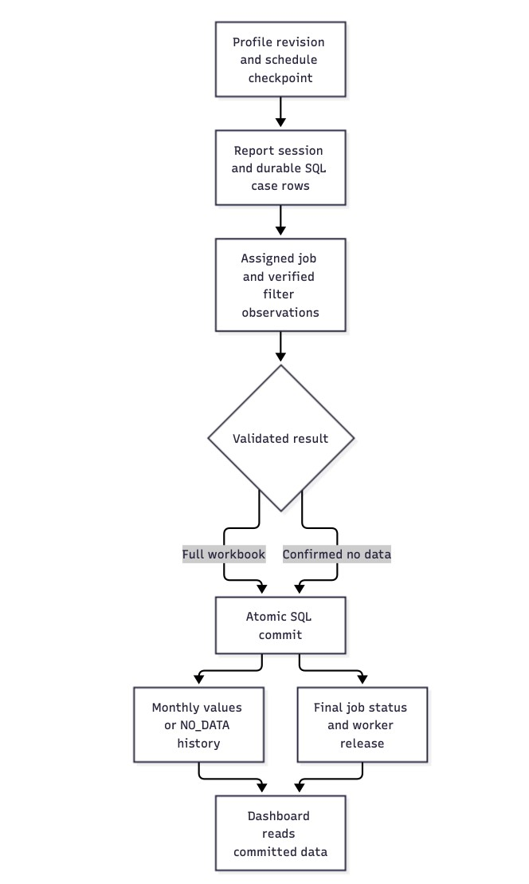
Figure 6. Database and data lifecycle. Editable Mermaid source.

Data group | Current function | Business result
Users and access | Account records and sessions enforce access; run ownership identifies the originating user. | Administration and activity remain traceable.
Profiles and schedules | Saved definitions, revisions, time zones, recurrence and execution checkpoints. | A run retains its intended reporting scope.
Cases jobs and workers | SQL queue state, attempt chain, runner assignment, status changes, timestamps and errors. | The system can resume the correct unfinished case.
Main report values | Filter scope, year, State, RTO, Maker, 12 monthly values and per-month provenance. | Blank remains distinct from zero; updates retain source history.
Update history | Added, unchanged, updated, no-data or review outcomes with source checksums and observation time. | Users can investigate changes and conflicts.
Maker update records | Baseline snapshots, Maker–State–RTO index, update runs and tasks for backend update paths. | Support for focused updates, subject to end-to-end acceptance.
The current flow parses the source workbook into SQL and generates exports on demand. It does not require a second master Excel workbook or a separate Excel processing service. Successful source workbooks are not retained as duplicate report files by the current commit path; diagnostic or historical artifacts may still exist separately.
The PostgreSQL volume preserves data across ordinary container stops and recreation. Backup and restore must preserve the database and the private key used for encrypted browser state. Availability checks and file checksums do not replace a tested recovery procedure.

8 CAPTCHA handling and verification
The current worker handles the image challenge presented in the VAHAN report flow. It captures the image in memory and passes it to its bundled Tesseract processor. A candidate response is associated with the active job and challenge; VAHAN determines whether the response is accepted. There is no separately deployed CAPTCHA service or third-party token service in the current Compose stack.
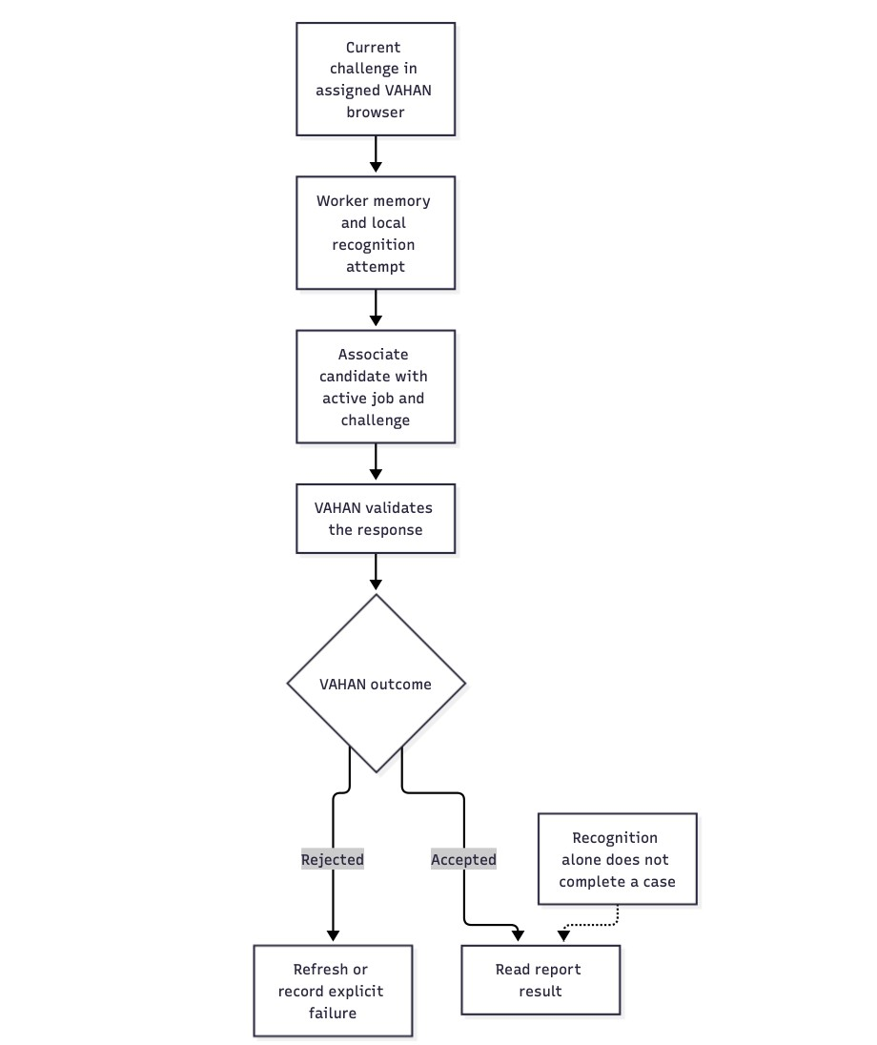
Figure 7. CAPTCHA handling and verification. Editable Mermaid source.
Function | Current behavior | Result or control
Challenge association | Keep the current challenge identifier with the assigned job. | Stale job/challenge responses are rejected.
Image lifecycle | Supply the image in memory to the existing processor; the normal path creates no CAPTCHA image file or SQL image copy. | No shared external imagestorage service is required.
Validation | Verify filters and required backend acknowledgements before Apply; inspect the actual VAHAN outcome afterward. | A candidate response alone does not complete the case.
Rejected response | Refresh the challenge or retain an explicit validation failure. Three rejected submissions fail the current job. | Validation errors remain separate from NO_DATA.
Current dashboard | The current dashboard has no CAPTCHA image, entry or refresh panel. Related schedule metadata contains job/worker status rather than challenge images. | The report does not promise an operator-entry function in the current UI.

9 Crawler worker execution
Each Playwright worker owns a separate Chromium browser context and processes one active job at a time. Multiple instances provide concurrent collection. A ready worker asks the API for an eligible SQL task; the API checks queue state, network availability, worker eligibility, concurrency and the bound UI Health gate before allowing work.
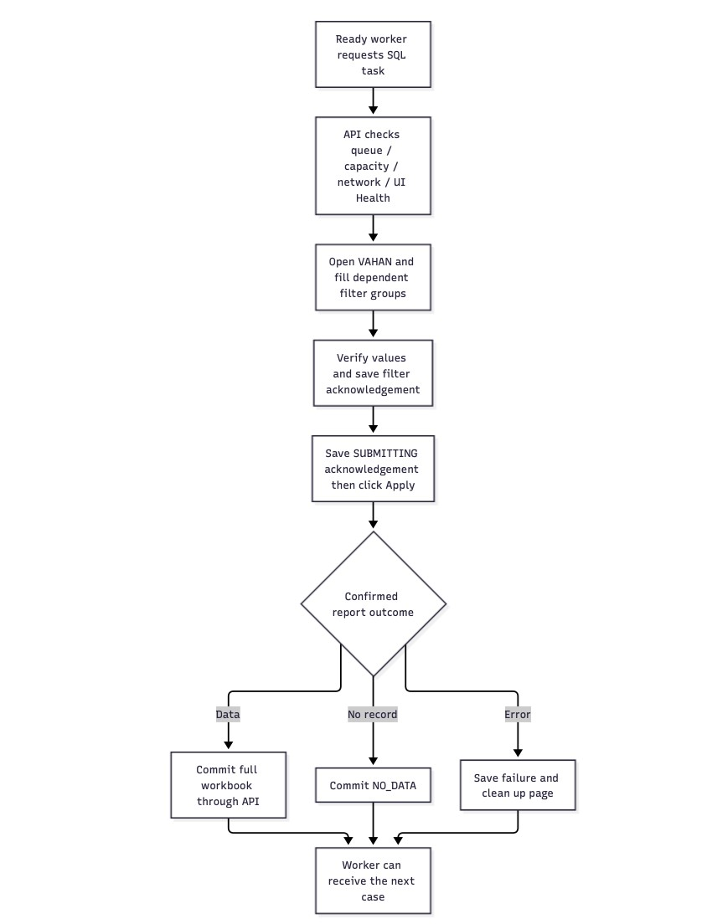
Figure 8. Crawler worker execution. Editable Mermaid source.
Stage | Crawler function | Completion condition
Claim and prepare | Claim through the API; open VAHAN, restore the browser session and apply SQL-approved selectors. | The worker has an assigned job and the required controls are available.
Fill filters | Process independent groups in parallel while preserving dependencies such as State → RTO and EV type → Fuel. | Observed values match the saved filters after dynamic loading.
Verify before Apply | Record filled and before-Apply observations; wait for backend acknowledgement. | Missing controls or mismatched values block submission.
Submit and wait | Wait for the SUBMITTING save acknowledgement, click Apply and confirm the resulting report state. | Late navigation is handled within the result deadline without repeating Apply.
Finish data case | Download the complete workbook and wait for the main-table save acknowledgement. | The API has committed data, history and final job status.
Stage | Crawler function | Completion condition
Finish no-data or error | Persist confirmed no-data; keep timeouts, verification failures and other execution errors explicit. | Only a confirmed no-record result becomes NO_DATA.
An independent worker instance can execute another case concurrently, but parallel filter groups inside one case do not mean that one worker owns multiple jobs. Failed-page cleanup retires the broken document before the next case while retaining the browser context where appropriate. This reduces repeated failures caused by a damaged page.
Actual throughput should be measured with the same profile, year and VAHAN conditions across worker counts. Increasing the SQL limit alone does not guarantee a faster run or allocate more Docker instances.

10 Excel processing and report aggregation
When VAHAN returns data, the crawler downloads the complete workbook and sends it to the API. The API parses all worksheets, validates the report context and aggregates values into the main SQL table. There is no independently deployed Excel aggregation worker in the current release.
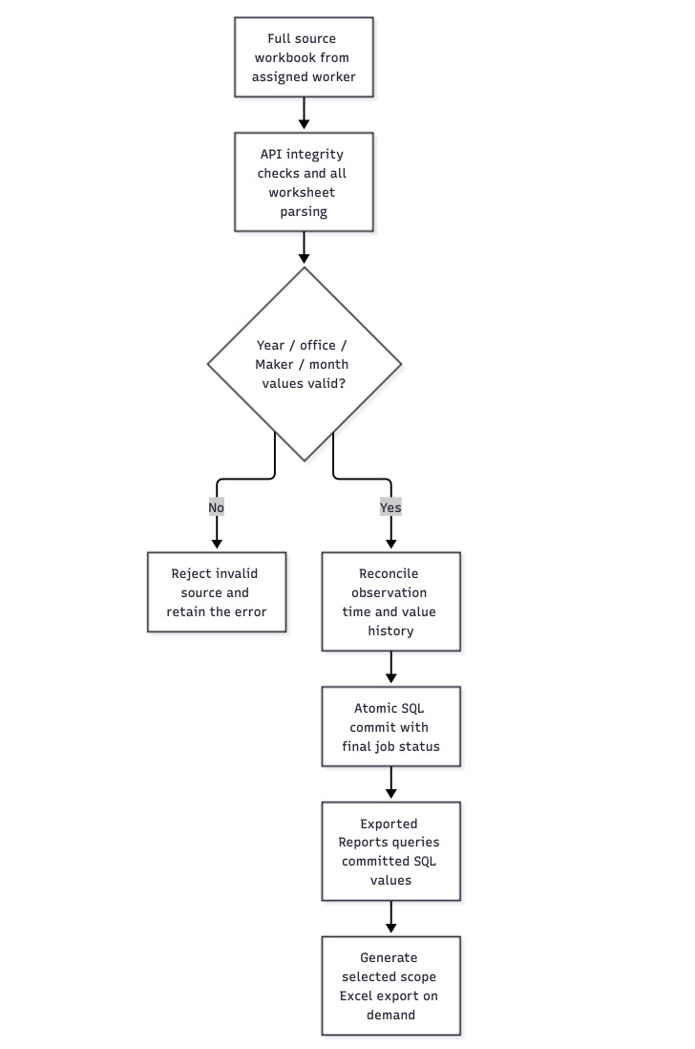
Figure 9. Excel processing and report aggregation. Editable Mermaid source.
Stage | Current function | Data quality result
Receive source | Accept the assigned job’s full workbook and verify its integrity and checksum. | Incomplete or damaged source content is rejected.
Read all sheets | Find Maker and month columns across worksheets; check the year and office context. | Ambiguous or invalid source data does not silently enter the main table.
Normalize values | Retain OTHERS, distinguish blank from zero, reject invalid counts and contradictory duplicate rows. | The monthly values preserve the source meaning.
Reconcile observations | Use the source observation time; allow a newer normal result to update monthly values with retained history. | Fresh data can replace older values without losing provenance.
Commit results | Save values, update history, final job status and worker release within one SQL transaction. | The dashboard reports completion after a successful save.
Serve exports | Query the selected filter dataset/year and current State/RTO scope; generate a workbook on demand. | The export reflects committed SQL data and the selected scope.
The source workbook is an input to validation and aggregation; it is not the system’s master data store. Reopening an exported workbook and comparing its monthly cells with the SQL report view remains an acceptance requirement. Export success alone does not confirm that every expected State/RTO was collected.
11.

