KARIBU CREDIT
Dashboard Visual Mockups
& Workflow Diagram Implementation Guide
7 Role Dashboards · 5 Workflow Diagrams · Full Implementation Notes
Karibu Credit Ltd · CBK NDTCP Regulated · Version 1.0 · May 2026

How the Diagrams Were Generated
Every workflow diagram and dashboard wireframe in this document was produced entirely in Python using Matplotlib — no design tool, no external assets, no SVG editor. Each diagram is rendered as a high-resolution PNG (180 DPI) and embedded directly into this Word document using the python-docx library.
Library | Version | Role
matplotlib | 3.10.x | Main drawing engine — axes, patches, text, arrows, charts
matplotlib.patches | Built-in | FancyBboxPatch for rounded boxes, FancyArrowPatch for arrows
numpy | 2.4.x | Data arrays for chart series, score distributions, trend lines
Pillow (PIL) | 12.x | PNG encoding — required by matplotlib Agg backend
python-docx | 1.2.x | Embedding PNG bytes into Word .docx via InlineShape

Section 1: Workflow Diagrams

1.1 Loan Application & Disbursement Flow
This flow illustrates the origination logic, showing how the system branches depending on whether the loan requires a single lump-sum payout or stage-wise tranches.
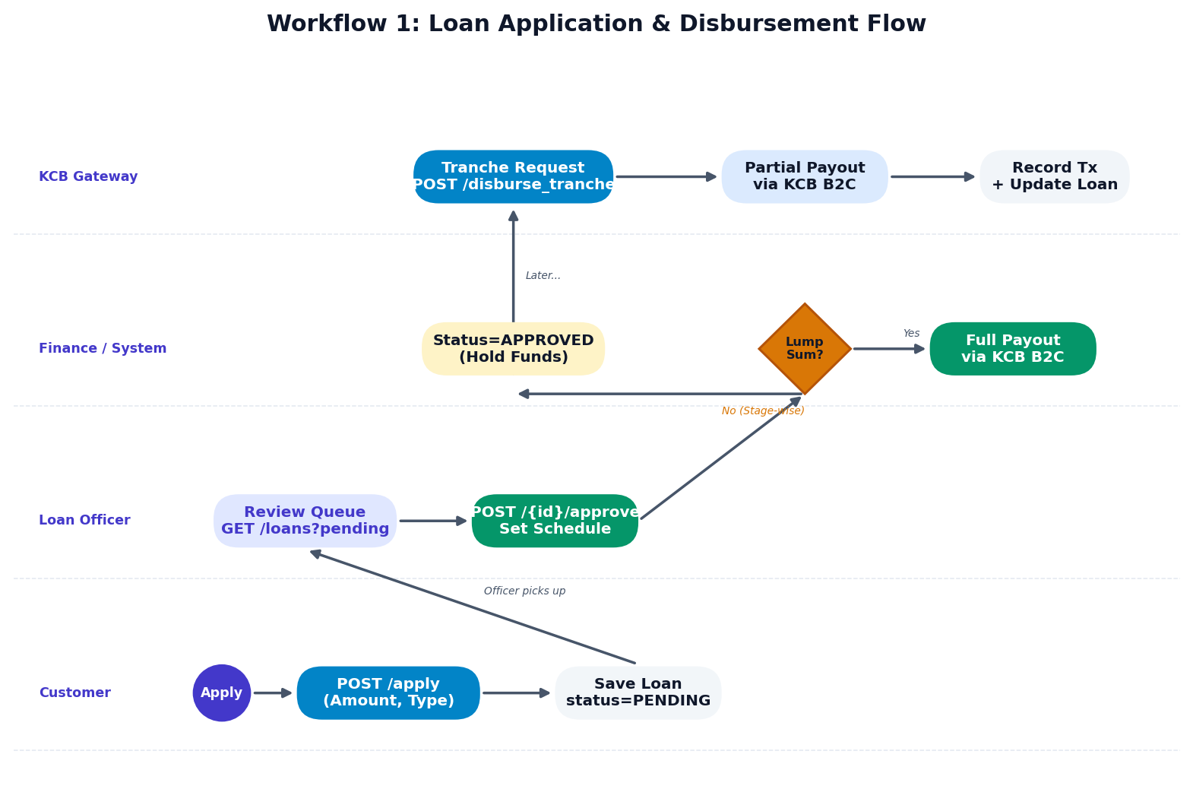

1.2 M-Pesa C2B Repayment & Auto-Clearing
Maps the Safaricom Daraja webhook integration that processes incoming Paybill payments and auto-clears the loan when the outstanding balance reaches zero.
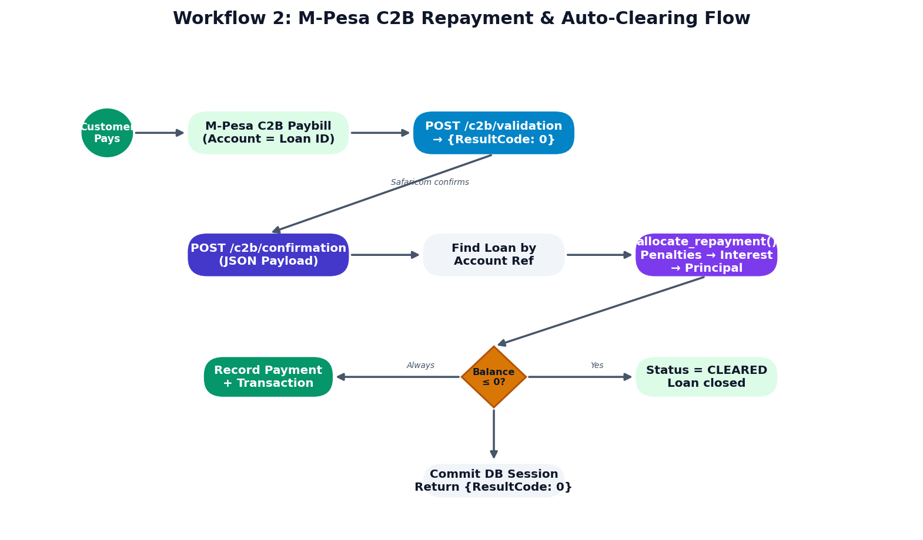

1.3 Nightly Penalties & Defaults (Cron Job)
Maps the logic within scripts/daily_penalties.py which runs at midnight to catch overdue borrowers and apply the configured penalty rate.
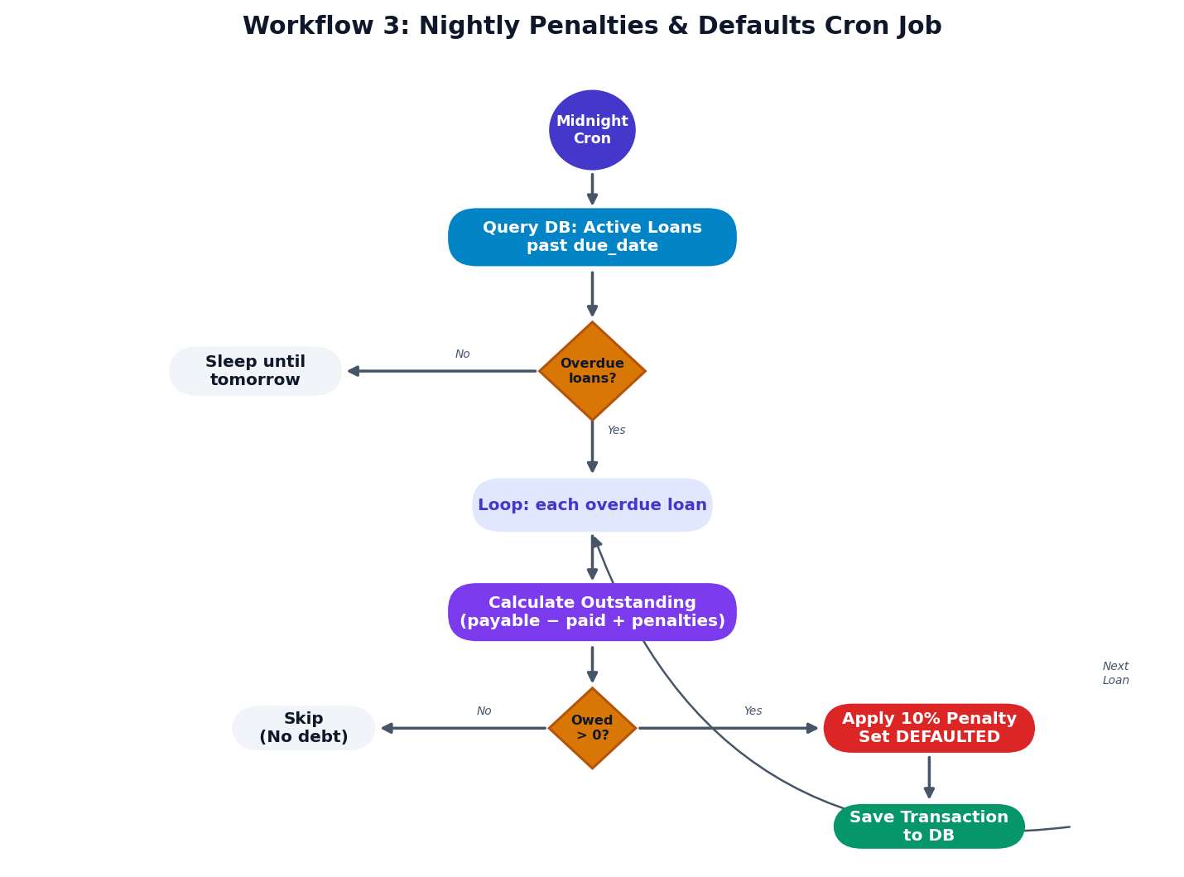

1.4 Loan Top-Up & Settlement Flow
New feature flow: existing borrowers request additional credit on active loans. The system merges balances and recalculates the amortization schedule.
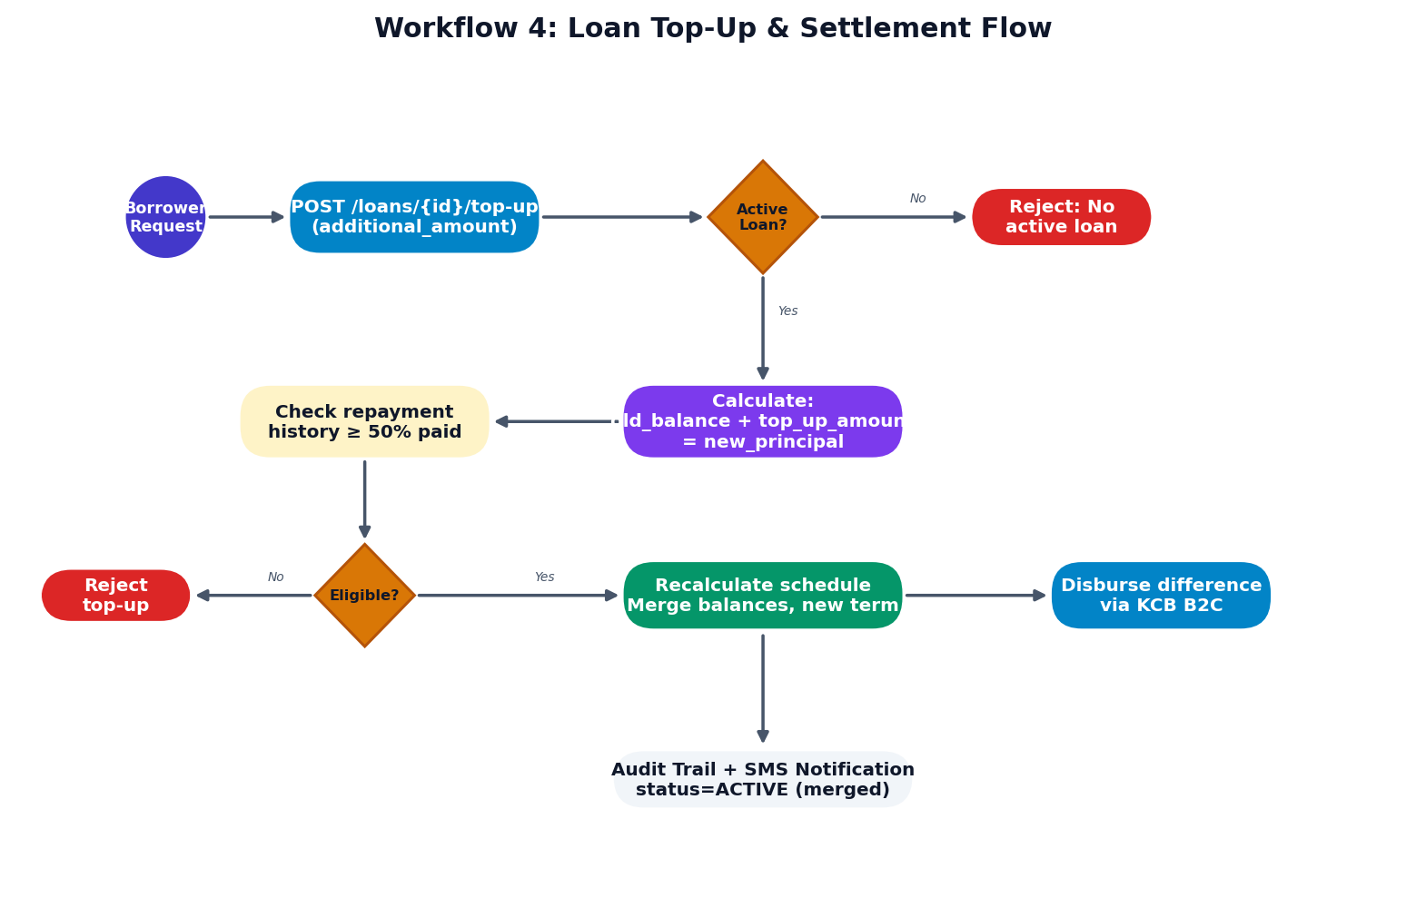

1.5 Group Lending — Joint Liability Disbursement
New feature flow: group lending where members share joint liability. If one member defaults, the remaining group members cover the shortfall.
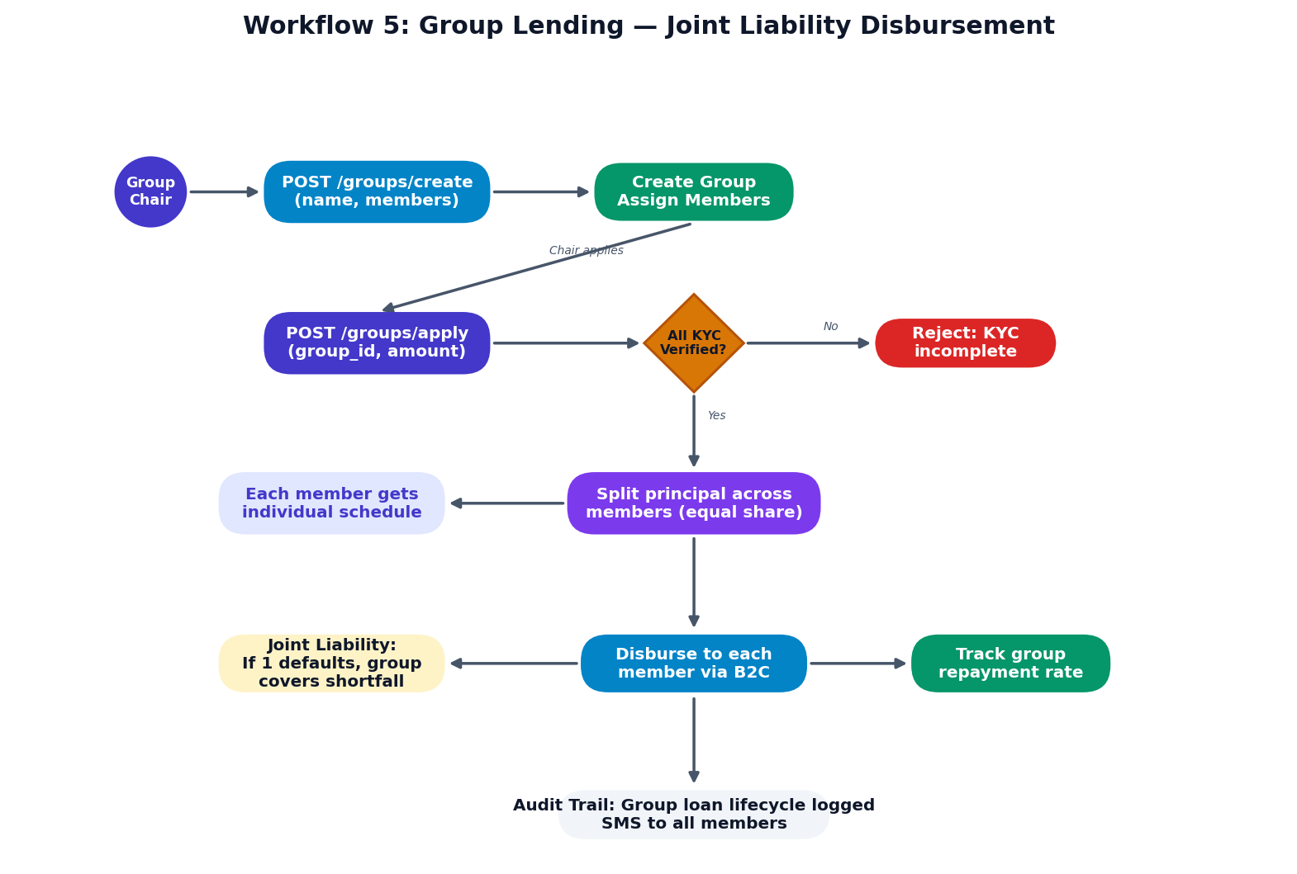

Section 2: Role-Based Dashboard Wireframes
Each dashboard below is tailored to a specific operational role within Karibu Credit. The admin panel includes a role-preview switcher that lets privileged users view any dashboard without changing actual permissions.

2.1 CEO / Managing Director
Executive overview with KPI metrics (Total Portfolio, Revenue, Profit Margin, Active Customers), disbursement vs collection bar chart, and portfolio product mix doughnut.
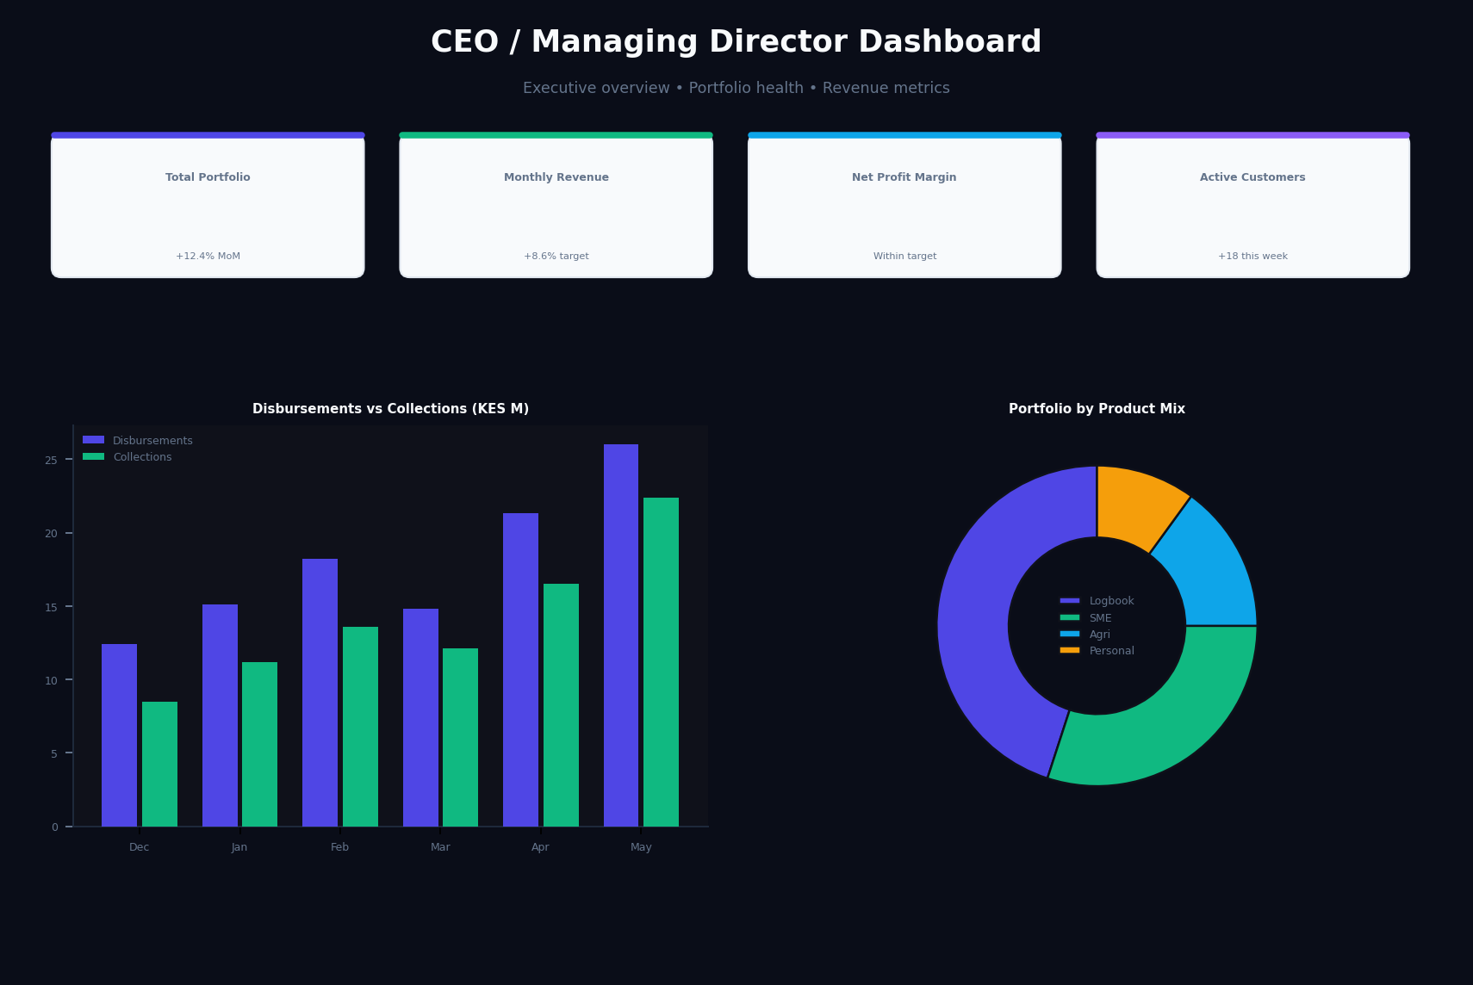

2.2 CFO / Finance
Financial dashboard showing revenue streams (Interest Income, Processing Fees, Gross Profit), Daraja B2C/C2B settlement audit table, and provision reserve tracking.
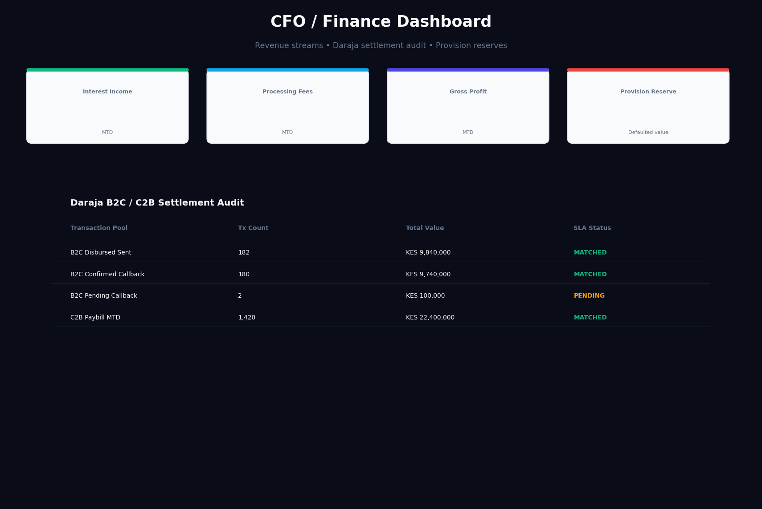

2.3 Branch Manager
Branch-level dashboard with officer performance board (TAT, PAR 30 per officer), branch portfolio stats, and PAR aging breakdown chart.
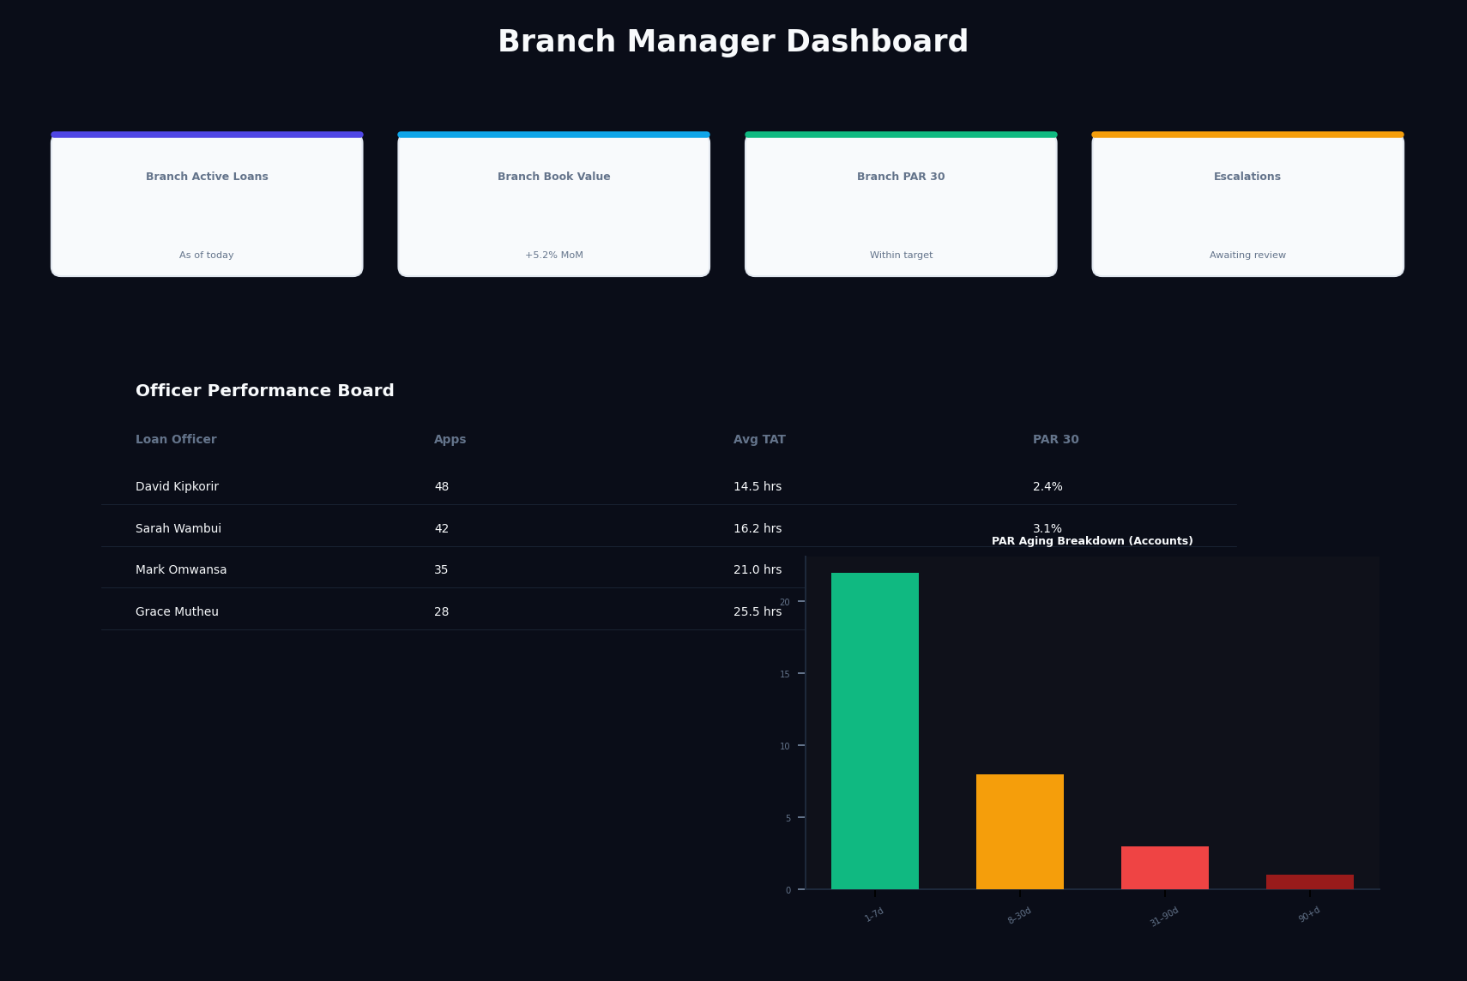

2.4 Loan Officer
Operational dashboard with pending application queue, appraisal checklist panel, and approval workflow controls (Approve/Reject/Escalate).
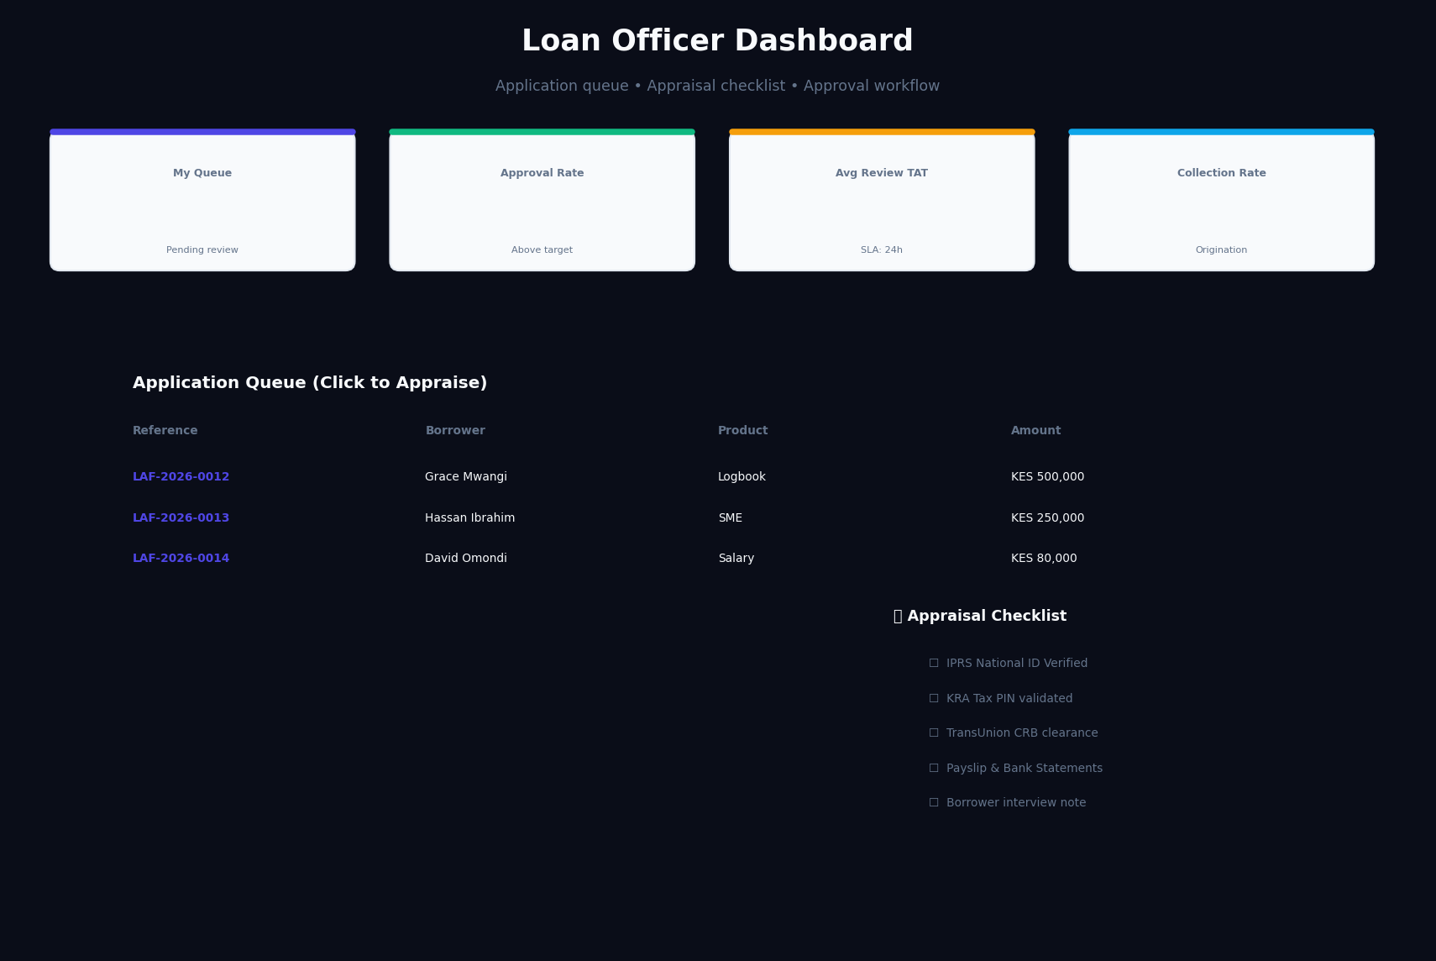

2.5 Collections Officer
Recovery-focused dashboard with Kanban-style arrears board (1-30 days, 31-60 days, 60+ days), restructuring controls, and CRB submission tracking.
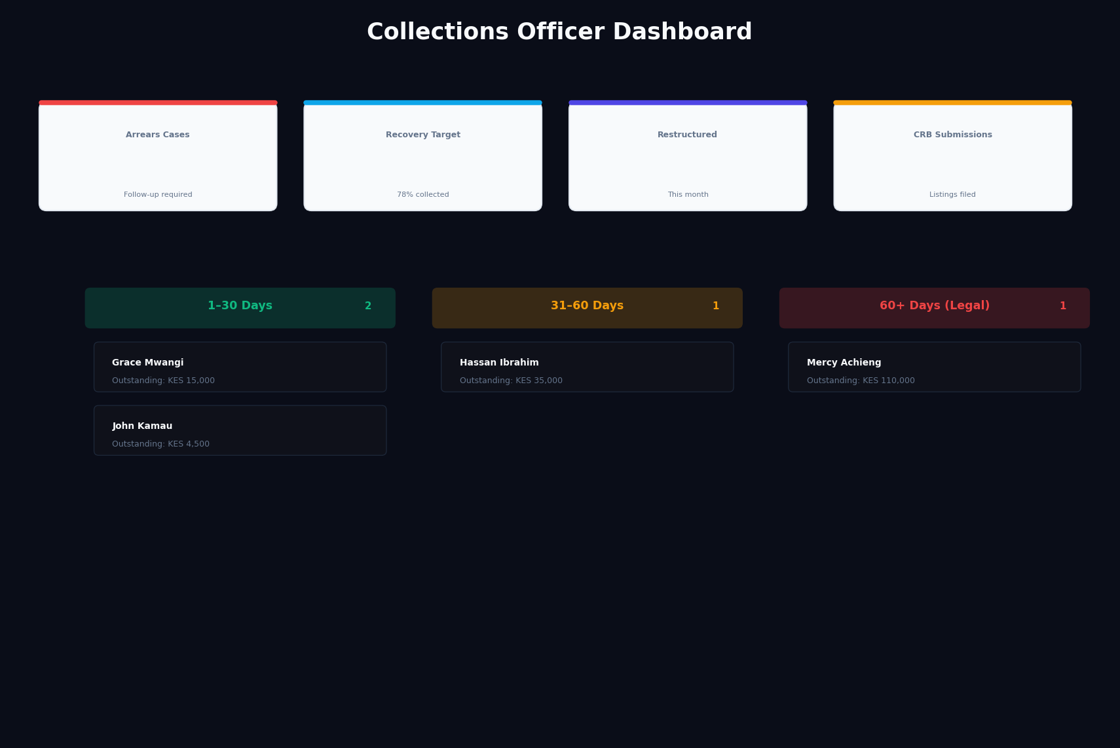

2.6 Compliance Officer
Regulatory compliance dashboard with CBK filing tracker, AML transaction flags, and KYC verification queue with 48-hour SLA monitoring.
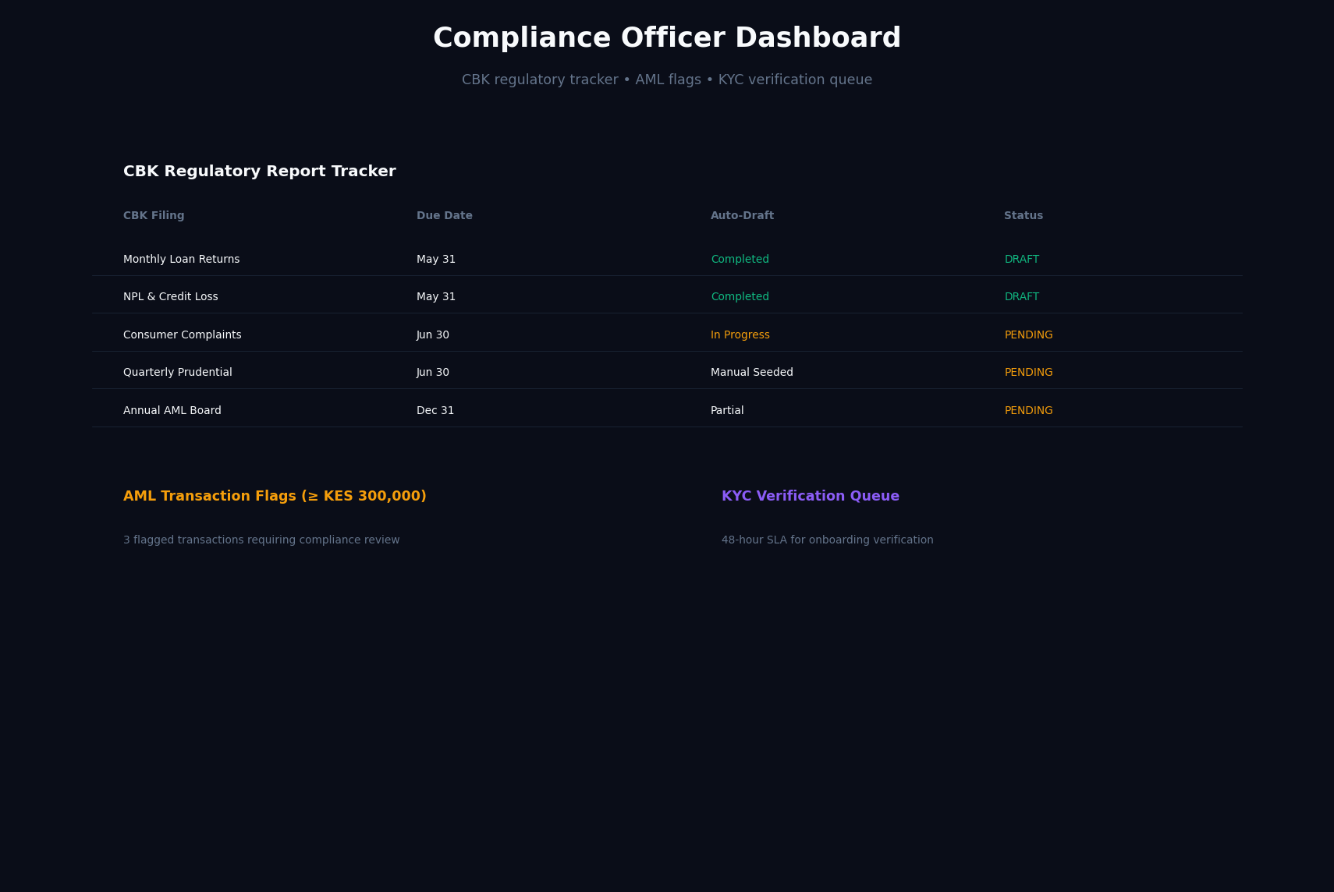

2.7 Credit Scoring Engine
Analytical dashboard with score distribution histogram, model weight tuning controls, and credit tier eligibility matrix.
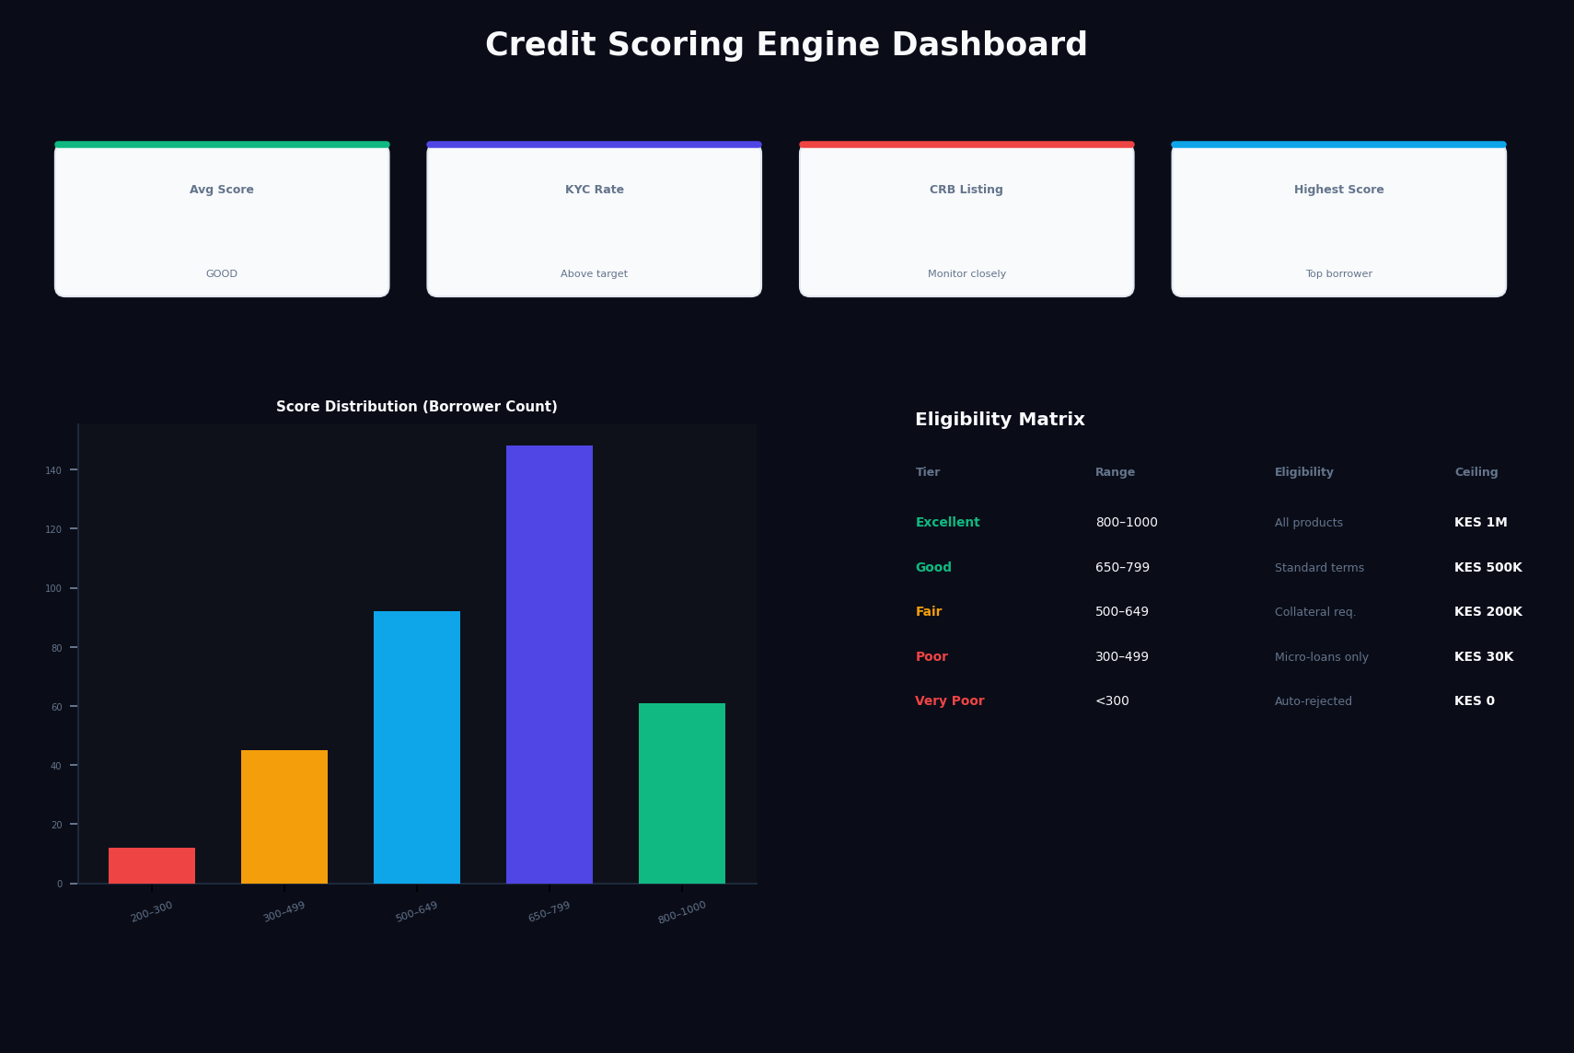

Section 3: Implementation Notes

3.1 Clean Architecture (Dependency Rule)
The Domain Layer is the inner-most layer. It must not import from Infrastructure. Application services orchestrate use cases by calling domain entities and repository ports. Infrastructure adapters (Daraja, KCB, SQLAlchemy) implement these ports.

3.2 Security & CBK Compliance
All endpoints enforce JWT-based RBAC. Audit trails log every sensitive action (loan approvals, borrower onboarding, CRB checks, policy changes). PAR thresholds (PAR 30 < 5%, NPL < 3%) are monitored and reported to CBK per NDTCP Regulations.

3.3 Repayment Allocation Waterfall
Incoming payments are allocated in order: (1) Outstanding Penalties/Fees, (2) Scheduled Installments (interest first, then principal per line), (3) Overpayment to global principal, (4) Auto-clearing if balance ≤ 0.

