FAKE NEWS DETECTION USING NLP

Name: Muthamil.S

NM_ID: au813821106071

Phase_4



Harnessing the power of advanced NLP techniques, we employ robust Text Preprocessing and Feature Extraction methods, followed by meticulous Model Training and Evaluation processes. we ensure accurate classification, providing a shield against misinformation in the digital age.

Project Building

Text Preprocessing and Vectorization:

* Uses custom preprocessing to remove stop words.
* 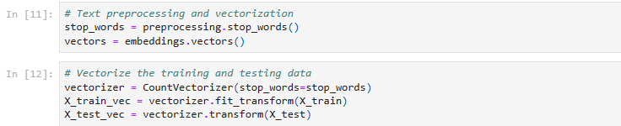Converts text data into numerical vectors using CountVectorizer.

Applying NLP techniques and training a classification model:

Different classifiers are used for analysis:

* 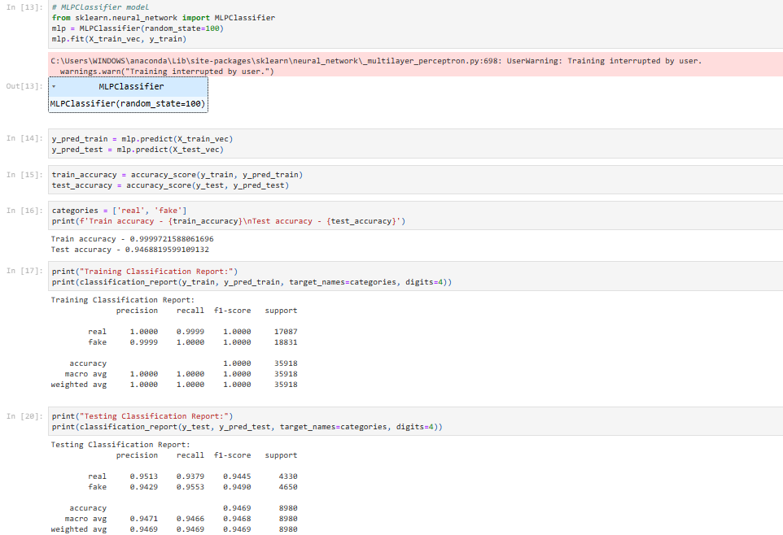Multi-Layer Perceptron (MLP) classifier
* 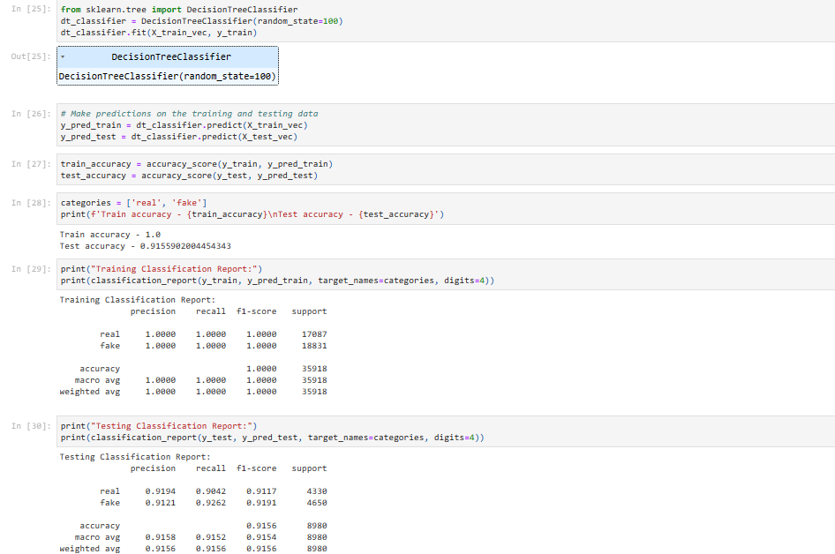DecisionTreeClassifier
* PassiveAggressiveClassifier

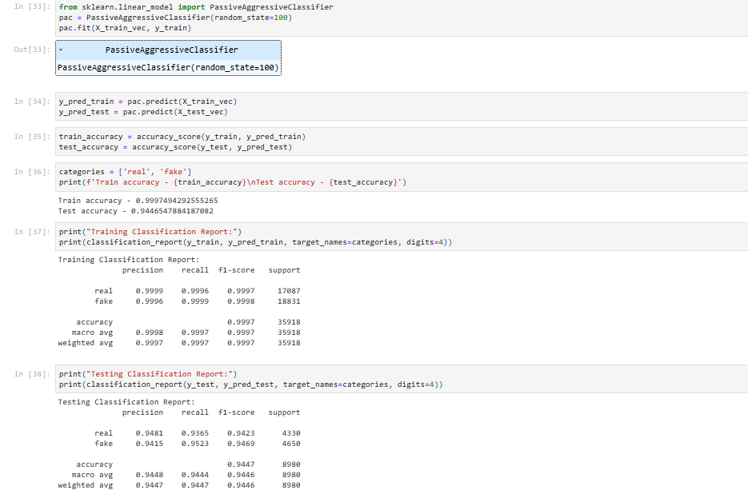

* 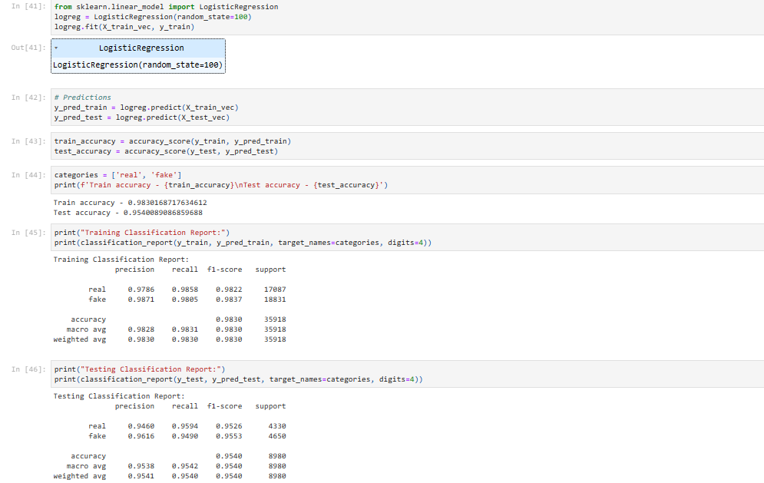LogisticRegression

Plot Accuracy Comparison:

Bar Charts comparing train and test accuracy.

* 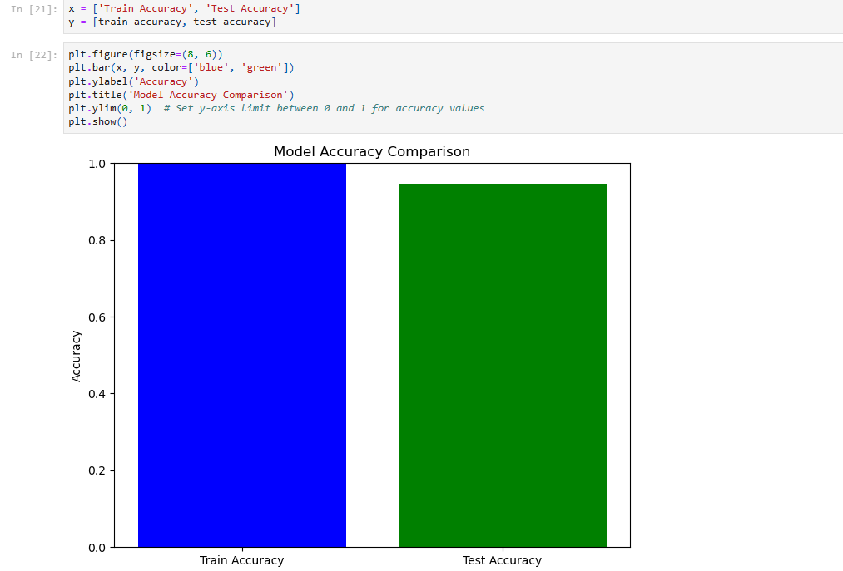Multi-Layer Perceptron (MLP) classifier
* 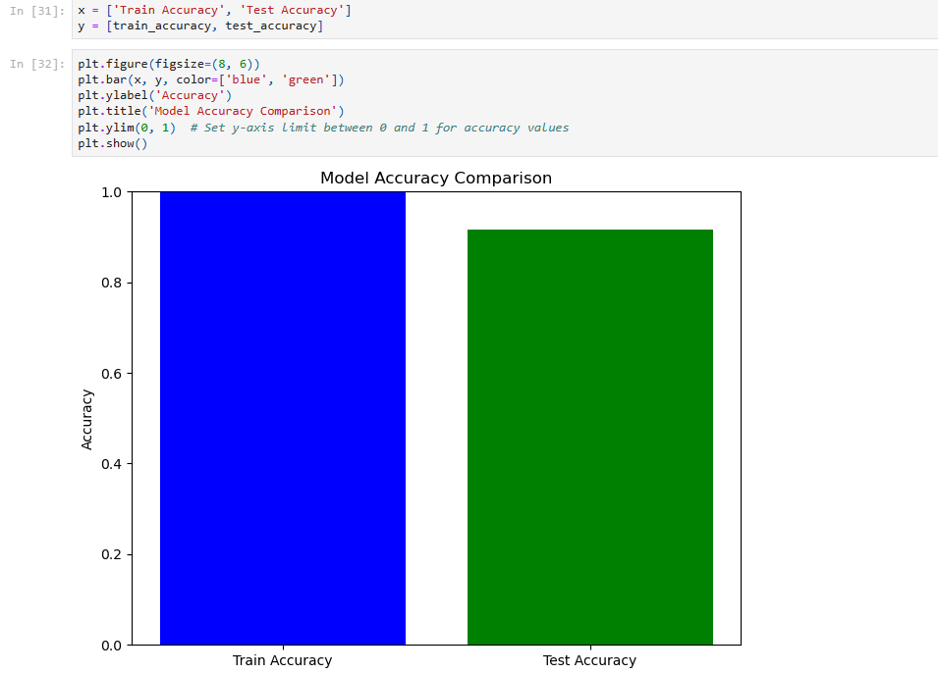DecisionTreeClassifier
* LogisticRegression

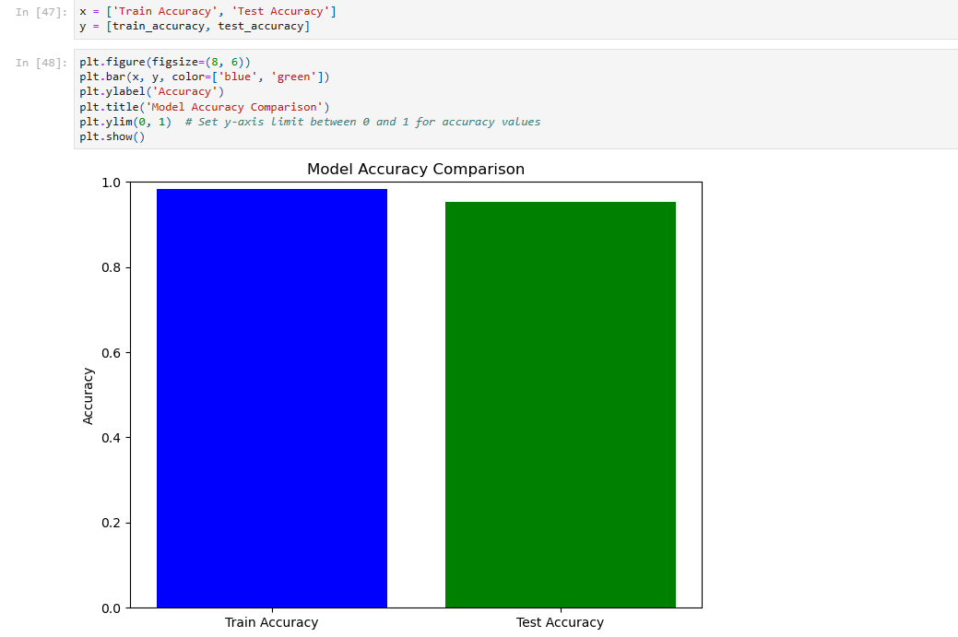

* 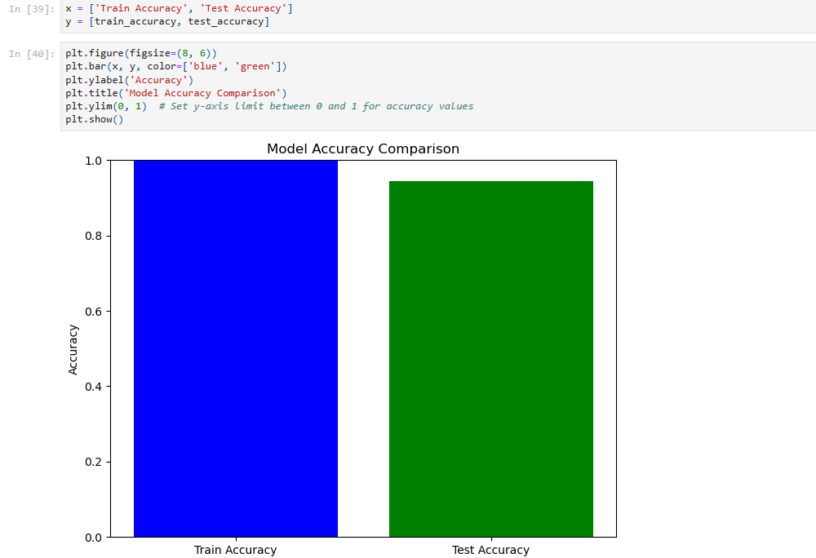PassiveAggressiveClassifier

Plotting Training Loss:

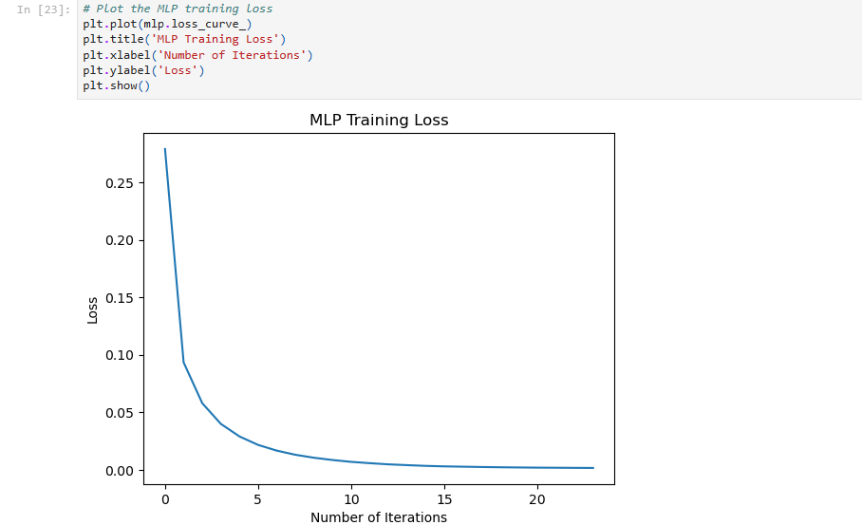The training loss curve of the model is plotted to visualize the model's learning process.

Function for Manual Input:

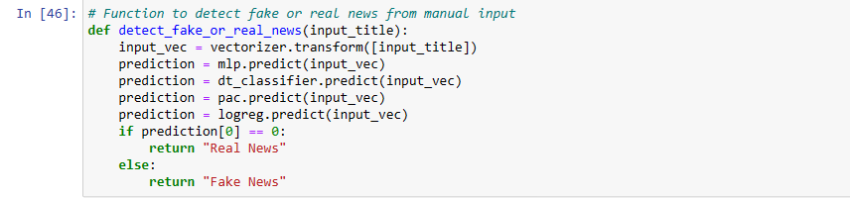A function named detect_fake_or_real_news is defined to detect whether a manually input news title is real or fake using all classifier models. It takes an input news title, vectorizes it, and makes a prediction.

Manual Input Example:

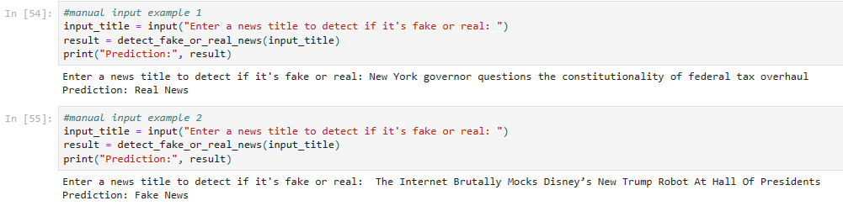The script allows the user to input a news title, and it provides a prediction (whether it's real or fake) based on the MLP model.

Conclusion:

The code performs text classification on news titles, comparing the accuracy of multiple machine learning models (MLP, Decision Tree, Passive Aggressive, Logistic Regression) and provides a function to detect fake or real news from a manual input news title.

|  |
| --- |
|  |
|  |  |

THANK YOU