**Fake news detection using nlp**

INNOVATION

**Name: Muthamil S**

**NM_ID: au813821106071**

**OVERVIEW**

**Develop a Fake News Detection system using NLP and machine learning.Utilize a dataset of labeled news articles (fake and real) for training and evaluation. The system will classify news articles as either "fake" or "real" based on linguistic and contextual features.**



**Tools used**

**Each library includes Pandas, matplotlib.pyplot, simple_nlp_library , sklearn, train_test_split, MLPClassifier, accuracy_score, classification_report.**

**Pandas is a popular Python library used for data manipulation and analysis.It provides data structures like DataFrame and Series, which are used for working with structured data.** **In this code, it is likely used for handling and preprocessing data.**

**Matplotlib is a widely-used Python library for creating static, animated, and interactive visualizations.**

**The pyplot module is commonly used to create various types of plots and charts.**

**Simple nlp library appears to be a custom or third-party library for natural language processing (NLP) tasks.**

**It includes functionalities related to preprocessing and embeddings for NLP tasks.**

**Scikit-learn is a popular machine learning library in Python that provides tools for various machine learning tasks, including classification, regression, clustering, and more.**

**train_test_split: This module is used for splitting the dataset into training and testing sets.**

**MLPClassifier: This module represents a Multi-Layer Perceptron (MLP) classifier, which is a type of neural network used for classification tasks.**

**Accuracy_score: This module provides a function for calculating the accuracy of a classification model.**

**Classification_report: This module generates a text-based summary of classification performance metrics like precision, recall, and F1-score.**

**FLOWCHART**

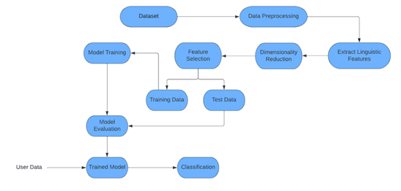

**THANK YOU**