SmartPizza AI
Online Pizza Ordering & Delivery Management System
Technical Project Documentation
Project Details | Modules | Design Patterns | Architecture
ER, UML (Use Case & Class) and DFD Diagrams
Technology Stack: Spring Boot 4 · Spring Security (JWT) · MySQL · React (Vite) · Azure OpenAI · Azure Maps · Razorpay

Table of Contents
Table of Contents 1
1. Project Overview 1
1.1 Introduction 1
1.2 Problem Statement 1
1.3 Objectives 1
1.4 Scope 1
1.5 Key Stakeholders / Actors 1
2. Technology Stack 1
2.1 Backend 1
2.2 Frontend 1
2.3 External / Cloud Services 1
3. System Modules 1
3.1 Module Summary 1
3.2 Module Interaction Summary 1
4. Design Patterns Used 1
4.1 Layered (N-Tier) Architecture 1
4.2 Repository Pattern 1
4.3 Dependency Injection / Inversion of Control 1
4.4 Data Transfer Object (DTO) Pattern 1
4.5 Strategy-like Conditional Dispatch (Coupon Discount) 1
4.6 Chain of Responsibility (Servlet Filter Chain) 1
4.7 Facade Pattern (External Service Wrappers) 1
4.8 Centralised Exception Handling (Controller Advice) 1
4.9 Builder Pattern (JWT Construction) 1
4.10 Template-style Lifecycle Hooks (JPA Callbacks) 1
4.11 Graceful Degradation / Fallback Strategy 1
5. System Architecture 1
5.1 Architectural Layers 1
5.2 Security Model 1
6. Entity-Relationship (ER) Diagram 1
6.1 Key Entities 1
7. UML Use Case Diagram 1
7.1 Representative Use Case — Place Order 1
8. UML Class Diagram 1
8.1 Notes on the Diagram 1
9. Data Flow Diagrams (DFD) 1
9.1 Level 0 — Context Diagram 1
9.2 Level 1 — Process Decomposition 1
9.3 Data Stores 1
10. Non-Functional Considerations 1
10.1 Error Handling 1
10.2 Resilience 1
10.3 Observability 1
10.4 Data Integrity 1
11. Conclusion 1

1. Project Overview

1.1 Introduction
SmartPizza is a full-stack online pizza ordering and delivery management platform built for a single restaurant chain operating its own fleet of delivery agents. The system replaces manual order-taking and phone-based delivery coordination with a web application that lets customers browse a menu, build a cart, pay online, and track their order on a live map, while giving restaurant staff a dashboard to manage products, orders, coupons and delivery agents, and giving delivery agents a simple mobile-friendly interface to receive and update assigned orders.
The platform is built around three cooperating applications that share a single backend: a customer-facing storefront, an administrator dashboard, and a delivery-agent console. All three are implemented as role-protected views inside one React single-page application, backed by a single Spring Boot REST API.

1.2 Problem Statement
- Manual phone-order taking is slow, error-prone, and does not scale during peak hours.
- Customers have no visibility into order status or delivery location once an order is placed.
- Restaurant staff lack a consolidated view of sales, popular items, delivery performance and customer behaviour.
- Combo and upsell suggestions are currently ad-hoc and not personalised to the customer or the season.
- Delivery assignment and route information is handled informally, leading to inconsistent delivery times.

1.3 Objectives
- Provide a self-service ordering experience: registration/login, menu browsing, cart, address management, coupon application and online payment.
- Provide real-time order tracking for customers using live delivery-agent location and an ETA computed from a mapping service.
- Provide an administrator dashboard for product/category/coupon/user/delivery-agent management and for revenue, order, customer and delivery analytics, including a geographic order heat-map.
- Provide AI-assisted product recommendations and "smart combo" suggestions personalised by season, price range, category and the customer's order history.
- Enforce strict role-based access control (Customer / Admin / Delivery Agent) end-to-end using stateless JWT authentication.
- Integrate with third-party services for payments (Razorpay), AI text generation (Azure OpenAI) and mapping/ETA (Azure Maps) behind a clean internal service boundary, with safe fallback behaviour if any external call fails.

1.4 Scope
The scope covers the complete backend REST API (Spring Boot) and a companion React frontend, supporting three user roles. It includes catalog and inventory management, cart and checkout, coupon-based discounting, order lifecycle management, payment capture and confirmation, delivery assignment and live tracking, AI-driven recommendations, and an administrator analytics dashboard. Multi-restaurant/multi-tenant support, native mobile apps, and SMS/email notification channels are outside the current scope.

1.5 Key Stakeholders / Actors
Actor | Description
Customer | Registers/logs in, browses the menu, manages cart and addresses, places orders, applies coupons, pays online, tracks delivery live, and views AI-based recommendations and order history.
Admin | Manages products and categories, coupons, users (block/delete), delivery agents, views and updates order status across all customers, and reviews analytics dashboards (revenue, orders, delivery performance, customer trends, order heat-map).
Delivery Agent | Views orders assigned to them, updates delivery status, and pushes live location updates that feed the ETA and tracking features.
Azure OpenAI | External AI text-generation service used to produce personalised pizza-combo recommendations.
Azure Maps | External mapping service used to geocode addresses, compute routes and estimate delivery time.
Razorpay | External payment gateway used to create payment orders and confirm successful payments.

2. Technology Stack

2.1 Backend
- Java 21 with Spring Boot 4 (spring-boot-starter-parent)
- Spring Web MVC — REST controllers (spring-boot-starter-webmvc)
- Spring Data JPA / Hibernate — ORM and repository abstraction
- MySQL — relational data store (mysql-connector-j driver)
- Spring Security — authentication and method/URL-level authorisation
- JJWT (io.jsonwebtoken) — JSON Web Token creation and validation
- Spring Validation (Jakarta Bean Validation) — request DTO validation
- Lombok — boilerplate reduction (getters/setters/constructors)
- Razorpay Java SDK — payment order creation
- Jackson — JSON serialisation and safe parsing of external API responses
- SLF4J — structured application logging
- JUnit 5 + Mockito — unit and integration testing

2.2 Frontend
- React 18 with Vite as the build tool/dev server
- Role-aware routing with protected routes and dedicated layouts for Customer, Admin and Delivery Agent
- Context API for authentication, theme (light/dark) and toast notifications
- Service modules (api.js and per-domain service files) wrapping REST calls to the backend

2.3 External / Cloud Services
Service | Purpose
Azure OpenAI | Generates natural-language pizza combo suggestions from a constructed prompt that includes season, category, price ceiling and the customer's recent order history.
Azure Maps | Geocodes delivery addresses, computes routes between two coordinates, and estimates delivery time in minutes.
Razorpay | Creates a payment order for the order total and confirms payment completion before the order is marked paid.

3. System Modules
The backend is organised into functional modules, each exposed through a dedicated REST controller and backed by a service interface / implementation pair. The table below summarises every module, its responsibility, and its primary REST endpoints.

3.1 Module Summary
Module | Responsibility | Key Endpoints (base path)
Authentication | Validates credentials and issues a signed JWT carrying username, role and user id. | POST /auth/login
User Management | Registration, profile retrieval/update, admin listing and deletion of users. | /users/register, /users/{id}, /users/all
Address Management | CRUD for customer delivery addresses, linked one-to-many from User. | /address/add/{userId}, /address/user/{userId}, /address/{id}
Product Catalog | CRUD for products/categories; search, filter by price/size/category, AI-tagged and random product listings. | /products, /products/search/{keyword}, /products/category/{category}
Cart | Add/update/remove items in a customer's cart and clear the cart after checkout. | /cart/add, /cart/{userId}, /cart/update, /cart/clear/{userId}
Coupon | Validate and apply discount coupons (flat or percentage) against an order total; admin CRUD on coupon definitions. | /coupon/apply, /coupon/all, /coupon (POST/PUT/DELETE)
Order | Places an order from the current cart, applies an optional coupon, computes totals, and supports cancellation, status and history queries. | /orders/place, /orders/user/{userId}, /orders/cancel/{orderId}
Payment | Creates a Razorpay payment order for an order, confirms/records payment, and generates a simple invoice. | /payment/create/{orderId}, /payment/confirm/{orderId}, /payment/invoice/{orderId}
Delivery & Tracking | Starts a delivery, tracks live location/ETA, and lets delivery agents view assigned orders and push status/location updates. | /delivery/start/{orderId}, /delivery/track/{orderId}, /delivery/agent/status
Delivery Agent Management | Admin CRUD for the pool of delivery agents available for assignment. | /admin/agent/add, /admin/agent
AI Recommendation | Builds a context-aware prompt (season, category, price, order history) and calls Azure OpenAI to generate combo suggestions, with a deterministic fallback if the AI call fails or cannot be parsed. | /ai/recommend
Smart Combo | A related, simpler combo-suggestion endpoint that pairs products based on a request payload. | /combo/smart
Admin Operations | Cross-cutting administrative actions: update/delete products, block/delete users, update any order's status, manage addresses. | /admin/product/{id}, /admin/user/block/{id}, /admin/orders/all
Admin Dashboard / Analytics | Aggregated reporting: revenue, order trends, delivery performance, customer analytics, daily order counts, and a geographic order heat-map. | /admin/dashboard/revenue, /admin/dashboard/heatmap, /admin/dashboard/customer-trends

3.2 Module Interaction Summary
A typical purchase flow touches six modules in sequence: Authentication issues the JWT used by every subsequent call; Product Catalog and Cart let the customer build an order; Order converts the cart into a persisted order and applies any Coupon; Payment creates and confirms the Razorpay transaction; and Delivery & Tracking takes over once the order is confirmed, assigning a delivery agent and exposing live tracking until the order is delivered. The AI Recommendation and Smart Combo modules sit alongside this flow, consulted independently by the customer at any time.

4. Design Patterns Used
The codebase consistently applies a small set of well-known design and architectural patterns rather than ad-hoc structure. The most significant are described below, with the concrete classes that implement them.

4.1 Layered (N-Tier) Architecture
Every feature is split into four layers — Controller (HTTP concerns), Service interface (contract), Service implementation (business logic), and Repository (persistence) — keeping each layer's responsibility narrow and replaceable. For example, OrderController depends only on the OrderService interface, never on OrderServiceImpl or OrderRepository directly.

4.2 Repository Pattern
All data access goes through Spring Data JPA repository interfaces (e.g. OrderRepository, ProductRepository, UserRepository) that extend JpaRepository. This abstracts SQL/JPQL behind declarative method names (findByUserId, findByStatus, findTop5ByOrderByPriceDesc) and named queries (e.g. Order.findByStatus), so services never construct queries by hand.

4.3 Dependency Injection / Inversion of Control
Spring's @Autowired field injection is used throughout controllers and service implementations (for example OrderServiceImpl wires in seven repositories and collaborating services). Controllers depend on service interfaces, not concrete classes, which is constructor/field-based Dependency Inversion in practice and makes every layer independently testable with Mockito.

4.4 Data Transfer Object (DTO) Pattern
JPA entities (User, Order, Product, Delivery, etc.) are never returned directly from controllers. Each domain has a paired DTO (UserDTO, OrderDTO, ProductDTO, DeliveryDTO, ...) that the service layer maps to before returning a response. This avoids leaking persistence concerns (lazy-loaded collections, internal IDs) to the client and decouples the public API contract from the database schema.

4.5 Strategy-like Conditional Dispatch (Coupon Discount)
Coupon.type is a DiscountType enum (FLAT, PERCENTAGE). CouponServiceImpl.applyCoupon() branches on this enum to choose the discount calculation, which is a lightweight strategy selection — the calculation strategy varies by enum value while the surrounding validation (expiry, minimum order amount) stays uniform.

4.6 Chain of Responsibility (Servlet Filter Chain)
JwtAuthFilter extends OncePerRequestFilter and is inserted into Spring Security's filter chain ahead of UsernamePasswordAuthenticationFilter. Each request flows through a chain of filters, and JwtAuthFilter's only responsibility is to validate the bearer token and populate the SecurityContext before passing control to the next filter — a textbook Chain of Responsibility.

4.7 Facade Pattern (External Service Wrappers)
AzureAIService, AzureMapsService and RazorpayService each wrap a third-party HTTP API behind a small, purpose-built Java method (getAIResponse, getETA, createOrder). Calling code never builds HTTP requests or parses raw JSON itself; it calls one method and gets a usable value or DTO, with the integration complexity and error handling hidden behind the facade.

4.8 Centralised Exception Handling (Controller Advice)
GlobalExceptionHandler is annotated @RestControllerAdvice and centralises translation of exceptions (ResourceNotFoundException, BadRequestException, validation errors, access-denied, and generic RuntimeException/Exception) into a consistent JSON error body with timestamp, status, message and path — avoiding repeated try/catch blocks in every controller.

4.9 Builder Pattern (JWT Construction)
JwtService.createToken() uses the fluent Jwts.builder() API (setClaims().setSubject().setIssuedAt().setExpiration().signWith().compact()) — a direct application of the Builder pattern supplied by the JJWT library to assemble an immutable, signed token step by step.

4.10 Template-style Lifecycle Hooks (JPA Callbacks)
Order and Payment both define an onCreate() method annotated @PrePersist, which JPA invokes automatically immediately before the first INSERT. This is a framework-provided lifecycle hook that lets each entity supply its own "fill in createdAt" behaviour without the service layer needing to remember to set it.

4.11 Graceful Degradation / Fallback Strategy
AIRecommendationServiceImpl never lets an external AI failure surface to the customer: if the Azure OpenAI call returns empty or unparseable text, the service falls back first to filtered combos (by category/price/season) and, if those are also unavailable, to a fixed default combo set (premium, budget, surprise) built directly from the product catalog — ensuring the recommendation endpoint always returns a usable result.

5. System Architecture
SmartPizza follows a layered client-server architecture. Three role-specific React experiences share one Spring Boot REST backend, secured uniformly by a stateless JWT filter and Spring Security role checks. The backend in turn delegates to three external cloud services for payments, AI recommendations and mapping, while all persistent state is stored in a single MySQL database accessed through Spring Data JPA repositories.
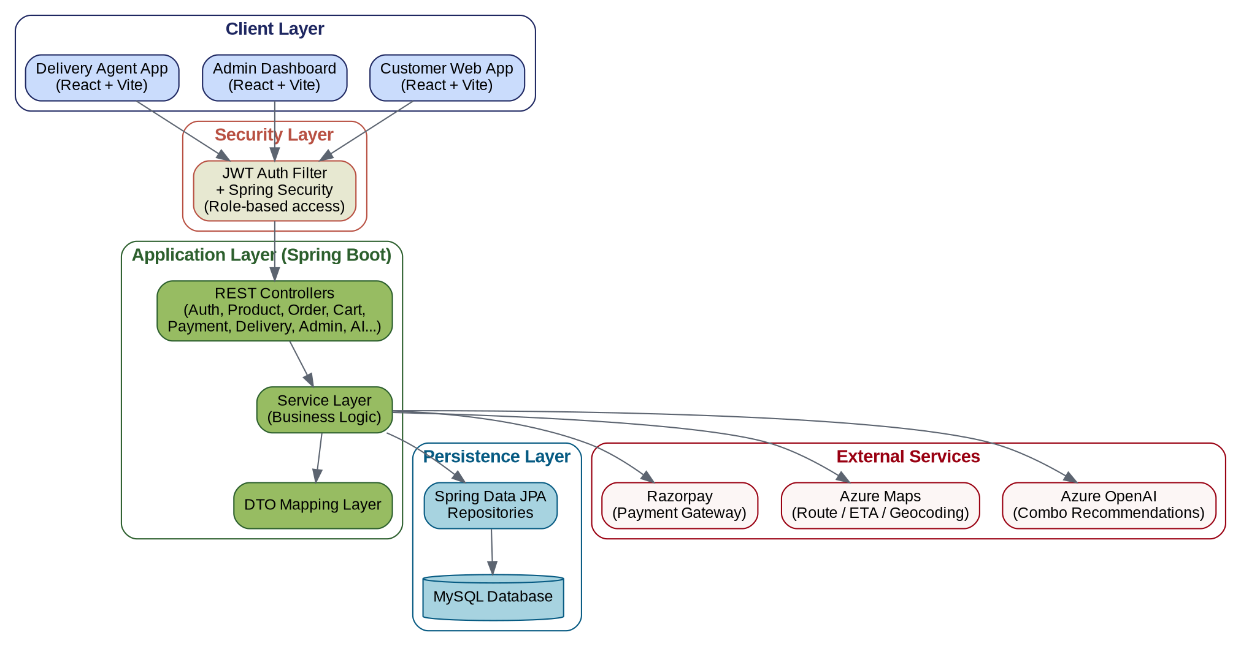
Figure 5.1 — System Architecture Diagram

5.1 Architectural Layers
- Client Layer — Three React views (Customer, Admin, Delivery Agent) built from a shared component library, calling the backend exclusively over HTTPS/JSON.
- Security Layer — A JwtAuthFilter validates the bearer token on every request and populates Spring Security's context; SecurityConfig then enforces per-role, per-endpoint authorisation rules declaratively.
- Application Layer — REST controllers translate HTTP requests into service calls; the service layer holds all business logic (order totals, coupon math, recommendation prompts, delivery assignment); a DTO mapping layer shields the API contract from the entity model.
- Persistence Layer — Spring Data JPA repositories provide a declarative data-access API over a MySQL schema managed by Hibernate (ddl-auto=update during development).
- External Services — Azure OpenAI, Azure Maps and Razorpay are called from dedicated facade services and are isolated so that a failure in any one of them degrades gracefully rather than breaking the request.

5.2 Security Model
Authentication is stateless: SecurityConfig sets SessionCreationPolicy.STATELESS, so no server-side session is kept and every request must carry a valid JWT (except the public /auth/** and /users/register endpoints). Authorisation is enforced with fine-grained requestMatchers rules per HTTP method and path, mapping to three roles:
Role | Representative Access Rules
ADMIN | Full access to /admin/**, product create/update/delete, coupon create/update/delete/list, and user listing/deletion.
USER (Customer) | Access to /cart/**, /orders/**, /payment/**, /ai/**, /combo/**, /address/** (shared with Admin), and coupon application.
DELIVERY | Access to /delivery/agent/** for viewing assigned orders and pushing status/location updates; general GET /delivery/** is shared across USER, ADMIN and DELIVERY.
Passwords are hashed with BCryptPasswordEncoder; CORS is restricted to the known frontend origin; and CSRF protection is disabled, which is the conventional and safe choice for a stateless, token-authenticated REST API rather than a cookie-session based one.

6. Entity-Relationship (ER) Diagram
The data model centres on User and Order. A user can have many addresses, many cart items and many orders; an order is built from order items copied out of the cart at checkout time and is linked to exactly one payment and one delivery record. Products belong to a category and can appear in many cart items and order items. Coupons are looked up by code at order time and are not stored as a foreign-key relationship on Order.
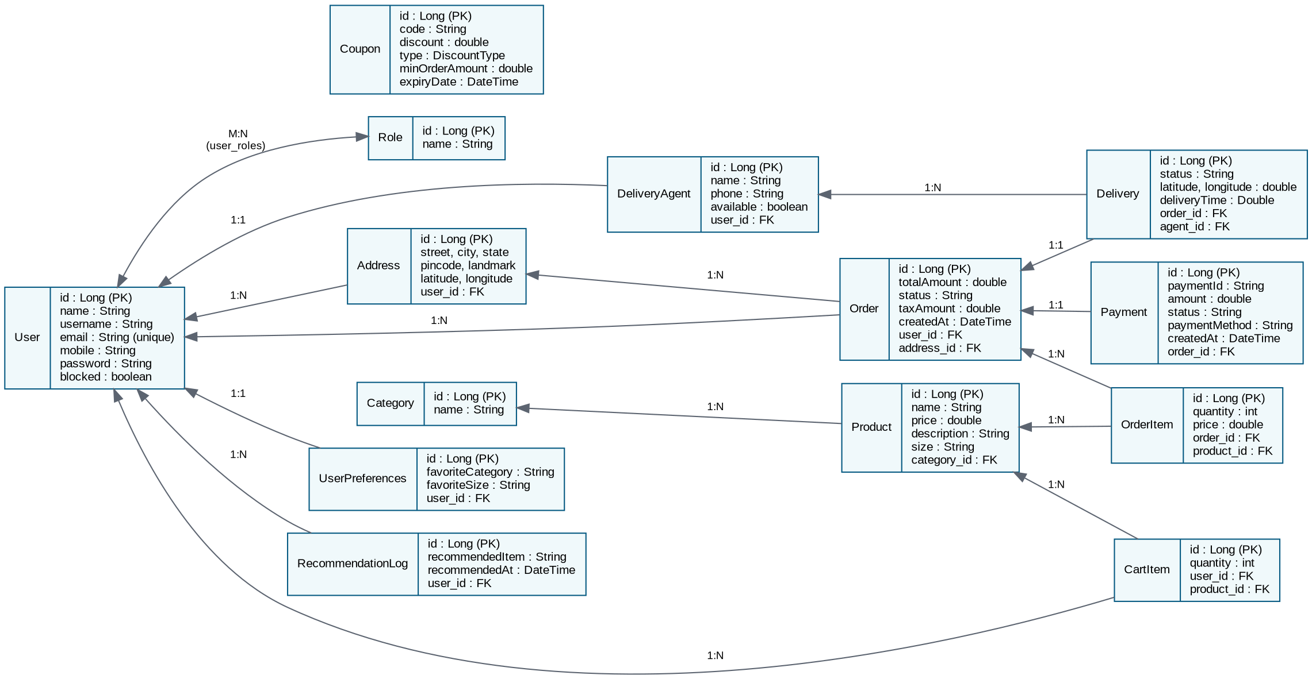
Figure 6.1 — Entity-Relationship Diagram

6.1 Key Entities
Entity | Notes
User | Core identity entity; many-to-many with Role (user_roles join table); one-to-many with Address, CartItem and Order; one-to-one with UserPreferences and DeliveryAgent.
Role | USER, ADMIN, DELIVERY — seeded at startup if missing.
Address | Belongs to a User; carries latitude/longitude used by Azure Maps for ETA calculation.
Category / Product | Category groups Products; Product carries price, size and description and feeds the catalog, cart, order-item and AI-recommendation flows.
CartItem | Transient pre-checkout association between a User and a Product with a quantity.
Order / OrderItem | Order is the checkout record (status, totals, timestamps); OrderItem is an immutable snapshot of product + price + quantity at the time of purchase, cascade-deleted with its parent order.
Payment | One-to-one with Order; stores the Razorpay payment id, amount, status and method.
Delivery / DeliveryAgent | Delivery is one-to-one with Order and many-to-one with DeliveryAgent; DeliveryAgent is one-to-one with the User account used to log in as that agent.
Coupon | Standalone discount definition (code, discount value, DiscountType, minimum order amount, expiry) looked up by code, not foreign-keyed from Order.
UserPreferences / RecommendationLog | Support personalisation: stored favourite category/size, and a log of items recommended to a user over time.

7. UML Use Case Diagram
Three actors interact with the system: Customer, Admin and Delivery Agent. All three share the Register/Login use case. The diagram groups use cases by actor and marks the three use cases that delegate to an external system (Azure OpenAI, Azure Maps or Razorpay).
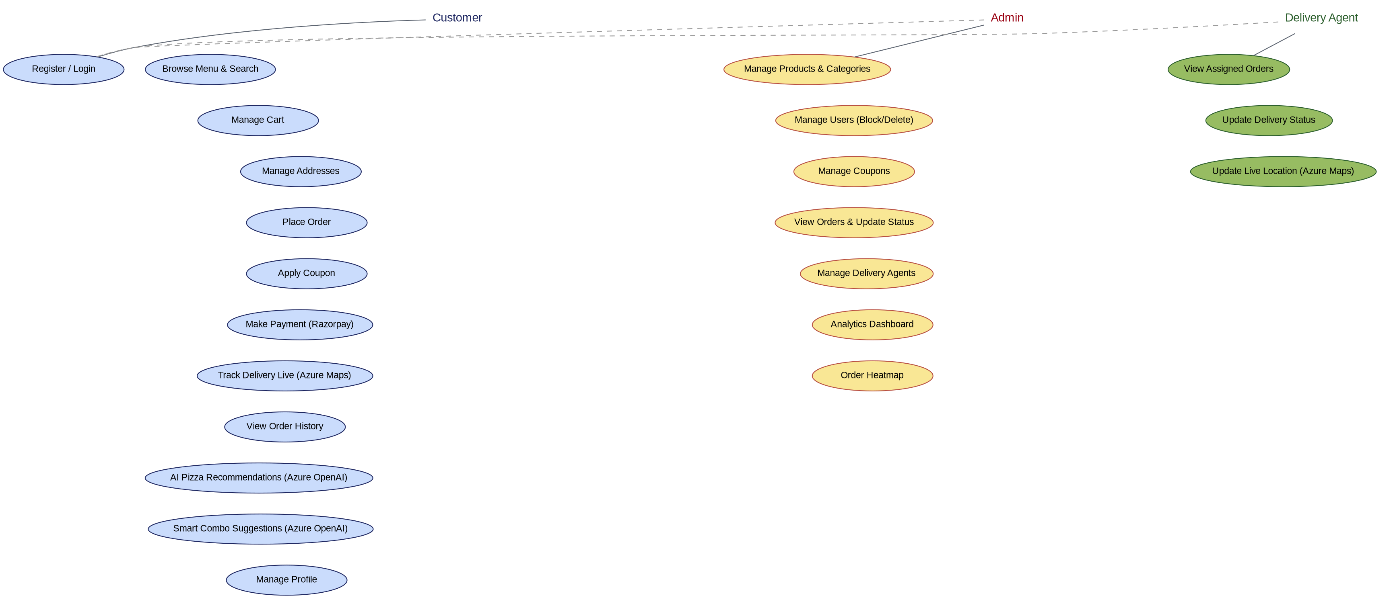
Figure 7.1 — Use Case Diagram

7.1 Representative Use Case — Place Order
Field | Description
Actor | Customer
Precondition | Customer is authenticated; cart is non-empty; at least one delivery address exists.
Main Flow | 1. Customer reviews cart. 2. Customer selects a delivery address and optionally enters a coupon code. 3. System validates the cart is not empty and the user is not blocked. 4. System converts cart items into order items and computes the subtotal. 5. If a coupon code was supplied, system validates it (exists, not expired, minimum order amount met) and applies the discount. 6. System persists the order and clears the cart. 7. System returns an order confirmation with the final total.
Alternate Flow | If the coupon is invalid or expired, or the minimum order amount is not met, the system rejects the coupon with a descriptive error while still allowing the order to proceed without a discount.
Postcondition | A new Order with associated OrderItem rows exists with status reflecting a freshly placed order; the cart is empty; the order becomes visible to Payment and Delivery modules.

8. UML Class Diagram
The class diagram below focuses on the Order subsystem because it best demonstrates the layered architecture and the patterns described in Section 4: a Controller depends on a Service interface, which is implemented by a Service class that uses Repository interfaces and produces DTOs, while the underlying entities carry their own JPA relationships. Supporting classes for coupons, AI recommendations, JWT handling and global exception handling are shown alongside.
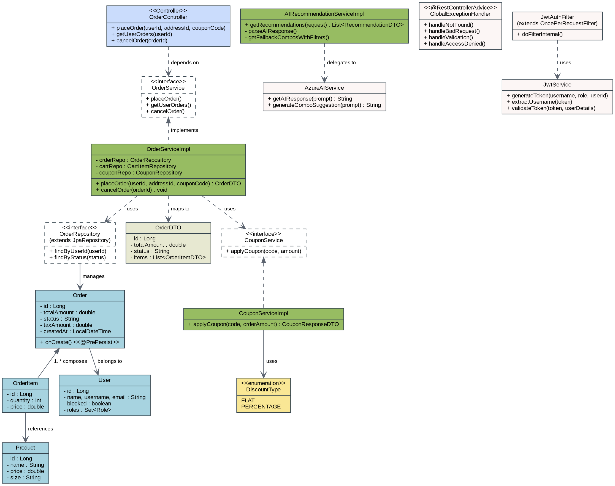
Figure 8.1 — UML Class Diagram (Order Subsystem and Supporting Services)

8.1 Notes on the Diagram
- Dashed arrows with an open-diamond / "implements" label denote interface realisation (e.g. OrderServiceImpl implements OrderService).
- Dashed arrows labelled "depends on" / "uses" denote a dependency injected via Spring (e.g. OrderController depends on OrderService; OrderServiceImpl uses OrderRepository).
- The diamond-headed edge between Order and OrderItem denotes composition: OrderItem rows are owned by, and cascade-deleted with, their parent Order (cascade = CascadeType.ALL, orphanRemoval = true).
- AIRecommendationServiceImpl "delegates to" AzureAIService, illustrating the Facade pattern described in Section 4.7.

9. Data Flow Diagrams (DFD)

9.1 Level 0 — Context Diagram
The Level 0 DFD treats SmartPizza as a single process and shows every external entity it exchanges data with: the three human actors and the three third-party services, plus the underlying database.
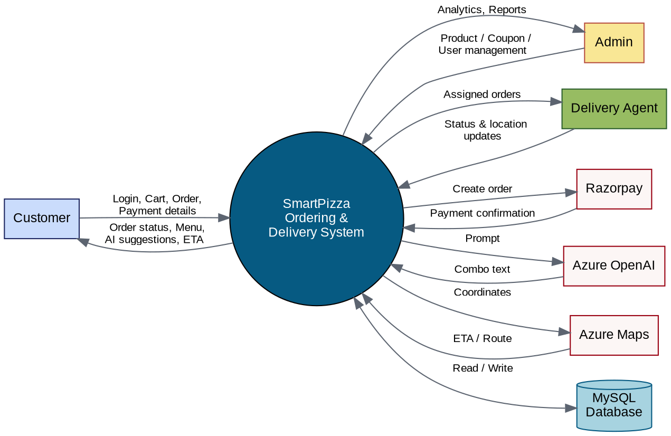
Figure 9.1 — DFD Level 0 (Context Diagram)

9.2 Level 1 — Process Decomposition
The Level 1 DFD decomposes the single context-level process into the seven major processes that correspond to the modules in Section 3, and shows the data stores each process reads from or writes to.
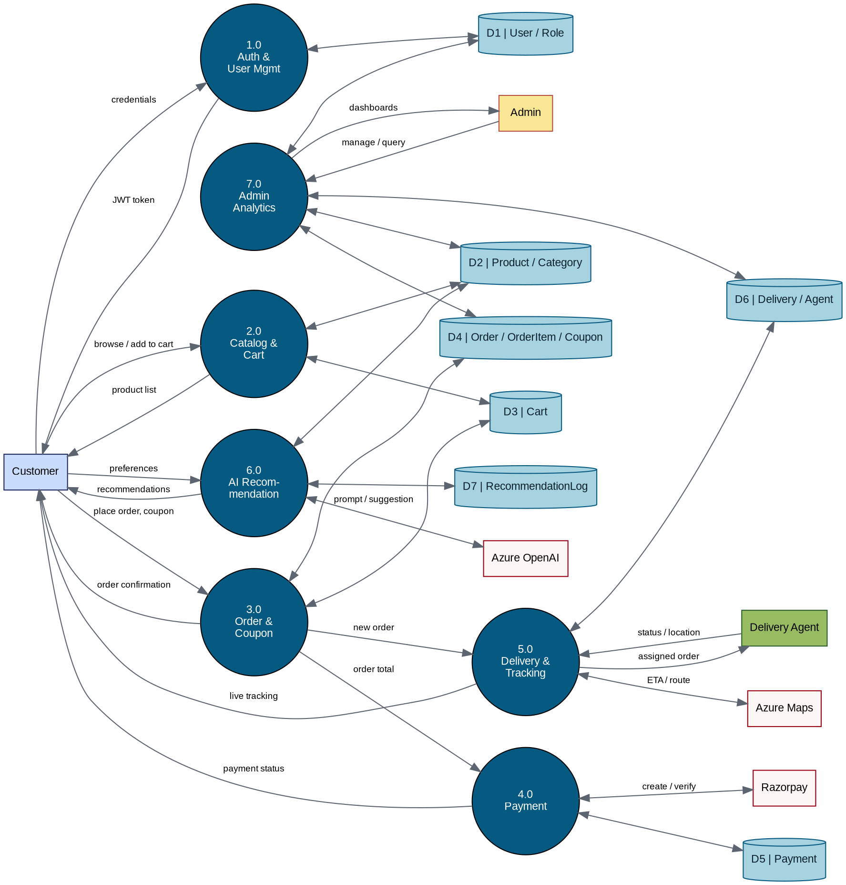
Figure 9.2 — DFD Level 1 (Process Decomposition)

9.3 Data Stores
ID | Store | Backing Entities
D1 | User / Role | User, Role, UserPreferences
D2 | Product / Category | Product, Category
D3 | Cart | CartItem
D4 | Order / OrderItem / Coupon | Order, OrderItem, Coupon
D5 | Payment | Payment
D6 | Delivery / Agent | Delivery, DeliveryAgent, Address
D7 | RecommendationLog | RecommendationLog

10. Non-Functional Considerations

10.1 Error Handling
All exceptions are funnelled through GlobalExceptionHandler, which returns a consistent JSON shape (timestamp, status, error, message, path) for not-found, bad-request, validation, access-denied and unexpected errors, making client-side error handling predictable across every endpoint.

10.2 Resilience
Both external integrations that affect the customer experience directly — AI recommendations and delivery ETA — have explicit fallback paths (a deterministic combo list, and a fixed 10-minute ETA respectively) so a third-party outage degrades the experience instead of breaking it.

10.3 Observability
SLF4J logging is used consistently across services and the JWT filter (info-level for business events such as order placement and token generation, warn-level for validation/authentication failures, error-level for unexpected exceptions), giving operators a clear audit trail without exposing internals to API responses.

10.4 Data Integrity
Jakarta Bean Validation annotations (@NotBlank, @Positive, @Email, @Pattern, @Min, @DecimalMin/@DecimalMax) are applied directly on entities and DTOs, and @Transactional wraps the multi-step order-placement flow so a failure partway through (e.g. an invalid coupon) does not leave a partially-created order in the database.

11. Conclusion
SmartPizza demonstrates a complete, production-shaped implementation of an online food-ordering and delivery platform: a cleanly layered Spring Boot backend secured with stateless JWT authentication and role-based authorisation, a relational data model that correctly captures the cart-to-order-to-payment-to-delivery lifecycle, and thoughtful integration of three external cloud services with explicit fallback behaviour. The consistent use of the Repository, DTO, Facade, Chain-of-Responsibility and centralised-exception-handling patterns keeps the codebase maintainable and testable as new modules — such as the AI recommendation and admin analytics features already present — continue to be added.

