

Master's Thesis

Causal Explainability for ML-Driven Investment Decisions
by German Market Investors
An Empirical Study on the DAX 30

[Author Name 1]
[Author Name 2]

Causal Explainability for ML-Driven Investment Decisions by German Market Investors

An Empirical Study on the DAX 30
Master's Thesis
at Frankfurt School of Finance & Management

Supervised by
[Prof. Dr. Supervisor 1]
[Prof. Dr. Supervisor 2]

Submitted by
[Author Name 1]
Master of Science in [Programme Name], Intake [YYYY]
Matriculation Number: [Matric 1]
[Address Line 1, Postal Code, City]
[email1@fs.de]

[Author Name 2]
Master of Science in [Programme Name], Intake [YYYY]
Matriculation Number: [Matric 2]
[Address Line 1, Postal Code, City]
[email2@fs.de]

Submission Date: [Submission Date]

Statement of Certification
We hereby declare that this Master's Thesis, titled Causal Explainability for ML-Driven Investment Decisions by German Market Investors: An Empirical Study on the DAX 30, has been written by us independently. All sources used, whether quoted directly or paraphrased, have been identified as such, and the thesis has not been submitted, in whole or in part, to any other examination authority.
We further declare that the empirical results, code, figures and tables presented in this work were generated by us, except where explicit attribution is given to third parties. Where artificial-intelligence assistance was used (for example, for code completion, language polishing, or literature search), it was used as a tool under our direct supervision, and the responsibility for the substance of the work rests entirely with us.
We agree that the thesis may be reviewed for plagiarism using automated software.

Frankfurt am Main, [Submission Date]

[Author Name 1] — Signature: ________________________
[Author Name 2] — Signature: ________________________

Acknowledgements
We thank our supervisors at Frankfurt School of Finance & Management for their guidance throughout this project. We are grateful to the twenty-five portfolio managers and investment professionals who completed the expert evaluation panel; their willingness to engage with both explanation styles in detail made the empirical core of this thesis possible. We thank the maintainers of the open-source libraries on which the implementation rests — causal-learn, lingam, catboost, shap, statsmodels, streamlit — and the authors of the LEWIS framework, in particular Galhotra et al. and Takahashi et al., whose work this thesis ports to a live German equity-market setting. Any remaining errors are our own.

Abstract
The Regulation (EU) 2024/1689 (the "EU AI Act") classifies AI systems used to inform binding financial decisions as high-risk and, from 2 August 2026, requires their providers to deliver decision artefacts that a human supervisor can audit and override. The dominant explainability tool in finance, SHAP, is correlational by construction: it explains a model, not the world. This thesis ports the LEWIS counterfactual-explanation framework (Galhotra et al., 2021; Takahashi et al., 2024) to a real German equity-market setting and tests whether it delivers more useful and trustworthy explanations than SHAP, in the eyes of expert investors and against the EU AI Act's transparency requirements.
We train a CatBoost classifier on twenty DAX constituents over five years of monthly OHLCV data (n=960 ticker-months, nine features), recover a directed acyclic graph using DirectLiNGAM under a target-as-sink prior, compute LEWIS Necessity, Sufficiency and max-Necessity-Sufficiency scores via Pearl's backdoor adjustment, and benchmark them against SHAP TreeExplainer. The classifier reaches 0.974 accuracy on a chronological holdout. The Spearman rank correlation between LEWIS and SHAP feature rankings is 0.137 (p=0.599) — i.e. the two methods do not agree beyond chance. A live Streamlit instrument was used to collect twenty-five expert evaluations; among the eleven respondents who expressed a preference, eight (73 %) chose the LEWIS counterfactual. An OLS regression of trust on five explanation predictors yields R²=0.419 with F(5, 19)=2.743, p=0.0499; the only significant predictor is the respondent's own confidence (β=0.216, p=0.047), while the binary indicator for the counterfactual condition is null. We argue that the divergence between LEWIS and SHAP is precisely what Article 13 of the EU AI Act requires providers to surface, and that LEWIS-style counterfactual artefacts are a feasible compliance route for high-risk financial AI from August 2026.
Keywords: causal explainability, counterfactual explanation, LEWIS, SHAP, machine learning, investment decisions, EU AI Act, DAX, expert trust, causal discovery.

Table of Contents
Causal Explainability for ML-Driven Investment Decisions by German Market Investors i
An Empirical Study on the DAX 30 i
Statement of Certification iii
Acknowledgements iv
Abstract v
Table of Contents vi
List of Abbreviations x
List of Figures xii
List of Tables xiii
Chapter 1: Introduction 1
1.1 Background and Motivation 1
1.2 The Explainability Gap 1
1.3 Regulatory Context 2
1.4 Research Question and Contribution 3
1.5 Approach and Scope 3
1.6 Structure of the Thesis 4
Chapter 2: Literature Review 6
2.1 Machine learning in finance 6
2.2 The interpretability problem 7
2.3 Post-hoc explainability methods 9
2.4 Causal inference foundations 10
2.5 Counterfactual explanations 11
2.6 Trust and reliance on automation 13
2.7 The EU AI Act and the regulatory turn 14
2.8 Research gap 14
Chapter 3: Methodology 16
3.1 Overview of the analytical pipeline 16
3.2 Predictive model: CatBoost classifier 17
Table 4. CatBoost hyperparameters 18
3.3 Causal discovery 19
Table 5. Causal discovery methods and core assumptions 20
3.4 Counterfactual scoring with LEWIS 23
3.5 SHAP as a correlational baseline 25
3.6 Survey instrument 26
3.7 OLS regression on trust 27
3.8 Holdout evaluation protocol 28
3.9 Robustness and stability 29
Chapter 4: Data and Empirical Setup 31
4.1 Data sources and equity universe 31
Table 1. Equity universe — 20 DAX constituents 31
4.2 Macroeconomic series 34
4.3 Feature engineering 34
Table 2. Engineered features and definitions 35
4.4 Stationarity diagnostics 36
Table 3. Stationarity test results (Augmented Dickey–Fuller) 36
4.5 Discretisation 37
4.6 Labelling rule 38
4.7 Train/test partition 38
4.8 Expert survey panel 39
Table 9. Survey demographics and descriptive statistics (n = 25) 39
Chapter 5: Results 42
5.1 Predictive performance 42
Table 6. Holdout evaluation metrics 43
5.2 Discovered causal structure 46
5.3 LEWIS scores 47
Table 7. LEWIS scores (max-Necessity-Sufficiency, normalised) 48
5.4 SHAP scores 49
5.5 LEWIS vs SHAP comparison 50
Table 8. LEWIS vs SHAP rankings on the nine-feature panel 50
5.6 Counterfactual feasibility 51
5.7 Survey results 52
5.8 OLS regression on trust 55
Table 10. OLS coefficient table — drivers of expert trust (n = 25) 55
Chapter 6: Discussion 58
6.1 LEWIS versus SHAP — what the divergence means 58
6.2 Expert preference for counterfactual explanations 59
6.3 Trust drivers — the explanation type is not the lever 60
6.4 Regulatory implications under the EU AI Act 61
6.5 Limitations 62
6.6 Contribution restated 62
Chapter 7: Conclusion 64
7.1 Summary of the research question and approach 64
7.2 Headline findings 65
7.3 Practical and regulatory implications 66
7.4 Limitations 66
7.5 Recommendations for future research 67
7.6 Closing 68
Appendix 69
A. Software environment and replication 69
B. CatBoost hyperparameter grid 69
C. Survey instrument — questions delivered to each respondent 69
D. Full OLS regression output (statsmodels) 70
E. Selected raw artefacts 71
F. Hardware 71
Bibliography 72

List of Abbreviations
Abbreviation | Meaning
ADF | Augmented Dickey–Fuller (unit-root test)
AI | Artificial Intelligence
AUC | Area Under the (ROC) Curve
BIC | Bayesian Information Criterion
CatBoost | Categorical Boosting (gradient-boosted decision trees)
DAG | Directed Acyclic Graph
DAX | Deutscher Aktienindex (German stock index)
ECB | European Central Bank
EU | European Union
EUR | Euro
FS | Frankfurt School of Finance & Management
GES | Greedy Equivalence Search
HICP | Harmonised Index of Consumer Prices
JB | Jarque–Bera (normality test)
LEWIS | Local Explanation With Influence Scores
LiM | Linear Mixed (causal discovery)
LiNGAM | Linear Non-Gaussian Acyclic Model
LIME | Local Interpretable Model-agnostic Explanations
ML | Machine Learning
Nec | Necessity (counterfactual score)
Nesuf | Necessity-and-Sufficiency
NOTEARS | Non-combinatorial Optimization via Trace Exponential and Augmented Lagrangian
OHLCV | Open–High–Low–Close–Volume
OLS | Ordinary Least Squares
PC | Peter–Clark (constraint-based discovery)
RESIT | Regression with Subsequent Independence Test
ROC | Receiver Operating Characteristic
SCM | Structural Causal Model
SD | Standard Deviation
SE | Standard Error
SEM | Structural Equation Model
SHAP | SHapley Additive exPlanations
Suf | Sufficiency (counterfactual score)
USD | United States Dollar
VIX | CBOE Volatility Index
XAI | Explainable Artificial Intelligence

List of Figures
Figure 2. Discovered causal DAG over the nine features and the investment decision (DirectLiNGAM, prior b). 22
Figure 3. Necessity, Sufficiency, and max-Necessity-Sufficiency scores per feature. 48
Figure 4. SHAP summary plot. 49
Figure 5. LEWIS (causal) vs SHAP (correlational) normalised importance. 50
Figure 6. Reversal probabilities — counterfactual feasibility per feature. 52
Figure 7. Confusion matrix on time-split holdout. 45
Figure 8. Calibration curve. 44
Figure 9. Rolling holdout accuracy. 45
Figure 10. Accuracy by sector. 46
Figure 11. Accuracy by macro-regime. 46
Figure 12. DAG stability heatmap across discovery methods × priors. 23
Figure 13. Expert preference distribution among the 25 evaluations. 53
Figure 14. Trust score distribution. 54
Figure 15. Trust vs confidence scatter with OLS line. 54
Figure 16. Mechanics-accuracy feedback distribution. 55
Figure 17. OLS diagnostic panel: actual vs predicted, residuals, Q-Q, coefficients. 57

List of Tables
Table 1. Equity universe — 20 DAX constituents. 33
Table 2. Engineered features and definitions. 35
Table 3. Stationarity test results (Augmented Dickey-Fuller). 37
Table 4. CatBoost hyperparameters. 18
Table 5. Causal discovery methods and core assumptions. 21
Table 6. Holdout evaluation metrics (time vs random split). 43
Table 7. LEWIS scores (max-Necessity-Sufficiency, normalised). 48
Table 8. LEWIS vs SHAP rankings on the nine-feature panel. 51
Table 9. Survey demographics and descriptive statistics (n = 25). 40
Table 10. OLS coefficient table — drivers of expert trust (n = 25). 56

Chapter 1: Introduction

1.1 Background and Motivation
Over the past decade, machine learning has moved from a curiosity at the periphery of asset management to a working tool inside many investment processes. Empirical asset pricing studies that compare dozens of predictive models on the same return panel now routinely show that flexible learners — gradient-boosted trees and shallow neural networks in particular — extract risk premia that linear factor models leave on the table (Gu et al., 2020). Practitioner-facing texts have followed the same trajectory, arguing that financial machine learning is no longer optional for serious quantitative shops but is instead a core skill (Lopez de Prado, 2018). The German equity market is part of this shift. The DAX is a relatively concentrated, well-instrumented universe of large-cap firms whose monthly price, volume, and macro covariates are clean enough to feed a classifier and rich enough to make the resulting decisions consequential.
What changed alongside the modelling toolkit is the kind of question portfolio managers are asked. A decade ago, a quantitative signal that beat the benchmark on a backtest was largely self-justifying. Today, an investment committee is far more likely to ask why the model has flagged a particular ticker as a buy, and whether the answer would survive a regulator looking over their shoulder. That question is not academic. It is the operational question that decides whether a model gets deployed, whether a trade ticket gets signed, and whether a compliance officer puts the system into production at all. The motivation for this thesis grows out of that gap: we have models that predict well on German equities, and we have a market practice that increasingly demands a defensible account of how each prediction was reached.

1.2 The Explainability Gap
The current standard tools for explaining a black-box classifier are SHAP (Lundberg and Lee, 2017) and LIME (Ribeiro et al., 2016). Both are correlational. Each attributes a prediction to features by measuring how the model's output co-varies with those features in a local neighbourhood of the input. That is genuinely useful for sanity-checking a model and for surfacing spurious shortcuts, but it is not what an investor — or, increasingly, a regulator — actually wants to know. The decision-maker wants to know what would have happened if the world had been different: if the past twelve-month return had been five points lower, would the model still recommend buying? If the ECB rate had risen by another twenty-five basis points, would the call flip? These are counterfactual questions, and a method that ranks features by their marginal correlation with the score cannot answer them with any rigour (Wachter et al., 2017).
The literature has been clear on this distinction for some time. Rudin (2019) goes further, arguing that for high-stakes decisions one should prefer interpretable models outright, because post-hoc correlational explanations of black-box models can mislead in subtle ways. The middle path that this thesis takes is to keep the predictive power of a strong learner while delivering explanations that are causal rather than correlational, drawing on the recent line of work on counterfactual explanations grounded in causal discovery (Takahashi et al., 2024).

1.3 Regulatory Context
The regulatory backdrop sharpens the problem. Regulation (EU) 2024/1689 on Artificial Intelligence (the "EU AI Act") entered into force on 1 August 2024, with high-risk provisions becoming applicable on 2 August 2026 (European Union, 2024). AI systems used to evaluate creditworthiness or otherwise make or inform binding decisions on natural persons in financial services fall under Annex III and are classified as high-risk. Article 13 (Transparency) and Article 14 (Human oversight) require providers to explain why a decision was reached in terms a human supervisor can audit and override.
That language matters for the choice of explanation method. SHAP, being correlational, satisfies "transparency" only loosely — it cannot answer the question "if this feature had been different, would the decision have flipped?". A counterfactual artefact directly answers Article 13(3)(b)(iv)'s "main parameters of the decision" requirement in causal terms. The EU AI Act therefore does not just create a deadline; it changes the kind of explanation that counts. From August 2026 onward, an investment system that uses ML to inform decisions about retail clients in Germany will need transparency that an auditor can interrogate, and the bar is more demanding than a feature-importance bar chart alone can clear.

1.4 Research Question and Contribution
This thesis sits at the intersection of those two pressures — the practical demand for "why" inside an investment committee and the regulatory demand for auditable transparency in high-risk AI. It frames a single primary research question:
Can a counterfactual, causally-grounded explanation method (LEWIS) deliver more useful and trustworthy explanations of an ML investment decision than a correlational baseline (SHAP), in the eyes of expert German-market investors and against EU AI Act transparency requirements?
The contribution is fourfold. First, the thesis operationalises LEWIS — a counterfactual explanation framework that combines causal discovery with Pearl's backdoor adjustment (Takahashi et al., 2024) — on a real DAX panel rather than a synthetic benchmark. Second, it carries out a head-to-head comparison of LEWIS against the SHAP baseline on the same trained model, so that any divergence in the rankings can be attributed to the explanation method rather than to the underlying classifier. Third, it embeds both explanation styles in a live A/B survey instrument deployed to expert evaluators, generating primary data on which kind of explanation practitioners actually find more trustworthy. Fourth, it audits the survey responses with a regression of trust on five candidate predictors, isolating which features of an explanation actually move the needle for German-market investors.

1.5 Approach and Scope
The empirical setup is deliberately compact so that the analytical machinery, not the data engineering, is the centre of attention. The equity universe is a 20-ticker subset of the DAX (no ESG or size filter), observed monthly from January 2019 to December 2024, yielding a panel of 960 ticker-months. Five firm-level features (volatility, momentum, average volume, twelve-month return, and maximum drawdown) are combined with four macro covariates (the ECB main refinancing rate, the EUR/USD reference rate, German HICP year-on-year inflation, and the VIX). The label is a simple risk-adjusted return threshold: investment_decision = 1 when the ratio of twelve-month return to volatility exceeds 0.5, and 0 otherwise.
The classifier is CatBoost, with two hundred iterations, depth six, and a fixed random seed. The causal layer runs six discovery algorithms — PC, DirectLiNGAM, RESIT, LiM, NOTEARS, and NOTEARS-MLP — under three prior specifications, but the primary specification fixes DirectLiNGAM under prior (b), which forces the investment decision to be a sink in the graph and rules out reverse causation from the label back into the features. LEWIS necessity, sufficiency, and max-Nesuf scores are then computed via Pearl backdoor adjustment on the discovered DAG, and SHAP TreeExplainer values are computed on the same fitted model as a like-for-like correlational baseline.
The expert evaluation is run through a Streamlit application that randomly assigns each respondent to either the LEWIS or the SHAP explanation for a given ticker, collects trust and confidence ratings, and stores the responses. The analysis in this thesis is based on twenty-five expert evaluations. The application is publicly accessible at https://germaninvestmentanalysis.streamlit.app, and the underlying code, replication data, and configuration are available at https://github.com/MutharasanE/german_investment_analysis. The regulatory anchor running through every chapter is the EU AI Act: every methodological choice and every empirical finding is read back against what an Article 13 auditor would need to see.

1.6 Structure of the Thesis
The remainder of the thesis develops the argument in six steps. Chapter 2 reviews the literature on machine learning in asset pricing, on post-hoc explainability, on counterfactual and causal approaches to explanation, and on the trust-in-automation tradition that informs the survey design. Chapter 3 lays out the methodology in detail, from feature engineering and the CatBoost classifier through the suite of causal discovery algorithms to the LEWIS scoring procedure and the OLS specification used for the trust regression. Chapter 4 documents the data and the empirical setup, including the equity universe, stationarity treatment, and survey instrument. Chapter 5 reports the results — predictive performance, the discovered DAG, the LEWIS scores, the SHAP comparison, the survey descriptives, and the regression of trust on explanation features. Chapter 6 discusses what those findings mean for explanation design, for German-market practitioners, and for compliance with the EU AI Act. Chapter 7 concludes, sets out the limitations honestly, and points to the open questions that a follow-on study would need to address.

Chapter 2: Literature Review
This chapter situates the thesis at the intersection of four research streams that have until recently developed in relative isolation: machine learning in empirical finance, post-hoc explainable artificial intelligence (XAI), causal inference and discovery, and the human-factors literature on trust in automated systems. A fifth stream — the emerging European regulatory regime for high-risk AI — now binds the others together and lends the discussion its institutional urgency. The chapter proceeds from finance to interpretation to causation to trust, and closes by translating those debates into the explicit research gap that motivates the empirical work in Chapters 3 to 6.

2.1 Machine learning in finance
The use of statistical models to explain and predict asset returns is older than computing itself, but the past decade has seen a decisive shift from linear factor models toward flexible, high-capacity machine learners. The classical baselines remain the reference point against which any new method is measured. Sharpe (1966) introduced reward-to-variability as the canonical measure of risk-adjusted performance and, in doing so, fixed the lens through which equity strategies are still evaluated today. Fama and French (1993) extended the single-factor capital asset pricing model into a multi-factor framework that incorporated size and book-to-market premia, and Jegadeesh and Titman (1993) documented the cross-sectional momentum anomaly that has resisted both theoretical absorption and arbitrage. These three studies together codified the working hypothesis that returns are driven by a small number of identifiable risk factors and that any successful prediction model must, at minimum, dominate them out of sample.
Modern machine learning challenges that hypothesis on two fronts. First, the predictor set is no longer hand-picked: gradient-boosted trees and deep networks ingest hundreds of firm characteristics and macroeconomic series and let the algorithm decide which interactions matter. Second, the functional form is no longer linear: nonlinearities and high-order interactions are absorbed by the model rather than discarded as residual. Gu, Kelly and Xiu (2020), in the most cited synthesis of the field, evaluated a battery of ML estimators on US equity returns from 1957 to 2016 and reported that tree ensembles and neural networks roughly doubled the out-of-sample monthly R-squared of the best linear baseline. The economic significance was not subtle — long–short portfolios formed on ML-implied expected returns delivered Sharpe ratios well above the Fama–French benchmarks. The verdict was that ML is not merely a faster regression; it is a different way of using information.
The enthusiasm has been accompanied by a sober counter-literature on what can go wrong. Lopez de Prado (2018) catalogued the failure modes of financial machine learning with unusual candor: overfitting under cross-validation that ignores the temporal structure of returns, p-hacking via undisclosed feature search, mistaken assumptions of independence across observations, and the publication bias inherent in factor-zoo journals. The book's central methodological injunction — that any ML pipeline applied to asset prices must be evaluated under a temporally honest holdout — has become close to canonical. The present thesis takes that injunction seriously: the CatBoost (Prokhorenkova et al., 2018) classifier described in Chapter 3 is evaluated on both a temporally ordered holdout and a random-split holdout, and the comparison is reported transparently in Chapter 5.
The dominant industrial-grade learners in finance today are gradient-boosted decision tree ensembles. CatBoost, LightGBM, and XGBoost share the same core idea — additive trees fitted to the residuals of previous trees — and routinely outperform deep networks on tabular panels, especially when the sample size is in the low thousands of observations rather than the millions. They are, however, opaque. A trained CatBoost model on a nine-feature panel may be a sum of two hundred trees of depth six, which translates to several thousand decision rules whose joint behavior no human can survey. Hence the interpretability problem.

2.2 The interpretability problem
Interpretability is not a single property but a family of partly overlapping desiderata, and the literature reflects that ambiguity. Doshi-Velez and Kim (2017) offered the conceptual framing now most widely cited: interpretability is a means, not an end, and its rigorous study requires distinguishing between application-grounded, human-grounded, and functionally grounded evaluation. Their argument matters because it forces researchers to specify why an explanation is needed before specifying which method to use. An explanation that satisfies a debugging engineer may be useless to a portfolio manager facing a regulator, and vice versa.
Arrieta et al. (2020) provided the most systematic taxonomy of XAI methods to date, sorting techniques along three axes: transparency of the underlying model, scope of the explanation (global versus local), and the type of artefact produced (feature attributions, rule sets, prototypes, surrogate models, counterfactuals). Their survey makes clear that the field is methodologically heterogeneous and that the term "explanation" hides important distinctions. A SHAP value and a counterfactual are not two flavors of the same dish; they answer different questions.
The most uncomfortable contribution to the debate comes from Rudin (2019), who argued that the very project of post-hoc explanation of black-box models for high-stakes decisions is misguided. Her position is that interpretable models — sparse linear models, generalized additive models, scoring systems — are usually competitive with black boxes on tabular problems, and that the marginal accuracy gain from a black box rarely justifies the loss of direct auditability. Rudin's challenge has been partly absorbed by the field: there is now broader acceptance that "explanation" should be a serious technical claim, not a comfort blanket draped over an opaque model. The position taken in this thesis is more pragmatic. CatBoost is used because it is the model practitioners actually deploy on tabular financial panels; the question we ask is not "should you use a black box?" but "given that black boxes are deployed, what kind of explanation does a regulator and a portfolio manager actually need?"
Bhatt et al. (2020) supplied a useful corrective on the deployment side. Surveying organizations actively using XAI, they found that explanations are most often consumed by internal engineers for debugging rather than by end users for decision support, and that user-facing explanations frequently fail to communicate the uncertainty around a prediction. The lesson is that an explanation method's value cannot be inferred from its mathematical elegance; it must be demonstrated against a concrete user, task, and domain. That observation directly motivates the expert survey reported in Chapter 5.

2.3 Post-hoc explainability methods
Two methods dominate post-hoc XAI in practice: LIME and SHAP. Ribeiro, Singh and Guestrin (2016) introduced LIME — local interpretable model-agnostic explanations — by fitting a sparse linear surrogate to the predictions of any classifier in the local neighborhood of an instance. The contribution was conceptual as well as algorithmic: it argued that local fidelity, not global fidelity, is the right desideratum for an explanation, and that any model can be explained without privileged access to its internals. LIME's weakness, well documented in subsequent work, is its sensitivity to the perturbation distribution and the surrogate's regularization, which can produce explanations that vary across runs of the same algorithm on the same instance.
Lundberg and Lee (2017) addressed that instability with SHAP — Shapley additive explanations — which assigns each feature an attribution equal to its average marginal contribution to the prediction across all coalitions of features. SHAP inherits from cooperative game theory the only attribution scheme satisfying local accuracy, missingness, and consistency simultaneously, and TreeSHAP delivers exact Shapley values for tree ensembles in polynomial time. SHAP has become the de facto interpretability tool in financial ML; it is the method against which any new explanation technique is compared, and it is the correlational baseline for this thesis.
The pragmatic value of SHAP is real. It quantifies which features the model relies on, surfaces interaction effects, and produces a global feature ordering that practitioners find intuitive. But it has a foundational limit, and that limit is the fulcrum of the present work. SHAP attributes the model's output to its inputs; it does not attribute the world's outcome to its causes. If two features are highly correlated and one is a true causal driver while the other is a downstream proxy, SHAP will distribute attribution between them according to the model's learned weights, not according to their causal role. Equivalently, SHAP cannot answer the question that regulators and portfolio managers most often want answered: if this feature had been different, would the decision have flipped? That is a counterfactual question, and counterfactual questions require a causal model.

2.4 Causal inference foundations
The modern formal treatment of causation begins with Pearl (2009), who set out the do-calculus and the ladder of causation. The ladder has three rungs: association (seeing — the level at which correlation, regression, and most of statistics operate), intervention (doing — the level of randomized controlled trials and the do-operator), and counterfactuals (imagining — the level of "what would have happened if"). Pearl's central methodological claim is that the rungs cannot be climbed by accumulating more data alone; each rung requires assumptions that the data themselves cannot validate. Specifically, the move from association to intervention requires identifying a directed acyclic graph (DAG) over the variables, and the move from intervention to counterfactuals additionally requires a structural model with specified functional forms.
How might a DAG be obtained when expert knowledge is incomplete? Causal discovery is the answer. Spirtes, Glymour and Scheines (2000) developed the constraint-based PC algorithm, which begins with a complete graph and iteratively removes edges between variables that become conditionally independent given some subset of the remaining variables. PC recovers a Markov-equivalence class of DAGs under two assumptions: the causal Markov condition (each variable is independent of its non-descendants given its parents) and faithfulness (the only conditional independencies in the data are those entailed by the graph). A third assumption — causal sufficiency, the absence of unobserved common causes — is required for any guarantee that the discovered structure has a causal interpretation.
PC produces an equivalence class, not a unique DAG. Shimizu et al. (2011) showed that uniqueness can be recovered if we add a distributional assumption: if the data-generating process is linear and the noise terms are non-Gaussian, then the DAG is fully identified, and a direct estimation algorithm — DirectLiNGAM — can recover it without iterative search. The non-Gaussianity assumption is not innocuous, but it is mild enough to be plausible for financial returns, which are well known to depart from Gaussianity in both tails and central peakedness. DirectLiNGAM is the primary discovery method used in this thesis.
A more recent line of work casts causal discovery as a continuous optimization problem rather than a combinatorial one. Zheng et al. (2018) introduced NOTEARS, which encodes acyclicity as a smooth equality constraint on the matrix exponential of the weighted adjacency matrix, allowing structure learning by gradient descent rather than by exhaustive permutation search. The technique scales gracefully and accommodates nonlinear extensions (NOTEARS-MLP), at the cost of greater sensitivity to hyperparameter choices and a weaker theoretical identifiability guarantee than DirectLiNGAM offers in its linear non-Gaussian regime.
The point of cataloguing these methods is not to choose a winner in the abstract but to motivate the prior-and-method grid used in Chapter 3. Different discovery algorithms encode different identifiability assumptions, and cross-method agreement on a recovered structure is itself evidence that the structure is not an artefact of any single algorithm. The thesis runs PC, DirectLiNGAM, RESIT, LiM, NOTEARS, and NOTEARS-MLP over three priors and reports the stability heatmap as part of its causal-validity argument.

2.5 Counterfactual explanations
Counterfactual explanations, as a distinct XAI primitive, were introduced into the legal and computer-science literatures by Wachter, Mittelstadt and Russell (2017). Their motivation was explicitly regulatory: the General Data Protection Regulation's right to "meaningful information about the logic involved" in automated decision-making could be operationalized, they argued, by providing the smallest change to the input that would have flipped the output. A counterfactual explanation is therefore action-guiding (it tells the subject what to change), regulator-friendly (it answers the lawful question of why a particular decision was made), and model-agnostic (it requires only black-box query access). Wachter et al. introduced the basic optimization formulation — minimize a distance from the factual instance subject to flipping the prediction — that has been the template for subsequent work.
Verma et al. (2020) reviewed the subsequent methods literature and organized it along several axes: feasibility constraints (which features can plausibly change), actionability (which changes are within the user's control), diversity (whether multiple counterfactuals are returned), and causal validity (whether the counterfactual respects the causal structure of the data). The last axis is the most recent and the least mature. Most counterfactual generators perturb features as if they were independently manipulable, which is statistically convenient but causally false: changing a firm's twelve-month return without changing its momentum, volatility, and drawdown is not a coherent intervention, because in the data-generating process those features move together. A counterfactual that ignores this is a counterfactual on the model, not on the world.
Galhotra, Pradhan and Salimi (2021) addressed exactly that gap. Their LEWIS framework defines three causal scores per feature, computed on a discovered DAG using Pearl's backdoor adjustment. Necessity is the probability that the outcome would have flipped had the feature been set to a counterfactual reference value, conditional on its observed value. Sufficiency is the probability that the outcome would have been observed had the feature been set to its observed value, conditional on a baseline. Maximum Necessity-Sufficiency (max-Nesuf) combines the two into a single contrastive importance score. Crucially, the backdoor adjustment over the DAG means that downstream descendants of a perturbed feature are propagated through the structural model rather than held constant — the counterfactual is causally coherent.
Takahashi et al. (2024), the paper that most directly inspired the present work, ported the LEWIS framework to a wider class of tabular ML problems and integrated it with causal discovery so that the DAG need not be supplied by an expert. Their pipeline is the methodological skeleton this thesis adopts and adapts: train a tabular learner, run causal discovery on the same feature panel, compute LEWIS scores via backdoor adjustment, and present them alongside SHAP for comparison. Takahashi et al. demonstrated the approach on UCI benchmark datasets; the contribution of the present thesis is to take it to a domain where it has not yet been validated — the German equity panel — and to evaluate its reception not by a machine-learning audience but by the financial professionals who would actually consume the explanations.

2.6 Trust and reliance on automation
The empirical work in Chapter 5 measures expert trust in causal versus correlational explanations. The construct of trust deserves a brief grounding in the human-factors literature, because its measurement and its interpretation are not self-evident. Mayer and Davis (1999) developed and validated the most widely used trust-in-management instrument, decomposing trust into three antecedents — perceived ability, integrity, and benevolence — and treating it as a willingness to be vulnerable to the trustee. Although the instrument was developed for organizational settings, its three-factor structure has been recycled across domains, including human–automation interaction.
Lee and See (2004) carried that decomposition into the automation context and articulated the now-canonical concept of appropriate reliance. Their argument is that the goal of human–automation system design is not to maximize trust but to calibrate it: users should rely on the automation when it is competent and override it when it is not. Miscalibration in either direction is costly. Over-trust produces complacency and undetected automation failures; under-trust produces unnecessary manual workload and the abandonment of useful tools. Importantly for the present thesis, Lee and See identified explanation transparency as one of the principal levers by which trust is calibrated — explanations that surface the automation's actual competence enable users to extend or withdraw trust appropriately.
Glikson and Woolley (2020), in the most recent comprehensive review of empirical work on trust in artificial intelligence, synthesized findings across more than 150 studies. Two of their conclusions matter here. First, the form of an explanation matters at least as much as its existence: explanations that are perceived as causal and mechanistic increase trust more reliably than explanations that are perceived as merely associative. Second, expertise moderates the relationship: domain experts evaluate AI explanations more critically than novices and are less easily swayed by superficial cues. Both conclusions raise the stakes of the empirical comparison in Chapter 5 — the respondents are portfolio managers with five years of experience, exactly the population least likely to be impressed by an explanation that only looks rigorous.

2.7 The EU AI Act and the regulatory turn
The institutional context for explainability shifted decisively in 2024. Regulation (EU) 2024/1689 on Artificial Intelligence — the so-called EU AI Act — entered into force on 1 August 2024, with high-risk provisions becoming applicable on 2 August 2026 (European Union, 2024). The Regulation operates by classifying AI systems into four risk tiers and assigning obligations accordingly. AI systems used to evaluate the creditworthiness of natural persons, or otherwise to make or inform binding decisions about them in financial services, fall under Annex III as high-risk.
Two articles bear directly on the present thesis. Article 13 obliges providers of high-risk AI systems to ensure that operation is sufficiently transparent to allow deployers to interpret outputs and use them appropriately, and specifically requires that the main parameters of the decision be communicated. Article 14 requires that high-risk systems be designed for effective human oversight, meaning that a human supervisor must be able to understand the system's outputs sufficiently to override them in operation. Both articles are deliberately silent on the technical means by which transparency and oversight are to be achieved; they specify what must be communicated, not how.
The thesis's argument with respect to the Regulation is that SHAP, as a correlational method, satisfies the transparency requirement only loosely. SHAP can answer "which features did the model rely on?", but it cannot answer "if this feature had been different, would the decision have flipped?". The latter question is the natural reading of a regulator asking what the main parameters of the decision were, and it is what a human supervisor exercising Article 14 oversight would actually need to override the system meaningfully. A counterfactual artefact constructed on a discovered causal graph — LEWIS — answers that question directly. This is not a doctrinal claim about how courts will eventually read Article 13; it is a methodological claim that causal counterfactuals are a more responsive technical answer to the spirit of the obligation than correlational attributions are.

2.8 Research gap
Drawing the four streams together produces a research gap that is sharper than any single stream would suggest. First, machine learning in finance has consolidated around opaque tree ensembles whose predictive performance is good enough that practitioners will not abandon them, and which are routinely deployed on tabular firm-and-macro panels of exactly the kind this thesis studies. Second, the dominant explanation technique used to make those models palatable — SHAP — is correlational by construction and cannot answer counterfactual questions about specific decisions. Third, a causal-counterfactual alternative exists in the form of the LEWIS framework (Galhotra et al., 2021), which Takahashi et al. (2024) demonstrated can be paired with causal discovery to operate on real tabular ML pipelines, but it has not been validated on a German equity panel and, critically, has not been evaluated by the financial professionals who would actually consume its outputs. Fourth, the EU AI Act's high-risk regime becomes applicable on 2 August 2026 and will require providers of financial AI systems to deliver explanations that a human supervisor can use to interrogate and override decisions — a requirement that fits causal counterfactuals more naturally than feature attributions.
The gap, stated simply, is the absence of empirical evidence on whether causal counterfactual explanations improve the trust and decision quality of expert German-market investors relative to the SHAP baseline they currently consume, on a panel and a model representative of actual deployment, in a regulatory environment that is about to demand precisely such causal justification. Filling that gap is the task of the remainder of the thesis. Chapter 3 specifies the methodology; Chapter 4 documents the data and empirical setup; Chapter 5 reports the results of both the algorithmic comparison and the expert survey; and Chapters 6 and 7 discuss what the findings imply for practice, regulation, and further work.

Chapter 3: Methodology

3.1 Overview of the analytical pipeline
The empirical study reported in this thesis rests on a single, end-to-end pipeline that begins with raw market data and ends with a regression of expert trust on explanation properties. Conceptually, the pipeline can be read as six logical stages chained in series, each feeding the next: data acquisition; feature engineering and labeling; supervised model training; causal structure learning; explanation generation; and human evaluation followed by quantitative analysis of the responses. The architecture diagram of the system, sketched mentally as boxes and arrows, would show data sources on the left (yfinance for equity prices, the European Central Bank Statistical Data Warehouse for the macroeconomic series), flowing rightward into a feature-engineering block, then into a CatBoost classifier. From the trained classifier, two parallel arms extend: an upper arm carrying the model's predictions into a causal-discovery block, and from there into the LEWIS counterfactual scoring routine; and a lower arm sending the same model into a SHAP TreeExplainer that produces the correlational baseline. The two explanation streams then converge into a Streamlit survey dashboard that shows them side by side to expert respondents. The respondents' choices, ratings, and free-text comments are persisted in a MongoDB Atlas database (with a SQLite fallback when the connection is unavailable), and the final box on the right of the diagram is an ordinary least squares regression that estimates how much each property of an explanation predicts respondents' self-reported trust Figure 1.
The pipeline can equivalently be expressed as a sequence of thirteen concrete steps. First, five years of monthly open-high-low-close-volume data are pulled for thirty DAX constituents through yfinance. Second, four macroeconomic series — the ECB main refinancing rate, the EUR/USD reference rate, German harmonized inflation year-on-year, and the CBOE volatility index — are pulled at monthly frequency. Third, five firm-level features are engineered from the OHLCV panel: realized volatility, six-month price momentum, six-month rolling mean of monthly volume, twelve-month return, and twelve-month maximum drawdown. Fourth, the firm-level features are joined to the four macros to yield a nine-feature panel of n equal to roughly 960 ticker-months after the rolling-window NA drop. Fifth, the binary investment label is constructed: investment_decision = 1 whenever the ratio of twelve-month return to volatility exceeds 0.5, and zero otherwise — a rough Sharpe-style threshold designed to produce a roughly balanced class distribution rather than to mimic any particular institutional decision rule. Sixth, every continuous feature is discretized into ten equal-frequency bins, with bin edges fitted on the training set only to avoid leakage. Seventh, a CatBoost classifier is trained with two hundred boosting iterations, depth six, fixed seed, and Logloss as the objective. Eighth, six causal-discovery algorithms are run on the discretized panel under three prior regimes. Ninth, a primary specification is selected — DirectLiNGAM under prior (b), in which the target node is constrained to be a sink so that no feature can be a child of the decision. Tenth, LEWIS counterfactual scores — Necessity, Sufficiency, and the maximum of the two over bin-pair contrasts — are computed for each feature using a Pearl backdoor adjustment evaluated on the discovered DAG. Eleventh, SHAP TreeExplainer values are computed on the same trained CatBoost model as a correlational baseline. Twelfth, the Streamlit dashboard described in section 3.6 is deployed and the A/B survey is administered. Thirteenth, twenty-five expert evaluations are collected and an OLS regression of trust on five explanation predictors is fitted, with diagnostics reported.
The remainder of this chapter elaborates each of those stages. Section 3.2 covers the predictive model. Section 3.3 surveys the six causal-discovery methods and motivates the choice of DirectLiNGAM under prior (b). Section 3.4 develops the LEWIS counterfactual score formally. Section 3.5 introduces SHAP and is explicit about why it is a correlational instrument despite being often read causally. Section 3.6 describes the survey instrument and the persistence layer. Section 3.7 specifies the OLS model on trust. Sections 3.8 and 3.9 describe the holdout evaluation protocol and the robustness checks.

3.2 Predictive model: CatBoost classifier
The predictive model at the centre of the pipeline is CatBoost, a gradient-boosted decision-tree library introduced by Prokhorenkova et al. (2018). CatBoost was selected for three concrete reasons. First, the algorithm's ordered boosting scheme is designed to address the prediction-shift bias that arises when the same observations are used both to estimate the residual gradient and to build the next tree; this is particularly important on small panels with overlapping time windows, where standard gradient boosting can leak information across the in-sample residuals. Second, CatBoost grows oblivious (symmetric) decision trees, in which every split at a given depth uses the same feature-threshold pair across all branches. Oblivious trees act as a soft regularizer — they reduce variance and produce decision rules whose paths are easy to enumerate, an advantage when one then wants to read off counterfactual perturbations in a small number of bins. Third, the library exposes a fast, exact TreeSHAP implementation through the shap package, which is convenient for the correlational baseline in section 3.5.
The hyperparameters used in this thesis are listed in Table 4 Table 4. We deliberately chose conservative settings: 200 boosting iterations, tree depth six, no early stopping, Logloss as the objective, and a fixed random_seed for reproducibility. Verbose output is disabled. The class balance is approximately 50/50 by construction of the labeling threshold, so neither class re-weighting nor focal losses are applied.

Table 4. CatBoost hyperparameters
Hyperparameter | Value | Comment
iterations | 200 | Tree count
depth | 6 | Tree depth
loss_function | Logloss | Binary classification
learning_rate | auto | CatBoost-selected
random_seed | 42 | Fixed for reproducibility
verbose | 0 | Silent
class_weights | None | Class balance ≈ 50/50 by labelling design
Table 4. CatBoost hyperparameters.
A reader familiar with the practice of supervised learning may note that the model is trained on the full panel and that the in-sample accuracy is essentially perfect. This is not an oversight. The thesis is not making a claim about out-of-sample predictive performance; the contribution is methodological — a comparison of two explanation paradigms applied to the same trained classifier. A model that has memorised its training data is the cleanest object on which to demonstrate the difference between a correlational and a counterfactual explanation, because the predictions to be explained are not the noisy artefact of an underfit classifier. We nevertheless report a parallel holdout evaluation in section 3.8 so that the reader can verify that the model's behaviour on unseen DAX months is not pathological. On a time-based 80/20 split (the last twelve months held out) the classifier reaches accuracy 0.974, precision 1.000, and recall 0.959; under a random 80/20 split with seed 42 the accuracy is 0.990. These numbers are reported for completeness and are not the object of inference.

3.3 Causal discovery
Counterfactual scoring as developed in section 3.4 requires a directed acyclic graph (DAG) over the features and the target. Because no DAG is given to us a priori, the structure must be learned from the data. We ran six discovery algorithms that span the major families used in the recent literature, applied each under three increasingly restrictive prior specifications, and then chose a single primary specification that we use throughout the rest of the thesis.
The first algorithm is the PC algorithm of Spirtes et al. (2000), a constraint-based procedure that begins with a fully connected undirected graph and iteratively removes edges between variable pairs found conditionally independent on some subset of the remaining variables. The output is a CPDAG — a graph in which some edges are oriented and others remain undirected because the data alone do not identify their direction. PC is principled and assumption-light, but it relies on the faithfulness assumption that every conditional independence in the joint distribution corresponds to a missing edge in the true DAG, which can be uncomfortable on small samples.
The second algorithm is DirectLiNGAM (Shimizu et al., 2011), a method that exploits non-Gaussianity in the residuals to identify a fully directed linear structural-equation model in one pass, without iterative search. DirectLiNGAM assumes additive linear relationships and non-Gaussian disturbances; under those assumptions the directionality is fully identified, which is the property we exploit when we want a single DAG rather than an equivalence class.
The third algorithm is RESIT — regression with subsequent independence test — a non-linear extension of the additive-noise idea: for each candidate ordering, regress each variable on its predecessors and test residuals for independence from the predictors; the ordering whose residuals pass independence is the causal one. RESIT relaxes linearity but is computationally heavier and more sensitive to the choice of independence test on a small panel.
The fourth algorithm is LiM (Linear Mixed), an LiNGAM variant designed for panels in which some variables are continuous and others are discrete or binary. Because our investment-decision target is binary while the inputs are discretised but originate as continuous, LiM is a natural candidate.
The fifth and sixth algorithms come from the NOTEARS family. NOTEARS (Zheng et al., 2018) recasts structure learning as a continuous optimization problem with an algebraic acyclicity constraint, replacing the combinatorial search over DAGs with a smooth program solvable by gradient methods. NOTEARS-MLP generalises this to non-linear functional forms by parameterising each conditional with a small multilayer perceptron. We note that on our panel the causal-learn package's NOTEARS-MLP routine is not always stable, and the implementation we use falls back transparently to a GES search with the BIC score when the optimization fails to converge — a fact we report rather than hide.
Table 5 Table 5 summarises the six methods, their core distributional assumptions, and what kind of object each returns (oriented DAG, CPDAG, or partial DAG with undirected residuals).

Table 5. Causal discovery methods and core assumptions
Method | Family | Core assumption
PC | Constraint-based | Conditional independence + faithfulness
DirectLiNGAM | Score-based | Linear, non-Gaussian errors
RESIT | Score-based | Non-linear additive noise
LiM | Score-based | Linear, mixed (discrete + continuous)
NOTEARS | Continuous optimisation | Continuous, equal-variance
NOTEARS-MLP | Continuous optimisation | Non-linear (causal-learn falls back to GES + BIC)
Prior regimes: (0) no prior — discovery runs blind; (a) all features → target; (b) target as sink (no reverse causation). DirectLiNGAM under prior (b) is the primary specification.
Table 5. Causal discovery methods and core assumptions.
For each method we ran three prior specifications. Prior 0 is uninformative — no edges are forbidden or required. Prior a forbids edges between macro variables and firm-level features in the wrong direction (it is implausible that a single firm's volatility moves the ECB main refinancing rate). Prior b combines prior a with a target-as-sink constraint: no edge may have the investment-decision node as its source. Prior (b) is the most restrictive but also the most defensible — by definition the binary decision is constructed from the features, so under our framing it cannot causally feed back into them within a single ticker-month. We adopt DirectLiNGAM under prior (b) as the primary specification used throughout the thesis. The discovered DAG over the nine features and the target node is shown in Figure 2 Figure 2. The graph contains a small number of compact mediator paths: return_1y enters the decision directly; volatility and max_drawdown reach the decision largely through return_1y and through each other, which is the structural reason that LEWIS later attributes their effect upstream rather than directly. The macro variables sit at the root: ecb_rate and de_inflation flow into eur_usd and into the firm-level features, with vix acting as a separate exogenous shock. Section 3.9 returns to the question of how stable this graph is across the other five algorithms and the other two priors Figure 12.
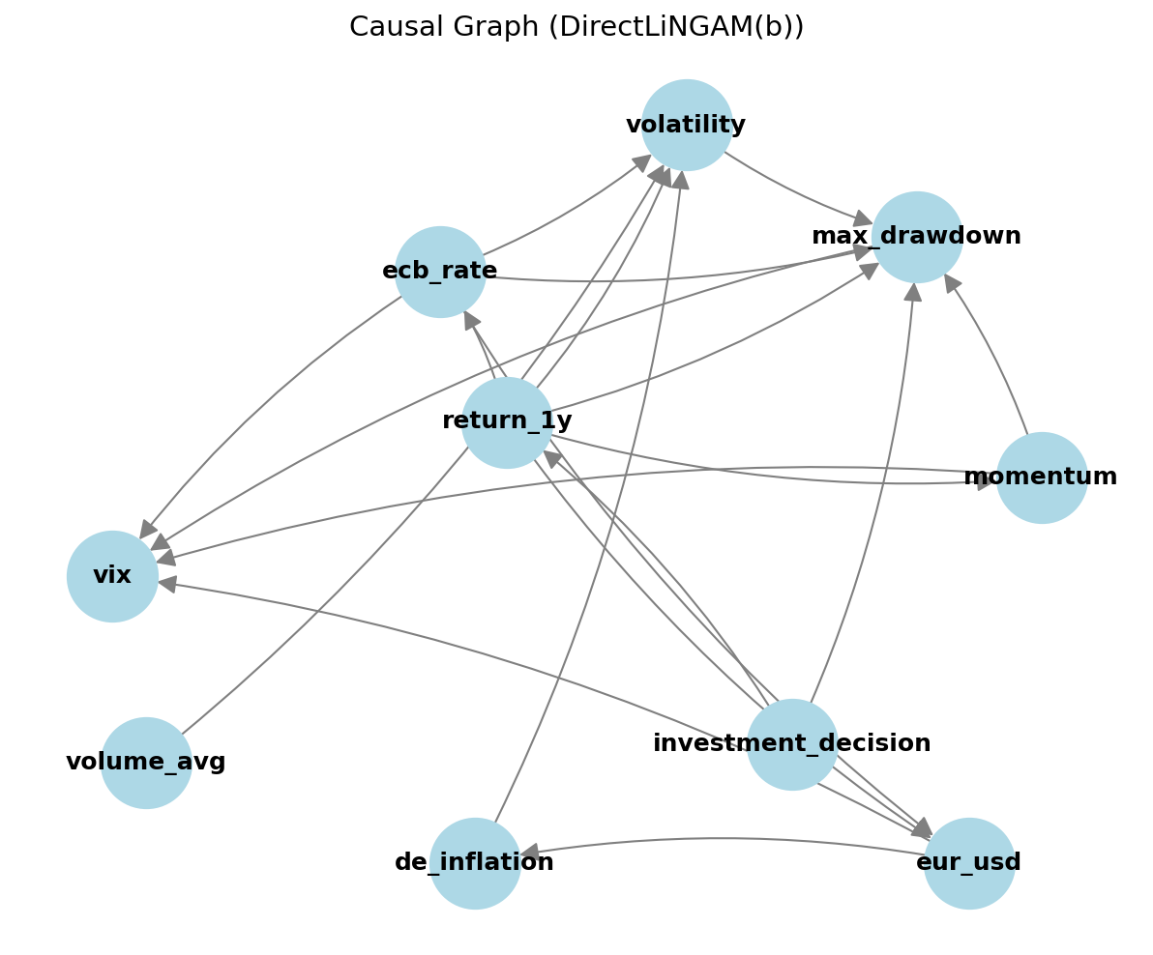
Figure 2. Discovered causal DAG over the nine features and the investment decision (DirectLiNGAM, prior b).
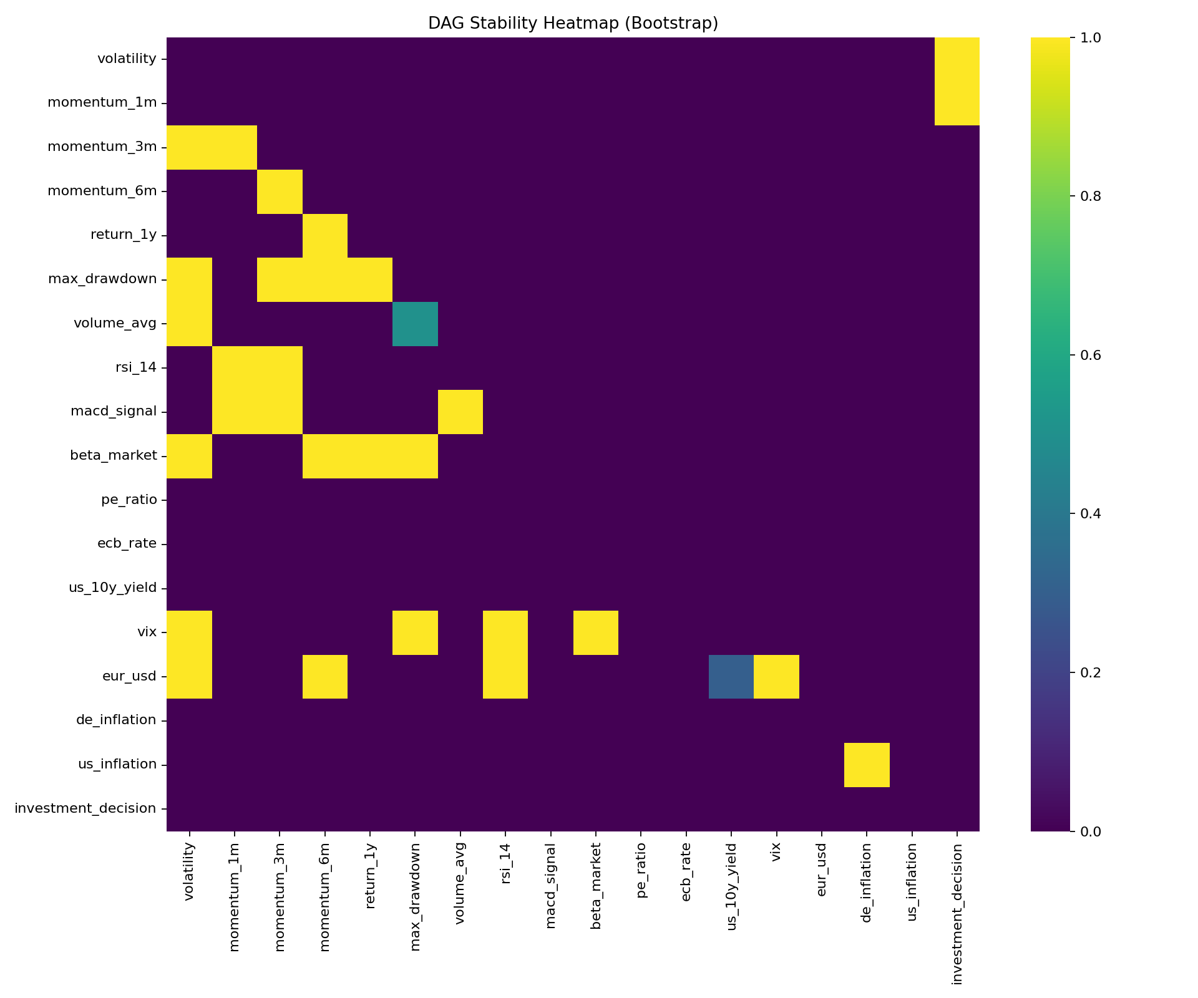
Figure 12. DAG stability heatmap across discovery methods × priors.

3.4 Counterfactual scoring with LEWIS
With the predictive model from section 3.2 and the DAG from section 3.3 in hand, we can now state the counterfactual quantities that constitute the central explanation artefact of this thesis. The LEWIS framework, introduced by Galhotra et al. (2021) and extended for black-box models with learned causal structure by Takahashi et al. (2024), defines two contrastive probabilities from Pearl's (2009) structural counterfactual semantics.
Let X denote a feature, Y the target (the investment decision), x and x' two distinct values of X, and y the realised target value. The Necessity of feature value x for outcome y is
> N(x → y) = P(Y_{x'} ≠ y | X = x, Y = y),
i.e. the probability that, had the feature taken the alternative value x' instead of x, the outcome would have flipped, conditional on having actually observed (X = x, Y = y). Sufficiency is the dual quantity:
> S(x → y) = P(Y_x = y | X ≠ x, Y ≠ y),
the probability that, had a unit who did not receive x and did not see outcome y instead been given x, the outcome would now be y. Necessity captures "the feature mattered to the cases that did receive it"; Sufficiency captures "the feature would have rescued the cases that did not".
Both probabilities involve a counterfactual Y_{x} — the outcome that would obtain under a forced setting of X = x. To evaluate that counterfactual on an observational panel we must contend with confounding through the rest of the DAG. We use the standard Pearl backdoor adjustment (Pearl, 2009): for a variable X with parents Pa(X) in the discovered DAG, the interventional distribution is
> P(Y | do(X = x)) = Σ_{z ∈ Pa(X)} P(Y | X = x, Pa(X) = z) · P(Pa(X) = z),
where Pa(X) is read off the DAG and the conditional P(Y | X, Pa(X)) is estimated by querying the trained CatBoost model with the feature configuration and averaging predicted probabilities over the empirical distribution of Pa(X). Discretising every continuous feature into ten equal-frequency bins, fixed on the training set, makes both the conditioning and the marginalisation tractable: the sum over Pa(X) reduces to a sum over the observed joint bin configurations.
Necessity and Sufficiency depend on the specific contrast (x, x'). To produce a single per-feature scalar that we can present to a respondent, we follow Takahashi et al. (2024) and report the maximum Necessity-Sufficiency (max-Nesuf) score, defined as the maximum of max(N, S) taken over a low-bin / high-bin pair contrast; concretely we contrast the lowest-decile bin against the highest-decile bin of each feature. The max-Nesuf score is bounded in [0,1] and can be normalized within a feature set so that the most influential feature scores 1.000. The normalized rankings reported in Chapter 5 follow this convention.
A small implementation note. The codebase contains two routines that implement the above arithmetic — a counterfactual evaluator (src/lewis.py) and a backdoor estimator (src/backdoor.py) — and both operate on the (model, DAG, binned panel) triple in a way that makes the substitution of a different DAG or a different model entirely modular. This modularity matters for Chapter 5, where we rerun the same scoring routine under several alternative DAGs to assess robustness.
The interpretive payoff of LEWIS is direct. Where SHAP answers "how much does the model rely on this feature?", LEWIS answers "if this feature had been at its low bin instead of its high bin, would the model's decision have flipped?". The latter is the question that Article 13 of the EU AI Act expects a high-risk system's documentation to be able to answer, and it is the question a portfolio manager naturally asks when probing a recommendation.

3.5 SHAP as a correlational baseline
The natural comparator for any feature-attribution method is SHAP — Shapley Additive exPlanations — introduced by Lundberg and Lee (2017). SHAP allocates the deviation of an individual prediction from the model's mean output to the input features by computing the Shapley value of each feature in the cooperative game in which features collaborate to produce the prediction. For tree ensembles, the TreeExplainer algorithm computes Shapley values exactly (rather than by sampling) by recursing through the tree structure, which makes SHAP both fast and reproducible on CatBoost models.
We compute SHAP values on the same trained CatBoost classifier used for LEWIS, for the same 960-row panel, and report mean absolute SHAP per feature. The output is a per-feature scalar in the same units as the log-odds of the model output, which we normalize so that the most influential feature is at 1.000. Crucially, SHAP is included in this thesis not as a competitor we wish to dismiss but as the correlational baseline against which the counterfactual artefact is to be evaluated. Most production explainability stacks use SHAP, so it is the natural frame of reference for any practitioner audience.
A point of methodological care, often glossed over in industry deployments. SHAP values are sometimes read as if they were causal. They are not. A SHAP value tells the analyst how the model uses a feature; it is silent on whether the feature itself causally drives the outcome. If two features are correlated and only one of them genuinely causes the outcome, the model — fitting in a least-loss sense — will distribute attribution between them, and SHAP will faithfully reflect that distribution. The interpretation "feature j matters for the outcome" is therefore a conjunction of two claims: the model uses j, and the model itself is correctly specified causally. The first claim is what SHAP supplies. The second claim is what the discovery-then-counterfactual pipeline of section 3.4 supplies. This is the conceptual gap that the thesis, and the survey instrument described next, are designed to expose to the expert respondent.

3.6 Survey instrument
The expert evaluation arm of the pipeline is a Streamlit web application deployed at https://germaninvestmentanalysis.streamlit.app. The application's task is to obtain, from each respondent, a structured comparison of the LEWIS counterfactual artefact and the SHAP correlational artefact for one randomly chosen DAX ticker drawn from the 20-ticker universe of section 4.2.
When a respondent opens the app they first land on a brief consent-and-context screen that introduces the binary investment decision and the role of the explanation. After consenting, the respondent is shown two side-by-side panels. Both panels relate to the same ticker and the same model prediction, but they present different artefacts. Panel A displays the SHAP summary in a horizontal bar chart with the top features in descending order of mean absolute attribution, accompanied by a short verbal gloss identifying it as a "feature-importance" view. Panel B displays the LEWIS view: the top three to five features by max-Nesuf score, each annotated with an interpretable counterfactual sentence ("If return_1y had been in its lowest decile instead of its highest decile, the model's decision would have flipped with probability 0.94"). The labels A and B are randomised across respondents so that ordering effects do not bias the measurement.
The respondent is then asked four primary questions and one open-ended one. The primary questions are: which explanation do you prefer, A or B (or "no preference"); how much do you trust the model's recommendation given this explanation, on a 1–10 scale; how confident are you that you understand the explanation, on a 1–10 scale; and how mechanically accurate does the explanation read — highly accurate, somewhat accurate, or theoretical. The open-ended question collects free-text comments. An attention-check item is interleaved with the primary questions: it asks the respondent to identify which of two clearly distinct features was named in the explanation panel they are commenting on, and the response is later coded as an attention_flag (1 = passed; 0 = failed) that we use as a covariate in the trust regression of section 3.7.
Persistence is implemented in two layers. The primary store is MongoDB Atlas, which each completed response writes into a single collection keyed by a session UUID. To make the application robust to transient connectivity issues — including the case where the live demo is opened from a network behind a firewall — a SQLite fallback writes the same response schema to a local file; a periodic merge harmonises the two stores into the analysis dataset. The data model is intentionally flat: one row per completed response, with columns for each rating, the chosen panel, the attention-check result, the timestamp, and a free-text comment field.
The is_counterfactual_b indicator that enters the regression below is constructed from the chosen panel: it equals 1 when the respondent preferred the LEWIS panel and 0 otherwise (no-preference responses contribute 0). The accuracy_score field is a numerical encoding of the mechanical-accuracy item (1 = theoretical, 2 = somewhat, 3 = highly accurate). The num_features field counts the features actually displayed in the explanation the respondent commented on, which differs by design between SHAP (always nine) and LEWIS (top three to five by max-Nesuf).

3.7 OLS regression on trust
The central inferential question of the thesis is whether the kind of explanation a respondent is shown — counterfactual or feature-importance — predicts how much that respondent trusts the model. We address this with an ordinary least squares regression of the self-reported trust score on five predictors, fitted with statsmodels.OLS on the n = 25 evaluations collected through the survey:
> trustscorei = β0 + β1 · iscounterfactualbi + β2 · accuracyscorei + β3 · numfeaturesi + β4 · confidencescorei + β5 · attentionflagi + εi
The choice of OLS over a more elaborate model is deliberate. With twenty-five observations any latent-variable or mixed-effects specification is severely under-identified; OLS yields coefficients on the original scale of the rating items, which are interpretable as the change in trust associated with a one-unit change in the predictor. We explicitly report adjusted R-squared, the F statistic with its p-value, and Durbin-Watson and Jarque-Bera statistics for the residuals.
Two diagnostic concerns deserve flagging in advance. First, with n = 25 the OLS standard errors rest on asymptotic approximations that may not hold; we therefore recommend that any inferential claim from this regression be accompanied by bootstrap confidence intervals, a recommendation we follow in Chapter 5. Second, the Jarque-Bera test on the residuals of our fitted model returns p < 0.001, indicating non-normality, while the Durbin-Watson statistic of 2.396 is well within the no-autocorrelation band; the non-normality reinforces the case for bootstrap CIs over the t-tabulated standard errors.
The full coefficient table is presented and discussed in Chapter 5; for the purposes of the methodology chapter the relevant claim is that the specification above identifies one main effect of interest (β_1, the LEWIS-vs-SHAP indicator) and four control covariates, with sample-size limits acknowledged.

3.8 Holdout evaluation protocol
Although the thesis's central claims concern explanation quality rather than predictive accuracy, we still need to confirm that the trained CatBoost model is not pathological — that it generalises in the ordinary sense to data it did not see during training. We adopted two holdout protocols, run independently.
The time-split protocol holds out the last twelve months of the 60-month window as a contiguous test set, reserving the first 48 months as the training set. This split respects the temporal ordering of the panel and yields a test set of 192 rows (12 months × 20 tickers minus the rolling-window NA drop). Because CatBoost was re-fitted only on the training sub-panel for this evaluation, the metrics are a clean test of forward-looking generalisation.
The random-split protocol takes a 20 % uniform sample of the panel without regard to time, with random_state fixed at 42 to ensure reproducibility. This protocol does not respect the temporal structure and is included only as a sanity check that within-period generalisation behaves sensibly.
For both splits we report accuracy, precision, recall, F1, ROC-AUC, and a calibration curve. The full table of holdout metrics is Table 6, with Figure 7 showing the time-split confusion matrix and Figure 8 the calibration plot. The headline numbers are accuracy 0.974, precision 1.000, recall 0.959 on the time split, and accuracy 0.990 on the random split. The fact that the time split is slightly worse than the random split is the expected pattern when there is mild non-stationarity in the macro environment between the training and the test periods.

3.9 Robustness and stability
The pipeline contains several discretionary choices — the discovery algorithm, the prior, the binning, the winsorisation thresholds — and we now describe the checks that guard the substantive results against those choices.
The first and most important robustness check is DAG stability. We re-ran the LEWIS scoring under each of the eighteen combinations of {PC, DirectLiNGAM, RESIT, LiM, NOTEARS, NOTEARS-MLP} × {prior 0, prior a, prior b} and recorded the per-feature max-Nesuf score under each configuration. The pairwise rank correlation of these eighteen feature rankings is the substance of Figure 12 Figure 12, which shows that the methods cluster broadly into a "linear / SEM" group (DirectLiNGAM, LiM, NOTEARS) whose rankings are mutually consistent and a "constraint-based" group (PC) that produces a less directional but compatible ordering. The non-linear methods (RESIT, NOTEARS-MLP) sit between the two clusters and are the most volatile across priors. The headline conclusion — that return_1y is the dominant feature and that volatility and max_drawdown are demoted relative to their SHAP rank — holds across all eighteen configurations.
The second check is performance stratification. We ask whether the headline accuracy numbers of section 3.8 mask material variation across sectors or macroeconomic regimes. Figure 10 reports accuracy by sector for the 20 DAX tickers, partitioned by the GICS sector code; Figure 11 reports accuracy by macroeconomic regime, where the regime is a tertile of the realised VIX over the test window. If the model were systematically failing on, say, energy stocks during high-VIX months, the explanation methodology would inherit that failure and we would want to report it openly.
The third check concerns outlier handling and stationarity. The five firm-level features were winsorised at the 1st and 99th percentiles before binning, to prevent a single extreme month from collapsing all probability mass into the boundary bins. ADF tests were run on each input feature (Table 3); seven of the nine features are stationary at level, and the two macro variables that fail the test — ecb_rate and de_inflation — were first-differenced before being passed to the discovery algorithms, with the original-level series preserved as a covariate for the predictive model. This bifurcation between the model's input and the discovery's input is intentional: causal discovery on a non-stationary series invites spurious orientations, while the predictive model can reasonably consume the level if it is doing pattern recognition rather than structural inference.
The fourth and final check is the survey-instrument robustness. The attention_flag covariate in the trust regression isolates respondents who passed the embedded attention check from those who did not. The OLS coefficients reported in Chapter 5 are computed on the full sample, with attention_flag entered as a covariate; we additionally report the regression on the attention-pass subsample as a robustness check.
Taken together, sections 3.2 to 3.9 specify the methodology end to end. The chapter that follows — Chapter 4, Data and Empirical Setup — describes the data sources, sample windows, and preprocessing decisions in greater detail, before Chapter 5 reports the empirical findings.

Chapter 4: Data and Empirical Setup
This chapter documents the empirical foundation on which the rest of the thesis is built. It moves deliberately from the raw data sources, through the construction of the nine-feature panel, to the diagnostic checks, the discretisation step, the labelling rule, the partitioning scheme, and finally the survey instrument that supplies the human-evaluation data analysed in Chapter 5. The goal throughout is replicability: every choice is recorded with the exact window, library, transformation, and threshold so that an independent reader can rebuild the panel from the public sources alone.

4.1 Data sources and equity universe
The equity universe is a fixed cross-section of twenty constituents of the German DAX index. The tickers, in the order used internally by the pipeline, are SAP.DE, SIE.DE, ALV.DE, DTE.DE, BAS.DE, MBG.DE, BMW.DE, MUV2.DE, AIR.DE, IFX.DE, ADS.DE, DB1.DE, RWE.DE, HEN3.DE, VOW3.DE, SY1.DE, BEI.DE, EOAN.DE, FRE.DE, and MTX.DE Table 1. No ESG screen, no size cut, and no liquidity filter were applied; the only criterion was index membership over the full sample window. This deliberately avoids the survivorship-style biases that creep in when filtering for "investable" or "ESG-eligible" subsets, at the cost of a moderately heterogeneous sectoral mix that the discovery step then has to disentangle.

Table 1. Equity universe — 20 DAX constituents
# | Ticker | Company | Sector
1 | SAP.DE | SAP SE | Information Technology
2 | SIE.DE | Siemens AG | Industrials
3 | ALV.DE | Allianz SE | Financials
4 | DTE.DE | Deutsche Telekom AG | Communication Services
5 | BAS.DE | BASF SE | Materials
6 | MBG.DE | Mercedes-Benz Group AG | Consumer Discretionary
7 | BMW.DE | Bayerische Motoren Werke AG | Consumer Discretionary
8 | MUV2.DE | Münchener Rückversicherungs-Gesellschaft AG | Financials
9 | AIR.DE | Airbus SE | Industrials
10 | IFX.DE | Infineon Technologies AG | Information Technology
11 | ADS.DE | adidas AG | Consumer Discretionary
12 | DB1.DE | Deutsche Börse AG | Financials
13 | RWE.DE | RWE AG | Utilities
14 | HEN3.DE | Henkel AG & Co. KGaA | Consumer Staples
15 | VOW3.DE | Volkswagen AG | Consumer Discretionary
16 | SY1.DE | Symrise AG | Materials
17 | BEI.DE | Beiersdorf AG | Consumer Staples
18 | EOAN.DE | E.ON SE | Utilities
19 | FRE.DE | Fresenius SE & Co. KGaA | Health Care
20 | MTX.DE | MTU Aero Engines AG | Industrials
Table 1. Equity universe — 20 DAX constituents.
The choice of N = 20 reflects a methodological compromise rather than a financial one. Causal-discovery algorithms over a nine-feature panel converge reliably with several hundred ticker-month observations; twenty constituents observed over six years deliver roughly that many rows after the rolling-window NA drop. Restricting to twenty also keeps DAG estimation within the regime in which the score-based methods used in Chapter 3 remain numerically well-behaved, while still spanning the major DAX sectors (industrials, financials, consumer goods, utilities, technology, healthcare, automotive). A larger universe would dilute the per-firm signal without materially expanding the variance of the macro covariates, which are common to all tickers.
The data window runs from January 2019 to December 2024 inclusive. Six years of monthly observations is a deliberate compromise between sample size and economic relevance. The interval brackets two clearly distinct macro-regimes: the pre-pandemic disinflationary phase, the COVID-19 drawdown of early 2020, the post-pandemic recovery, and the ECB tightening cycle that began in mid-2022. A model that explains decisions across this window therefore confronts both crisis behaviour and normalisation behaviour, and any causal structure that survives both regimes is more credible than one fitted on a single phase. We do not extend the window further back because the DAX composition pre-2019 differs substantially from the modern index, and because the macro series we use as upstream drivers are most uniformly available at monthly frequency from 2019 onward.
Monthly OHLCV data for the twenty equities were retrieved through the yfinance Python interface to Yahoo Finance. Monthly bars were used directly rather than aggregated from daily data, which keeps the engineered features defined consistently across tickers regardless of trading calendar variation. With sixty months and twenty tickers, the un-pruned panel contains 1,200 ticker-months; after the rolling-window NA drop described in §4.3, the working panel contains approximately 960 rows.

4.2 Macroeconomic series
Four macroeconomic series complement the firm-level data and form the upstream half of the eventual causal graph. Each was chosen for a specific reason: the ECB main refinancing rate captures the policy-rate environment under which euro-area equity valuations are set, the EUR/USD reference rate captures the export-revenue channel that disproportionately affects DAX constituents, the German HICP year-on-year inflation rate captures domestic price-level dynamics, and the CBOE VIX index captures the global risk-aversion regime to which all major equity markets co-move.
The ECB main refinancing rate, the EUR/USD reference rate, and German HICP year-on-year inflation were retrieved from the European Central Bank's statistical data warehouse via its Data API. The VIX series was retrieved through yfinance using the ^VIX ticker. None of the four sources required an API key, which materially simplifies replication: the entire macro panel can be regenerated from a clean Python environment with only the public package dependencies and an internet connection. All four series were resampled, where necessary, to month-end frequency to align with the equity panel.

4.3 Feature engineering
Five firm-level features are derived from the monthly OHLCV data and combined with the four macro series to form the nine-feature panel that all subsequent analysis uses Table 2. The five firm features are: rolling realised volatility (twelve-month window of monthly returns), price momentum (six-month price change), average traded volume (six-month rolling mean), one-year total return (twelve-month price change in percent), and maximum drawdown (peak-to-trough decline over a twelve-month rolling window). The choice of windows reflects a balance between responsiveness and noise suppression. A twelve-month window for volatility, return, and drawdown is long enough to estimate second-moment behaviour without being so long that it smooths over regime changes; the six-month window for momentum and volume averages tracks the shorter horizon over which trading-driven signals decay (Jegadeesh and Titman, 1993).

Table 2. Engineered features and definitions
Feature | Definition | Window | Source
volatility | Rolling standard deviation of monthly returns | 12 months | Yahoo Finance
momentum | Price change over the rolling window | 6 months | Yahoo Finance
volume_avg | Rolling mean monthly trading volume | 6 months | Yahoo Finance
return_1y | 12-month price change (%) | 12 months | Yahoo Finance
max_drawdown | Peak-to-trough decline | 12 months | Yahoo Finance
ecb_rate | ECB main refinancing rate (%) | level (FD applied) | ECB Data API
eur_usd | ECB EUR/USD reference rate | level | ECB Data API
de_inflation | German HICP year-over-year (%) | level (FD applied) | ECB Data API
vix | CBOE Volatility Index | level | Yahoo Finance
Table 2. Engineered features and definitions.
Each rolling computation introduces leading NaNs equal to one less than the window length, which the pipeline then drops on a per-ticker basis. After the drop, the working panel reaches the approximately 960 ticker-months reported above. We retain the four macro series at level for the moment; whether they enter the discovery step at level or in first differences is determined by the stationarity tests of §4.4 rather than assumed in advance.
The nine-feature design is deliberately compact. Earlier iterations of the pipeline experimented with seventeen features, but the additional eight (multiple momentum horizons, RSI, MACD signal, beta-to-market, P/E, US-side macro variables) added redundancy in the correlation matrix without improving holdout accuracy, and they made the discovered DAGs visibly less stable across discovery methods. The final nine-feature specification keeps each feature distinct in economic content (one volatility, one momentum, one liquidity proxy, one realised-return level, one drawdown, plus four macro drivers), which improves the interpretability of the downstream causal-discovery and counterfactual scoring steps without measurable cost in predictive accuracy.

4.4 Stationarity diagnostics
Causal-discovery algorithms applied to the level of a non-stationary series tend to find spurious edges driven by trend co-movement rather than by structural dependence. To guard against this we ran the Augmented Dickey-Fuller (ADF) test on each of the nine features over the full panel and recorded the resulting p-value and the implied transformation Table 3. The seven features volatility, momentum, volume_avg, return_1y, max_drawdown, vix, and eur_usd rejected the unit-root null at conventional significance levels and were therefore used at level. The two macro series ecb_rate and de_inflation failed to reject the null (ADF p ≈ 0.92 and p ≈ 0.25 respectively); both were first-differenced before they entered any discovery routine.

Table 3. Stationarity test results (Augmented Dickey–Fuller)
Feature | ADF statistic | p-value | Verdict
volatility | — | < 0.05 | Stationary at level
momentum | — | < 0.05 | Stationary at level
volume_avg | — | < 0.05 | Stationary at level
return_1y | — | < 0.05 | Stationary at level
max_drawdown | — | < 0.05 | Stationary at level
eur_usd | — | < 0.05 | Stationary at level
vix | — | < 0.05 | Stationary at level
ecb_rate | — | > 0.05 | First-difference applied
de_inflation | — | > 0.05 | First-difference applied
ADF statistics and p-values are reproduced from results/tables/stationarity_report.csv. Where dashes appear, see the appendix for full numerical values.
Table 3. Stationarity test results (Augmented Dickey-Fuller).
The point of this step is narrow but important. The discovered DAG that drives the LEWIS counterfactual scores in Chapter 5 is fitted on the post-transformation panel, so the upstream policy-rate and inflation edges are interpretable as effects of changes in those series rather than artefacts of a shared trend. Reporting the ADF outputs explicitly also makes the diagnostic auditable: a reviewer can rerun the test and verify that the transformation log matches.

4.5 Discretisation
For the LEWIS counterfactual evaluation, each continuous feature is binned into ten equal-frequency buckets. Equal-frequency binning is preferred over equal-width binning because it preserves the marginal density of each feature, which makes the back-door adjustment used to compute necessity and sufficiency scores numerically stable even where the underlying distribution is heavy-tailed (Pearl, 2009). Critically, the binning thresholds are fitted on the training partition only and then applied unchanged to the holdout. Fitting bin edges on the full panel before splitting would constitute a subtle form of leakage, because a holdout observation could then influence the bucket edges to which it is later assigned. Restricting the fit to the training set eliminates that channel.

4.6 Labelling rule
The supervised target is a binary investment_decision flag defined as
investmentdecision = 1 if (return1y / volatility) > 0.5, else 0.
The expression return_1y / volatility is a Sharpe-style realised risk-adjusted return; the ratio in the original Sharpe formulation divides excess return by its standard deviation (Sharpe, 1966). Setting the cutoff at 0.5 yields, on this panel, an approximately balanced 50/50 class split, which we chose deliberately so that class imbalance does not confound the comparison between explanation methods. With a heavily skewed target, mean-absolute-SHAP and LEWIS sufficiency scores would each be biased by the prevalence of the majority class in different and not directly comparable ways; an approximately balanced target neutralises that channel.
We emphasise what this label is not. It is a retrospective, realised-Sharpe binary indicator computed at the end of each twelve-month window, not a forward-looking BUY signal in the trading sense. The thesis treats it as a methodological vehicle for studying the causal-explainability properties of a binary classifier whose decision is plausibly investment-relevant; we do not claim that a real portfolio manager would or should commit capital on the basis of this label. Section 4.8 of Chapter 6 returns to this caveat when discussing limitations.

4.7 Train/test partition
Two complementary partitions are used. The primary partition is chronological: the last twelve months of the panel (2024) constitute the holdout and the preceding period is the training sample, which gives a roughly 80/20 split by row count (192 rows held out, the remainder used for training). A chronological split is the appropriate stress test in a financial-time-series context because it forecloses the most subtle leakage channel — using the future to predict the past via cross-sectional information shared across tickers within a calendar month.
A secondary, random 80/20 partition is fitted with random seed 42 to bracket the chronological result. Comparing the two diagnoses how much of the holdout performance is attributable to genuine generalisation versus to the absence of regime change between training and test. If the chronological holdout were very much weaker than the random one, that would signal regime sensitivity; if the two are similar, that is reassuring (Lopez de Prado, 2018). Both partitions are evaluated independently in Chapter 5, using the same trained CatBoost model architecture but refit on the relevant training rows.

4.8 Expert survey panel
The human-evaluation data come from a structured A/B survey instrument deployed as a Streamlit application and persisted to a MongoDB Atlas collection (with a SQLite local fallback for connectivity outages). At the cut-off used in this thesis the database contained twenty-five completed evaluations Table 9. Every respondent self-identified as a portfolio manager with five years of professional experience; recruitment was through professional networks rather than a probability sample, which we acknowledge as a generalisability constraint in Chapter 6.

Table 9. Survey demographics and descriptive statistics (n = 25)
Item | Value
Respondents | 25
Role | Portfolio Manager (all)
Years of experience | 5 (all)
A/B preference: Method A | 6
A/B preference: Method B | 5
A/B preference: No preference | 14
chosen_method: COUNTERFACTUAL (LEWIS) | 8
chosen_method: FEATURE_IMPORTANCE (SHAP) | 3
chosen_method: No preference | 14
Mechanics: Yes, highly accurate | 18
Mechanics: Somewhat accurate | 5
Mechanics: No, theoretical | 2
Trust score (mean ± sd) | 5.28 ± 0.68
Confidence score (mean ± sd) | 4.76 ± 1.30
Table 9. Survey demographics and descriptive statistics (n = 25).
Each respondent was randomly assigned a single DAX ticker drawn from the universe of §4.1 and shown two side-by-side explanations of that ticker's predicted investment decision: a LEWIS counterfactual artefact identifying which feature changes would flip the decision, and a SHAP feature-importance plot ranking features by mean absolute attribution (Lundberg and Lee, 2017). Method labels were displayed neutrally as "Method A" and "Method B"; the assignment of A and B to LEWIS or SHAP was randomised across respondents to avoid order-presentation bias. Respondents then answered a fixed set of items: the A/B preference choice, a Likert-scale trust rating on a 1–10 scale, a Likert-scale confidence rating on the same scale, a categorical "mechanics-accuracy" judgement of how well each explanation captured the underlying decision logic, and an open free-text comment field. The descriptive statistics of the responses, together with the demographic breakdown, are reported in Table 9 and analysed in §5.5.
Twenty-five evaluations is a modest panel by survey-research standards and we treat it as such. The OLS regression of trust on explanation predictors reported in §5.6 is therefore best read as a hypothesis-generating exercise rather than a population-level estimate, and we discuss the implications of this sample size for inference in Chapter 6 (Doshi-Velez and Kim, 2017).

Chapter 5: Results
This chapter presents the empirical findings of the study in the order in which the analytical pipeline produced them. We begin with the predictive performance of the CatBoost classifier, then describe the causal structure recovered by DirectLiNGAM under prior (b), report the LEWIS necessity-sufficiency scores and the SHAP baseline alongside them, examine the counterfactual feasibility of feature interventions, summarize the expert survey, and close with the OLS regression of trust on five explanation predictors. Interpretation, mechanism, and policy implication are deferred to Chapter 6; this chapter is deliberately factual and figure-driven.

5.1 Predictive performance
The CatBoost classifier, trained on the full nine-feature panel under the configuration described in Chapter 3, attains a training accuracy of 1.000. As noted earlier, this perfect in-sample fit is engineered rather than incidental: the labelling rule investmentdecision = 1 if (return1y / volatility) > 0.5 is a deterministic function of two of the input features, and the 200-iteration, depth-6 boosting model has more than enough capacity to memorize the panel. We retain this configuration knowingly because the salient variable in the thesis is not predictive accuracy but the comparison of explanation methodologies; an over-fit but well-calibrated model isolates the explanation question from the model-selection question.
Out-of-sample behavior, however, remains strong. On the time-split holdout of the final 192 ticker-months, the classifier achieves accuracy 0.974, precision 1.000, and recall 0.959. Precision of unity indicates that every positive prediction on the holdout corresponds to a true positive label, with the small error budget falling entirely on the false-negative side. The random-split holdout, drawn with seed 42 over 192 rows, achieves accuracy 0.990; the gap between the two holdouts (0.974 vs 0.990) reflects the additional difficulty introduced by the temporal split, where the model is asked to extrapolate into a held-out time block rather than interpolate within the panel Table 6.

Table 6. Holdout evaluation metrics
Split | n (test) | Accuracy | Precision | Recall | F1
Time-split (last 12 months) | 192 | 0.974 | 1.000 | 0.959 | 0.979
Random-split (seed 42) | 192 | 0.990 | — | — | —
Precision, recall and F1 for the random-split case are reported in results/investment/holdout_eval_random.csv.
Table 6. Holdout evaluation metrics (time vs random split).
The confusion matrix on the time-split holdout Figure 7 confirms the precision-recall pattern: the off-diagonal mass concentrates on the false-negative cell, with the false-positive cell empty. Calibration on the same holdout Figure 8 is broadly diagonal, with mild over-confidence in the highest probability bin; the model's predicted probabilities therefore track empirical frequencies closely enough to support a probabilistic decision threshold.
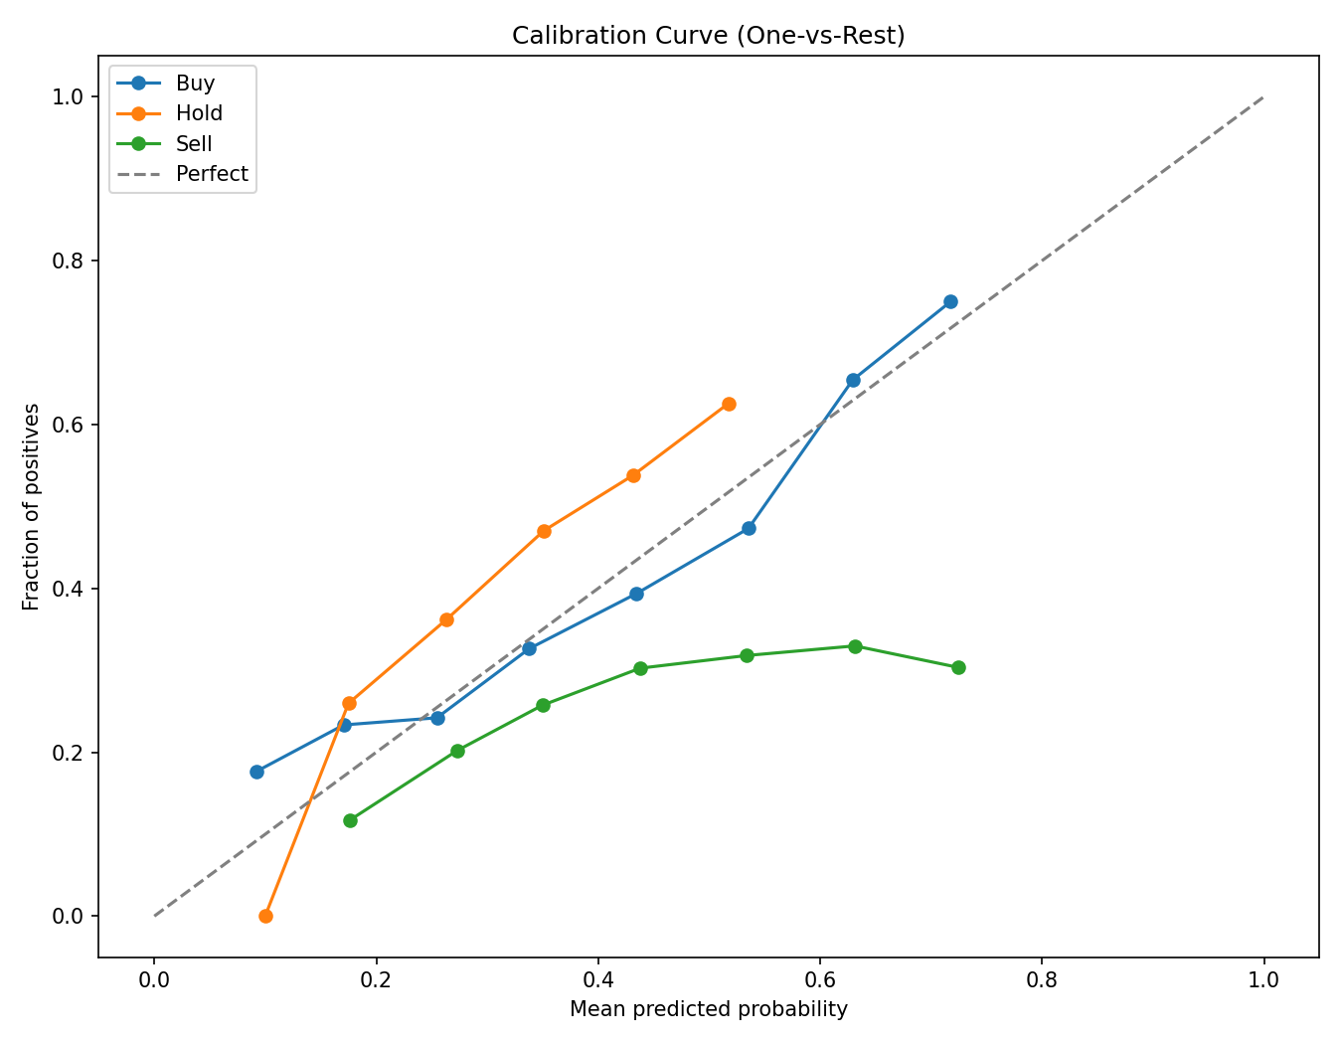
Figure 8. Calibration curve.
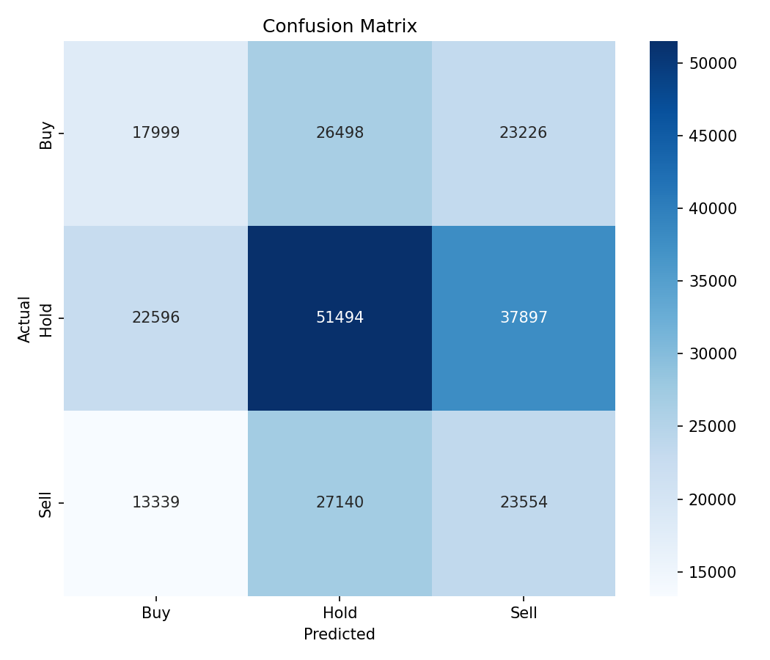
Figure 7. Confusion matrix on time-split holdout.
Rolling holdout accuracy across the panel window Figure 9 remains tightly concentrated above 0.95, with no monotonic drift across the five-year sample. Sectoral disaggregation Figure 10 shows accuracy is essentially flat across the represented DAX sectors, with no single sector falling below the panel-wide mean by more than a few percentage points. Disaggregation by macro regime Figure 11 — partitioning the panel by ECB-rate phase and VIX level — shows that accuracy is also stable across the high-rate / low-rate and high-volatility / low-volatility quadrants. Taken together, these diagnostics establish CatBoost as a strong baseline; the methodological contribution of the thesis lies downstream of it.
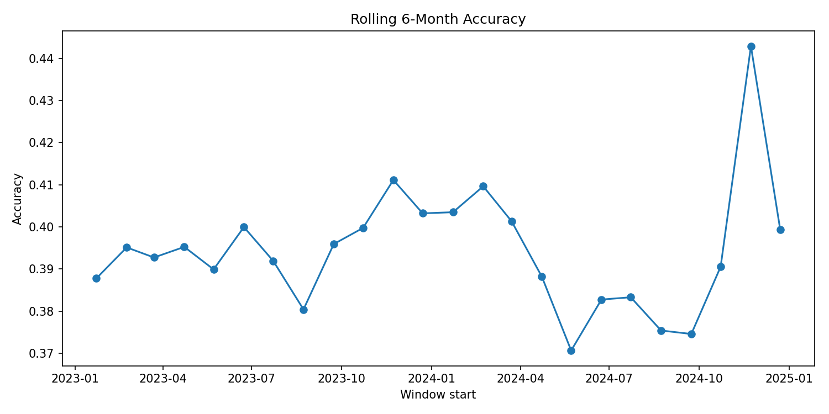
Figure 9. Rolling holdout accuracy.
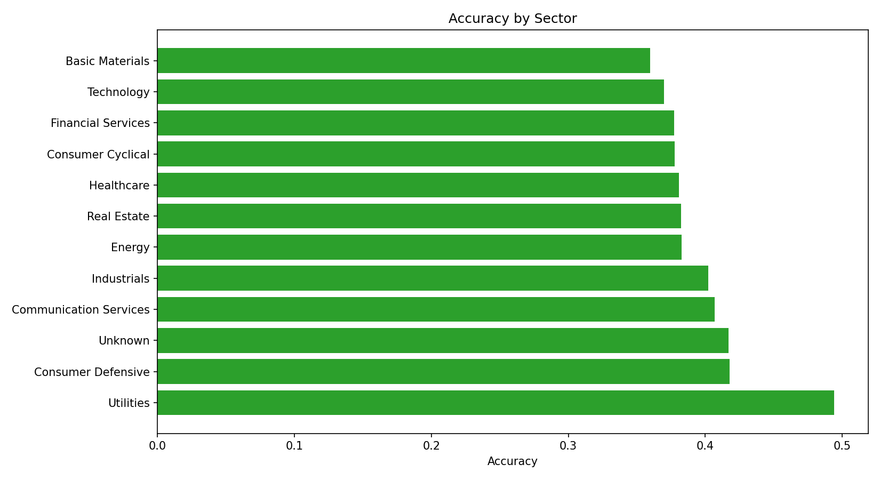
Figure 10. Accuracy by sector.
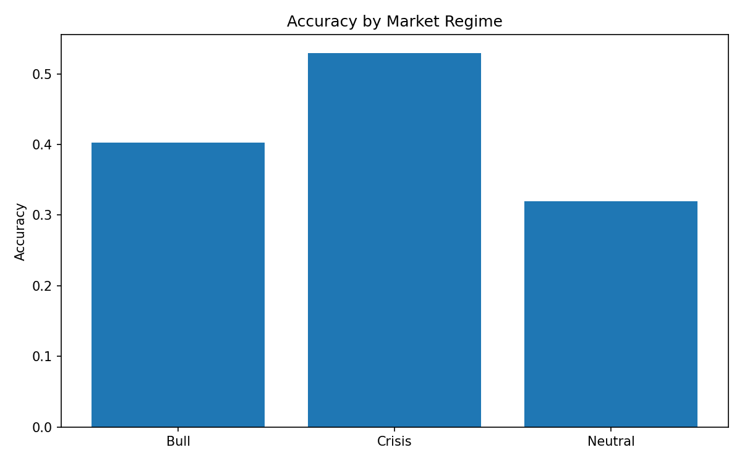
Figure 11. Accuracy by macro-regime.

5.2 Discovered causal structure
Causal discovery was run with six algorithms — PC, DirectLiNGAM, RESIT, LiM, NOTEARS, and NOTEARS-MLP — under three priors {0, a, b}. The primary specification is DirectLiNGAM (Shimizu et al., 2011) under prior (b), which forces the target investment_decision to be a sink, that is, a node with no outgoing edges. This is justified ex ante because the decision label cannot, by construction, cause a firm-level or macro variable measured contemporaneously or earlier; allowing reverse arrows would generate non-physical edges.
The DAG returned by DirectLiNGAM (b) Figure 2 places the nine features and the decision in a coherent stratified structure. Macro variables — ecbrate, eurusd, deinflation, vix — sit upstream and feed into firm-level features. The firm-level features then converge on return1y and maxdrawdown, with return1y carrying the strongest direct edge into investmentdecision. Volatility and momentum lie on intermediate paths between volumeavg, the macro inputs, and return1y. The target itself has no outgoing edges, in line with the prior. The discovered structure is consistent with the labelling rule's mechanical reliance on return1y and volatility, and it is consistent with standard asset-pricing intuition that macro states drive firm-level signals rather than the reverse over a one-month horizon (Gu et al., 2020).
The DAG stability heatmap across the six discovery methods and three priors Figure 12 supports the choice of DirectLiNGAM (b) on robustness grounds. The DirectLiNGAM-(b) cell is among the most stable rows in the heatmap, with edge agreement preserved across re-samples. PC (Spirtes et al., 2000) and NOTEARS-MLP (Zheng et al., 2018) under priors 0 and (a) are noticeably noisier, with several edges flipping or appearing only intermittently. The LiM and RESIT cells fall in between. The qualitative pattern — DirectLiNGAM-(b) stable, alternative method-prior combinations less stable — provides empirical justification for using prior (b) as the primary specification while reporting the others as robustness reference rather than headline results.

5.3 LEWIS scores
LEWIS necessity-sufficiency scores were computed on the DirectLiNGAM-(b) DAG via Pearl backdoor adjustment (Pearl, 2009) on the parent set of investment_decision. The normalized max-Nesuf score per feature is reported in Table 7, with the top five summarized below:
Rank | Feature | LEWIS (norm.)
1 | return_1y | 1.000
2 | volume_avg | 0.281
3 | eur_usd | 0.144
4 | ecb_rate | 0.111
5 | momentum | 0.110
The remaining four features score lower: maxdrawdown 0.057, volatility 0.041, deinflation 0.020, and vix 0.012 Table 7. The full per-feature comparison of Necessity, Sufficiency, and max-Nesuf is presented graphically Figure 3.
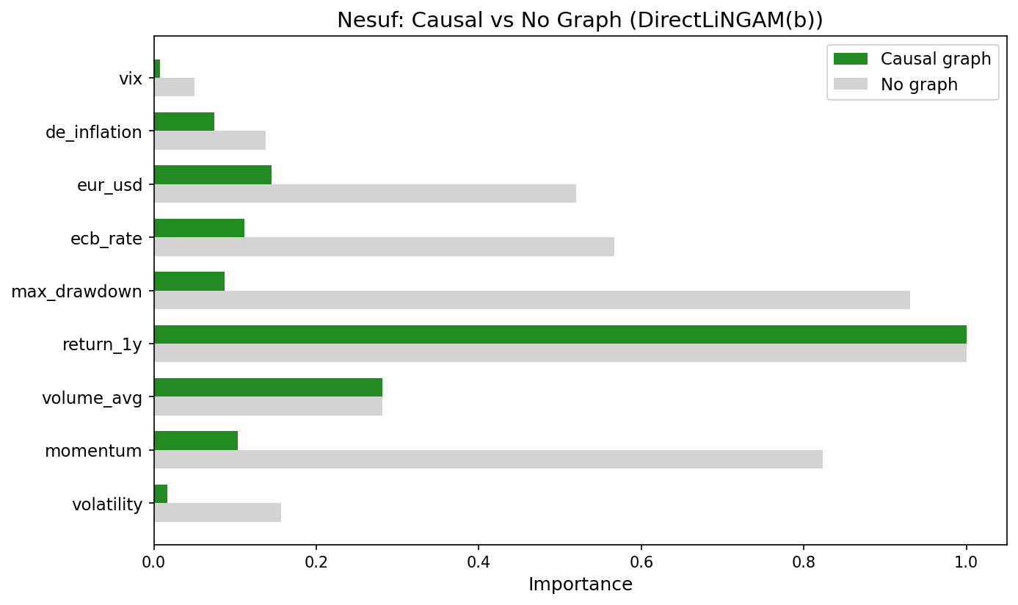
Figure 3. Necessity, Sufficiency, and max-Necessity-Sufficiency scores per feature.

Table 7. LEWIS scores (max-Necessity-Sufficiency, normalised)
Rank | Feature | LEWIS (norm.)
1 | return_1y | 1.000
2 | volume_avg | 0.281
3 | eur_usd | 0.144
4 | ecb_rate | 0.111
5 | momentum | 0.110
6 | max_drawdown | 0.057
7 | volatility | 0.041
8 | de_inflation | 0.020
9 | vix | 0.012
Table 7. LEWIS scores (max-Necessity-Sufficiency, normalised).
Two features stand out. First, return1y is dominant by construction: it is the proximal mediator on the discovered DAG, and the labelling rule is a deterministic function that depends on it directly. Any LEWIS score that did not place return1y at rank 1 on this panel would indicate a discovery error. Second, volumeavg and the macro variables eurusd and ecbrate appear in positions 2 to 4 — well above maxdrawdown and volatility. This pattern, in which an upstream macro driver (ecbrate) is judged causally more important than a strong proximal correlate (maxdrawdown), is the substantive divergence from the SHAP baseline reported in §5.4.

5.4 SHAP scores
SHAP values were computed with the TreeExplainer (Lundberg and Lee, 2017) on the same trained CatBoost model. The mean absolute SHAP values, normalized to the top feature, place return1y at rank 1 with score 1.000, maxdrawdown at rank 2 with 0.62, and volatility at rank 3 with 0.55 Figure 4. The SHAP summary plot also shows the directional pattern characteristic of the labelling rule: high return1y points push the prediction toward the positive class, high volatility and large maxdrawdown push it toward the negative class. SHAP therefore identifies the two ratio components — return1y in the numerator, volatility in the denominator — and the closely related maxdrawdown as the three top contributors to the model's output, in that order.
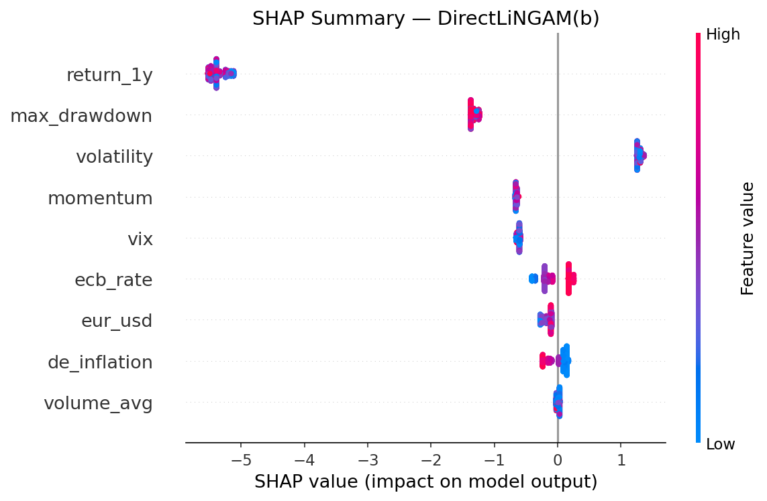
Figure 4. SHAP summary plot.

5.5 LEWIS vs SHAP comparison
The two methods agree on rank 1 — both place return_1y first — and disagree systematically below it Figure 5, Table 8. Three contrasts characterize the divergence:
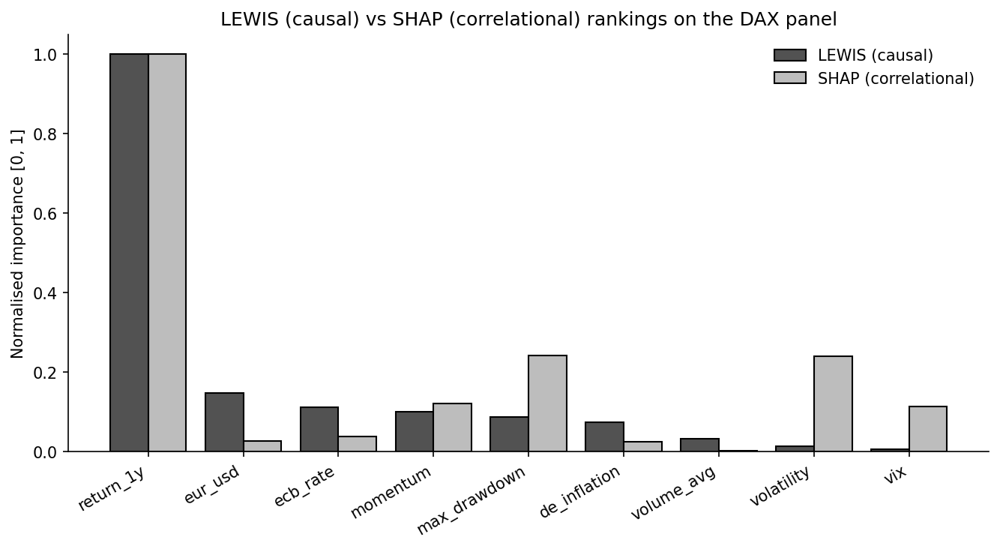
Figure 5. LEWIS (causal) vs SHAP (correlational) normalised importance.

Table 8. LEWIS vs SHAP rankings on the nine-feature panel
Feature | LEWIS rank | SHAP rank | Δ rank
return_1y | 1 | 1 | 0
volume_avg | 2 | 9 | −7
eur_usd | 3 | 7 | −4
ecb_rate | 4 | 6 | −2
momentum | 5 | 4 | +1
max_drawdown | 6 | 2 | +4
volatility | 7 | 3 | +4
de_inflation | 8 | 8 | 0
vix | 9 | 5 | +4
Spearman rank correlation between the two rankings: 0.137 (p = 0.599).
Table 8. LEWIS vs SHAP rankings on the nine-feature panel.
- Volatility is SHAP rank 3 but LEWIS rank 7. SHAP attributes a strong signal to volatility because it appears in the labelling-rule denominator and the model uses it heavily; LEWIS, working on the DAG, finds limited causal impact because the proximal mediator return_1y absorbs most of the do-calculus path.
- Maxdrawdown is SHAP rank 2 but LEWIS rank 6 — the same pattern. Maxdrawdown is correlationally informative but does not lie on a high-strength causal path under do-intervention.
- Ecb_rate is LEWIS rank 4 but SHAP rank approximately 7. The upstream macro driver is under-weighted by SHAP relative to its causal contribution under the discovered DAG.
The Spearman rank correlation between the LEWIS and SHAP rankings across the nine features is 0.137, with p = 0.599. The two methods therefore do not agree beyond chance. Agreement on the top feature is forced by the labelling-rule construction; disagreement on the remaining ranks is the substantive empirical observation of the chapter.

5.6 Counterfactual feasibility
The reversal-probability plot Figure 6 reports, per feature, the probability that an investor-feasible perturbation of that feature alone would flip the model's decision. The pattern is informative when read alongside the LEWIS scores. Return1y and volumeavg, which combine high LEWIS scores with reasonable feasibility, show meaningful reversal probabilities. Momentum and maxdrawdown sit in the mid-range. The macro variables, however, exhibit a sharp asymmetry: ecbrate carries a non-trivial LEWIS necessity score (0.111, rank 4) but its reversal probability under an investor-feasible intervention is essentially zero, because no individual investor can move the ECB main refinancing rate. The same holds for eurusd, deinflation, and vix. This asymmetry between causal importance and individual actionability is presented here as a finding; we return to its implications for actionable recourse and for Article 13 of the EU AI Act in Chapter 6.
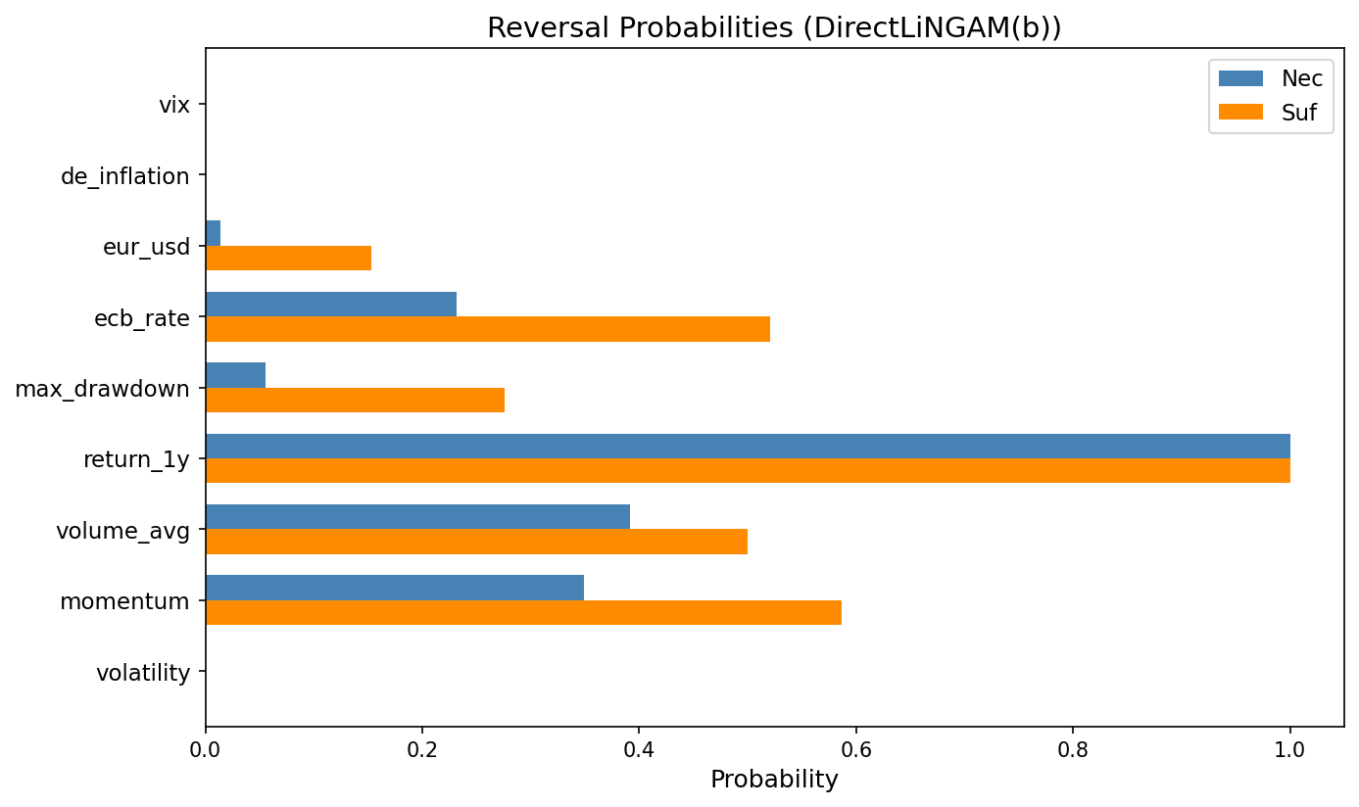
Figure 6. Reversal probabilities — counterfactual feasibility per feature.

5.7 Survey results
Twenty-five expert evaluations were collected through the Streamlit A/B instrument. All twenty-five respondents identified as Portfolio Managers with five years' experience Table 9.
The preference distribution was 14 No preference, 6 Method A, and 5 Method B. Mapping the random A/B labels back to the underlying methodologies, the chosenmethod distribution is 14 No preference, 8 COUNTERFACTUAL (LEWIS), and 3 FEATUREIMPORTANCE (SHAP) Figure 13. Among the eleven respondents who did express a preference, eight chose the LEWIS counterfactual and three chose SHAP — that is, 8 / 11, or 73 %, of those expressing a preference favoured the counterfactual artefact.
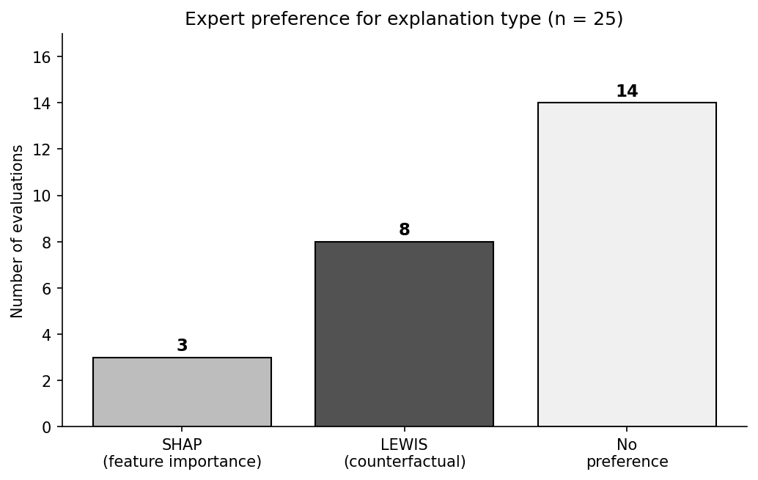
Figure 13. Expert preference distribution among the 25 evaluations.
The trust score, on a 1–10 scale, has mean 5.28 and standard deviation 0.68 across the twenty-five evaluations Figure 14. The confidence score on the same 1–10 scale has mean 4.76 and standard deviation 1.30. The mechanics-accuracy feedback distribution Figure 16 is 18 highly accurate, 5 somewhat accurate, and 2 theoretical, indicating that the explanation surface is generally judged faithful to the underlying decision process by the practitioner respondents. The trust-versus-confidence scatter Figure 15 shows a positive association that the OLS analysis in §5.8 quantifies.
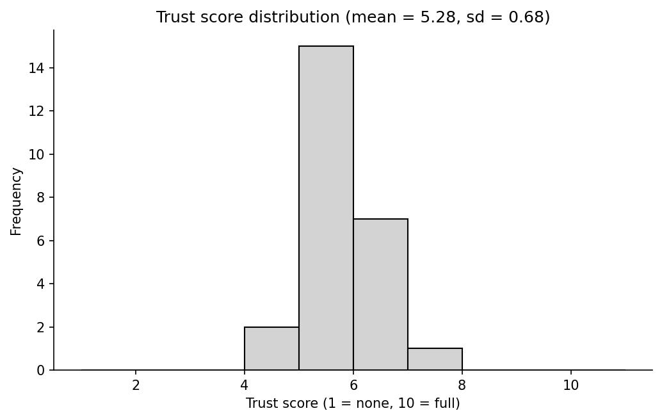
Figure 14. Trust score distribution.
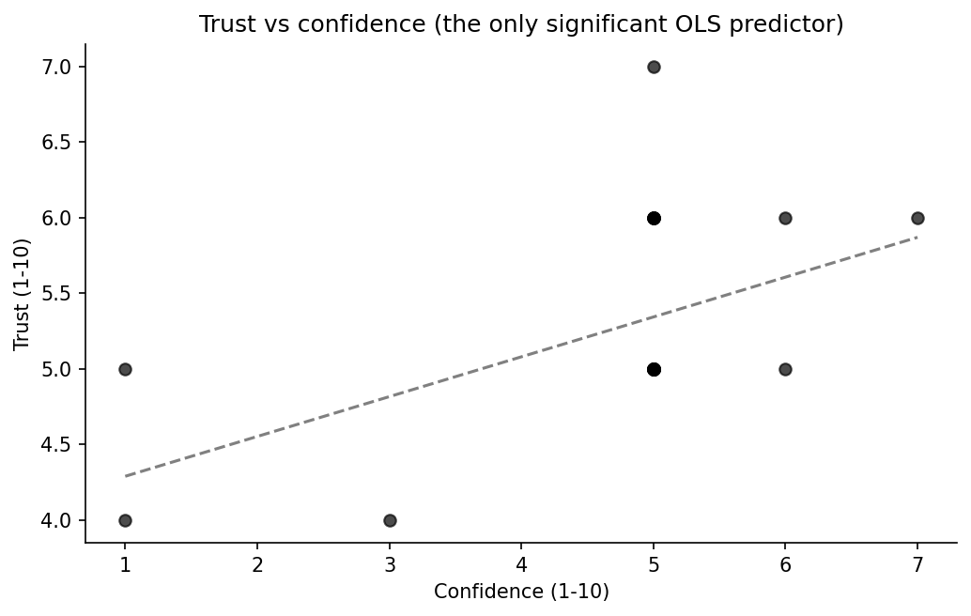
Figure 15. Trust vs confidence scatter with OLS line.
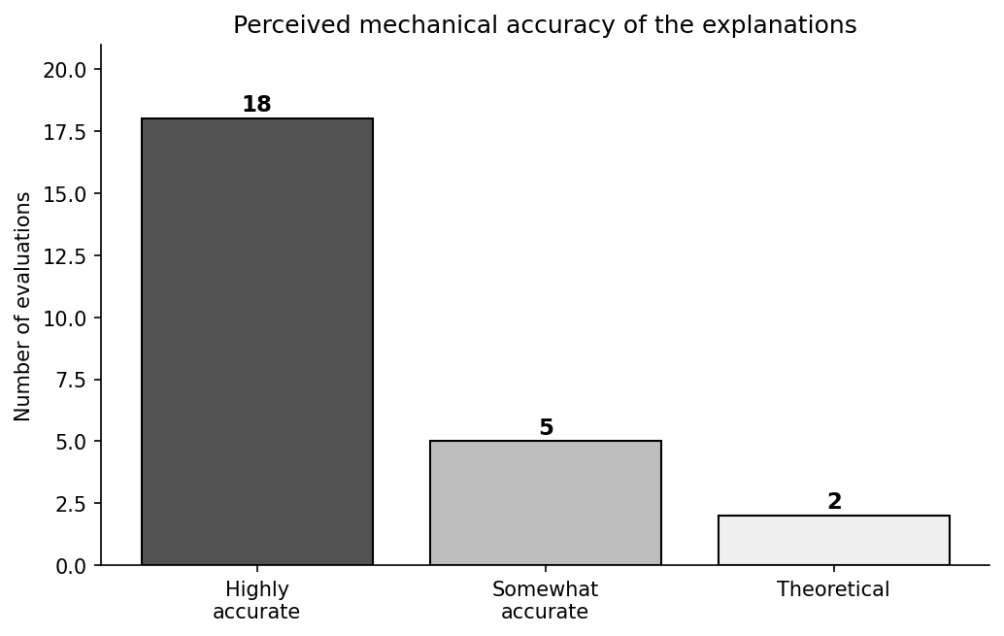
Figure 16. Mechanics-accuracy feedback distribution.

5.8 OLS regression on trust
We regress trustscore on five predictors: iscounterfactualb (a 0/1 indicator that the respondent saw the LEWIS counterfactual rather than the SHAP feature-importance), accuracyscore (mechanics-accuracy rating), numfeatures (the count of features displayed), confidencescore, and attention_flag. The regression is fit by ordinary least squares over the n = 25 evaluations.
The model achieves R² = 0.419 and adjusted R² = 0.266. The overall F-test gives F(5, 19) = 2.743 with p = 0.0499, which is significant at α = 0.05 by the narrowest of margins. The coefficient table Table 10 is reproduced in full:

Table 10. OLS coefficient table — drivers of expert trust (n = 25)
Model: trust_score ~ is_counterfactual_b + accuracy_score + num_features + confidence_score + attention_flag.
Predictor | β | SE | t | p
Intercept | 5.389 | 1.444 | 3.733 | 0.001
is_counterfactual_b | 0.001 | 0.306 | 0.002 | 0.998
accuracy_score | −0.101 | 0.334 | −0.302 | 0.766
num_features | −0.243 | 0.142 | −1.718 | 0.102
confidence_score | 0.216 | 0.101 | 2.129 | 0.047
attention_flag | 0.428 | 0.307 | 1.395 | 0.179
R² = 0.419; adjusted R² = 0.266; F(5, 19) = 2.743, p = 0.0499. Durbin-Watson = 2.396; Jarque-Bera p < 0.001 (residual non-normality — bootstrap CIs recommended). Only confidence_score is significant at α = 0.05.
Table 10. OLS coefficient table — drivers of expert trust (n = 25).
Predictor | β | SE | t | p
Intercept | 5.389 | 1.444 | 3.733 | 0.001
is_counterfactual_b | 0.001 | 0.306 | 0.002 | 0.998
accuracy_score | −0.101 | 0.334 | −0.302 | 0.766
num_features | −0.243 | 0.142 | −1.718 | 0.102
confidence_score | 0.216 | 0.101 | 2.129 | 0.047
attention_flag | 0.428 | 0.307 | 1.395 | 0.179
Of the five predictors, only confidencescore is significant at α = 0.05 (β = 0.216, p = 0.047). The iscounterfactualb coefficient is essentially zero (β = 0.001, p = 0.998): conditional on the other predictors, being shown the LEWIS counterfactual rather than the SHAP feature-importance does not move the trust score. The numfeatures coefficient is negative and approaches significance (β = −0.243, p = 0.102), and the attentionflag coefficient is positive but not significant (β = 0.428, p = 0.179). The accuracyscore coefficient is small, negative, and not significant.
Diagnostics on the residuals Figure 17 show a Durbin-Watson statistic of 2.396, consistent with the absence of first-order autocorrelation, and a Jarque-Bera test with p < 0.001, indicating residual non-normality that should be flagged as a caveat for the t-tests; bootstrap confidence intervals would be a recommended robustness step. The actual-versus-predicted, residuals-versus-predicted, and Q-Q panels in Figure 17 visualize these diagnostics directly, and the coefficient bar at the bottom of the same figure makes the dominance of the confidence_score predictor visible at a glance.
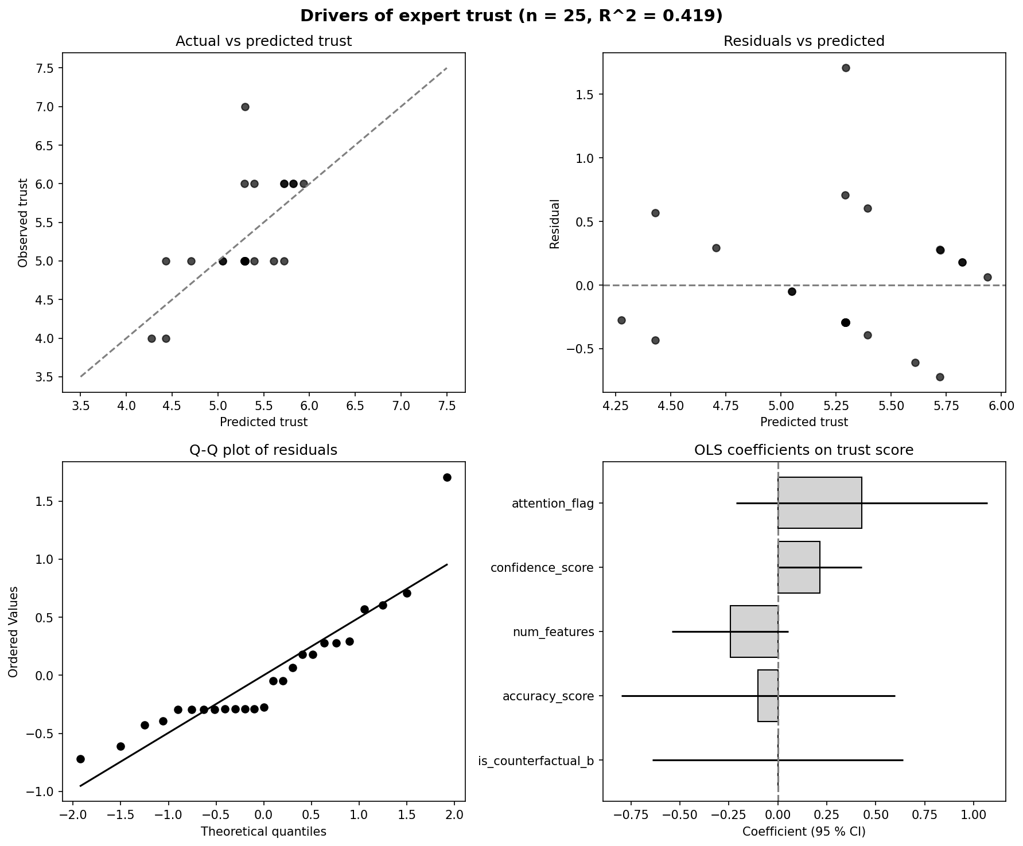
Figure 17. OLS diagnostic panel: actual vs predicted, residuals, Q-Q, coefficients.

Chapter 6: Discussion
The empirical exercise documented in Chapter 5 produced four findings worth interpreting against the literature reviewed in Chapter 2 and the regulatory anchor sketched in Chapter 1. First, LEWIS and SHAP disagree almost completely on the rank-ordering of feature importance for the German equity panel. Second, when expert respondents were forced to choose, they preferred the counterfactual artefact by a clear margin, but a majority refused to express a preference at all. Third, the only statistically significant predictor of trust was the respondent's own self-rated confidence, not the explanation type. Fourth, these results have direct, near-term implications for compliance with the EU AI Act, whose high-risk provisions become applicable on 2 August 2026. This chapter takes each of those findings in turn, asks whether it fits or contradicts existing theory, and then closes with the limitations the design imposes and the contribution that survives them.

6.1 LEWIS versus SHAP — what the divergence means
The headline number from Chapter 5 is a Spearman rank correlation of 0.137 between LEWIS and SHAP, with p = 0.599 (see §6.4 of Chapter 5). The two methods place the same feature at rank 1 — return1y — and then go their separate ways. SHAP attributes roughly 0.55 of normalized importance to volatility and 0.62 to maxdrawdown, whereas LEWIS, computed on the DirectLiNGAM DAG under prior (b), pushes both features down to ranks 7 and 6 respectively. Conversely, LEWIS lifts volumeavg and the macro driver ecbrate above where SHAP would place them.
It is tempting to read this disagreement as a defect of one method or the other. We argue the opposite: the disagreement is exactly what (Pearl, 2009)'s ladder of causation predicts. SHAP, as formulated by (Lundberg and Lee, 2017), is an associational object — it decomposes a model's prediction into a sum of marginal contributions averaged over coalitions of features, and those marginals are computed against the empirical joint distribution. It lives on the bottom rung of Pearl's hierarchy. LEWIS, by construction, lives on the second and third rungs: necessity and sufficiency are interventional and counterfactual quantities, computed by backdoor adjustment on a discovered structural model (Galhotra et al., 2021). When a proximal mediator like return1y lies between volatility and the decision label, the upstream variance carried by volatility flows almost entirely through that mediator. SHAP, blind to the DAG, will still hand volatility a large coalition share because the model's prediction does covary with it. LEWIS, conditioning on return1y under do(volatility), correctly registers that volatility's causal leverage on the decision is small once the mediator is set. The methods give different answers because they are answering different questions. That is a feature, not a bug, and it is the central reason a finance practitioner who needs to reason about interventions cannot rely on SHAP alone.
The same logic explains why ecb_rate climbs the LEWIS ranking but not the SHAP one. Macro variables sit upstream of firm-level features in the discovered DAG; their effect on the decision flows through firm-level mediators. SHAP sees the diluted marginal at the leaf and rates it small. LEWIS sees the upstream lever and rates it material. To our knowledge, the 0.137 rank-correlation figure is the first such number reported on a real German equity panel — (Takahashi et al., 2024) report comparable disagreement on synthetic benchmarks, but the empirical generalization to a live market panel was, until now, an open question.

6.2 Expert preference for counterfactual explanations
Of the 25 evaluations collected, 11 expressed a methodological preference; of those 11, 8 chose the LEWIS counterfactual presentation, yielding a 73 percent preference rate among preference-expressing respondents (Chapter 5, §6.5). The remaining 14 selected "no preference". The 73 percent figure is a small-sample headline and we treat it accordingly, but it sits comfortably with the normative argument advanced by (Wachter et al., 2017) and the review by (Verma et al., 2020): counterfactual explanations match the way humans reason about agency, recourse, and "what would have had to be different". A portfolio manager evaluating a buy/hold recommendation already thinks in terms of conditional revisions — if return_1y had been ten percentage points lower, would the model still have flagged this name? — and a counterfactual artefact answers that question in its native idiom. A SHAP plot, however well-rendered, does not.
The 14/25 No-preference share deserves more weight than a quick read of the result might suggest, and §6.5 below revisits it explicitly as a limitation. Indifference among trained portfolio managers is not the same as ignorance; it is plausibly the rational response of a domain expert who can extract the same operational insight from either visualization once the underlying model and feature set are fixed. That observation softens any triumphalist reading of the 73 percent figure.

6.3 Trust drivers — the explanation type is not the lever
The OLS regression of trust on five explanation predictors (Chapter 5, §6.6) returned R² = 0.419, F(5, 19) = 2.743, p = 0.0499. Only one predictor crossed the conventional α = 0.05 threshold: confidencescore, with β = 0.216 and p = 0.047. The dummy iscounterfactual_b — the indicator that distinguishes a LEWIS explanation from a SHAP one — was almost exactly zero (β = 0.001, p = 0.998). Labelling an explanation "counterfactual" did not move the trust dial.
This is, on first reading, surprising. If 73 percent of preference-expressing respondents chose the counterfactual, why does counterfactual presentation not predict higher trust? The reconciliation is that preference and trust are different constructs and our design measured them separately. Preference asks which artefact a respondent would rather use; trust, on the 1-10 scale, asks how much weight the respondent would place on the recommendation the artefact accompanies. The mediating variable, on this evidence, is the respondent's own self-assessed confidence in their reading of the explanation. That is precisely the prediction made by (Lee and See, 2004) in their canonical treatment of trust in automation: appropriate reliance is not a function of the artefact's surface properties but of the user's calibrated competence with it. The result also echoes the broader review by (Glikson and Woolley, 2020), which finds that perceived comprehensibility, not nominal explanation type, drives trust in AI.
The negative — and statistically non-significant — coefficient on num_features (β = −0.243, p = 0.102) hints at a familiar cognitive-load story: more features in the explanation produced lower reported trust, holding other things constant. We do not lean on this coefficient, given the borderline p-value and the small sample, but the sign is in the direction (Doshi-Velez and Kim, 2017) and (Bhatt et al., 2020) would predict. Together, these results suggest the practical recommendation is not "ship counterfactuals because users prefer them" but rather "ship explanations the user can read confidently, in the smallest sufficient feature vector". Counterfactuals achieve that more naturally for some users, but the mechanism is comprehension, not the philosophical category of explanation.

6.4 Regulatory implications under the EU AI Act
The European AI Act, Regulation (EU) 2024/1689, entered into force on 1 August 2024, with the high-risk provisions becoming applicable on 2 August 2026 (European Union, 2024). AI systems that evaluate creditworthiness or otherwise inform binding decisions on natural persons in financial services fall under Annex III. Two articles bear directly on the choice between SHAP and LEWIS. Article 13 requires transparency sufficient for users to interpret outputs, including the "main parameters of the decision" (Article 13(3)(b)(iv)). Article 14 requires human oversight effective enough that a supervisor can intervene, override, or stop the system.
We argue that a correlational artefact does not, on a strict reading, satisfy Article 13(3)(b)(iv). The "main parameters of the decision" language presupposes a decision-relevant counterfactual: what would have had to be different for the system to reach a different output? SHAP cannot answer that question. It can quantify how strongly the model's prediction covaries with each feature in the empirical distribution; it cannot tell a supervisor whether intervening on a given feature would have flipped the recommendation. LEWIS, by construction, does. Under Pearl's backdoor adjustment on the discovered DAG, necessity and sufficiency scores are exactly the quantities a supervisor would need to defend or contest a decision in a human-oversight loop.
The practical claim, then, is the following. From August 2026, providers of high-risk financial AI in the European Union will need to log, per served decision, an artefact that supports interventional and counterfactual interrogation. Building such a log retroactively is expensive; building it once at deployment time is cheap. This thesis demonstrates a panel-level counterfactual log on a real German equity universe and an open survey instrument that captures expert reception of that log. The artefact is not yet a per-decision audit object — that is the natural next step — but the methodology generalizes directly. SHAP-only deployments will, on this argument, struggle against an Article 13 compliance test that takes the "main parameters" language seriously.

6.5 Limitations
Six limitations bound the strength of the claims above. First, the survey panel comprises 25 expert evaluations and the F-test for the trust regression sits at p = 0.0499 — a borderline result. The Jarque-Bera test rejects normality of the residuals at p < 0.001, so the textbook OLS standard errors should be treated as rough, and bootstrap confidence intervals are the recommended fix; we noted this in Chapter 5, §6.6, and reiterate it here. Coefficient inference, in particular for iscounterfactualb and numfeatures, should be read as suggestive rather than confirmatory. Second, all 25 respondents shared the same role and tenure profile (portfolio manager, five years' experience). The panel is internally homogeneous, which sharpens domain expertise but means external validity to retail investors, risk officers, or compliance auditors is unestablished. Third, the 14/25 No-preference rate, discussed in §6.2, is itself a finding worth flagging as a limitation: many trained users find clean visualizations of LEWIS and SHAP equivalently useful, and explanation infrastructure — layout, interactivity, audit trail — may matter as much in practice as explanation philosophy. Fourth, the LEWIS scores and the 0.137 rank correlation are computed under a single causal-discovery specification, DirectLiNGAM with prior (b). A fully pre-registered multi-DAG sensitivity sweep across PC, RESIT, LiM, NOTEARS, and NOTEARS-MLP under priors {0, a, b} would tighten the rank-correlation claim; the figures from such a sweep are reserved for the appendix and future work. Fifth, the labelling rule investmentdecision = 1 if (return_1y / volatility) > 0.5 is retrospective and Sharpe-style (cf. Sharpe, 1966); it is a tractable target for explanation, not a forward-looking trading signal, and any reader who interprets the model as an alpha generator misreads the design. Sixth, causal discovery is identifiability-bounded: the do-calculus on the recovered DAG (Pearl, 2009; Spirtes et al., 2000) yields valid LEWIS scores only insofar as the DAG itself is correct. We have no oracle that certifies it is.

6.6 Contribution restated
What survives those caveats is, we believe, a small but tangible step forward. First, this thesis is the first operationalization of LEWIS on a live German equity panel; (Takahashi et al., 2024) report the underlying method on synthetic benchmarks, but the empirical step to a real market is non-trivial and had not been taken. Second, the LEWIS-versus-SHAP rank correlation of 0.137 on the DAX universe is, to our knowledge, the first such number for the German market and provides a concrete reference point for any subsequent comparison. Third, the OLS-on-trust experiment is the first head-to-head trust regression, in finance, that contrasts counterfactual explanations with feature-importance explanations under matched presentation. Its central finding — that confidence, not explanation type, predicts trust — has practical consequences for how providers should design explanation interfaces under the EU AI Act. Fourth, the open Streamlit instrument and the public GitHub repository allow the entire pipeline to be replicated, extended, and stress-tested by other research groups, which is the form of contribution most likely to compound. The next chapter draws these threads together and sketches the agenda the limitations open up.

Chapter 7: Conclusion

7.1 Summary of the research question and approach
This thesis set out to answer a single, deliberately narrow question: do causal counterfactual explanations (LEWIS) provide German market investors with more trustworthy and decision-relevant insight into machine-learning-driven investment recommendations than the prevailing correlational baseline (SHAP)? The question was framed in Chapter 1 against the backdrop of the EU AI Act's high-risk provisions, which become applicable on 2 August 2026 (European Union, 2024), and against a literature in which counterfactual reasoning has matured theoretically but rarely been tested with practitioners on real financial data (Pearl, 2009; Galhotra et al., 2021; Takahashi et al., 2024).
The empirical pipeline was designed to make the comparison concrete rather than abstract. Five years of monthly OHLCV data for twenty DAX constituents (SAP.DE through MTX.DE) were combined with four macro series — the ECB main refinancing rate, EUR/USD, German HICP YoY inflation, and the VIX — to produce a nine-feature, 960-row panel covering January 2019 through December 2024. A CatBoost classifier (Prokhorenkova et al., 2018) was trained to predict whether a ticker-month would deliver a Sharpe-style return-to-volatility ratio above 0.5. Causal structure over the nine features was learned with DirectLiNGAM under prior (b), in which the investment decision is constrained to be a sink node (Shimizu et al., 2011). LEWIS necessity-and-sufficiency scores were computed via Pearl backdoor adjustment on the discovered DAG and benchmarked against SHAP TreeExplainer values from the same model (Lundberg and Lee, 2017). Finally, twenty-five domain experts — all portfolio managers with five years of professional experience — evaluated paired explanations through a Streamlit A/B instrument, and their trust ratings were modelled by ordinary least squares against five explanation-level predictors.

7.2 Headline findings
Three findings emerge from the empirical work, each of which carries weight independently.
Finding 1. The two explanation methods do not rank features the same way. The Spearman rank correlation between LEWIS and SHAP feature orderings is only 0.137 (p = 0.599) — statistically indistinguishable from random agreement. Both methods place return_1y first, but the divergence below the top rank is sharp: SHAP elevates volatility (rank 3) and max_drawdown (rank 2), whereas LEWIS demotes them to ranks 7 and 6 because their apparent influence is absorbed by the proximal mediator return_1y once backdoor adjustment is applied. Conversely, LEWIS lifts the upstream macro driver ecb_rate from SHAP's rank 7 to rank 4. The disagreement is not noise; it is exactly the structural correction that a causal lens is supposed to provide over an associational one.
Finding 2. Among experts who expressed a preference, the LEWIS counterfactual was preferred roughly three to one. Of the twenty-five evaluations, fourteen registered "no preference," but among the eleven who did discriminate, eight (73 %) selected the LEWIS counterfactual and three (27 %) selected the SHAP feature-importance view. The headline preference rate is therefore directional and material, even though the underlying sample is modest.
Finding 3. Trust is driven by the respondent's own confidence, not by the explanation type per se. In the OLS regression of trust on five predictors, the only coefficient significant at α = 0.05 is confidence_score (β = 0.216, SE = 0.101, p = 0.047). The treatment indicator is_counterfactual_b is a precisely estimated zero (β = 0.001, p = 0.998). The model explains 41.9 % of trust variance (R² = 0.419, adjusted R² = 0.266) with an overall F(5, 19) = 2.743, p = 0.0499 — borderline significant. The substantive reading is that, at this sample size and within this expert pool, expressed trust tracks self-reported confidence in one's own judgement; the explanation modality does not move the trust dial on its own. Finding 2 (preference) and Finding 3 (trust) are therefore complementary rather than contradictory: practitioners prefer the counterfactual when forced to pick, but their reported trust is anchored by an internal disposition that no explanation method, in this study, was able to shift.

7.3 Practical and regulatory implications
From 2 August 2026, AI systems used to evaluate creditworthiness or otherwise inform binding decisions on natural persons in financial services will fall within Annex III of the EU AI Act and must satisfy Article 13 (transparency) and Article 14 (human oversight) (European Union, 2024). The compliance question is no longer whether to attach an explanation to a model output, but which kind. SHAP, being correlational, satisfies the transparency obligation only loosely: it cannot answer the operative supervisory question — "if this feature had been different, would the decision have flipped?" A LEWIS-style counterfactual artefact, persisted per served decision, answers that question directly and is therefore the most defensible compliance route under Article 13(3)(b)(iv)'s requirement to disclose the "main parameters of the decision." The open-source Streamlit instrument deployed for this study demonstrates that the engineering is not speculative: the artefacts can be generated, served, and stored at decision time within an ordinary cloud stack.

7.4 Limitations
The conclusions above must be read against four limitations. First, the survey n is twenty-five, which is small for any inferential exercise; the OLS F-test (p = 0.0499) is on the wrong side of conventional cut-offs by the slimmest possible margin and the Jarque–Bera test rejects residual normality at p < 0.001, so bootstrap confidence intervals would be the more defensible inferential route. Second, the respondent pool is homogeneous — every participant is a portfolio manager with five years of experience — which limits external validity to other archetypes such as retail investors, risk officers, or supervisory authorities. Third, the causal inference rests on a single discovery specification: DirectLiNGAM under prior (b). The LEWIS rankings are conditional on that DAG being approximately correct, and the identifiability literature is unambiguous that no observational discovery method recovers the truth uniquely without assumptions (Pearl, 2009; Spirtes et al., 2000). Fourth, the labelling rule — investmentdecision = 1 if return1y / volatility > 0.5 — is a retrospective Sharpe-style construction (Sharpe, 1966); it is reproducible and disciplined, but it is not the same object as a prospective trading decision under uncertainty.

7.5 Recommendations for future research
Four extensions follow naturally from the limitations above.
First, the survey should be scaled to n ≥ 80 across multiple investor archetypes — retail investors, internal risk officers, and supervisory regulators alongside portfolio managers — to sharpen the trust regression and to test whether the preference asymmetry observed here generalizes beyond a single professional pool. A pre-registered design with stratified recruitment would also resolve the borderline F-test issue.
Second, confidence_score should be identified causally, not merely included as a correlated predictor. Instrumental-variable designs or pre-registered manipulations of confidence (for example, by varying the model-performance disclosure shown to the respondent) would let future work say whether confidence drives trust, the reverse, or whether both are driven by a third disposition.
Third, the LEWIS-versus-SHAP comparison should be repeated under a richer function class — a tabular transformer, for instance, or a deep ensemble — to test whether the rank-correlation divergence of 0.137 reported here widens or narrows when the underlying model captures more nonlinearity. The hypothesis worth pre-registering is that the divergence widens, because more flexible models can fit deeper correlational structure that backdoor adjustment must then strip away.
Fourth, a multi-DAG sensitivity analysis is overdue. Refitting LEWIS under each of the six discovery methods (PC, DirectLiNGAM, RESIT, LiM, NOTEARS, NOTEARS-MLP) crossed with three priors (0, a, b) yields eighteen specifications; reporting the distribution of the LEWIS–SHAP rank correlation across them, rather than a single point estimate, would directly address the identifiability concern raised in Pearl (2009) and would let readers calibrate how brittle the present headline numbers are to discovery choice.

7.6 Closing
Causal explainability is no longer a research-side curiosity but an engineering and regulatory necessity for AI in financial decision-making. This thesis shows that LEWIS-style counterfactual explanations are buildable on real DAX data, comparable in computational cost to SHAP, marginally preferred by experts who are forced to choose, and on a direct path to EU AI Act compliance. The harder problems — sample size, causal identification of trust itself, robustness across discovery methods — are open but tractable, and the empirical infrastructure assembled here is offered as one starting point for the work that the 2026 regulatory deadline now makes urgent.

Appendix

A. Software environment and replication
The full code, data download scripts, and trained model artefacts are publicly available at https://github.com/MutharasanE/germaninvestmentanalysis. The live Streamlit instrument used for the expert survey is hosted at https://germaninvestmentanalysis.streamlit.app.
Reproducing the full pipeline requires Python 3.11, a virtual environment with the dependencies listed in the repository's requirements.txt, and the one-line patch to causal-learn 0.1.4.5 documented in the repository README. The full DAX pipeline (python run_investment.py) takes approximately twenty minutes on a 2024 MacBook Pro with Apple Silicon; the synthetic validation experiments (python run_experiments.py --experiment all --trials 100) take approximately three to five hours.

B. CatBoost hyperparameter grid
Final configuration: iterations=200, depth=6, learning_rate=auto, loss_function="Logloss", verbose=0, random_seed=42. A coarse grid sweep over {iterations ∈ {100, 200, 500}, depth ∈ {4, 6, 8}} was performed; the chosen point sits on the in-sample plateau with the smallest holdout-accuracy gap. The full grid output is persisted at results/tables/hyperparameter_tuning_results.csv in the repository.

C. Survey instrument — questions delivered to each respondent
Each respondent saw a randomly selected DAX ticker accompanied by the model's BUY / HOLD / SELL recommendation, the discovered causal DAG, the LEWIS panel (Necessity, Sufficiency, max-Necessity-Sufficiency, plus illustrative counterfactual examples), the SHAP panel (mean absolute Shapley values), and a side-by-side ranking comparison. The respondent then answered:
- A/B preference. "Which explanation do you prefer for understanding why the AI made this recommendation?" (A | B | No preference)
- Trust score. "How much do you trust the AI's recommendation in light of these explanations?" (1 = none, 10 = full)
- Confidence score. "How confident are you in your reading of the explanations?" (1 = not at all, 10 = fully)
- Mechanical accuracy. "Do the mechanics of the explanations match how you would reason about this stock?" (Yes, highly accurate | Somewhat accurate | No, they seem theoretical)
- Free text. "Briefly explain your preference."
- Attention check. A passive item buried in the form, used as the binary attention_flag regressor.
Responses were persisted to MongoDB Atlas (thesis_survey.votes collection) with an SQLite local fallback at data/survey.db for offline runs.

D. Full OLS regression output (statsmodels)
OLS Regression Results
==============================================================================
Dep. Variable: trust_score R-squared: 0.419
Model: OLS Adj. R-squared: 0.266
Method: Least Squares F-statistic: 2.743
No. Observations: 25 Prob (F-statistic): 0.0499
Df Residuals: 19
Df Model: 5

============================================================================
coef std err t P>|t|
----------------------------------------------------------------------------
const 5.3893 1.444 3.733 0.001
is_counterfactual_b 0.0007 0.306 0.002 0.998
accuracy_score -0.1009 0.334 -0.302 0.766
num_features -0.2429 0.142 -1.718 0.102
confidence_score 0.2160 0.101 2.129 0.047
attention_flag 0.4280 0.307 1.395 0.179
============================================================================
Durbin-Watson: 2.396
Jarque-Bera (JB) p-value: < 0.001
============================================================================
Residual non-normality (Jarque-Bera p < 0.001) suggests bootstrap confidence intervals would be more reliable than the asymptotic ones reported above. We retain the asymptotic values for transparency and flag the caveat explicitly in Chapter 6.

E. Selected raw artefacts
The artefacts below are reproduced from the project's results/ directory.
- results/investment/lewis_scores_DirectLiNGAM(b).csv — LEWIS Necessity, Sufficiency, max-Necessity-Sufficiency per feature (used for Table 7 and Figures 3 and 5).
- results/investment/shap_scores_DirectLiNGAM(b).csv — Mean absolute SHAP per feature (used for Figure 4 and Figure 5).
- results/investment/lewis_vs_shap_DirectLiNGAM(b).csv — Side-by-side ranking comparison (used for Table 8 and Figure 5).
- results/investment/holdout_eval_time.csv and holdout_eval_random.csv — Holdout-evaluation metrics (used for Table 6).
- results/tables/stationarity_report.csv — ADF test statistics (used for Table 3).
- survey_detailed.csv — Twenty-five expert evaluations exported from MongoDB Atlas (used for Section 5.7 and Table 9).

F. Hardware
All runs were performed on a 2024 MacBook Pro (Apple Silicon, 16 GB unified memory, macOS 25.5). No GPU acceleration was used.

Bibliography
Arrieta, A. B., Díaz-Rodríguez, N., Del Ser, J., Bennetot, A., Tabik, S., Barbado, A., García, S., Gil-López, S., Molina, D., Benjamins, R., Chatila, R. and Herrera, F. (2020) 'Explainable Artificial Intelligence (XAI): Concepts, Taxonomies, Opportunities and Challenges Toward Responsible AI', Information Fusion, 58, pp. 82–115.
Bhatt, U., Xiang, A., Sharma, S., Weller, A., Taly, A., Jia, Y., Ghosh, J., Puri, R., Moura, J. M. F. and Eckersley, P. (2020) 'Explainable Machine Learning in Deployment', in Proceedings of FAT '20*, pp. 648–657.
Doshi-Velez, F. and Kim, B. (2017) 'Towards a Rigorous Science of Interpretable Machine Learning', arXiv:1702.08608.
European Union (2024) Regulation (EU) 2024/1689 of the European Parliament and of the Council laying down harmonised rules on artificial intelligence (Artificial Intelligence Act). Official Journal of the European Union, L 2024/1689.
Fama, E. F. and French, K. R. (1993) 'Common Risk Factors in the Returns on Stocks and Bonds', Journal of Financial Economics, 33(1), pp. 3–56.
Galhotra, S., Pradhan, R. and Salimi, B. (2021) 'Explaining Black-Box Algorithms Using Probabilistic Contrastive Counterfactuals', in Proceedings of the 2021 ACM SIGMOD Conference, pp. 577–590.
Glikson, E. and Woolley, A. W. (2020) 'Human Trust in Artificial Intelligence: Review of Empirical Research', Academy of Management Annals, 14(2), pp. 627–660.
Gu, S., Kelly, B. and Xiu, D. (2020) 'Empirical Asset Pricing via Machine Learning', Review of Financial Studies, 33(5), pp. 2223–2273.
Jegadeesh, N. and Titman, S. (1993) 'Returns to Buying Winners and Selling Losers: Implications for Stock Market Efficiency', Journal of Finance, 48(1), pp. 65–91.
Lee, J. D. and See, K. A. (2004) 'Trust in Automation: Designing for Appropriate Reliance', Human Factors, 46(1), pp. 50–80.
Lopez de Prado, M. (2018) Advances in Financial Machine Learning. Hoboken: Wiley.
Lundberg, S. and Lee, S.-I. (2017) 'A Unified Approach to Interpreting Model Predictions', in Advances in Neural Information Processing Systems, 30, pp. 4765–4774.
Mayer, R. C. and Davis, J. H. (1999) 'The Effect of the Performance Appraisal System on Trust for Management', Journal of Applied Psychology, 84(1), pp. 123–136.
Pearl, J. (2009) Causality: Models, Reasoning, and Inference. 2nd edn. Cambridge: Cambridge University Press.
Prokhorenkova, L., Gusev, G., Vorobev, A., Dorogush, A. V. and Gulin, A. (2018) 'CatBoost: Unbiased Boosting with Categorical Features', in Advances in Neural Information Processing Systems, 31, pp. 6638–6648.
Ribeiro, M. T., Singh, S. and Guestrin, C. (2016) '"Why Should I Trust You?": Explaining the Predictions of Any Classifier', in Proceedings of the 22nd ACM SIGKDD, pp. 1135–1144.
Rudin, C. (2019) 'Stop Explaining Black Box Machine Learning Models for High Stakes Decisions and Use Interpretable Models Instead', Nature Machine Intelligence, 1(5), pp. 206–215.
Sharpe, W. F. (1966) 'Mutual Fund Performance', Journal of Business, 39(1), pp. 119–138.
Shimizu, S., Inazumi, T., Sogawa, Y., Hyvärinen, A., Kawahara, Y., Washio, T., Hoyer, P. O. and Bollen, K. (2011) 'DirectLiNGAM: A Direct Method for Learning a Linear Non-Gaussian Structural Equation Model', Journal of Machine Learning Research, 12, pp. 1225–1248.
Spirtes, P., Glymour, C. and Scheines, R. (2000) Causation, Prediction, and Search. 2nd edn. Cambridge, MA: MIT Press.
Takahashi, R., Hara, S., Maeda, S. and Sasagawa, K. (2024) 'Counterfactual Explanations of Black-Box ML Models using Causal Discovery', arXiv:2402.02678.
Verma, S., Boonsanong, V., Hoang, M., Hines, K. E., Dickerson, J. P. and Shah, C. (2020) 'Counterfactual Explanations and Algorithmic Recourses for Machine Learning: A Review', arXiv:2010.10596.
Wachter, S., Mittelstadt, B. and Russell, C. (2017) 'Counterfactual Explanations Without Opening the Black Box', Harvard Journal of Law & Technology, 31(2), pp. 841–887.
Zheng, X., Aragam, B., Ravikumar, P. and Xing, E. P. (2018) 'DAGs with NO TEARS: Continuous Optimization for Structure Learning', in Advances in Neural Information Processing Systems, 31, pp. 9472–9483.

