**PHASE ONE**

**HTML**

1. **Homepage.html**

<!DOCTYPE html>

<html lang="en">

<head>

<meta charset="UTF-8">

<meta name="viewport" content="width=device-width, initial-scale=1.0">

<meta http-equiv="X-UA-Compatible" content="IE=edge">

<title>Software Consultancy Firm</title>

<link rel="stylesheet" href="style.css">

</head>

<body>

<!-- Navigation Menu -->

<header>

<nav>

<ul>

<li><a href="homepage.html">Home</a></li>

<li><a href="services.html">Services</a></li>

<li><a href="about.html">About Us</a></li>

<li><a href="contact.html">Contact</a></li>

<li><a href="clients.html">Clients</a></li>

<li><a href="book_with_us.html">Book with Us</a></li>

<li><a href="team_access.html">Team Access</a></li>

</ul>

</nav>

</header>

<!-- Main Content -->

<main>

<section class="intro">

<h1>Welcome to Our Software Consultancy Firm</h1>

<p>We provide high-quality software solutions tailored to your business needs.</p>

<button onclick="window.location.href='services.html';">Learn More</button>

</section>

<section class="services-overview">

<h2>Our Services</h2>

<ul>

<li>Custom Software Development</li>

<li>IT Consulting</li>

<li>Cloud Solutions</li>

<li>System Integration</li>

</ul>

</section>

<section class="why-choose-us">

<h2>Why Choose Us?</h2>

<p>We deliver innovative solutions that help businesses streamline operations and enhance performance.</p>

</section>

</main>

<!-- Footer -->

<footer>

<p>&copy; 2024 Software Consultancy Firm. All rights reserved.</p>

</footer>

</body>

</html>

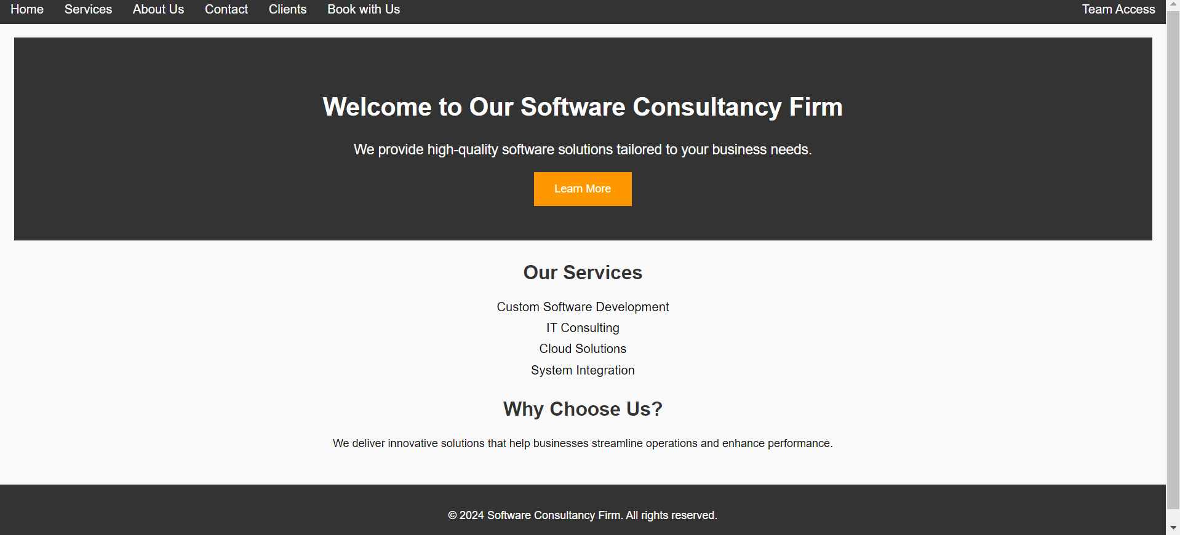

1. **Services.html**

<!DOCTYPE html>

<html lang="en">

<head>

<meta charset="UTF-8">

<meta name="viewport" content="width=device-width, initial-scale=1.0">

<meta http-equiv="X-UA-Compatible" content="IE=edge">

<title>Our Services | Software Consultancy Firm</title>

<link rel="stylesheet" href="style.css">

</head>

<body>

<!-- Navigation Menu -->

<header>

<nav>

<ul>

<li><a href="homepage.html">Home</a></li>

<li><a href="services.html">Services</a></li>

<li><a href="about.html">About Us</a></li>

<li><a href="contact.html">Contact</a></li>

<li><a href="clients.html">Clients</a></li>

<li><a href="book_with_us.html">Book with Us</a></li>

<li><a href="team_access.html">Team Access</a></li>

</ul>

</nav>

</header>

<!-- Services Section -->

<main>

<section class="services-page">

<h1>Our Services</h1>

<p>We offer a range of software solutions tailored to help your business thrive in the digital age.</p>

<div class="service-box">

<h2>Custom Software Development</h2>

<p>We specialize in creating custom software solutions designed specifically for your business needs, helping to improve efficiency and drive innovation.</p>

</div>

<div class="service-box">

<h2>IT Consulting</h2>

<p>Our team of experts will assess your current IT infrastructure and provide you with strategies for optimizing your operations.</p>

</div>

<div class="service-box">

<h2>Cloud Solutions</h2>

<p>We provide scalable and secure cloud solutions to help you move your operations online, reducing costs and increasing accessibility.</p>

</div>

<div class="service-box">

<h2>System Integration</h2>

<p>We help integrate new software into your existing infrastructure, ensuring seamless communication between your systems.</p>

</div>

</section>

</main>

<!-- Footer -->

<footer>

<p>&copy; 2024 Software Consultancy Firm. All rights reserved.</p>

</footer>

<!-- JavaScript File -->

<script src="script.js"></script>

</body>

</html>

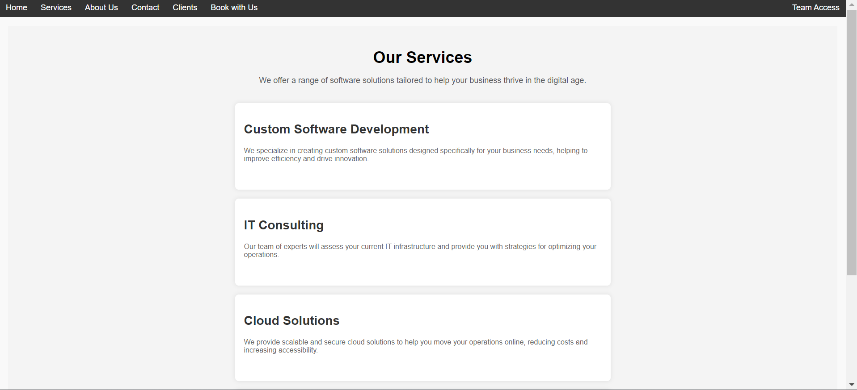

1. **About.html**

<!DOCTYPE html>

<html lang="en">

<head>

    <meta charset="UTF-8">

    <meta name="viewport" content="width=device-width, initial-scale=1.0">

    <meta http-equiv="X-UA-Compatible" content="IE=edge">

    <title>About Us | Software Consultancy Firm</title>

    <link rel="stylesheet" href="style.css">

</head>

<body>

    <!-- Navigation Menu -->

    <header>

        <nav>

            <ul>

                <li><a href="homepage.html">Home</a></li>

                <li><a href="services.html">Services</a></li>

                <li><a href="about.html">About Us</a></li>

                <li><a href="contact.html">Contact</a></li>

                <li><a href="clients.html">Clients</a></li>

                <li><a href="book_with_us.html">Book with Us</a></li>

                <li><a href="team_access.html">Team Access</a></li>

            </ul>

        </nav>

    </header>

    <!-- About Us Section -->

    <main>

        <section class="about-us-page">

            <h1>About Us</h1>

            <p>We are a forward-thinking software consultancy firm dedicated to helping businesses unlock their full potential through innovative technology solutions.</p>

            <div class="mission">

                <h2>Our Mission</h2>

                <p>Our mission is to deliver high-quality, custom software and IT consulting services that drive success and growth for businesses of all sizes.</p>

            </div>

            <div class="values">

                <h2>Our Values</h2>

                <ul>

                    <li>Innovation: We bring creativity and cutting-edge solutions to every project.</li>

                    <li>Integrity: We maintain transparency and honesty in all our dealings.</li>

                    <li>Customer-Centric: We prioritize client needs and tailor solutions to ensure their success.</li>

                    <li>Excellence: We strive for perfection in everything we do, from code to customer service.</li>

                </ul>

            </div>

            <div class="team">

                <h2>Meet Our Team</h2>

                <p>Our team is made up of highly skilled software engineers, consultants, and project managers, all passionate about delivering exceptional results. With years of experience across multiple industries, we bring deep expertise and a collaborative spirit to every project.</p>

            </div>

        </section>

    </main>

    <!-- Footer -->

    <footer>

        <p>&copy; 2024 Software Consultancy Firm. All rights reserved.</p>

    </footer>

    <!-- JavaScript File -->

    <script src="script.js"></script>

</body>

</html>

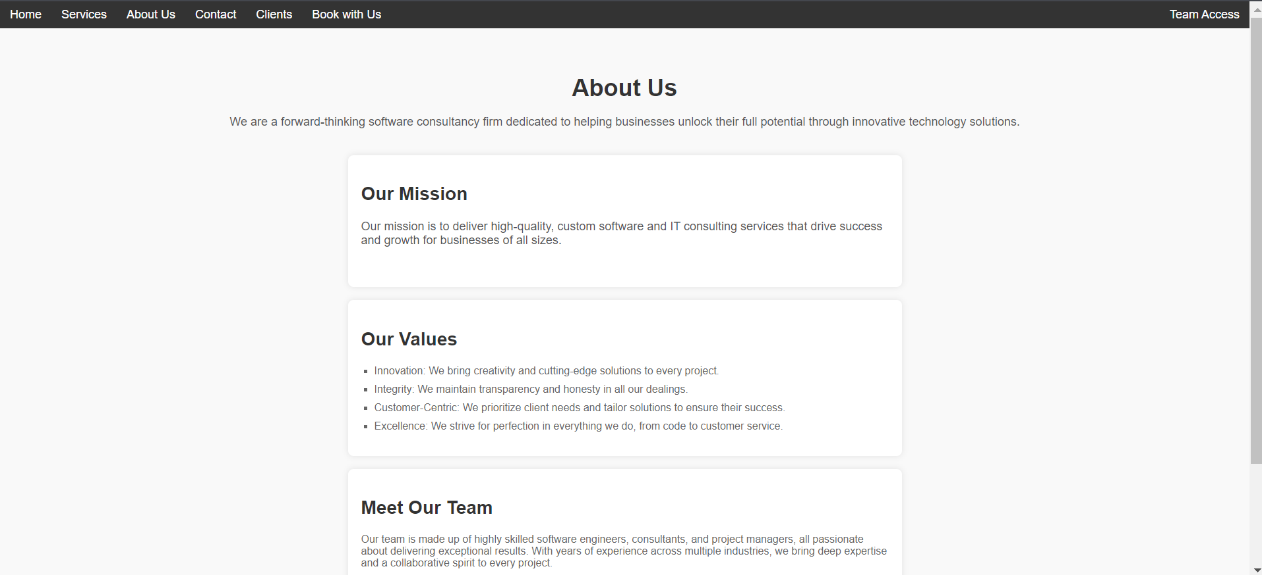

1. **Contact.html**

<!DOCTYPE html>

<html lang="en">

<head>

<meta charset="UTF-8">

<meta name="viewport" content="width=device-width, initial-scale=1.0">

<meta http-equiv="X-UA-Compatible" content="IE=edge">

<title>Contact Us | Software Consultancy Firm</title>

<link rel="stylesheet" href="style.css">

</head>

<body>

<!-- Navigation Menu -->

<header>

<nav>

<ul>

<li><a href="homepage.html">Home</a></li>

<li><a href="services.html">Services</a></li>

<li><a href="about.html">About Us</a></li>

<li><a href="contact.html">Contact</a></li>

<li><a href="clients.html">Clients</a></li>

<li><a href="book_with_us.html">Book with Us</a></li>

<li><a href="team_access.html">Team Access</a></li>

</ul>

</nav>

</header>

<!-- Contact Section -->

<main>

<section class="contact-page">

<h1>Contact Us</h1>

<p>We'd love to hear from you! Whether you have a question, need help, or want to discuss a project, feel free to get in touch.</p>

<!-- Contact Form -->

<div class="contact-form">

<form id="contactForm" action="submit_contact.php" method="post">

<label for="name">Name:</label>

<input type="text" id="name" name="name" placeholder="Your Name" required>

<label for="email">Email:</label>

<input type="email" id="email" name="email" placeholder="Your Email" required>

<label for="message">Message:</label>

<textarea id="message" name="message" placeholder="Your Message" required></textarea>

<input type="submit" value="Send Message">

</form>

</div>

<!-- Contact Details -->

<div class="contact-details">

<h2>Our Contact Information</h2>

<p>Email: contact@softwareconsultancy.com</p>

<p>Phone: +123 456 7890</p>

<p>Address: 123 Software Lane, Tech City, 10001</p>

</div>

</section>

</main>

<!-- Footer -->

<footer>

<p>&copy; 2024 Software Consultancy Firm. All rights reserved.</p>

</footer>

<!-- JavaScript File -->

<script src="script.js"></script>

</body>

</html>

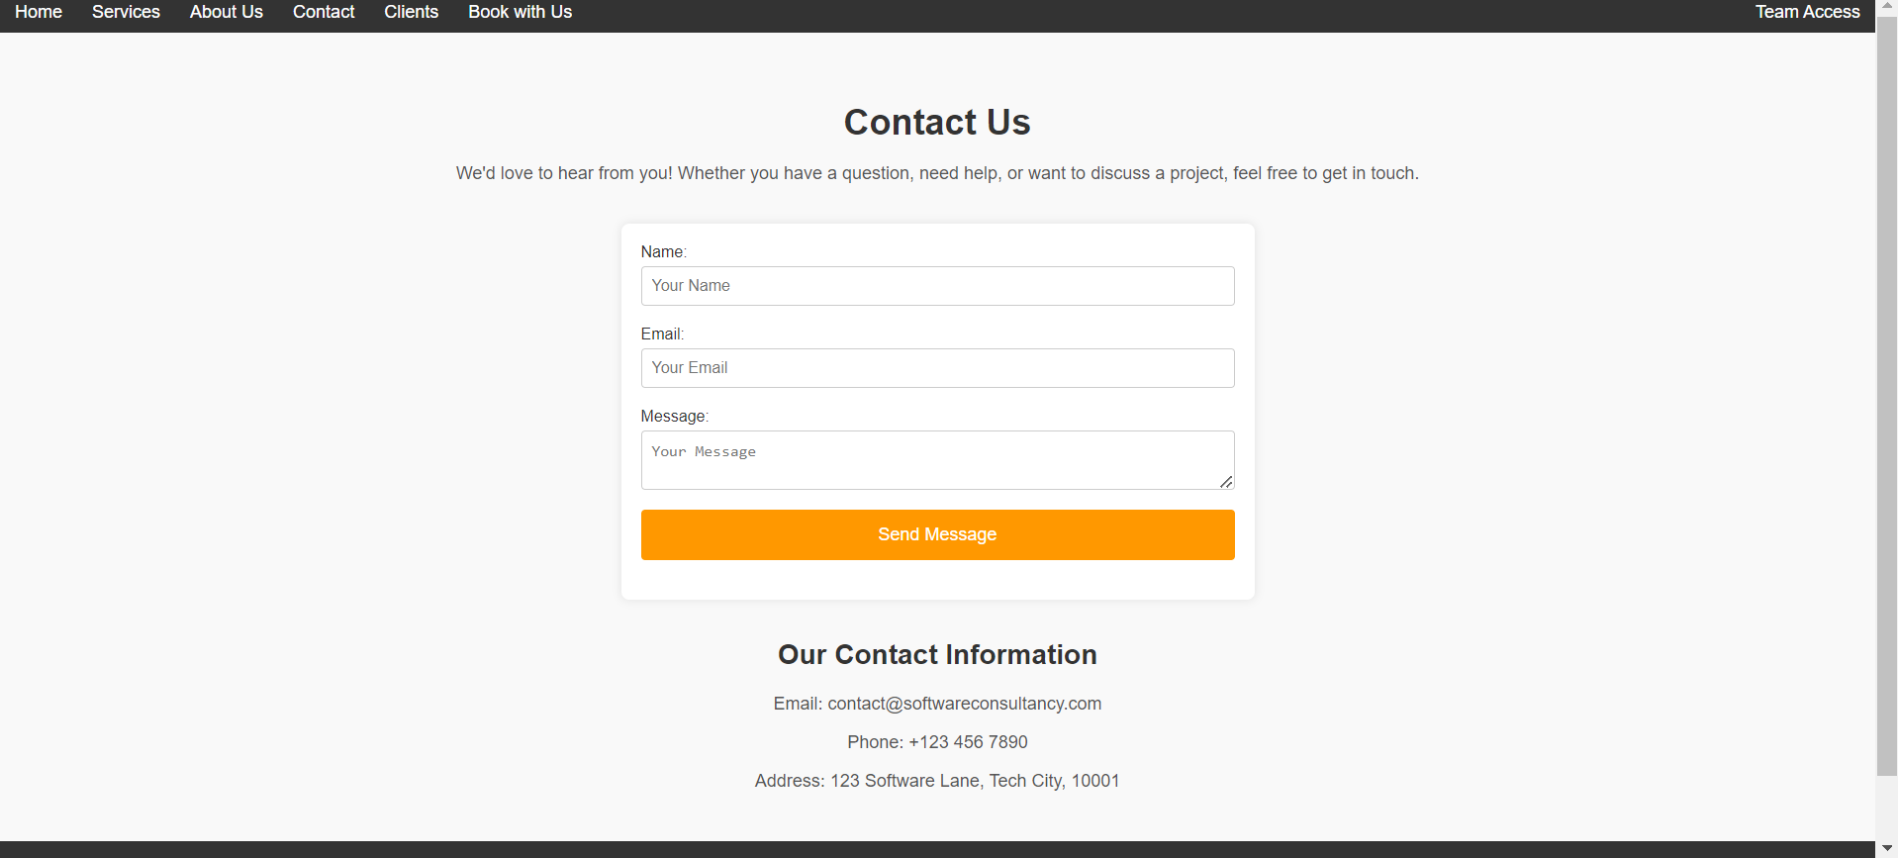

1. **Clients.html**

<!DOCTYPE html>

<html lang="en">

<head>

<meta charset="UTF-8">

<meta name="viewport" content="width=device-width, initial-scale=1.0">

<meta http-equiv="X-UA-Compatible" content="IE=edge">

<title>Our Clients | Software Consultancy Firm</title>

<link rel="stylesheet" href="style.css">

</head>

<body>

<!-- Navigation Menu -->

<header>

<nav>

<ul>

<li><a href="homepage.html">Home</a></li>

<li><a href="services.html">Services</a></li>

<li><a href="about.html">About Us</a></li>

<li><a href="contact.html">Contact</a></li>

<li><a href="clients.html">Clients</a></li>

<li><a href="book_with_us.html">Book with Us</a></li>

<li><a href="team_access.html">Team Access</a></li>

</ul>

</nav>

</header>

<!-- Clients Section -->

<main>

<section class="clients-page">

<h1>Our Clients</h1>

<p>We are proud to have partnered with a range of businesses, helping them achieve their goals through our expert software consultancy services.</p>

<!-- Client Logos / Testimonials -->

<div class="clients-container">

<div class="client-box">

<img src="pics/client3.jpeg" alt="Client 1 Logo">

<h3>Client 1</h3>

<p>"The software solutions provided by this team transformed our business and improved our operational efficiency."</p>

</div>

<div class="client-box">

<img src="pics/client2.jpeg" alt="Client 2 Logo">

<h3>Client 2</h3>

<p>"Their expertise in IT consulting has been invaluable. We wouldn't have reached where we are today without their support."</p>

</div>

<div class="client-box">

<img src="pics/client1.jpeg" alt="Client 3 Logo">

<h3>Client 3</h3>

<p>"Excellent customer service, innovative solutions, and timely delivery! We highly recommend this firm."</p>

</div>

<div class="client-box">

<img src="pics/client4.jpeg" alt="Client 4 Logo">

<h3>Client 4</h3>

<p>"A highly skilled team with great insights into software development. They delivered exactly what we needed."</p>

</div>

</div>

</section>

</main>

<!-- Footer -->

<footer>

<p>&copy; 2024 Software Consultancy Firm. All rights reserved.</p>

</footer>

</body>

</html>

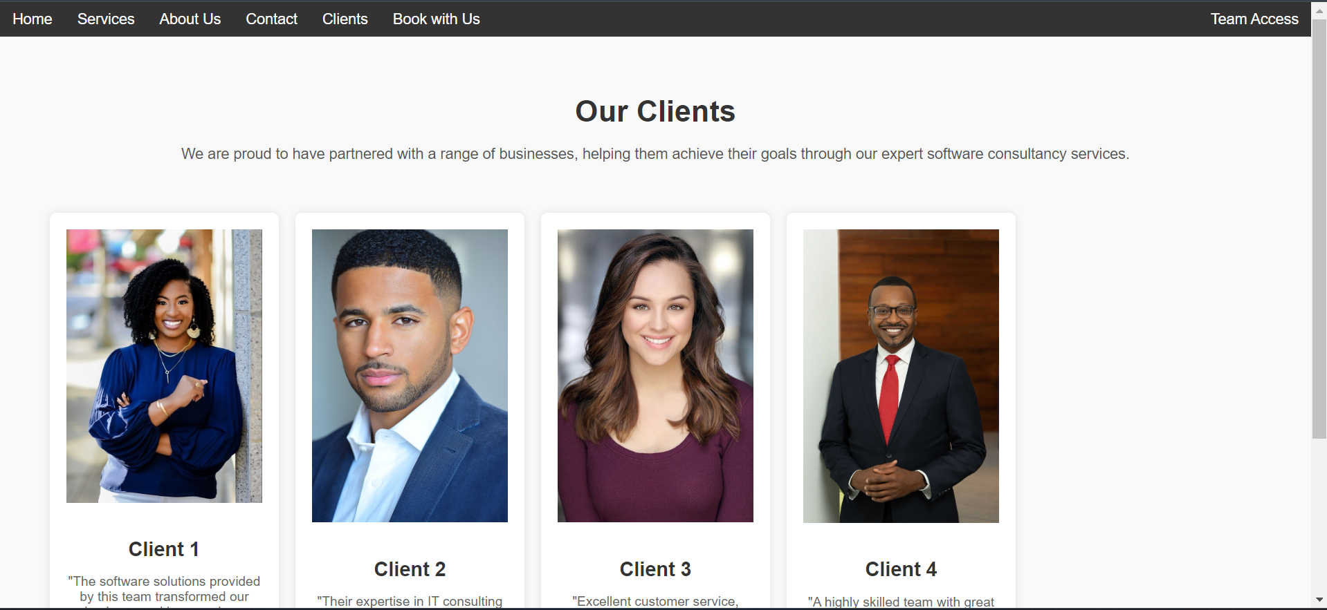

1. **Book_with_us.html**

<!DOCTYPE html>

<html lang="en">

<head>

<meta charset="UTF-8">

<meta name="viewport" content="width=device-width, initial-scale=1.0">

<meta http-equiv="X-UA-Compatible" content="IE=edge">

<title>Book with Us | Software Consultancy Firm</title>

<link rel="stylesheet" href="style.css">

</head>

<body>

<!-- Navigation Menu -->

<header>

<nav>

<ul>

<li><a href="homepage.html">Home</a></li>

<li><a href="services.html">Services</a></li>

<li><a href="about.html">About Us</a></li>

<li><a href="contact.html">Contact</a></li>

<li><a href="clients.html">Clients</a></li>

<li><a href="book_with_us.html">Book with Us</a></li>

<li><a href="team_access.html">Team Access</a></li>

</ul>

</nav>

</header>

<!-- Main Content -->

<main>

<section class="book-with-us-page">

<h1>Book a Consultation</h1>

<p>Schedule a consultation with us to discuss how we can help your business with our expert software solutions. Please fill out the form below, and we will get back to you as soon as possible.</p>

<!-- Booking Form -->

<div class="booking-form">

<form action="book_with_us.php" method="post">

<label for="booking_name">Full Name:</label>

<input type="text" id="booking_name" name="name" required>

<label for="booking_email">Email:</label>

<input type="email" id="booking_email" name="email" required>

<label for="booking_phone">Phone Number:</label>

<input type="tel" id="booking_phone" name="phone" required>

<label for="booking_consultation_date">Preferred Consultation Date:</label>

<input type="date" id="booking_consultation_date" name="consultation_date" required>

<label for="booking_message">Message (optional):</label>

<textarea id="booking_message" name="message"></textarea>

<input type="submit" value="Book Now">

</form>

</div>

</section>

</main>

<script>

document.addEventListener("DOMContentLoaded", function() {

// Form validation and submission

document.querySelector('form').addEventListener('submit', function(event) {

// Prevent default form submission behavior

event.preventDefault();

// Get form fields

var name = document.querySelector('input[name="name"]').value.trim();

var email = document.querySelector('input[name="email"]').value.trim();

var phone = document.querySelector('input[name="phone"]').value.trim();

var consultationDate = document.querySelector('input[name="consultation_date"]').value.trim();

var message = document.querySelector('textarea[name="message"]').value.trim();

// List of validation errors

var errors = [];

// Validate Name

if (name === "") {

errors.push("Full Name is required.");

}

// Validate Email

var emailPattern = /^[^ ]+@[^ ]+\.[a-z]{2,3}$/;

if (email === "") {

errors.push("Email is required.");

} else if (!email.match(emailPattern)) {

errors.push("Please enter a valid email address.");

}

// Validate Phone Number

var phonePattern = /^[0-9]{10}$/; // 10 digits (can adjust based on requirements)

if (phone === "") {

errors.push("Phone Number is required.");

} else if (!phone.match(phonePattern)) {

errors.push("Please enter a valid 10-digit phone number.");

}

// Validate Consultation Date

if (consultationDate === "") {

errors.push("Preferred Consultation Date is required.");

}

// Check if there are any validation errors

if (errors.length > 0) {

// Show the error messages in an alert

alert("The following errors occurred:\n" + errors.join("\n"));

} else {

// If no errors, submit the form

this.submit();

}

});

});

</script>

<!-- Footer -->

<footer>

<p>&copy; 2024 Software Consultancy Firm. All rights reserved.</p>

</footer>

</body>

</html>

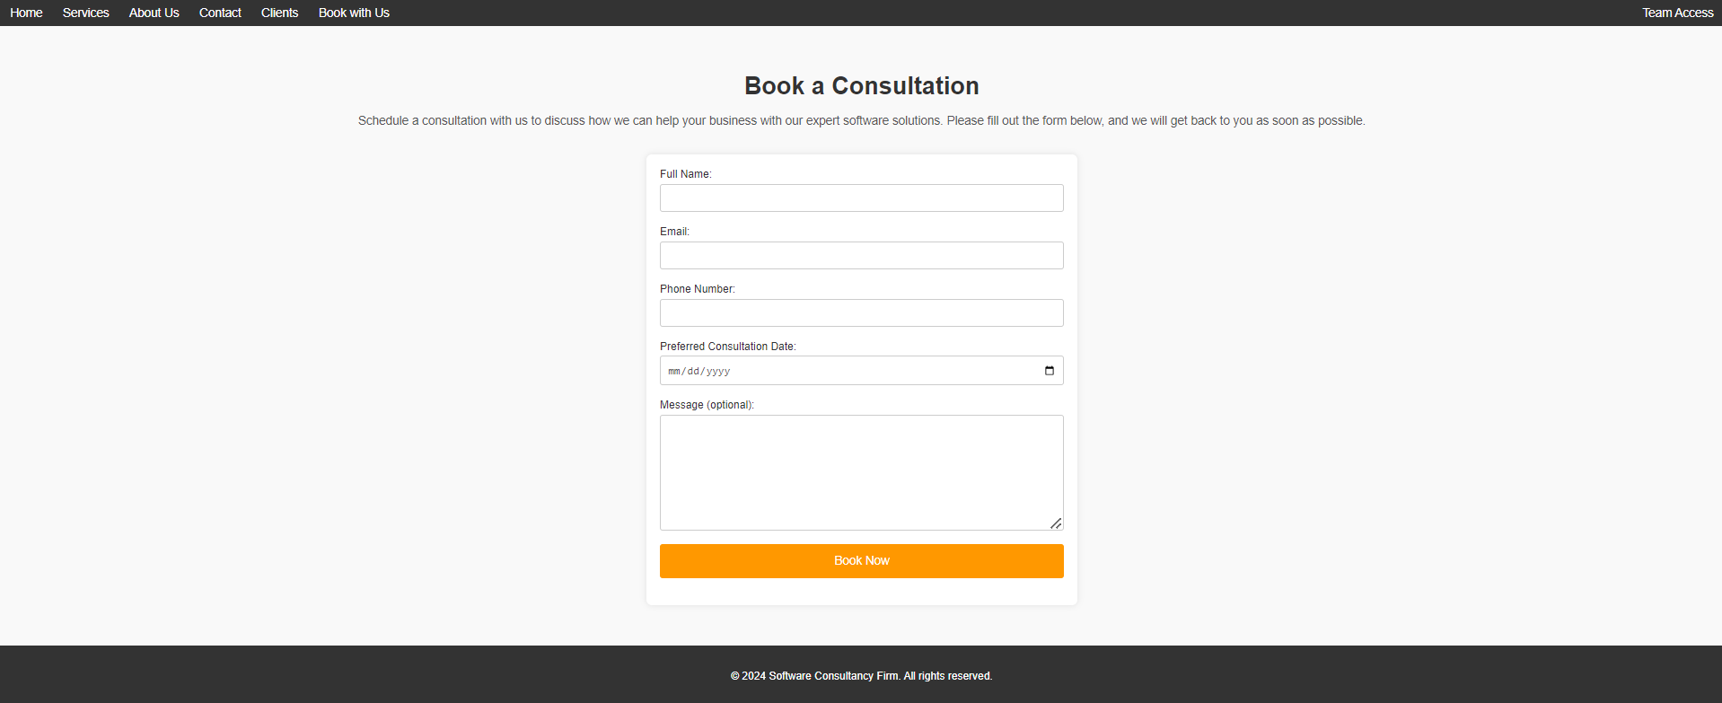

1. **Team_access.html**

<!DOCTYPE html>

<html lang="en">

<head>

<meta charset="UTF-8">

<meta name="viewport" content="width=device-width, initial-scale=1.0">

<meta http-equiv="X-UA-Compatible" content="IE=edge">

<title>Team Access Only</title>

<link rel="stylesheet" href="style.css">

</head>

<body>

<header>

<nav>

<ul>

<li><a href="homepage.html">Home</a></li>

<li><a href="services.html">Services</a></li>

<li><a href="about.html">About Us</a></li>

<li><a href="contact.html">Contact</a></li>

<li><a href="clients.html">Clients</a></li>

<li><a href="book_with_us.html">Book with Us</a></li>

<li><a href="team_access.html">Team Access</a></li>

</ul>

</nav>

</header>

<main>

<section class="team-login">

<h1>Team Access</h1>

<p>Only authorized team members can access this page. Please log in below:</p>

<!-- Updated form to POST data to team_access.php -->

<form method="POST" action="team_access.php">

<label for="username">Username:</label>

<input type="text" id="username" name="username" required><br><br>

<label for="password">Password:</label>

<input type="password" id="password" name="password" required><br><br>

<button type="submit">Login</button>

</form>

</section>

</main>

<footer>

<p>&copy; 2024 Software Consultancy Firm. All rights reserved.</p>

</footer>

</body>

**</html>**

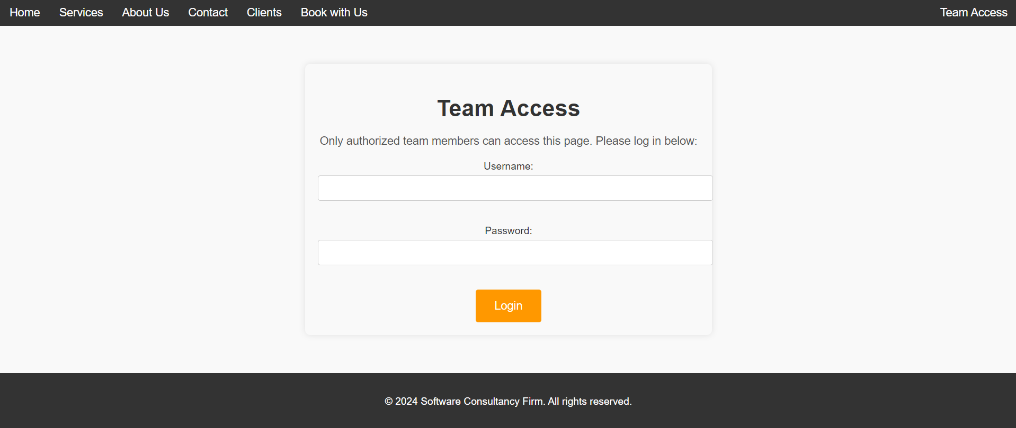

1. **Team_page.html**

<!DOCTYPE html>

<html lang="en">

<head>

<meta charset="UTF-8">

<meta name="viewport" content="width=device-width, initial-scale=1.0">

<meta http-equiv="X-UA-Compatible" content="IE=edge">

<title>Team Management</title>

<link rel="stylesheet" href="style.css">

</head>

<body>

<header>

<nav>

<ul>

<li><a href="team_access.html">Logout</a></li>

</ul>

</nav>

</header>

<main>

<section class="manage-database">

<h1>Manage Client Bookings and Contact Messages</h1>

<!-- View Section -->

<div class="view-section">

<h2>View Records</h2>

<form method="POST" action="team_page.php">

<button type="submit" name="view_bookings">View Client Bookings</button>

<button type="submit" name="view_messages">View Contact Messages</button>

</form>

</div>

<!-- Update Section -->

<div class="update-section">

<h2>Update Records</h2>

<form method="POST" action="team_page.php">

<label for="booking_id">Booking ID:</label>

<input type="text" id="booking_id" name="id" required>

<label for="client_name">Client Name:</label>

<input type="text" id="client_name" name="name" required>

<label for="phone">Phone:</label>

<input type="text" id="phone" name="phone" required>

<label for="date">Date:</label>

<input type="date" id="date" name="consultation_date" required>

<label for="email">Email(not necessary):</label>

<input type="text" id="email" name="email">

<button type="submit" name="update_booking">Update Booking</button>

</form>

</div>

<!-- Delete Section -->

<div class="delete-section">

<h2>Delete Records</h2>

<form method="POST" action="team_page.php">

<label for="delete_id">Record ID:</label>

<input type="text" id="delete_id" name="delete_id" required>

<button type="submit" name="delete_booking">Delete Booking</button>

<button type="submit" name="delete_message">Delete Message</button>

</form>

</div>

</section>

</main>

<footer>

<p>&copy; 2024 Software Consultancy Firm. All rights reserved.</p>

</footer>

</body>

</html>

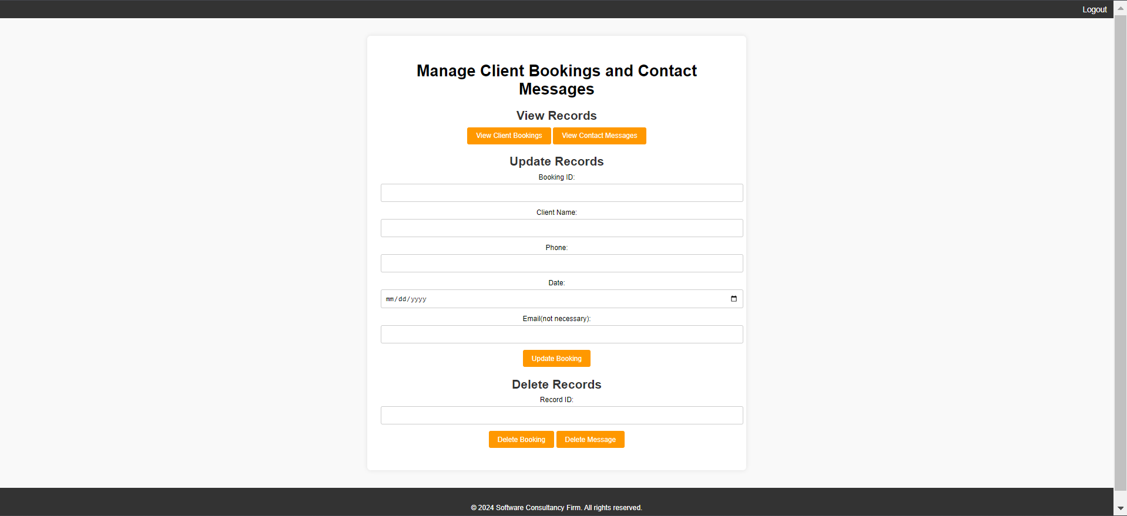

**Explanation:**

The screenshots above show the different web pages of the software consultation firm and their html codes. The pages include:

A homepage which shows the user a brief introduction of the firm.

A services page which goes into detail about the services offered by the firm.

An about us page that show the mission, vision and an insight to the team members.

A contact page where there is a form that the user can write to the firm.

A clients page that shows the firm’s past clients.

A book with us page that shows a form where the client can book with the firm.

A team access page which allows specific members to access a page which they can update, delete and view records.

**CSS**

/* General Styles */

body {

    font-family: Arial, sans-serif;

    margin: 0;

    padding: 0;

    box-sizing: border-box;

    background-color: #f4f4f4;

}

/* Navigation Menu */

header {

    background-color: #333;

    padding: 10px 0;

}

nav ul {

    list-style-type: none;

    margin: 0;

    padding: 0;

    display: flex; /* Use flexbox for layout */

    justify-content: center; /* Center items horizontally */

    align-items: center; /* Align items vertically */

    position: relative;

}

nav ul li {

    margin: 0 15px;

}

nav ul li a {

    color: #fff;

    text-decoration: none;

    font-size: 18px;

}

nav ul li a:hover {

    color: #ff9800;

}

/* Move the last item (Team Access) to the far right */

nav ul li:last-child {

    margin-left: auto; /* Push the last item to the right */

}

/* Main Content */

main {

    padding: 20px;

    text-align: center;

}

.intro {

    background-color: #333;

    color: #fff;

    padding: 50px;

}

.intro h1 {

    font-size: 36px;

}

.intro p {

    font-size: 20px;

    margin: 20px 0;

}

button {

    background-color: #ff9800;

    border: none;

    color: white;

    padding: 15px 30px;

    text-align: center;

    font-size: 16px;

    cursor: pointer;

    transition: background-color 0.3s;

}

button:hover {

    background-color: #e68900;

}

.services-overview, .why-choose-us {

    margin: 30px 0;

}

h2 {

    font-size: 28px;

    color: #333;

}

ul {

    list-style-type: none;

    padding: 0;

}

ul li {

    font-size: 18px;

    margin: 10px 0;

}

/* Services Page */

.services-page {

    padding: 20px;

    text-align: center;

    background-color: #f4f4f4;

}

.services-page h1 {

    font-size: 36px;

    margin-bottom: 20px;

}

.services-page p {

    font-size: 18px;

    margin-bottom: 40px;

    color: #555;

}

.service-box {

    background-color: #fff;

    margin: 20px auto;

    padding: 20px;

    border-radius: 8px;

    box-shadow: 0 0 10px rgba(0, 0, 0, 0.1);

    max-width: 800px;

    text-align: left;

}

.service-box h2 {

    font-size: 28px;

    color: #333;

}

.service-box p {

    font-size: 16px;

    color: #666;

}

/* About Us Page */

.about-us-page {

    padding: 20px;

    text-align: center;

    background-color: #f9f9f9;

}

.about-us-page h1 {

    font-size: 36px;

    margin-bottom: 20px;

    color: #333;

}

.about-us-page p {

    font-size: 18px;

    margin-bottom: 40px;

    color: #555;

}

.mission, .values, .team {

    background-color: #fff;

    margin: 20px auto;

    padding: 20px;

    border-radius: 8px;

    box-shadow: 0 0 10px rgba(0, 0, 0, 0.1);

    max-width: 800px;

    text-align: left;

}

.mission h2, .values h2, .team h2 {

    font-size: 28px;

    color: #333;

}

.values ul {

    list-style-type: square;

    padding-left: 20px;

}

.values ul li {

    font-size: 16px;

    margin-bottom: 10px;

    color: #666;

}

.team p {

    font-size: 16px;

    color: #666;

}

/* Contact Page */

.contact-page {

    padding: 20px;

    text-align: center;

    background-color: #f9f9f9;

}

.contact-page h1 {

    font-size: 36px;

    margin-bottom: 20px;

    color: #333;

}

.contact-page p {

    font-size: 18px;

    margin-bottom: 40px;

    color: #555;

}

/* Contact Form Styling */

.contact-form {

    background-color: #fff;

    padding: 20px;

    margin: 20px auto;

    border-radius: 8px;

    box-shadow: 0 0 10px rgba(0, 0, 0, 0.1);

    max-width: 600px;

    text-align: left;

}

.contact-form form {

    display: flex;

    flex-direction: column;

}

.contact-form label {

    font-size: 16px;

    margin-bottom: 5px;

    color: #333;

}

.contact-form input, .contact-form textarea {

    padding: 10px;

    margin-bottom: 20px;

    font-size: 16px;

    border: 1px solid #ccc;

    border-radius: 4px;

}

.contact-form input[type="submit"] {

    background-color: #ff9800;

    color: #fff;

    border: none;

    padding: 15px;

    cursor: pointer;

    font-size: 18px;

    border-radius: 4px;

    transition: background-color 0.3s ease;

}

.contact-form input[type="submit"]:hover {

    background-color: #0056b3;

}

/* Contact Details Styling */

.contact-details {

    margin-top: 40px;

    font-size: 18px;

    color: #333;

}

.contact-details p {

    margin-bottom: 10px;

}

/* Clients Page */

.clients-page {

    padding: 20px;

    text-align: center;

    background-color: #f9f9f9;

}

.clients-page h1 {

    font-size: 36px;

    margin-bottom: 20px;

    color: #333;

}

.clients-page p {

    font-size: 18px;

    margin-bottom: 40px;

    color: #555;

}

/* Clients Container */

.clients-container {

    display: grid;

    grid-template-columns: repeat(auto-fill, minmax(250px, 1fr));

    gap: 20px;

    justify-content: center;

    align-items: stretch;

    padding: 20px;

}

.client-box {

    background-color: #fff;

    padding: 20px;

    border-radius: 8px;

    box-shadow: 0 0 10px rgba(0, 0, 0, 0.1);

    text-align: center;

}

.client-box img {

    max-width: 100%;

    height: auto;

    margin-bottom: 15px;

}

.client-box h3 {

    font-size: 24px;

    color: #333;

    margin-bottom: 10px;

}

.client-box p {

    font-size: 16px;

    color: #666;

}

/* Book with Us Page */

.book-with-us-page {

    padding: 20px;

    text-align: center;

    background-color: #f9f9f9;

}

.book-with-us-page h1 {

    font-size: 36px;

    margin-bottom: 20px;

    color: #333;

}

.book-with-us-page p {

    font-size: 18px;

    margin-bottom: 40px;

    color: #555;

}

/* Booking Form Styling */

.booking-form {

    background-color: #fff;

    padding: 20px;

    margin: 20px auto;

    border-radius: 8px;

    box-shadow: 0 0 10px rgba(0, 0, 0, 0.1);

    max-width: 600px;

    text-align: left;

}

.booking-form form {

    display: flex;

    flex-direction: column;

}

.booking-form label {

    font-size: 16px;

    margin-bottom: 5px;

    color: #333;

}

.booking-form input,

.booking-form textarea {

    padding: 10px;

    margin-bottom: 20px;

    font-size: 16px;

    border: 1px solid #ccc;

    border-radius: 4px;

}

.booking-form input[type="date"] {

    font-size: 16px;

    color: #555;

}

.booking-form input[type="submit"] {

    background-color: #ff9800;

    color: #fff;

    border: none;

    padding: 15px;

    cursor: pointer;

    font-size: 18px;

    border-radius: 4px;

    transition: background-color 0.3s ease;

}

.booking-form input[type="submit"]:hover {

    background-color: #e68900;

}

.booking-form textarea {

    min-height: 150px;

    resize: vertical;

}

/* Team Access Page */

.team-login {

    background-color: #f9f9f9; /* Light background to match the rest of the site */

    padding: 20px;

    max-width: 600px; /* Ensure the form is centered and not too wide */

    margin: 40px auto;

    border-radius: 8px;

    box-shadow: 0 0 10px rgba(0, 0, 0, 0.1); /* Soft shadow for the login box */

    text-align: center; /* Center-align content inside the form */

}

.team-login h1 {

    font-size: 36px;

    color: #333; /* Dark color for headers */

    margin-bottom: 20px;

}

.team-login p {

    font-size: 18px;

    color: #555;

    margin-bottom: 20px;

}

.team-login label {

    font-size: 16px;

    color: #333;

    margin-bottom: 5px;

    display: block;

}

.team-login input[type="text"],

.team-login input[type="password"] {

    width: 100%;

    padding: 10px;

    margin-bottom: 20px;

    border: 1px solid #ccc;

    border-radius: 4px;

    font-size: 16px;

}

.team-login button {

    background-color: #ff9800;

    color: #fff;

    border: none;

    padding: 15px 30px;

    font-size: 18px;

    border-radius: 4px;

    cursor: pointer;

    transition: background-color 0.3s ease;

}

.team-login button:hover {

    background-color: #e68900;

}

/* General Styles */

body {

    font-family: Arial, sans-serif;

    margin: 0;

    padding: 0;

    background-color: #f9f9f9;

}

/* Navigation */

header {

    background-color: #333;

    padding: 10px 0;

}

nav ul {

    list-style: none;

    margin: 0;

    padding: 0;

    display: flex;

    justify-content: center;

}

nav ul li {

    margin: 0 15px;

}

nav ul li a {

    color: #fff;

    text-decoration: none;

    font-size: 18px;

}

nav ul li a:hover {

    color: #ff9800;

}

/* Main Content */

main {

    padding: 20px;

    text-align: center;

}

.manage-database {

    background-color: #fff;

    padding: 30px;

    margin: 20px auto;

    max-width: 800px;

    border-radius: 8px;

    box-shadow: 0 0 10px rgba(0, 0, 0, 0.1);

}

.manage-database h1 {

    font-size: 36px;

    margin-bottom: 20px;

}

.manage-database h2 {

    font-size: 28px;

    margin-bottom: 10px;

}

.manage-database form {

    margin-bottom: 20px;

}

.manage-database label {

    font-size: 16px;

    display: block;

    margin-bottom: 5px;

}

.manage-database input {

    padding: 10px;

    width: 100%;

    margin-bottom: 15px;

    border: 1px solid #ccc;

    border-radius: 4px;

    font-size: 16px;

}

.manage-database button {

    background-color: #ff9800;

    color: white;

    padding: 10px 20px;

    border: none;

    border-radius: 4px;

    font-size: 16px;

    cursor: pointer;

}

.manage-database button:hover {

    background-color: #e68900;

}

/* Footer */

footer {

    background-color: #333;

    color: #fff;

    padding: 20px 0;

    text-align: center;

}

**Explanation:**

This is the CSS code used to style the web application.

**JavaScript**

document.addEventListener("DOMContentLoaded", function() {

    // Form validation and submission

    document.getElementById('contactForm').addEventListener('submit', function(event) {

        // Prevent the default form submission behavior

        event.preventDefault();

        // Get form fields

        var name = document.getElementById('name').value.trim();

        var email = document.getElementById('email').value.trim();

        var message = document.getElementById('message').value.trim();

        // List of validation errors

        var errors = [];

        // Validate Name

        if (name === "") {

            errors.push("Name is required.");

        }

        // Validate Email

        var emailPattern = /^[^ ]+@[^ ]+\.[a-z]{2,3}$/;

        if (email === "") {

            errors.push("Email is required.");

        } else if (!email.match(emailPattern)) {

            errors.push("Please enter a valid email address.");

        }

        // Validate Message

        if (message === "") {

            errors.push("Message cannot be empty.");

        }

        // Check if there are any errors

        if (errors.length > 0) {

            // Show the error messages in a popup

            alert("The following errors occurred:\n" + errors.join("\n"));

        } else {

            // If no errors, submit the form using the form's submit method

            this.submit();

        }

    });

});

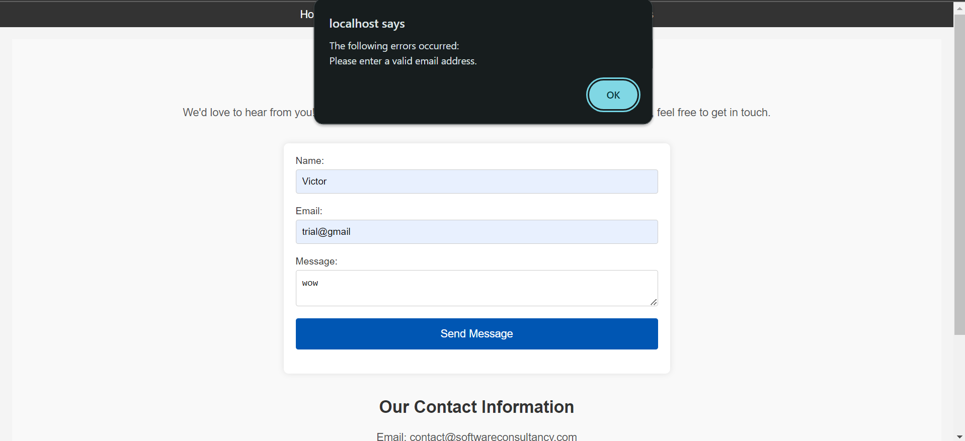

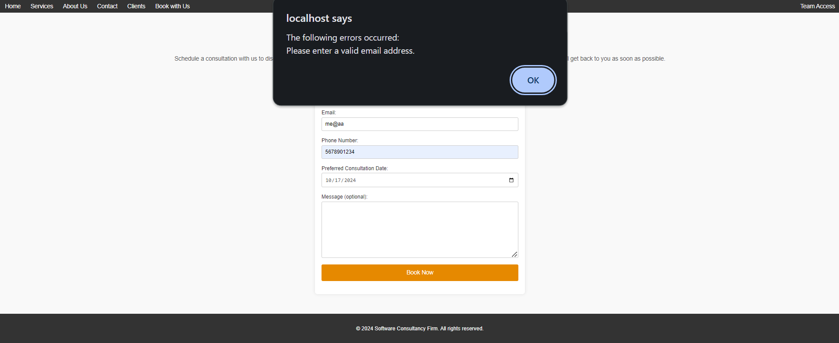

**Explanation:**

This shows the JavaScript code that is used to validate forms in the website.