**PHASE 2**

**SQL**

-- Table structure for table `client_bookings`

--

CREATE TABLE `client_bookings` (

  `id` int(11) NOT NULL,

  `name` varchar(255) NOT NULL,

  `email` varchar(255) NOT NULL,

  `phone` varchar(20) NOT NULL,

  `consultation_date` date NOT NULL,

  `message` text DEFAULT NULL,

  `submission_date` timestamp NOT NULL DEFAULT current_timestamp()

) ENGINE=InnoDB DEFAULT CHARSET=utf8mb4 COLLATE=utf8mb4_general_ci;

--

-- Dumping data for table `client_bookings`

--

INSERT INTO `client_bookings` (`id`, `name`, `email`, `phone`, `consultation_date`, `message`, `submission_date`) VALUES

(7, 'ryan', 'monyaabdeen@gmail.com', '5678901234', '2024-11-02', '', '2024-10-04 17:27:10'),

(8, 'eunice', 'Esther@gmail.com', '6789054321', '2024-10-19', '', '2024-10-04 20:56:58'),

(9, 'Beth Martin', 'beth@gmail.com', '1234567890', '2024-10-31', '', '2024-10-04 20:59:15');

-- --------------------------------------------------------

--

-- Table structure for table `contact_messages`

--

CREATE TABLE `contact_messages` (

  `id` int(11) NOT NULL,

  `sender_name` varchar(100) NOT NULL,

  `sender_email` varchar(100) NOT NULL,

  `message` text NOT NULL,

  `submitted_date` timestamp NOT NULL DEFAULT current_timestamp()

) ENGINE=InnoDB DEFAULT CHARSET=utf8mb4 COLLATE=utf8mb4_general_ci;

--

-- Dumping data for table `contact_messages`

--

INSERT INTO `contact_messages` (`id`, `sender_name`, `sender_email`, `message`, `submitted_date`) VALUES

(13, 'eunice', 'eunice@gmail.com', 'I just want to hear back from you. I have a problem.', '2024-10-04 14:43:59');

-- --------------------------------------------------------

--

-- Table structure for table `logins`

--

CREATE TABLE `logins` (

  `username` varchar(78) NOT NULL,

  `password` varchar(100) NOT NULL

) ENGINE=InnoDB DEFAULT CHARSET=utf8mb4 COLLATE=utf8mb4_general_ci;

--

-- Dumping data for table `logins`

--

INSERT INTO `logins` (`username`, `password`) VALUES

('dan', 'no'),

('Manager', 'manager@123'),

('Esther', 'dev@123');

--

-- Indexes for dumped tables

--

--

-- Indexes for table `client_bookings`

--

ALTER TABLE `client_bookings`

  ADD PRIMARY KEY (`id`);

--

-- Indexes for table `contact_messages`

--

ALTER TABLE `contact_messages`

  ADD PRIMARY KEY (`id`);

--

-- AUTO_INCREMENT for dumped tables

--

--

-- AUTO_INCREMENT for table `client_bookings`

--

ALTER TABLE `client_bookings`

  MODIFY `id` int(11) NOT NULL AUTO_INCREMENT, AUTO_INCREMENT=10;

--

-- AUTO_INCREMENT for table `contact_messages`

--

ALTER TABLE `contact_messages`

  MODIFY `id` int(11) NOT NULL AUTO_INCREMENT, AUTO_INCREMENT=14;

COMMIT;

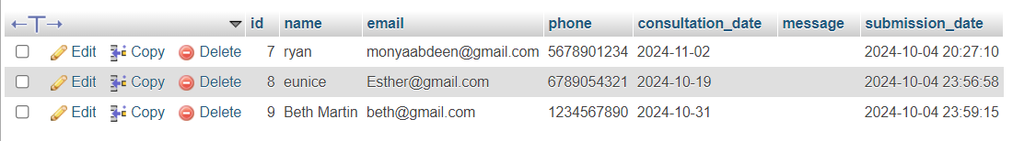

**Client_booking table**

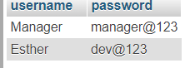

**Logins table**

**PHP+DB (SELECT)**

<?php

// Start the session to store login state

session_start();

// Database credentials

$host = 'localhost';

$dbname = 'software_consultancy_firm';

$username = 'root';

$password = '';

// Connect to the database

$conn = new mysqli($host, $username, $password, $dbname);

// Check if the connection was successful

if ($conn->connect_error) {

    die("Connection failed: " . $conn->connect_error);

}

// Check if the form was submitted

if ($_SERVER['REQUEST_METHOD'] === 'POST') {

    // Get the submitted form data

    $user = $_POST['username'];

    $pass = $_POST['password'];

    // Prepare a SQL statement to prevent SQL injection

    $stmt = $conn->prepare("SELECT * FROM logins WHERE username = ? AND password = ?");

    $stmt->bind_param("ss", $user, $pass);

    // Execute the query

    $stmt->execute();

    $result = $stmt->get_result();

    // Check if a matching row was found

    if ($result->num_rows > 0) {

        // Successful login, redirect to team_page.html

        header("Location: team_page.html");

        exit();

    } else {

        // Login failed, redirect back to the login page with an error

        echo "<script>alert('Invalid username or password. Please try again.'); window.location.href = 'team_access.html';</script>";

    }

    // Close the statement and the connection

    $stmt->close();

    $conn->close();

}

?>

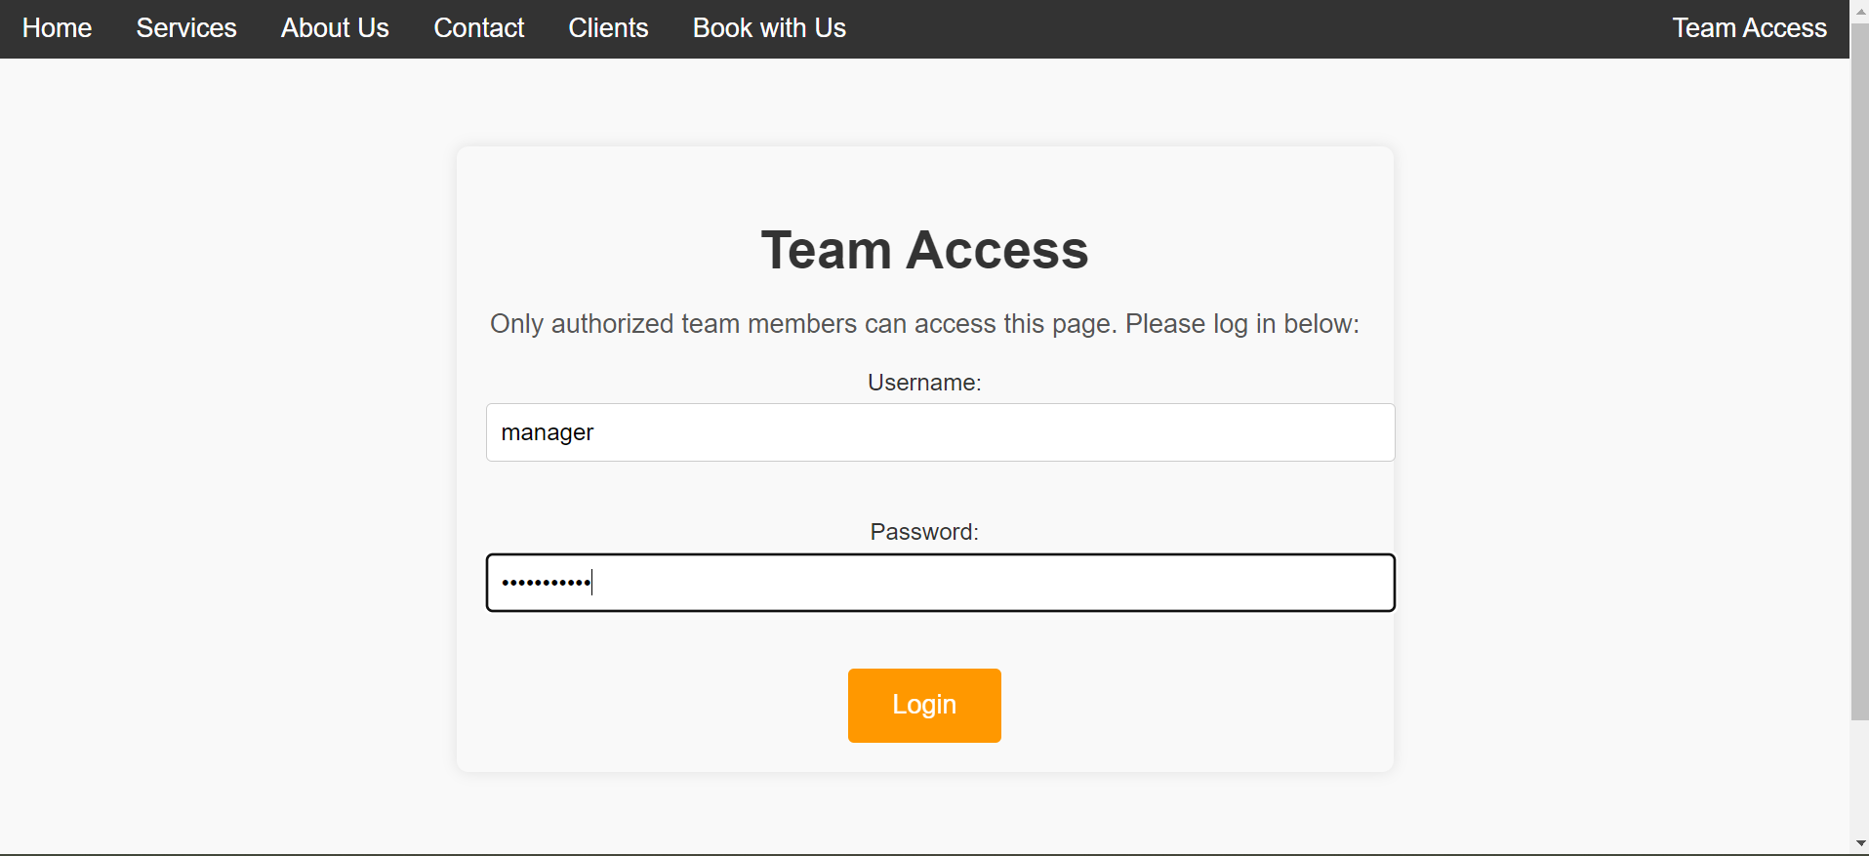

**Explanation:**

The above code selects from the database the username and password so that the user can access another part of the website.

**PHP+DB (INSERT)**

<?php

// Enable error reporting for debugging

ini_set('display_errors', 1);

ini_set('display_startup_errors', 1);

error_reporting(E_ALL);

// Check if the form is submitted via POST

if ($_SERVER["REQUEST_METHOD"] == "POST") {

    // Get form data and trim any extra spaces

    $name = trim($_POST['name']);

    $email = trim($_POST['email']);

    $phone = trim($_POST['phone']);

    $consultation_date = $_POST['consultation_date'];

    $message = trim($_POST['message']);

    // Validate required fields

    if (empty($name) || empty($email) || empty($phone) || empty($consultation_date)) {

        echo "<script>alert('Please fill in all required fields.'); window.location.href='book_with_us.html';</script>";

        exit();

    }

    // Database connection parameters

    $servername = "localhost";

    $username = "root";

    $password = "";

    $dbname = "software_consultancy_firm";

    // Create MySQL connection

    $conn = new mysqli($servername, $username, $password, $dbname);

    // Check database connection

    if ($conn->connect_error) {

        die("Connection failed: " . $conn->connect_error);

    }

    // Insert data into the bookings table

    $sql = "INSERT INTO client_bookings (name, email, phone, consultation_date, message) VALUES (?, ?, ?, ?, ?)";

    $stmt = $conn->prepare($sql);

    // Check if prepare was successful

    if ($stmt === false) {

        die("MySQL prepare statement error: " . $conn->error);

    }

    // Bind the parameters to the prepared statement

    $stmt->bind_param("sssss", $name, $email, $phone, $consultation_date, $message);

    // Execute the statement

    if ($stmt->execute()) {

        // Success, redirect to homepage

        echo "<script>alert('Your consultation has been successfully booked! We will contact you soon.'); window.location.href='homepage.html';</script>";

    } else {

        // On error, show the MySQL error message

        echo "<script>alert('Error: " . $stmt->error . "'); window.location.href='book_with_us.html';</script>";

    }

    // Close the prepared statement and the MySQL connection

    $stmt->close();

    $conn->close();

}

?>

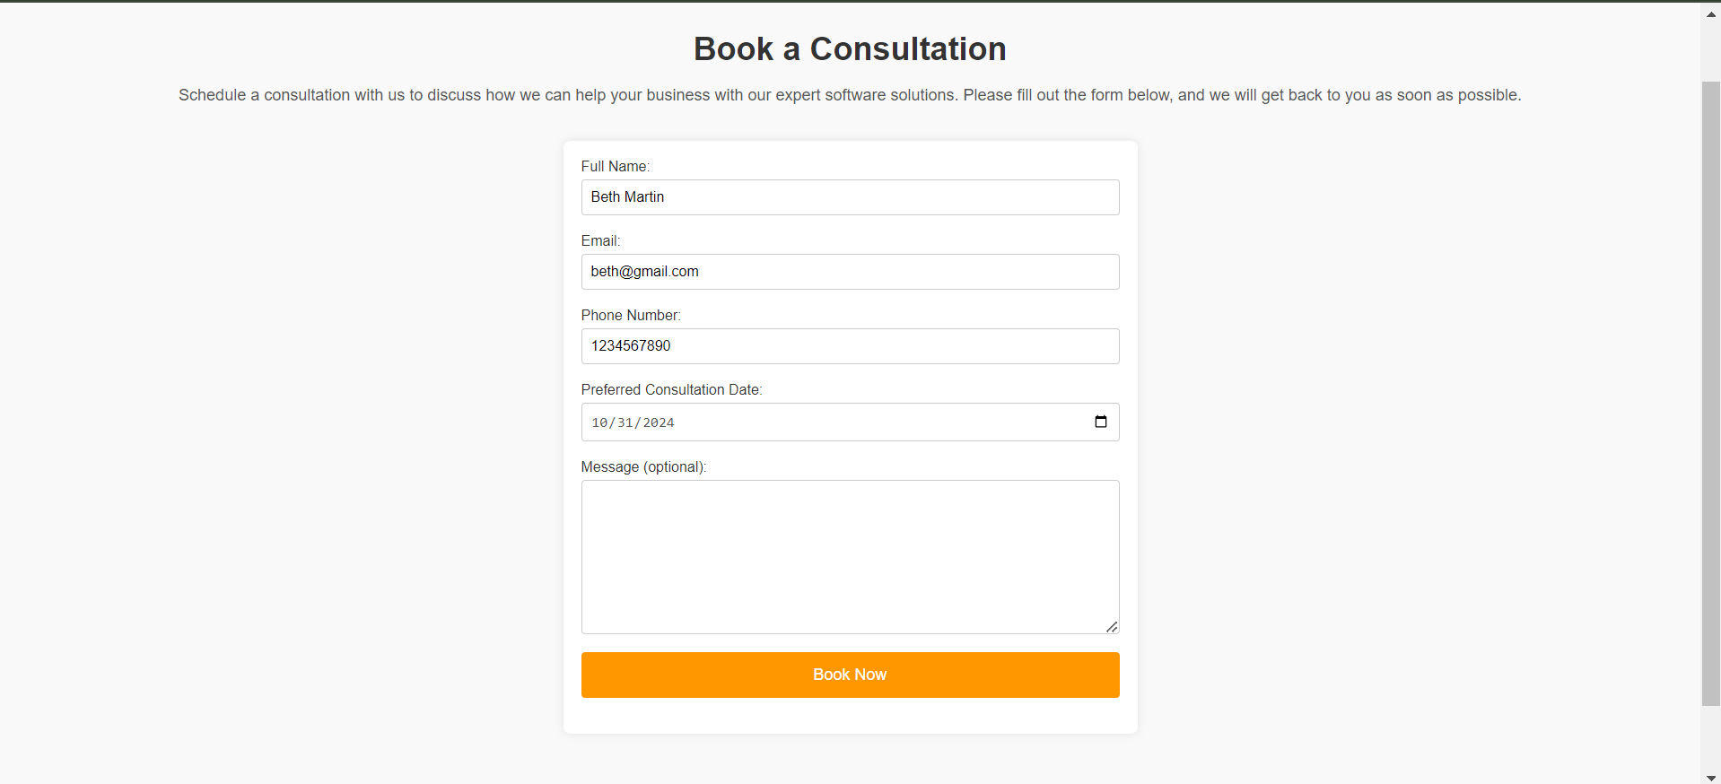



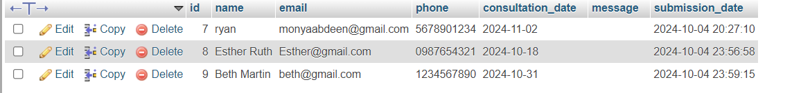

**Explanation:**

The above code inserts data that the user puts in to book with the firm into the database(software_consultancy_firm).

**PHP+DB (UPDATE)**

<?php

// Database connection

$servername = "localhost";

$username = "root";

$password = "";

$dbname = "software_consultancy_firm";

$conn = new mysqli($servername, $username, $password, $dbname);

// Check connection

if ($conn->connect_error) {

    die("Connection failed: " . $conn->connect_error);

}

// View records

if (isset($_POST['view_bookings'])) {

    $result = $conn->query("SELECT * FROM client_bookings");

    if ($result->num_rows > 0) {

        echo "<h2>Client Bookings</h2><ul>";

        while($row = $result->fetch_assoc()) {

            echo "<li>Booking ID: " . $row['id'] . " | Name: " . $row['name'] . " | Email: " . $row['email'] . "  | Phone Number: " . $row['phone'] . "  | Message: " . $row['message'] . "| Date: " . $row['submission_date'] . "</li>";

        }

        echo "</ul>";

    } else {

        echo "No bookings found.";

    }

} elseif (isset($_POST['view_messages'])) {

    $result = $conn->query("SELECT * FROM contact_messages");

    if ($result->num_rows > 0) {

        echo "<h2>Contact Messages</h2><ul>";

        while($row = $result->fetch_assoc()) {

            echo "<li>Message ID: " . $row['id'] . "  | Email: " . $row['sender_email'] . "| Name: " . $row['sender_name'] . " | Message: " . $row['message'] . "</li>";

        }

        echo "</ul>";

    } else {

        echo "No messages found.";

    }

}

// Update client booking

if (isset($_POST['update_booking'])) {

    // Ensure all necessary fields are set

    if (isset($_POST['id']) && isset($_POST['name']) && isset($_POST['phone']) && isset($_POST['consultation_date'])) {

        $id = $_POST['id'];

        $name = $_POST['name'];

        $phone = $_POST['phone'];

        $consultation_date = $_POST['consultation_date'];

        $email = $_POST['email'];

        // Update query - make sure to use the correct column names in your table

        $stmt = $conn->prepare("UPDATE client_bookings SET name=?, phone=?, consultation_date=? WHERE id=?");

        $stmt->bind_param("sssi", $name, $phone, $consultation_date, $id);

        if ($stmt->execute()) {

            echo "<script>alert('Record updated successfully!'); window.location.href='team_page.html';</script>";

        } else {

            echo "<script>alert('Error updating record: " . $conn->error . "'); window.location.href='team_page.html';</script>";

        }

        $stmt->close();

    } else {

        echo "<script>alert('Missing required fields.'); window.location.href='team_page.html';</script>";

    }

}

// View bookings

if (isset($_POST['view_bookings'])) {

    $result = $conn->query("SELECT * FROM client_bookings");

    if ($result->num_rows > 0) {

        echo "<h2>Client Bookings</h2><ul>";

        while ($row = $result->fetch_assoc()) {

            echo "<li>Booking ID: " . $row['id'] . " | Name: " . $row['name'] . " | Phone: " . $row['phone'] . " | Consultation Date: " . $row['consultation_date'] . "</li>";

        }

        echo "</ul>";

    } else {

        echo "No bookings found.";

    }

}

// Delete booking or message

if (isset($_POST['delete_booking'])) {

    $delete_id = $_POST['delete_id'];

    $sql = "DELETE FROM client_bookings WHERE id=$delete_id";

    if ($conn->query($sql) === TRUE) {

       echo "<script>alert('Booking deleted successfully!'); window.location.href='team_page.html';</script>";

    } else {

        echo "<script>alert('Error deleting booking: '. $conn->error); window.location.href='team_page.html';</script>";

    }

} elseif (isset($_POST['delete_message'])) {

    $delete_id = $_POST['delete_id'];

    $sql = "DELETE FROM contact_messages WHERE id=$delete_id";

    if ($conn->query($sql) === TRUE) {

       echo "<script>alert('Message deleted successfully!'); window.location.href='team_page.html';</script>";

    } else {

        echo "Error deleting message: " . $conn->error; echo "<script>alert('Error deleting message: ' . $conn->error'); window.location.href='team_page.html';</script>";

    }

}

$conn->close();

?>

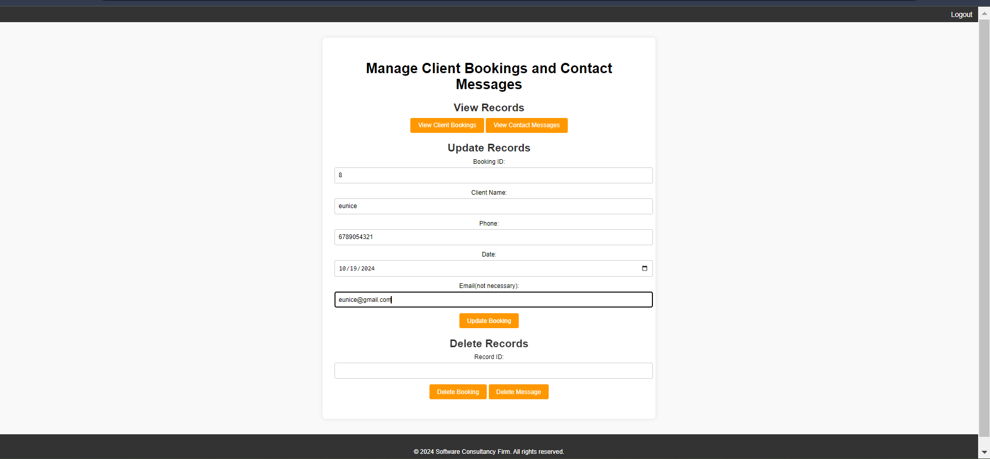

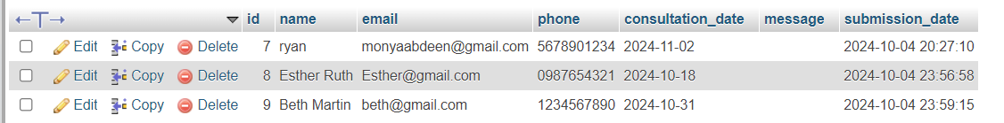

**Before updating**

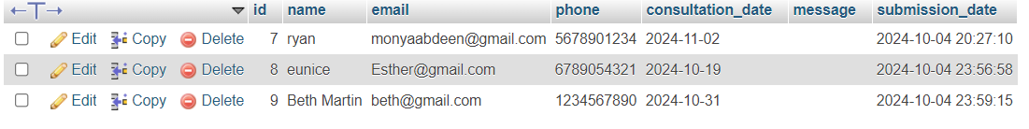

**After updating**

**Explanation:**

The code above allows the team members to update, delete and view data from the database.