**######Which model performed better**

The HOG model performed better than the CNN model which were both created for the task of performing gender classification.

**####And by how much**

HOG model screenshot showing the model accuracy of 98.40003%

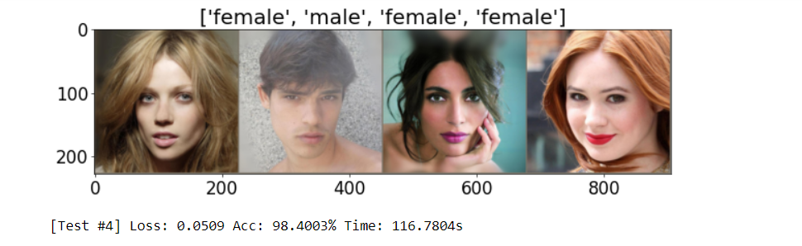

CNN model screenshot showing model accuracy of 96.9141%

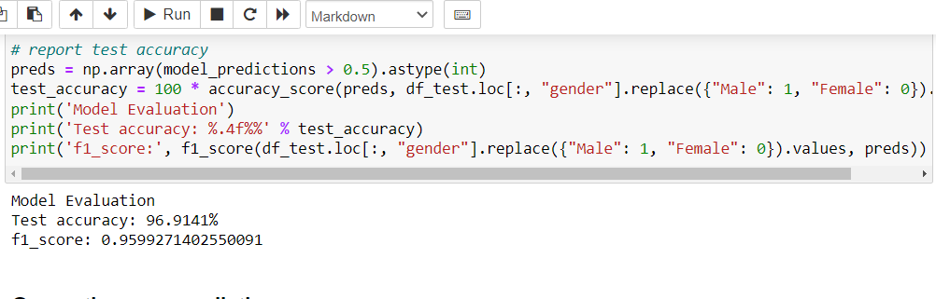

Therefore HOG is the best model for classification of gender when compared with CNN model based on their accuracy.