**EVI-based vegetation phenology and productivity**

For this assignment, I used Sentinel-2 Harmonized imagery accessed through Google Earth Engine (GEE) for two periods: 1 March 2022 – 28 February 2023 and 1 March 2023 – 29 February 2024. I calculated three vegetation indices: NDVI, EVI, and MSAVI. To reduce data gaps, since Sentinel-2 data is collected every 5 days and the tropics are heavily affected by clouds, I applied a 14-day time window to resample and smooth the data. This resulted in 26 composite images for each period.

To better understand the potential seasonality of the region, I plotted the zonal mean for each period separately. The results showed that: 1) both periods had two seasons, although 2022/2023 was less productive than 2023/2024; 2) NDVI identified higher vegetation vigor, followed by EVI and then MSAVI (Figure 1). The observed differences are likely due to how each index calculates vegetation greenness. For example, NDVI is sensitive to soil and atmospheric effects, EVI reduces these effects using the blue band and canopy correction, and MSAVI minimizes soil influence, making it useful for sparse vegetation.

Since the study area includes both croplands and savanna grasslands, I chose EVI as it may better capture phenology across both dense and open vegetation.

*Figure 1: Zonal means of the various vegetation indices within the study area extent.*

Using the resampled and smoothed EVI composites, phenological metrics were extracted for two seasons, initially using a randomly selected pixel (in this case, plot number 106 from the SOC data). In 2022/2023, this location experienced lower productivity during the long rainy season compared to 2023/2024 (Figure 2). While the start of season (SOS) was roughly the same in both periods, the 2022/2023 season ended earlier. For the short rainy season, the overall seasonality at this location was also similar across both periods, although in 2022/2023 the SOS was slightly delayed (Figure 2).

*Figure 2: Phenological metrics for a single sample location. SOS = Strat of the Season and EOS = End of the Season.*

Spatial phenological metrics show variability both within and between the two periods (Figure 3). In some areas, vegetation did not green up during the expected 'long rains' season (April–May) but instead showed a late green-up starting around September or October (Figure 3). This pattern is especially noticeable in the 2022/2023 period, suggesting that rainfall during this season may not have followed the usual pattern, with the long rains failing in many parts of the region. In contrast, the 2023/2024 period shows a more typical seasonal pattern across most areas. During this period, green-up in the long rainy season begins around April and ends around July, while the short rainy season starts around September/October and ends by January. This suggests that 2023/2024 was a relatively normal year compared to 2022/2023.

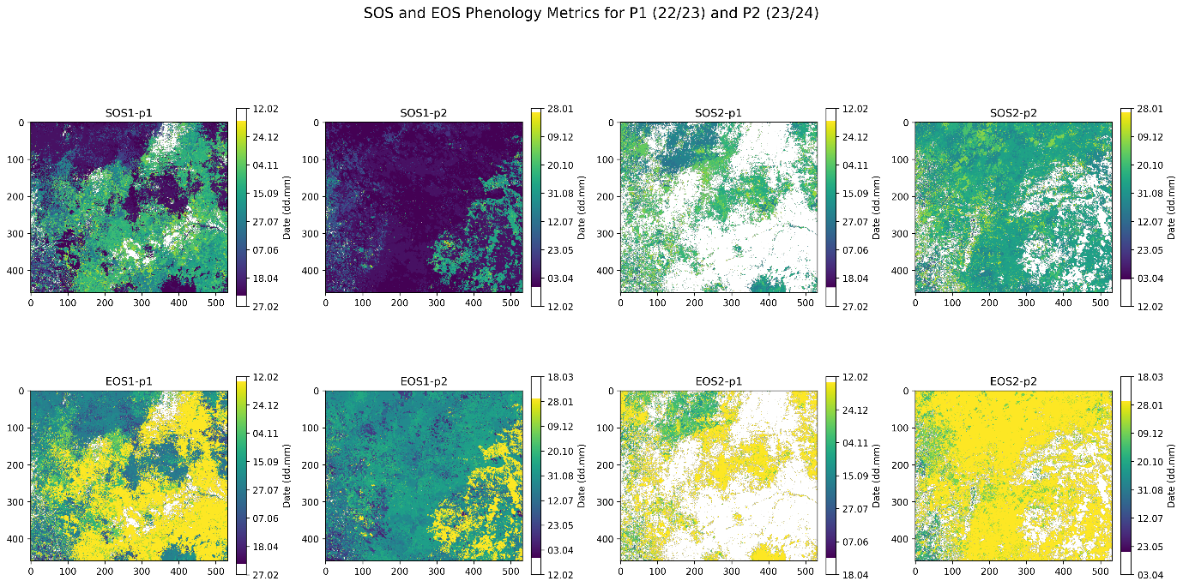

*Figure 3: Phenological metrics for the study extent. P1 is 2022/2023 and P2 is 2023/2024. SOS= Start of the Season and EOS = End of the Season. The scale bar shows day.month.*

For vegetation productivity estimated as the total EVI between the start (SOS) and end (EOS) of each season, results (Figure 4) show a consistent increase in productivity during Period 2 (P2: 2023/2024) compared to Period 1 (P1: 2022/2023). In Season 1, mean productivity rose from 1.76 in P1 to 2.73 in P2, and in Season 2, from 1.92 to 3.04 (Table 1). The difference maps further highlight this trend, with average differences of −1.04 (Season 1) and −1.40 (Season 2), indicating higher productivity in P2 across most of the study area. While a few localized areas had slightly greater productivity in P1, the broader spatial pattern points to more favorable vegetation conditions in P2.

*Table 1: Summary statistics of EVI-based vegetation productivity.*

|  |  |  |  |  |  |
| --- | --- | --- | --- | --- | --- |
|  | Mean | Median | Min | Max | std |
| Season 1 – 22/23 | 1.76 | 1.57 | 0.054 | 10.59 | 0.89 |
| Season 1 – 23/24 | 2.73 | 2.58 | 0.054 | 11.39 | 1.23 |
| Diff – Season 1 | -1.04 | -1.03 | -8.11 | 6.75 | 1.18 |
| Season 2 – 22/23 | 1.92 | 1.76 | 0.06 | 8.84 | 0.86 |
| Season 2 – 22/23 | 3.04 | 3.10 | 0.07 | 8.84 | 1.01 |
| Diff – Season 2 | -1.40 | -1.60 | -6.52 | 5.21 | 1.31 |

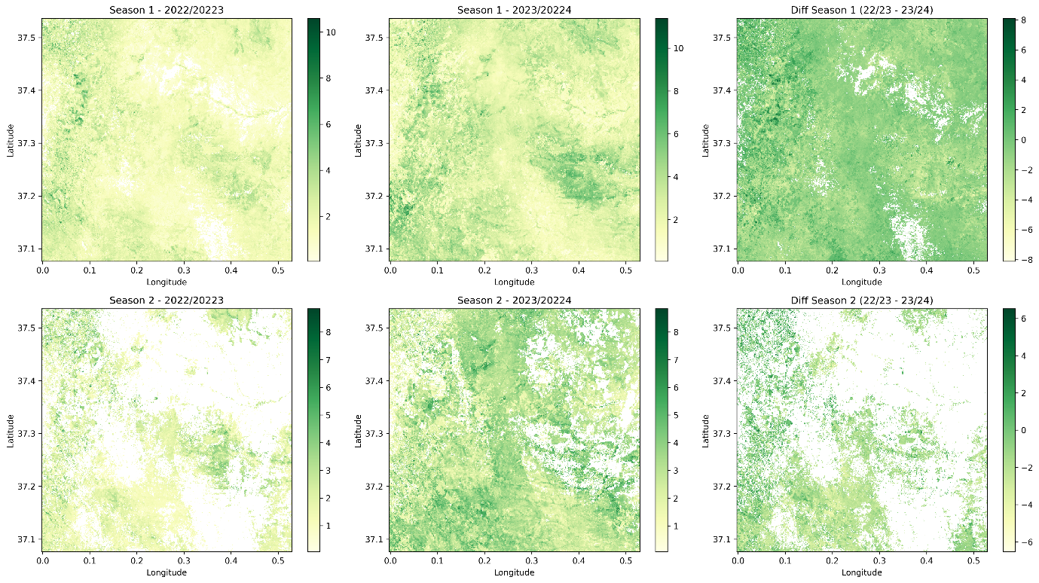

*Figure 4: Vegetation productivity for both periods and the difference between 2022/2023 and 2023/2024 for each season separately.*