System Design Document — AI Data Pipeline RCA Agent

1. Overview
This project is an AI agent that investigates failed runs of a data pipeline and produces a structured, evidence-backed root-cause report. It is built on the Claude Agent SDK and is composed of two repositories:
Repo | Role
produce-error-pipeline | A real, runnable orders ETL pipeline that deliberately produces genuine failures (real tracebacks from real execution) covering several root-cause categories. Acts as the system's data surface and fixture generator.
ai-data-pipeline-rca-agent | The investigating agent itself: reads a failure log, gathers evidence via real tools, and returns a structured root-cause report. Also owns the evaluation loop that scores the agent's history against ground truth.

The agent's job is strictly to investigate and report — it has no Bash, file-editing, or write access to anything. It cannot modify the pipeline, the database, or fix the failure itself. A human (SRE) is the only party that acts on its output.

2. High-Level Architecture
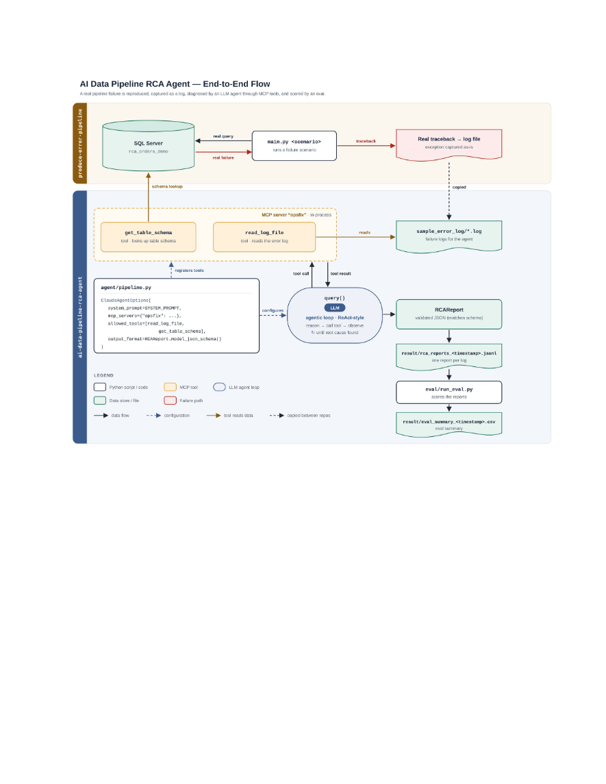

3. Data Surface
The agent's tools query two real, live data sources during an investigation — nothing is pre-fetched or fabricated on its behalf:
- SQL Server (`rca_orders_demo`) — get_table_schema(table_name) queries INFORMATION_SCHEMA.COLUMNS directly, returning the table's real, current column names and types. This is how the agent confirms whether a failure is a schema change (upstream renamed/dropped a column) versus something else (the schema is unremarkable).
- Log files (`sample_error_log/*.log`) — read_log_file(path) reads a pipeline run's full log text, containing the real Python traceback, the stage-by-stage INFO trail (Extract stage started, Columns found: [...], etc.), and a Scenario: <name> line used only for eval ground truth, never as evidence the agent is told to trust.
Both tools are registered as an in-process MCP server (opsfix), built with the Claude Agent SDK's create_sdk_mcp_server() — no external MCP process, no network hop. They are the only two tools in allowed_tools; there is no Bash, Write, or Edit tool available, which makes auto-remediation structurally impossible rather than merely discouraged.

4. Core Flow — Agentic Investigation Loop
The core flow is a single-agent, tool-using, ReAct-style loop, not a RAG pipeline (no embeddings/vector retrieval) and not a multi-agent system (one agent, two tools is right-sized for this scope).
- main.py cheaply pre-classifies every log in sample_error_log/ as SUCCESS or FAILED using deterministic Python (extract_error_sections) — no LLM call for `SUCCESS` runs, so healthy runs cost nothing.
- For each FAILED log, agent/pipeline.py starts a Claude Agent SDK query() session:
- System prompt (agent/prompts.py) defines the agent's role, its two tools, the current category taxonomy, and the evidence-citation rule: every claim must trace to an actual tool call, never an assumption.
- User prompt is deliberately minimal: "Investigate the pipeline run logged at: <path>" — all real behavior lives in the system prompt.
- The model reasons, calls read_log_file and/or get_table_schema as needed, observes each result, and continues until it has enough evidence to answer.
- Structured output is enforced via output_format={"type": "json_schema", "schema": RCAReport.model_json_schema()} — the SDK validates (and internally retries) the final answer against the Pydantic schema. The result lands in ResultMessage.structured_output.
- The validated RCAReport is printed and appended as one line to result/rca_reports_<timestamp>.jsonl.

5. Output Schema (agent/schemas.py)
RCAReport
├── category: FailureCategory (schema_drift | data_quality | infra_timeout | code_bug | other)
├── confidence: float (0-1)
├── needs_more_context: bool # calibration signal, not an afterthought
├── summary: str
├── evidence: list[EvidenceCitation] # source, quote, relevance -- must trace to a real tool call
├── impact: ImpactAnalysis # affected_component, severity, downstream_effects
└── remediation: RemediationSuggestion
├── summary: str
├── steps: list[str] # short, imperative, one action each
└── risk_notes: str

category == OTHER is structurally required to also set needs_more_context = True (enforced by a Pydantic model_validator, not just prompt wording) — OTHER is a permanent, honest catch-all for failures that don't fit any live category, not a dumping ground the model can use to sound confident about the wrong thing.

6. Failure Category Rollout Policy
Categories are added to the live FailureCategory enum one at a time, only once a real fixture and a verified classification exist for it — never all six speculative categories up front. Current state:
Category | Status | Fixture
schema_drift | Live | produce-error-pipeline's schema_drift scenario
data_quality | Live | data_quality + data_quality_malformed scenarios (two distinct real defects)
infra_timeout | Live | timeout scenario (missing join predicate → real query-timeout error)
code_bug | Live | code_bug scenario (real ZeroDivisionError from a wrong assumption, on otherwise-healthy data)
credential_config, resource_exhaustion | Not yet live | Commented out in schemas.py pending a real fixture
other | Permanent catch-all | Not part of the rollout; never commented out

7. Data Surface — Real Failure Generation
produce-error-pipeline produces every failure from genuine execution, never a hand-typed log line. Each scenario is one run() function in src/scenarios/<name>.py, wiring together whichever stages (extract/validate/transform/enrich/report) it needs, registered in a {name: run} dispatch table in main.py — no shared branching logic between scenarios. python main.py with no argument runs every scenario once, each writing its own timestamped log.

8. Results & Evaluation Persistence
- `result/rca_reports_<timestamp>.jsonl` — one JSON object per investigated log, one file per main.py run. JSON Lines was chosen over CSV specifically because evidence and remediation.steps are nested lists that don't flatten cleanly into spreadsheet cells (see Failure Analysis in the repo README for the CSV attempt that was tried and replaced).
- `result/eval_summary_<timestamp>.csv` — one row per eval/run_eval.py run, summarizing accuracy across the accumulated history.
Full evaluation methodology is covered in the companion document, Problem Definition, Data Processing, and Evaluation Criteria.

9. Technology Stack
- Claude Agent SDK (claude_agent_sdk) — the agentic loop, MCP tool registration, structured output enforcement
- Pydantic — RCAReport schema, validation, the OTHER/needs_more_context invariant
- pyodbc + SQL Server (ODBC Driver 17) — the live data surface
- pytest — 15 unit tests covering tools, results persistence, and eval metrics (no LLM calls in the test suite)
- Authentication via a logged-in Claude Code session on the host machine, not a separate ANTHROPIC_API_KEY

10. Known Scope Boundaries
- No auto-remediation. The narrow allowed_tools list makes this a structural guarantee, not just a prompt instruction.
- No UI. Interaction is console-based (python main.py), matching the Claude Agent SDK's own documented dev/test workflow — there is no browser-based dev UI equivalent for this SDK.
- Local SQL Server dependency. get_table_schema queries a real, specific database (rca_orders_demo), so this base version is not portable to "any arbitrary log file" without that database reachable and seeded to match.
- No human-approval gate implemented yet. The design brief calls for a mandatory SRE approval step before any report is finalized; this is currently an application-level extension point (present the parsed RCAReport via CLI before persisting), not yet built.

