**Employee Name: Muthuraj Periyasamy**

**Employee Id:11949**

**Date: 09-02-2024**

**Microproject: Online Courier Services:**

**Git Push The Project:**

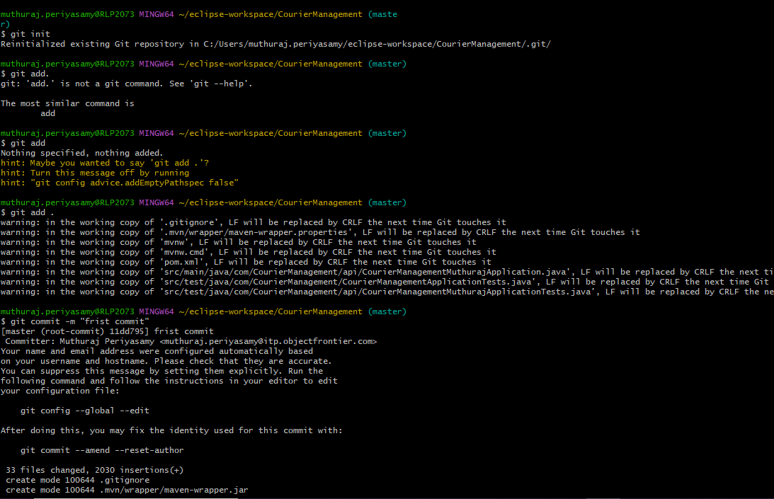

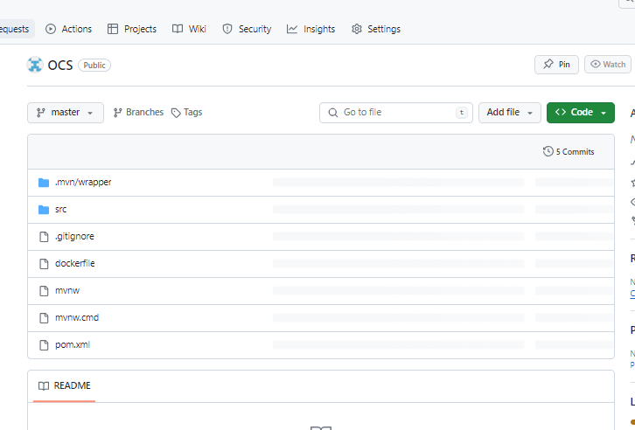

**Docker File add in Git Project:**

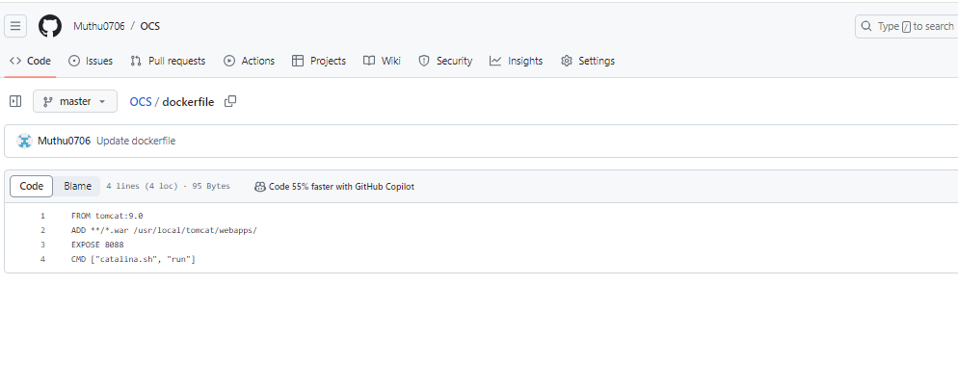

**1.Create the Jenkins Project:**

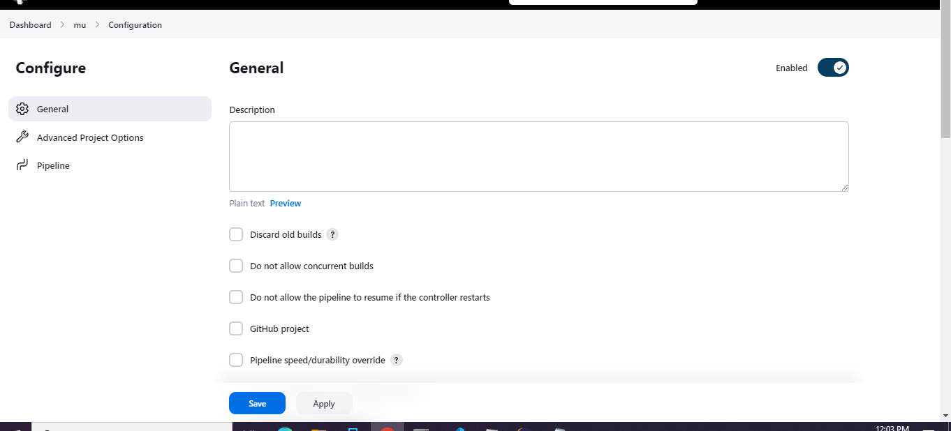

**1.GIT Checkout:**

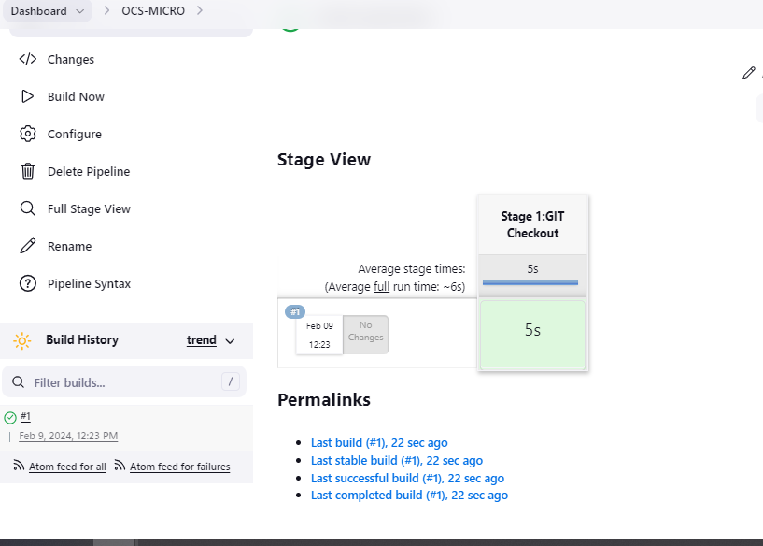

**2.Build The Project:**

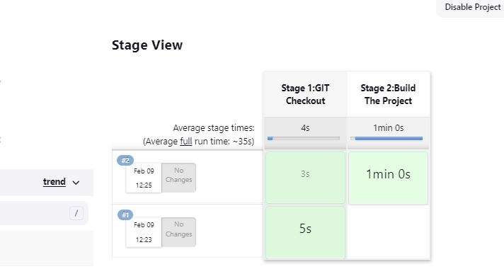

**3.Run the test Cases:**

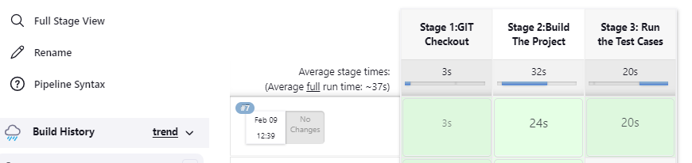

**4.Quality Test:**

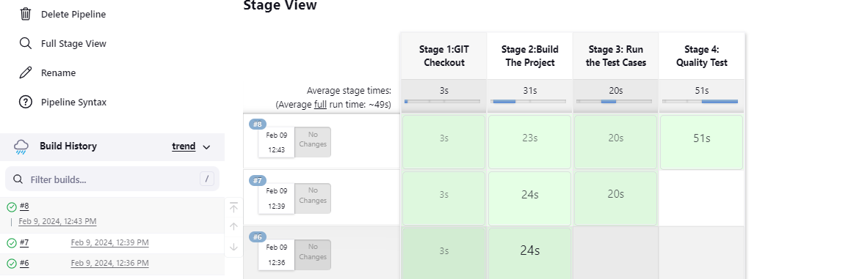

**5.Docker Deploy:**

