Employee Id: 11949

Employee Name: [Muthuraj Periyasamy](mailto:muthuraj.periyasamy@relevantz.com)

1. I request you to jeban:

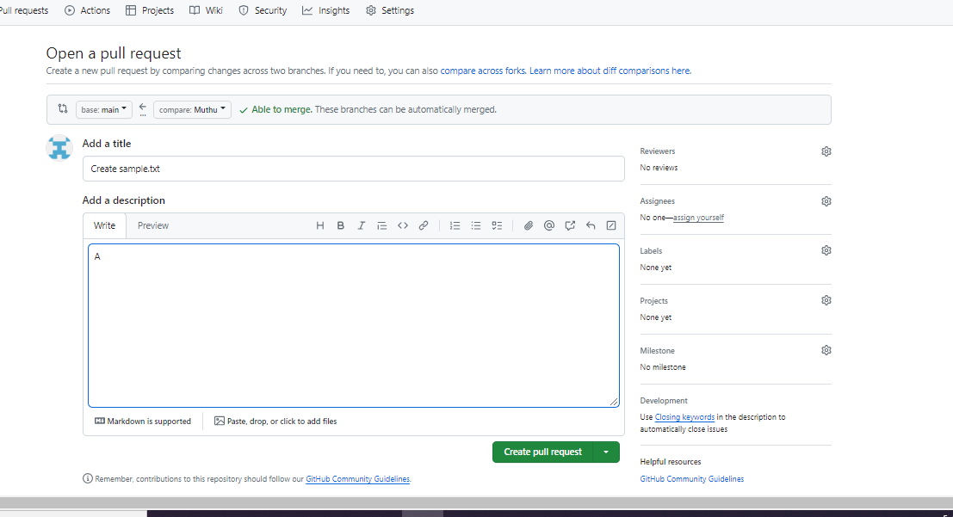

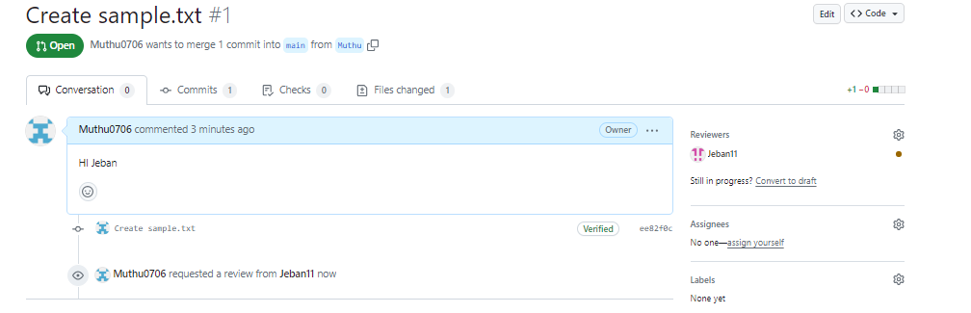

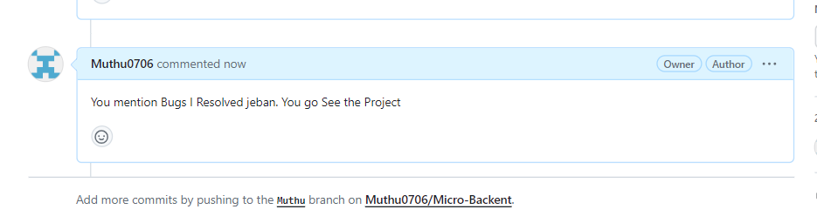

Jeban replied that there were some bugs have in project: Mention it.

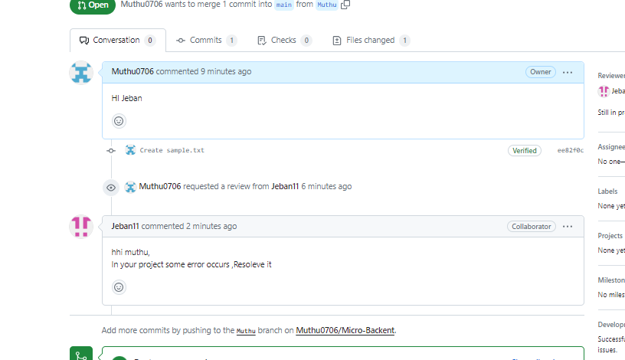

**I clear the Bugs:**

