**Employee Name: Muthuraj Periyasamy**

**Employee ID: 11949**

**Date:9-02-2023**

Microproject-Online Courier Service

1.

**SonarQube Start:**

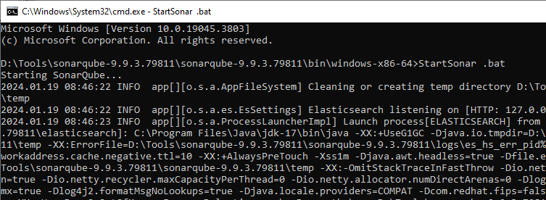

1.Only Create Name- **Microproject**

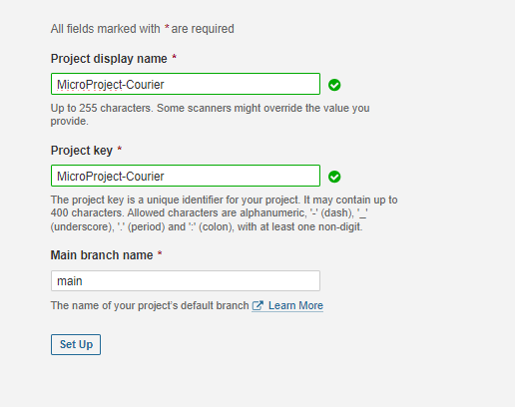

**1.Generate a Project Token:**

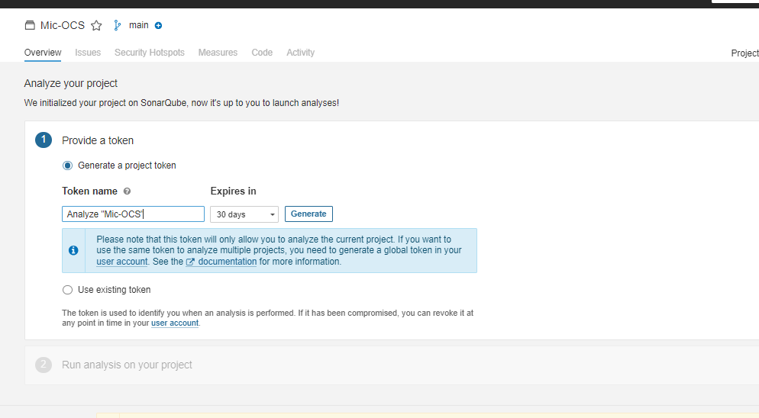

**2.Run analysis on your Project - Maven**

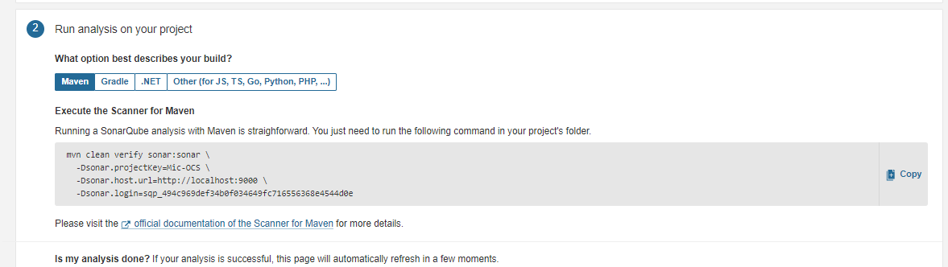

**3.Java Project:**

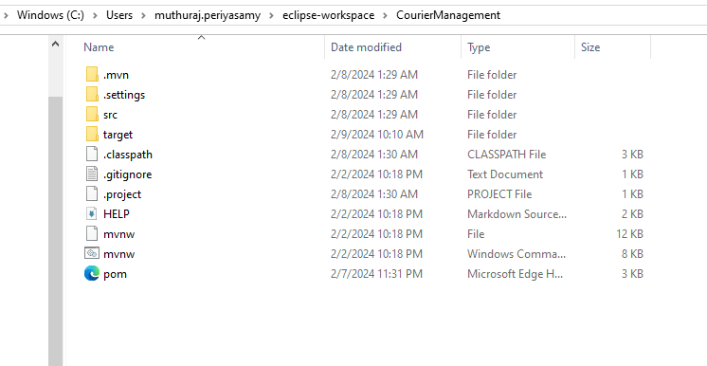.

**4.Plugin the Sonarqube in Project:**

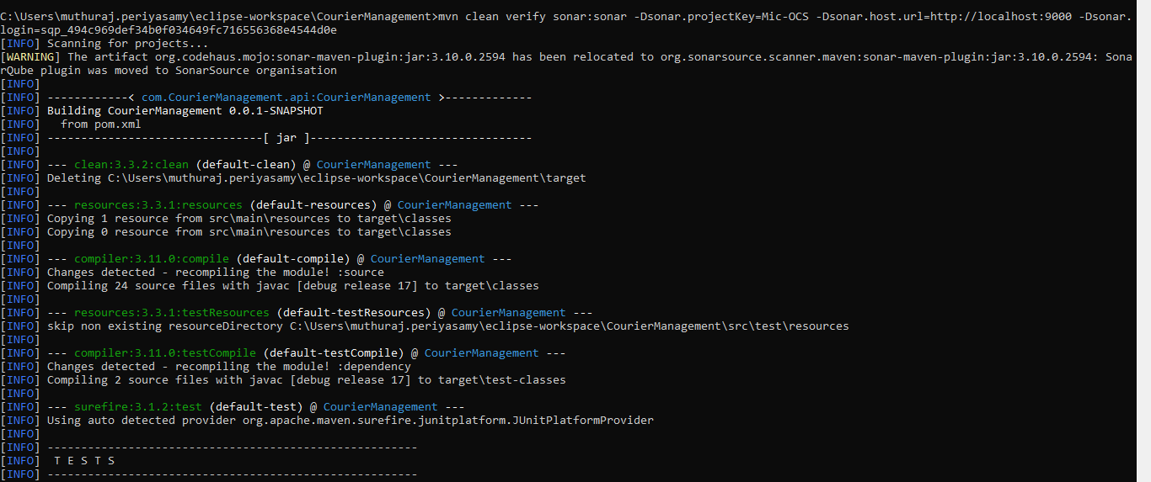

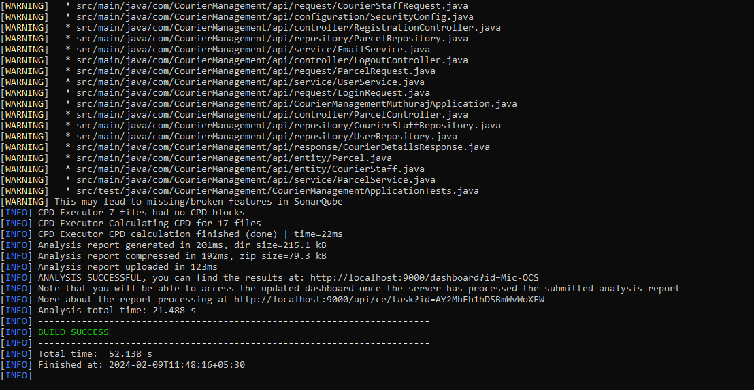

1.There is an BUG here

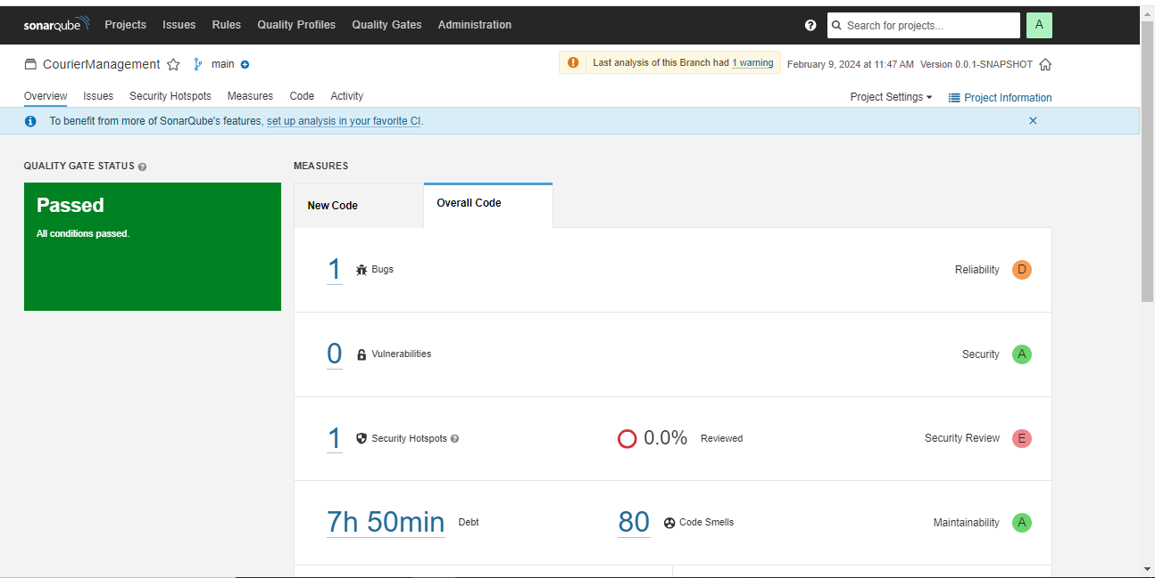

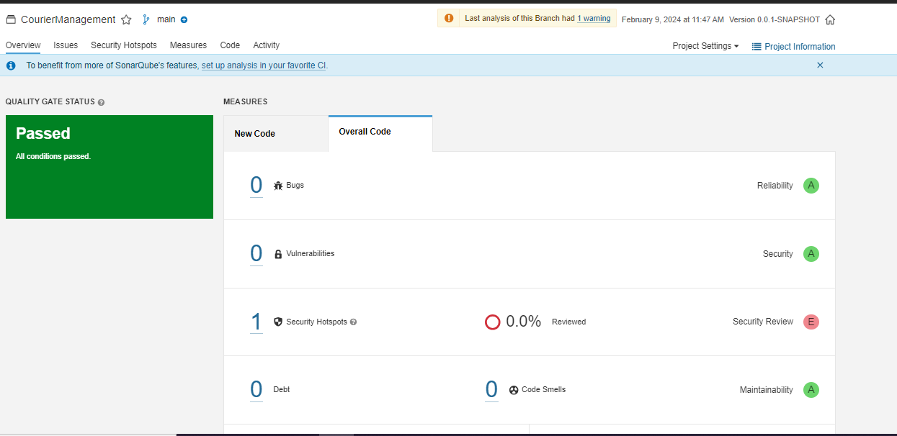

**RESOLVED BUG:**

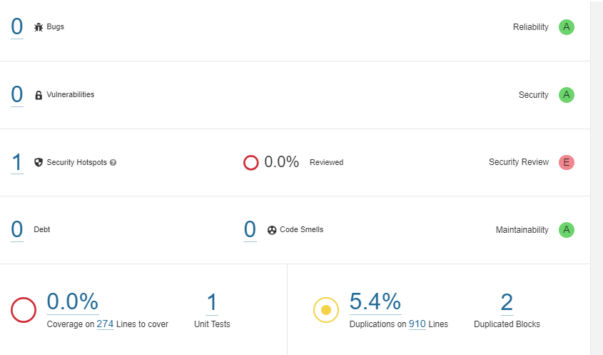

**FINALLY TAKE THE EXPORT OUTPUT:**

**Click The Export: Generate the Report:**

