|  |  |
| --- | --- |
| **Ex. No: 10** | **Route53** |
|  |

**Aim: To perform DNS mapping using Route 53 service in AWS**

**Program:**

- Start the AWS Muthu Pal Instance

- Go to Godaddy

- Create a NS record by rollnumber (21011101079) and the value with one from the AWS route 53 service (.com)

- Comeback to AWS create a record with www. and simple routing policy

- nslookup 21011101079.ngaws.xyz

- links 21011101079.ngaws.xyz

**Output:**

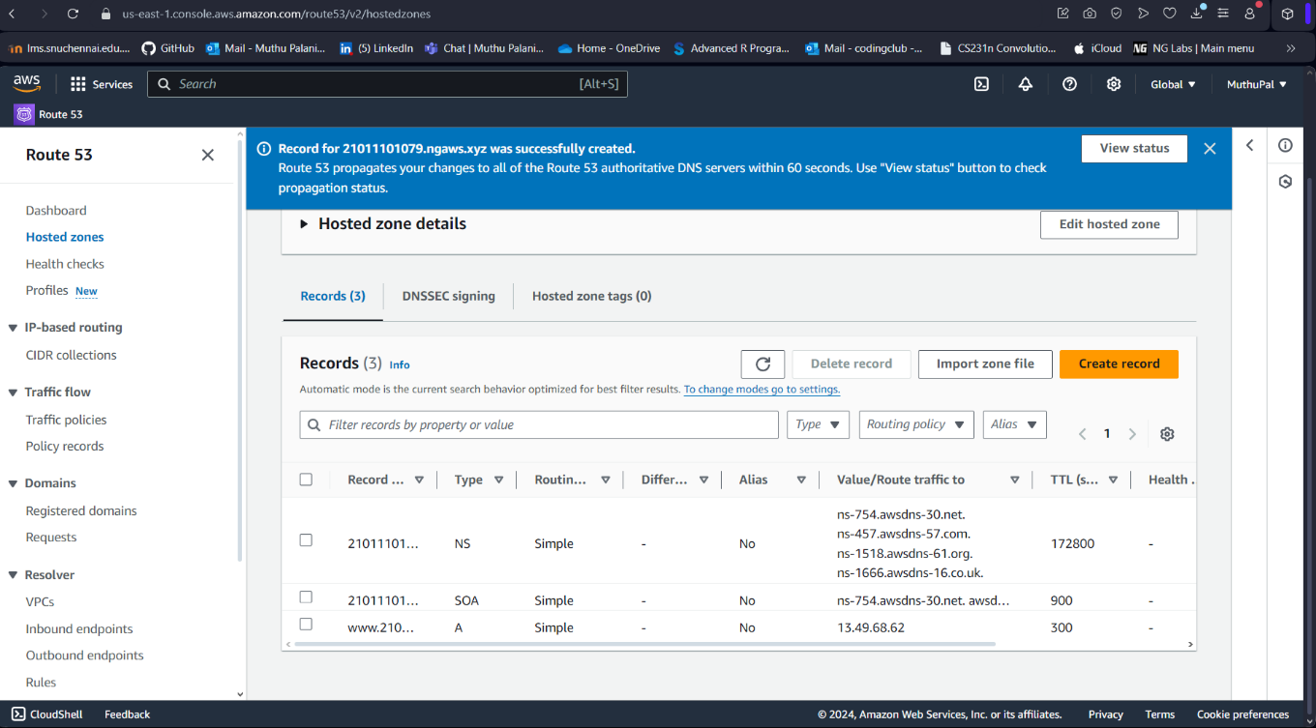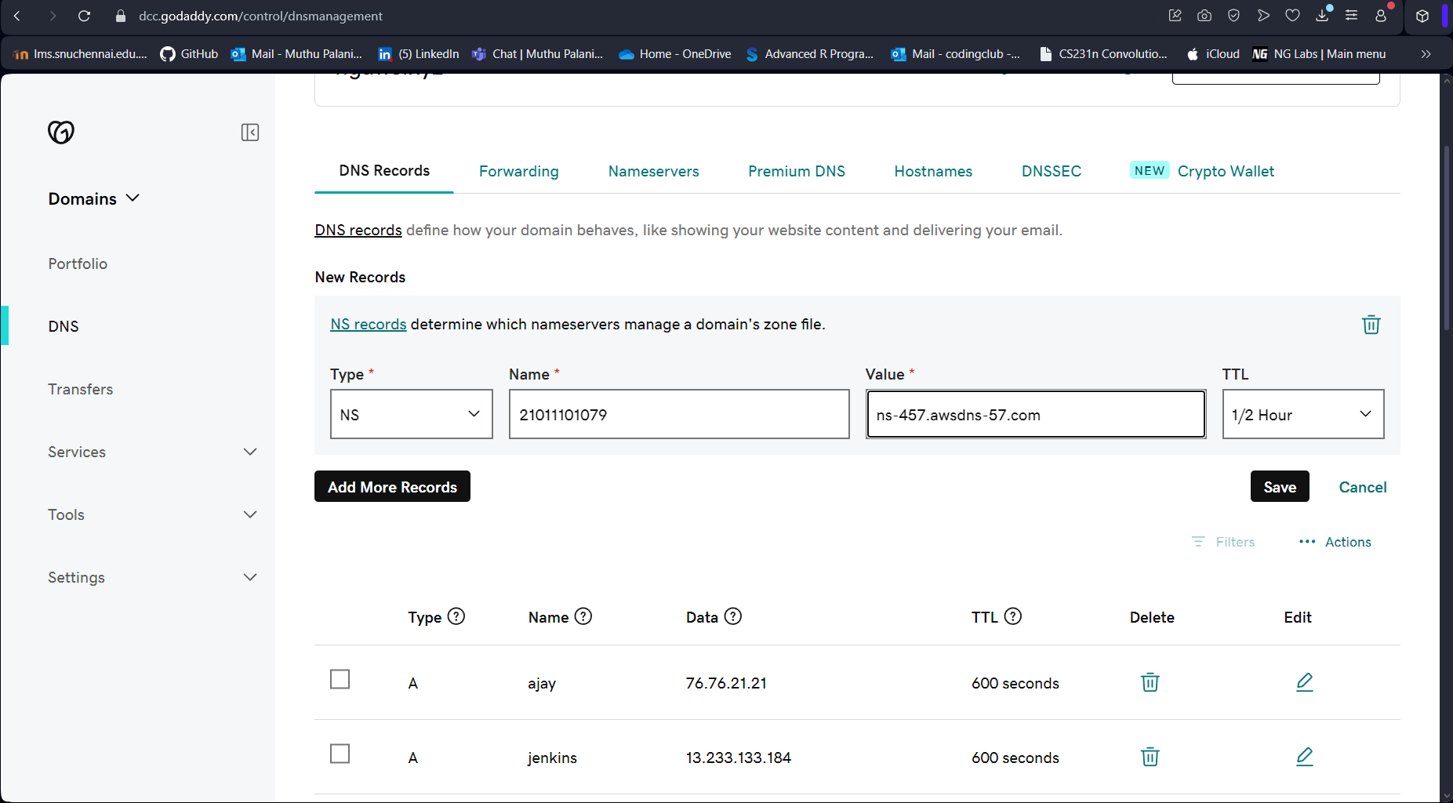

**Result: Thus, using Route 53 service in AWS, we have successfully mapped DNS**