|  |  |
| --- | --- |
| **Ex. No: 4** | **Implementing MapReduce2** |
|  |

**Aim: To understand how map reduce program works using Apriori algorithm**

**Program:**

**Mapper.py**

**import sys**

**from itertools import combinations**

**def generate_combinations(items, k):**

**return combinations(sorted(set(items)), k)**

**k = 3**

**for line in sys.stdin:**

**items = line.strip().split()[1:]**

**item_combinations = generate_combinations(items, k)**

**for itemset in item_combinations:**

**print(f"{','.join(itemset)}\t1")**

**Reducer.py**

**import sys**

**current_itemset = None**

**current_count = 0**

**min_support = 2**

**for line in sys.stdin:**

**itemset, count = line.strip().split("\t")**

**count = int(count)**

**if current_itemset == itemset:**

**current_count += count**

**else:**

**if current_itemset and current_count >= min_support:**

**print(f"{current_itemset}\t{current_count}")**

**current_itemset = itemset**

**current_count = count**

**if current_itemset and current_count >= min_support:**

**print(f"{current_itemset}\t{current_count}")**

**Output:**

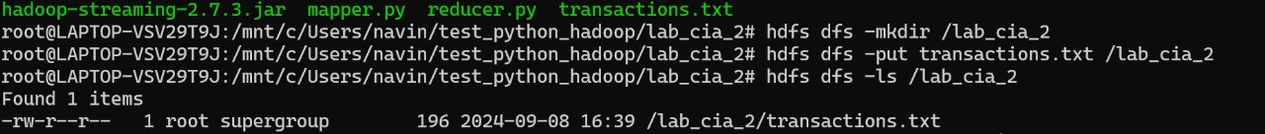

**Result: Thus Apriori implemented using the map reduce program**