**Pandya Kingdom**

The Kingdom of Pandya is one of the oldest, and three most famous Tamil lineages(Muvendar), and has long ruled South India. The rule of the Pandyas is one of the oldest reigns in the world and the wealthies and more civilized one. They ruled Tamil Nadu till the 14th century.

**Origin:**

Information about the Pandyas is very limited in history. According to the information we have, the **first Pandyan king was PudapPandyan**. It is not known exactly what year he ruled, but he lived in the second century AD. Mudukudumi Paruvaludi ruled the Pandya kingdom after PudapPandyan. After these two, Nedunchelian I, one of the greatest kings of Pandya kingdom ruled the country. **Nedunchelian I ruled the Pandya kingdom from 180 to 210 AD**. As proof of this, his name is mentioned in the ‘Silappadhikaram’.

**History:**

The history of the Pandyas is very long. We can classify Pandya’s Kingdom in “Early Pandyas, Medieval Pandyas, Late Pandyas”. According to the information available to us, they ruled from the second century AD to the 15th century AD. They ruled over Ramanathapuram, Tirunelveli, Madurai, north Srilanka and present-day southern Kerala. The Pandyas were dividing Tamil Nadu with the Cholas. The Cholas ruled the northern part of Tamil Nadu and at the same time, the Cheras ruled northern India.

The Pandya kingdom was ruled by several kings. But the most notable king in this history was **Kadungon**. The Pandya kingdom began to disappear after the 3rd century. Then in the 7th century, Kodungon revived the Pandya kingdom. During his reign the Pandya’S kingdom began to expand.

**Early Pandyas:**

The early Pandyas ruled in the third century AD. The history of the early Pandyas is very limited due to the destruction of many ancient Tamil texts but it is mentioned in a few places in the Tamil poets like silapadhigaram, tholkaapiyam, nattriani. Notable among the early Pandyan kings was King Nedunchezhiyan I. The king who ruled for a long time during that period is called Nedunchezhiyan I. According to this, he has been ruled well for a long time. Then Nedunchezhiyan II became king following Nedunchezhiyan I and Neduncheziyan III followed by Nedunchezhiyan II.

* The Roman great emperor Julius received an embassy from a Pandya about 361 AD.
* Chinese historian Yu Huan wrote a note about the Pandyas in his historical account in the 3rd CE.
* Society, the culture of Pandyas is mentioned in the Akananuru and Purananuru poems.

Above the mentions and poems are the proof of Early Pandyas.

**Medival Pandyas:**

This period can also be called the period of the rise of the Pandyas. The period from the 6th CE to 10th CE is called the medieval Pandya. It was during this reign that the kingdom of the Pandyas flourished. Kodungan was the 1st king of Medival Pandyas. He revived the Pandya kingdom from the bottom. Pandya accepted and adopted The Pallava ambitions that developed in South India and from time to time allied themselves with the kingdoms of the Deccan Plateau.

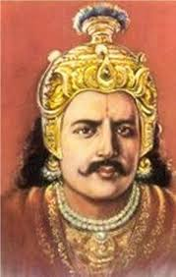

kadungon

In this period The Pandyan kings conquered many places and lost some battles. King Sendan won some Chera’s land, Arikesari Maravarman is known for his battle against Pallava, and Kirtivarman II (r. 744/5–55 CE), the last Chalukya king lost his southern countries to the Pandyas, and the Pallava king Parameshwaran who was famous for the conqueror of Badami defeted to the pandyas . These battles symbolize the prowess of Pandyas. Kings who ruled according to the information we have,

Kadungon - Maravarman Avanisulamani - Cheliyan Sendan (Chendan) - Arikesari Maravarmam - Ko Chadaiyan Ranadhira - Maravarman Rajasimha I - Jatila Parantaka Nedunjadaiyan - Maravarman Srimara Srivallabha - Varaguna-varman II - Parantaka Viranarayana - Maravarman Rajasimha III.

**10th – 13th Centuries:**

This period is considered to be the period of the rise of the Cholas. The Cholas began to invade the Pandya kingdom. The Chola king Vijayalaya emerged from the Kaveri delta and took the chieftains of Thanjavur. This makes the big blow of Pandya’s Kingdom. Then after the arrival of The great Chola Rajaraja I the kingdom of the Pandyas began to shrink. He captured Madurai, the main city of the Pandyas. He also won the Cheras. This is where the fall of the Pandyas began. Pandya kings who were ruled between 10th – 13th centuries

Sundara Pandya I - Vira Pandya I - Vira Pandya II - Amarabhujanga Tivrakopa - Jatavarman Sundara Chola Pandya - Maravarman Vikrama Chola Pandya - Maravarman Parakrama Chola Pandya - Jatavarman Chola Pandya - Srivallabha Manakulachala - Maravarman Srivallabha -Parakrama I - Kulasekara III - Vira Pandya III - Jatavarman Srivallabha - Jatavarman Kulasekara I

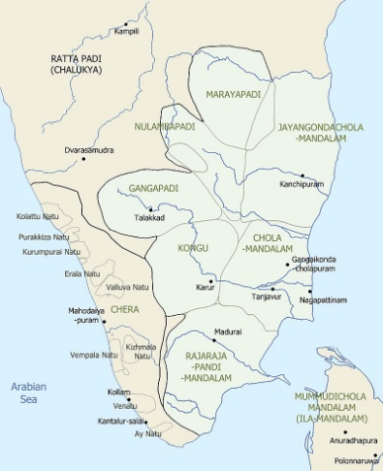

**Late Pandyas:**

It was during this period(13th – 14th century) that the Pandyas ruled the vast territory including large portions of Srilanka. But the dominance of the Cholas was greater. But Maravarman Sundara I recaptured Thanjavur and invaded the Chola country and won the Uraiyur from Kulathuga III.

After Maravarma Kulasekara I his sons Vira Pandya IV and Sundara Pandya IV started the civil war for the kingdom. Hoysala king Ballala III was taking this as an advantage and invaded into the Pandya’s territory. But he could not conquer the Pandya kingdom so he abandoned that idea. After that Vira Pandya IV won the Sundara Pandya IV. These two were the last two great kings of Pandya’s Kingdom. The Pandyas who were ruled in 13th – 14th century.

Maravarman Sundara I - Sundaravarman Kulasekara II - Maravarman Sundara II - Jatavarman Sundara I - Maravarman Kulasekara I - Sundara Pandya IV - Vira Pandya IV.

**End of Pandyas:**

After the Civil War, Proscan in 1314 and Mohammed in 1323 fought the Pandyan Empire. The Pandya Empire came to an end due to family maneuver and Sultanates wars. After this, the Pandyas could not rise. The centuries-old rule of the prosperous, honest, proud, and heroic Pandyas came to an end in the 14th century.

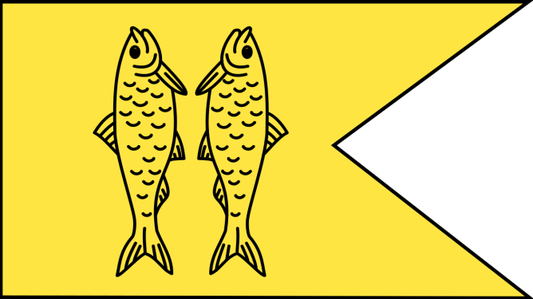

**Pandya’s Flag**

* The Pandya’s Flag - Fish flag
* The Pandya’s Capital – Madurai (The former capital was Korkai and later made Madurai the capital to facilitate the rule).
* The Pandyas traded by ocean to Greece, China, Rome, Malasiya and the Maldives.
* Capital Madurai and Korkai were the great ceters of trade.
* Pandya’s traded the one of the finest Pearl along South India.

**Culture:**

The Pandya’s culture and people’s social life were very wealthy, prosperous, and civilized. During the reign of the Pandya king, the society was divided into four major sections namely Brahmins, Kshatriyas, Vaisyas and Sudras. Although the society was divided into four sections, the people lived in unity. People wore clothes made of silk and the rich wore silk garments. Women were greatly respected and also rich women were got an opportunity to educated.

**Language and Literature:**

The role of the Pandyan kings in the development of the Tamil language was great. Their Captial Madurai is shown as Tamil and Tamilnadu’s oldest history. Many poets have written many songs during their time. Great poets like Nammazhvar Periyarvar Andal Gumbar wrote songs in their time. They had even composed about the Lord Vishnu. Sanskrit and Tamil languages were taught.

**Education:**

Pandya’s had great teachers and poets. They had so much interest in the growth of education. They donated lands for education. Educational monasteries were established at Cheranmakhadevi, Tirunelveli, Alagarkoil, and Vanamamalai. The place where higher education was taught was called Salais. Grammar, Law, Politics, Literature was taught in Salais and monasteries.

**Art and Archietecture:**

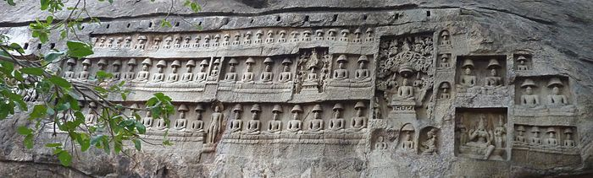

**Kalugumalai Jain Beds**

The Pandyas were considered to be the best in the arts and the temples they built are still examples of this. The finest of their arts are rock-cut, temple walls, murals, temple statues, temple towers, sculptures. **Kalugumalai Jain Beds** is the masterpiece of them. Meenakshi Temple was built by Kulasekara Pandya. This is one of the biggest temples in Tamilnadu. Vattuvan kovil, Kalugasalamoorthy Temple, Sittanavasal Cave, Srivilliputhur Andal temple, Ranganathaswamy Temple, and Tirunelveli’s Nellaiyappar temple are an example of Pandya’s art and architecutre.