**CRON**

**WHAT IS CRON COMMAND?**

* The cron tool allows Linux users to execute commands or scripts at a specific date and time.
* It is very useful to perform regular tasks such as regular backups, daily scans, /tmp directory cleanup, and restarting the system at a given time.
* cron executes scheduled jobs automatically in the backend at a specific time.
* Each user can have their own ctrontab, and this can be found it in “/var/spool”.
* cron jobs can be allowed or disallowed for any users by adding a user in the “cron.allow” and “cron.deny” file.

**Package install:**

* yum install crontabs

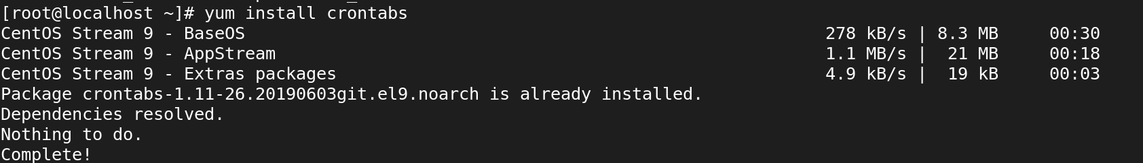

**Edit Crontab Entries:**

* crontab -e

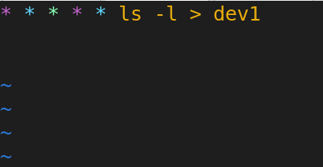

**5 Star Represents:**

* Minute — (0–59)
* Hour — (0–23)
* Day of the month — (1–31)
* Month — (1–12)
* Day of the week — (0–7) (Sunday is represented by both 0 and 7)

**To Watch live output:**

* watch ‘cat dev1’

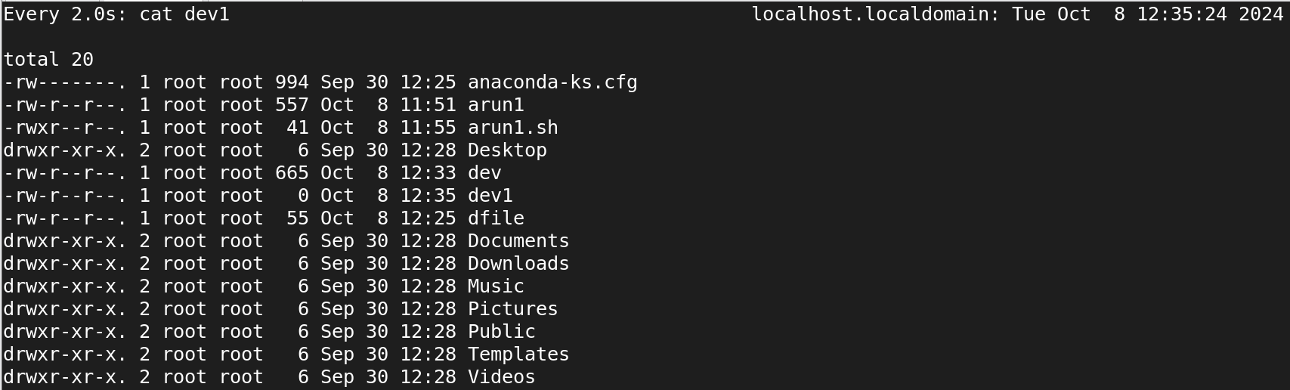

**APPENDING OUTPUT TO A FILE:**

* crontab -e

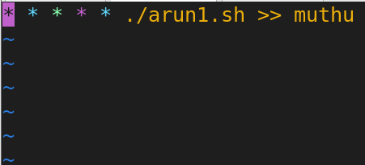

**Script file:**

* vi arun1.sh

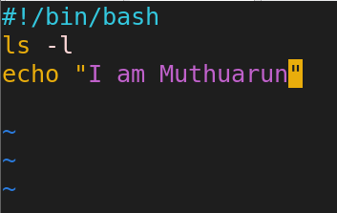

**To Watch live output:**

* watch ‘cat muthu’

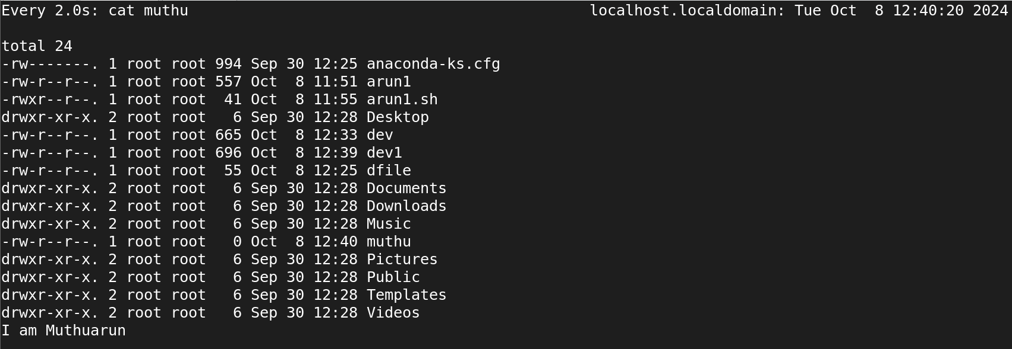

**List Existing Cron Jobs:**

* crontab -l

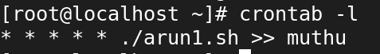

**To remove cron Jobs:**

* crontab -r

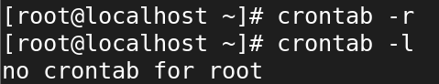

**EDIT CRONTAB FOR A DIFFERENT USER:**

* crontab -u username -e

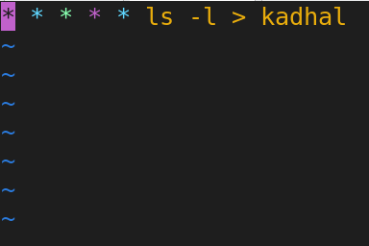

**List Existing Cron Jobs specific user:**

* crontab -u username -l

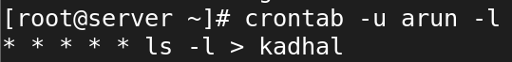

* watch ‘cat kadhal’



* crontab -u username -r

