**DNS – DOMAIN NAME SYSTEM**

**What is DNS?**

The Domain Name System ([DNS](https://www.cloudflare.com/learning/dns/what-is-dns/)) is the phonebook of the Internet. When users type [domain names](https://www.cloudflare.com/learning/dns/glossary/what-is-a-domain-name/) such as ‘google.com’ or ‘nytimes.com’ into web browsers, DNS is responsible for finding the correct [IP address](https://www.cloudflare.com/learning/dns/glossary/what-is-my-ip-address/) for those site.

**Setting up DNS server:**

* **Step-1:** Installing the DNS Server Packages**:**
* yum install bind

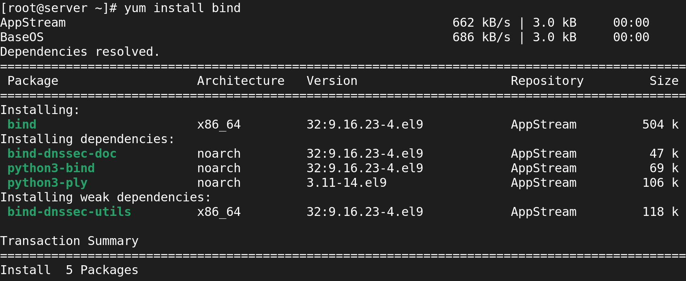

* **Step2:** Modify named.conf file
* vi /etc/named.conf
* delete from logging to root.key (unwanted things)

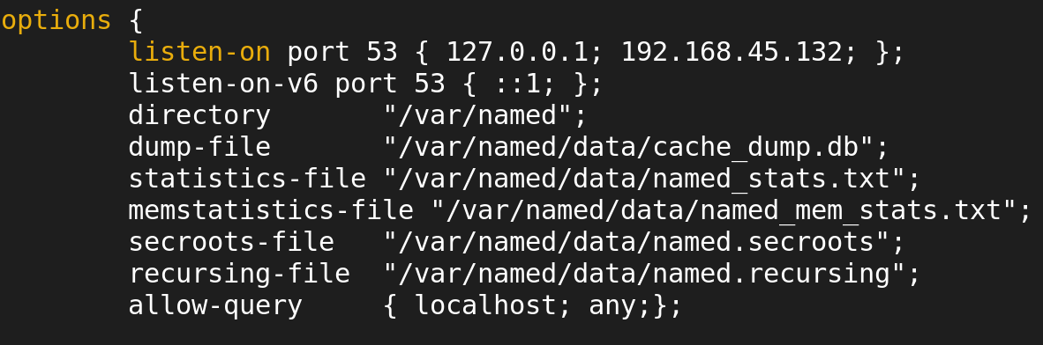

* Set the DNS Server IP Address 192.168.45.132 and allow-query any;.
* **Step3:** Append /etc/named.rfc1912.zone with /etc/named.conf



* **Step4:** Modify /etc/named.conf
* vi /etc/named.conf

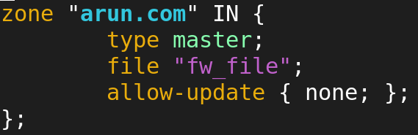

* **Step5:** goto **“/var/named”** and create **“fw_file”** file:
* cd /var/named

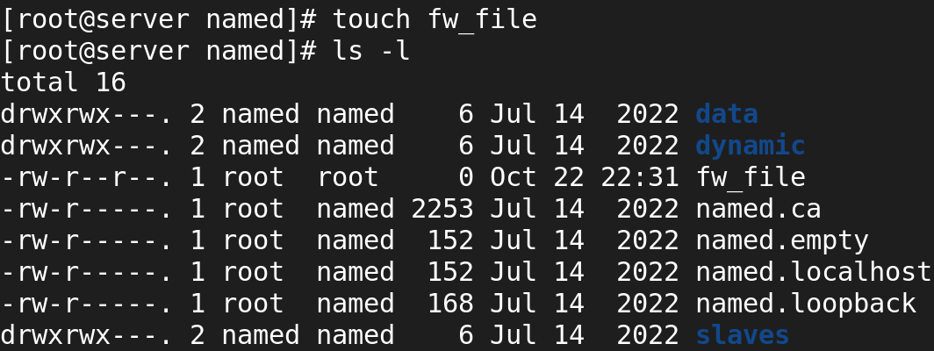

* cp named.localhost fw_file



* **Step6:** Change the ownership of fw_file file to “named”

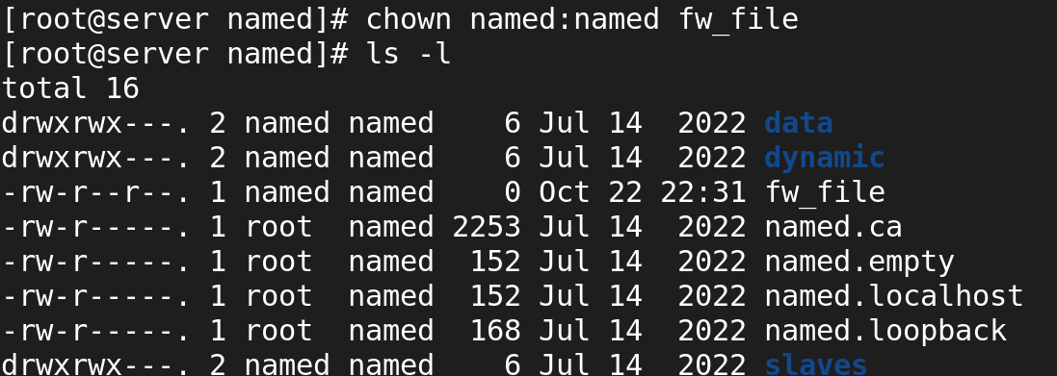

* **Step7:** Modify fw_file file
* vi fw_file

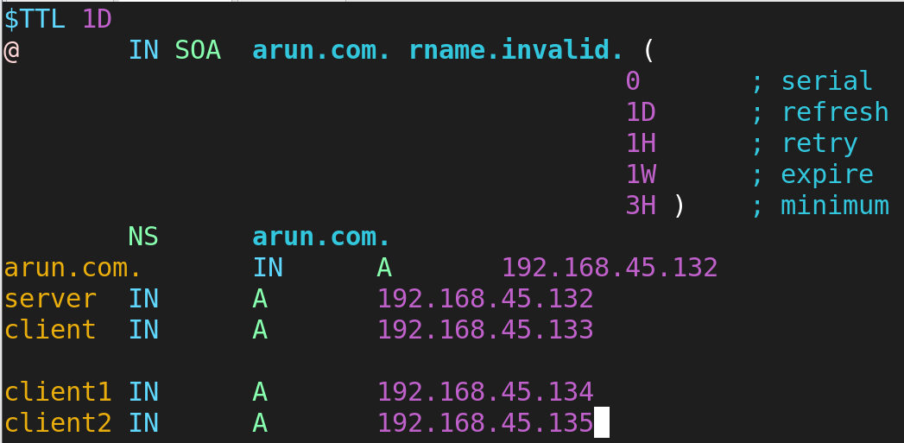

* **Step8:** Update /etc/resolv.conf file
* vi /etc/resolv.conf

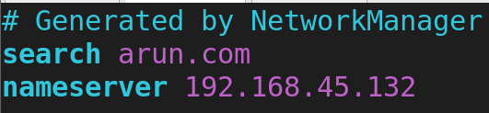

* **Step9:** restart named service
  + - * systemctl restart named
      * systemctl enable named

### ****In Client Side:****

### ****Step1:** Update /etc/resolv.conf file**

### **vi /etc/resolv.conf**

### 

### ****Step2:** Validation:**

### **host arun.com**

### 