**FTP – FILE TRANSFER PROTOCOL**

**What is FTP?**

* **FTP (File Transfer Protocol)** is a standard network protocol used for the transfer of files from one host to another over a TCP-based network, such as the Internet.
* FTP works by opening two connections that link the computers trying to communicate with each other.
* Port:
* 21 – FTP
* 20 – FTP Data

**SERVER SIDE:**

* **Install the packages:**
* Yum install vsftpd

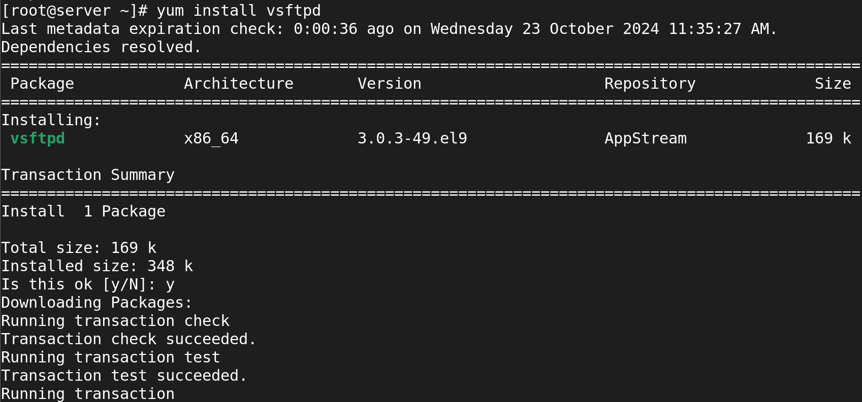

* **Edit the Configuration File:**
* vi /etc/vsftpd/vsftpd.service



* Next step we should go to /var/ftp/car in that dir we should put some file like /etc/*.config

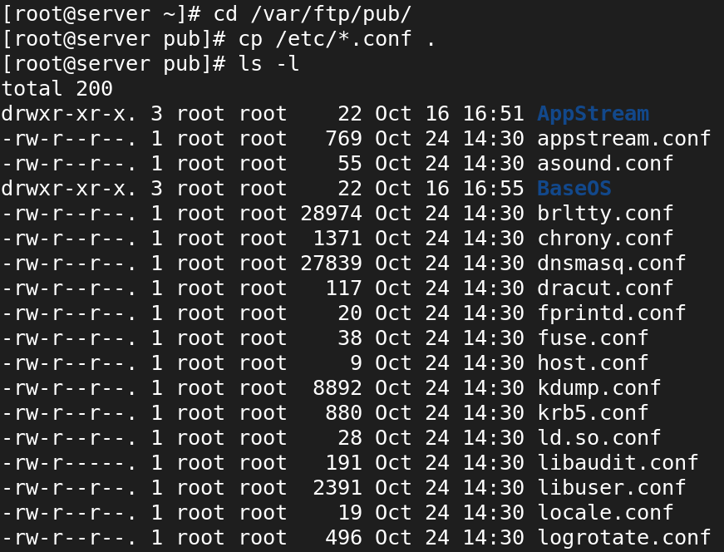

* **Enable and start the service:**
* systemctl enable vsftpd.service && systemctl start vsftpd.service

**CLIENT SIDE**: