**LOGS**

**What are Logs?**

* Linux maintains various log files to help administrators track system activities and troubleshoot issues.

1. /var/log/messages:

* This is the primary log file that records a wide range of system events, including boot messages, service startup and shutdown, and general system errors.

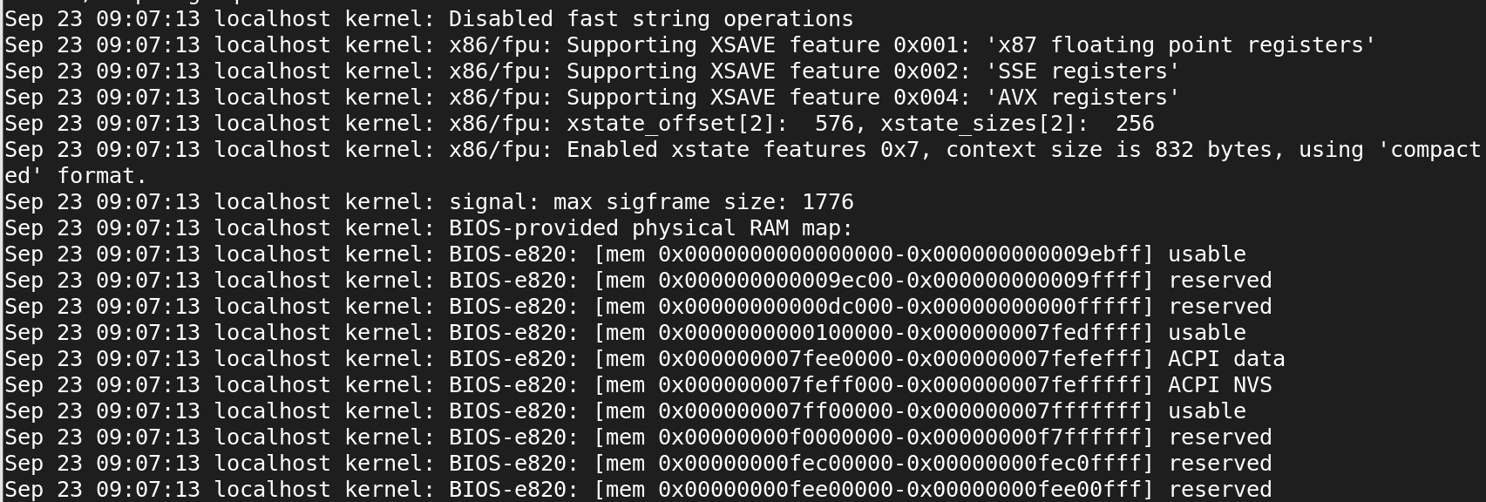

1. /var/log/secure:

* This log file keeps track of security-related events, such as authentication attempts (successful and failed), sudo usage, and other security-related messages.
* Newly created user to check in secure.log



* Password is changed, and check in secure.log



* Switch root user to dev user, and check in secure.log



1. /var/log/cron

* Logs generated by the cron daemon, which schedules and executes periodic tasks, are recorded here.

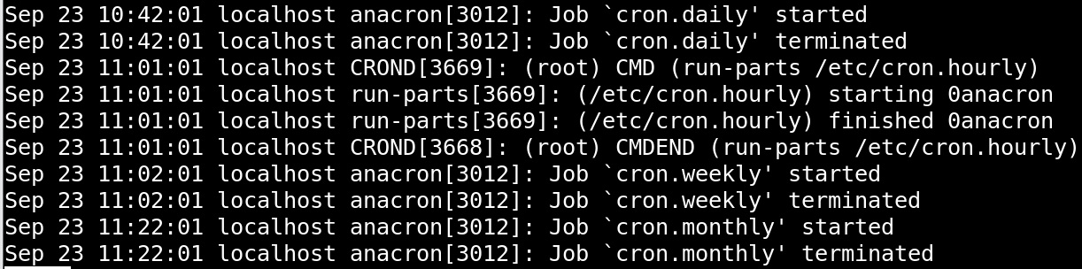

1. /var/log/dmesg

* Contains kernel ring buffer messages, which are low-level system messages useful for diagnosing hardware and driver issues.

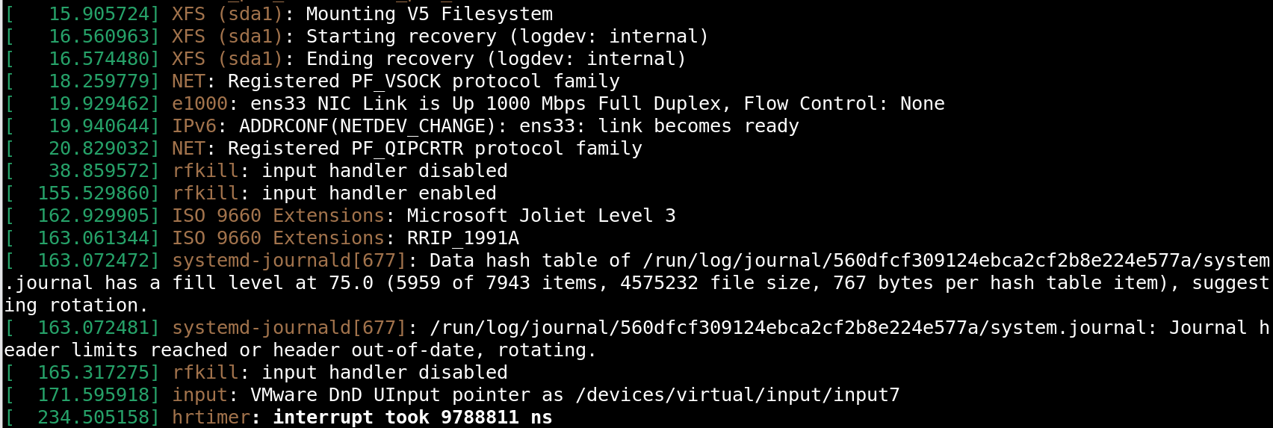

1. /var/log/boot.log

* Captures messages related to system boot processes, including the startup of various services.

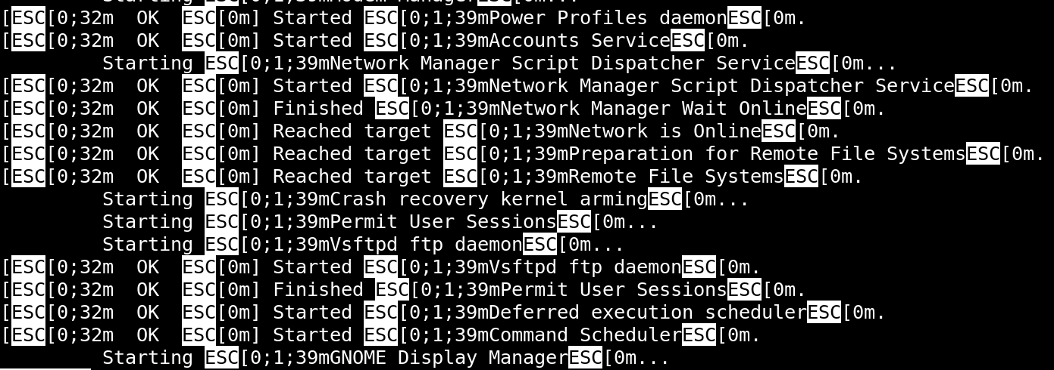

1. /var/log/dnf.log

* Tracks package installation, updates, and removal activities performed using the YUM package manager.

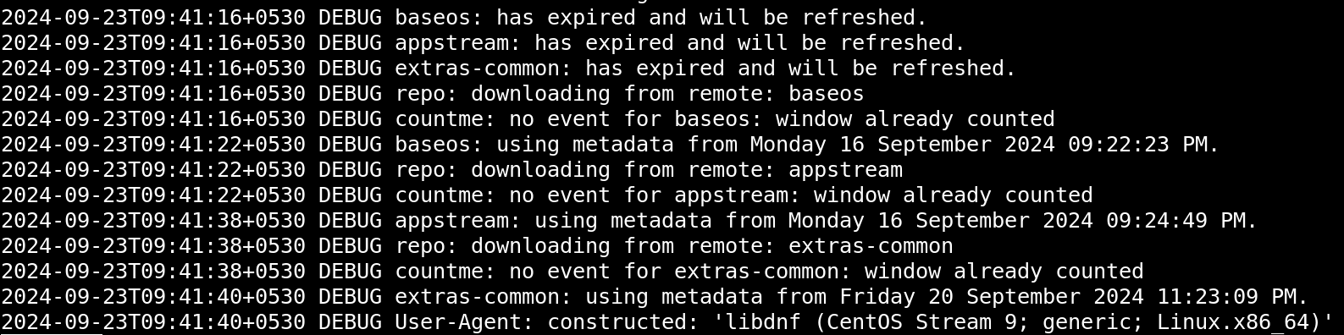

1. /var/log/lastlog

* Records the last login time of each user. It is not a regular text file but can be viewed using the lastlog command.

