### NFS - NETWORK FILE SYSTEM

**What is NFS?**

* Network file sharing (NFS) is a protocol used for sharing files and directories between computers on a network.
* NFS is useful when there is a need to quickly share a large number of files across many devices.
* **Port:**
* **2049**

**Setting up NFS server:**

* **Step-1:** Installing the NFS Server Packages**:**
* yum install nfs-utils

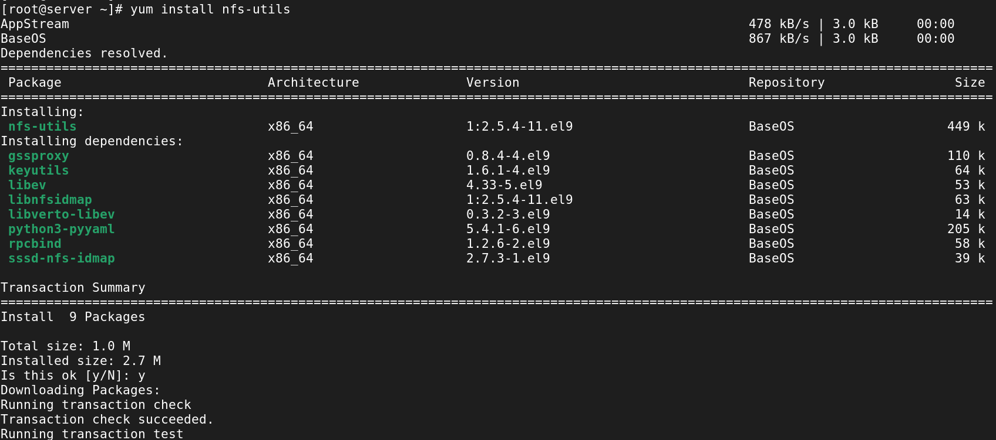

* **Step-2:** Create a directory to be exported**:**
* mkdir /arun

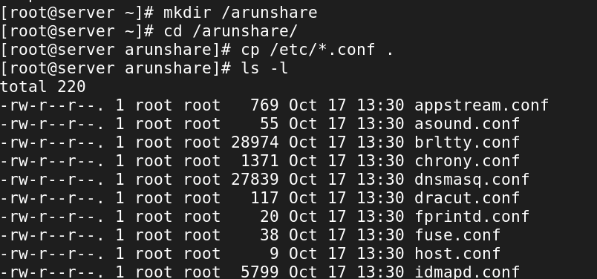

* **Step3:** Configuration file to export the directory**:**
* vi /etc/exports

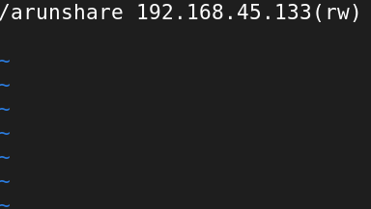

* **Step4:** Start and enable the NFS services**:**
* systemctl enable –now nfs-server.service

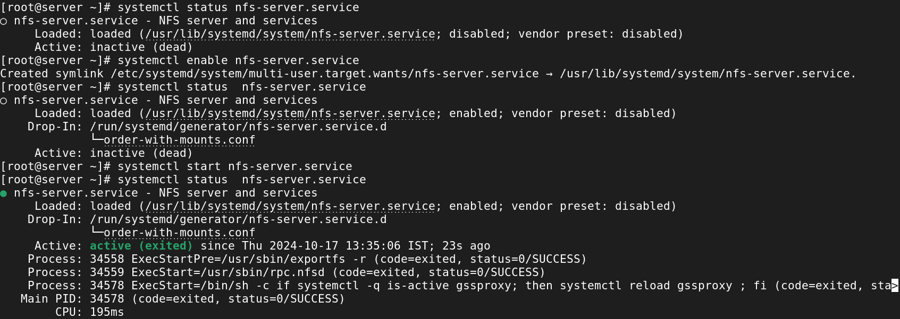

**Configuring NFS Client:**

* **Step-1:** Installing the NFS Server Packages**:**
* yum install nfs-utils

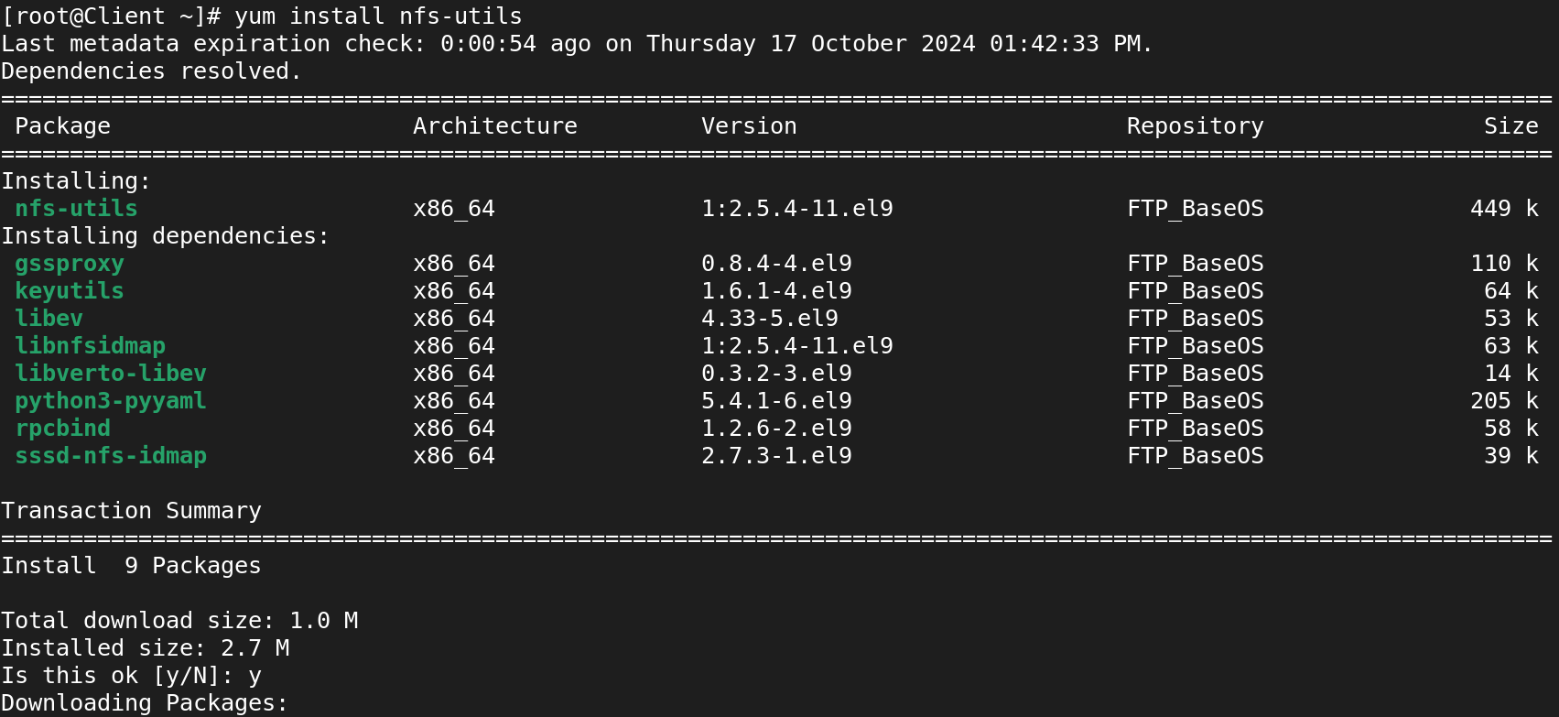

* **Step-2:** Create a directory to mount the NFS share:
* mkdir /serverfile



* **Step-3:** Create a directory to mount the NFS share:
* mount 192.168.45.132:/arunshare /serverfile/



* **Step-4:** Verify that the NFS share is mounted:
* df -h

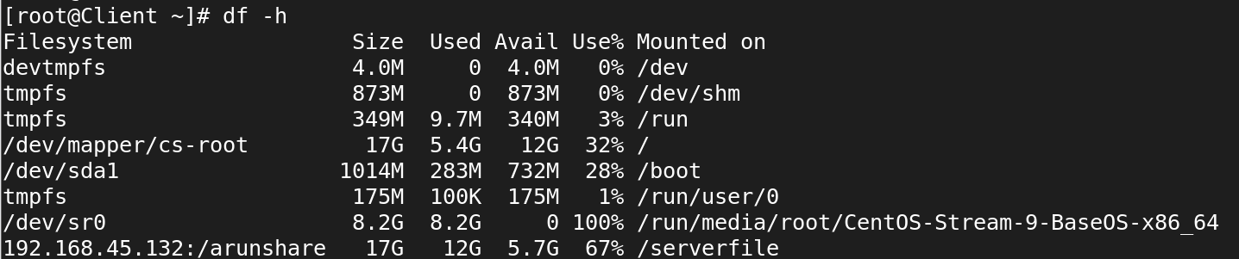

* **Step-5:** For Permanent Mount the NFS Share:
* vi /etc/fstab



**AUTOMOUNT:**

* Automount in uses the autofs service to automatically mount filesystems when they are accessed and unmount them after a period of inactivity.

### ****Lab Exercise 1: Basic Automount of an NFS Share****

### ****In Client Side:****

### Step-1: Install the Packages for auto mount:

### yum install autofs

### 

### Step-2: Create a Directory:

### mkdir /arun

### 

### Step-3: Edit the Config file and add:

### vi /etc/auto.master

### 

### Step-4: Edit the /etc/auto.misc:

### vi /etc/auto.misc

### 

* **Step-5:** Restart **autofs** Service:
* systemctl restart autofs



* **Step-6:** Access the directory to see if it auto mounts:

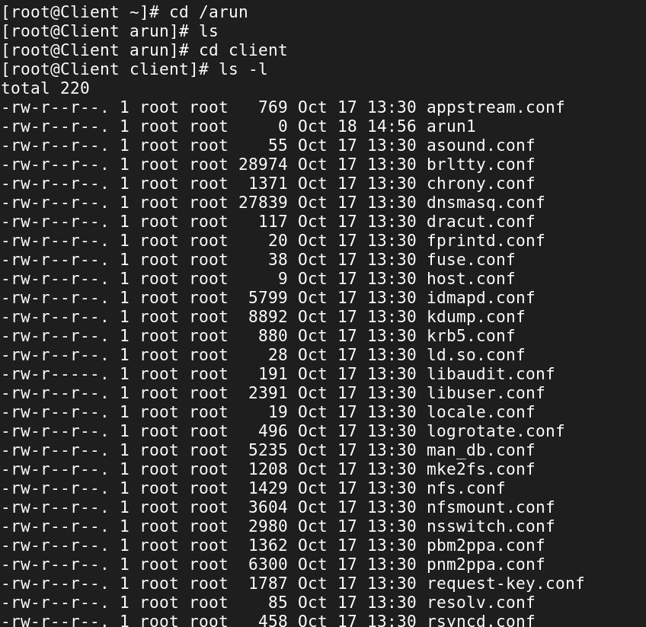

* **Step-7:** Verify that the NFS share is auto mounted:
* df -h

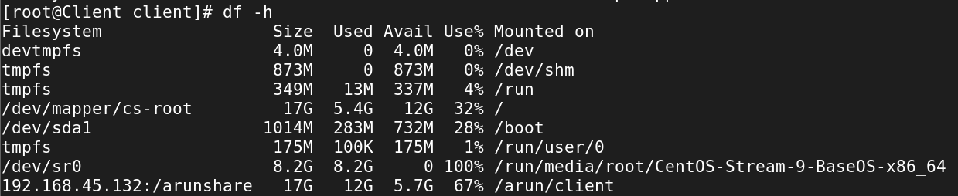

**Lab Exercise 3: Set an Automount Timeout**

### Step-1: Install the Packages for auto mount:

### yum install autofs

### 

### Step-2: Create a Directory:

### mkdir /arun

### 

### Step-3: Edit the Config file and add:

### vi /etc/auto.master

### 

### Step-4: Edit the /etc/auto.misc:

### vi /etc/auto.misc

### 

* **Step-5:** Restart **autofs** Service:
* systemctl restart autofs



* **Step-6:** Access the directory to see if it auto mounts:



* **Step-7:** Verify that the NFS share is auto mounted:
* df -h



* **Step-8:** After the Timeout 30 seconds check the mount status:

