**SWAP**

**What is SWAP?**

* Swap is a space on a disk that is used when the amount of physical RAM memory is full.
* When a Linux system runs out of RAM, inactive pages are moved from the RAM to the swap space.
* Swap space can take the form of either a dedicated swap partition or a swap file.
* In most cases when running CentOS on a virtual machine a swap partition is not present so the only option is to create a swap file.

**Commands to create partition:**

* fdisk /dev/sdb

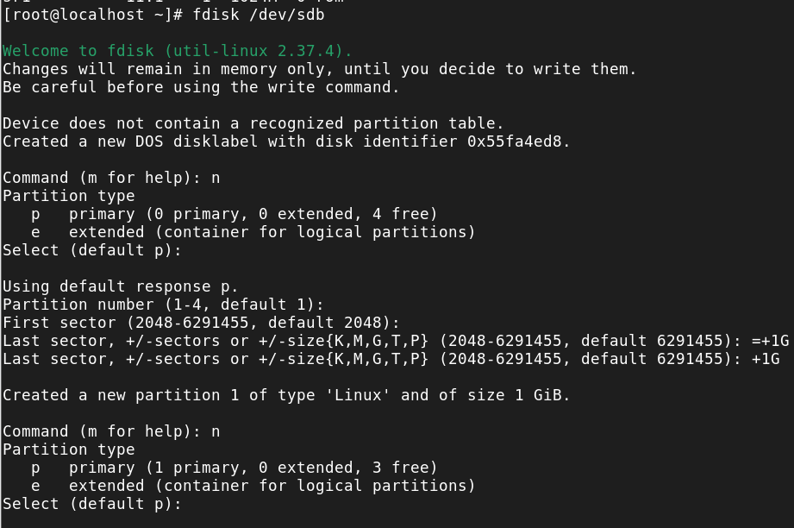

**To check partition is created or not:**

* lsblk

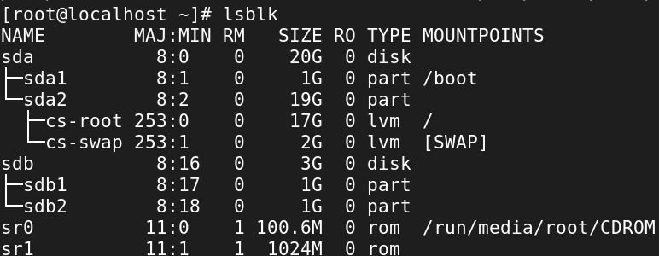

**Make SWAP:**

* mkswap /dev/sdb1



**On the SWAP:**

* swapon /dev/sdb1

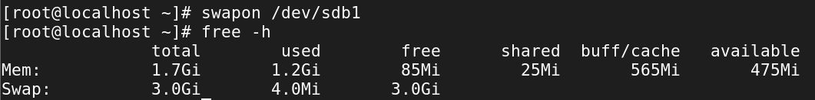

**Creating a Swap File:**

1. fallocate -l 4G /swapfile



1. For Swapping the file we should change 644 to 600 Permission:

* chmod 600 /swapfile



1. Make SWAP:

* mkswap /swapfile



1. On the SWAP:

* swapon /swapfile

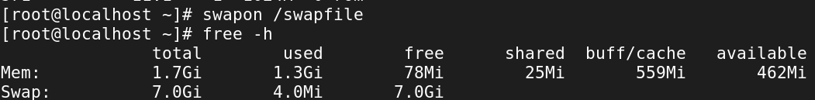

1. For Permanent Mount:

* Vi /etc/fstab

