**TASK – 1**

1. **What command is used to list all files and directories, including hidden ones, in a directory?**

**ls -a** is used list all files and directories, including hidden ones in a directory.

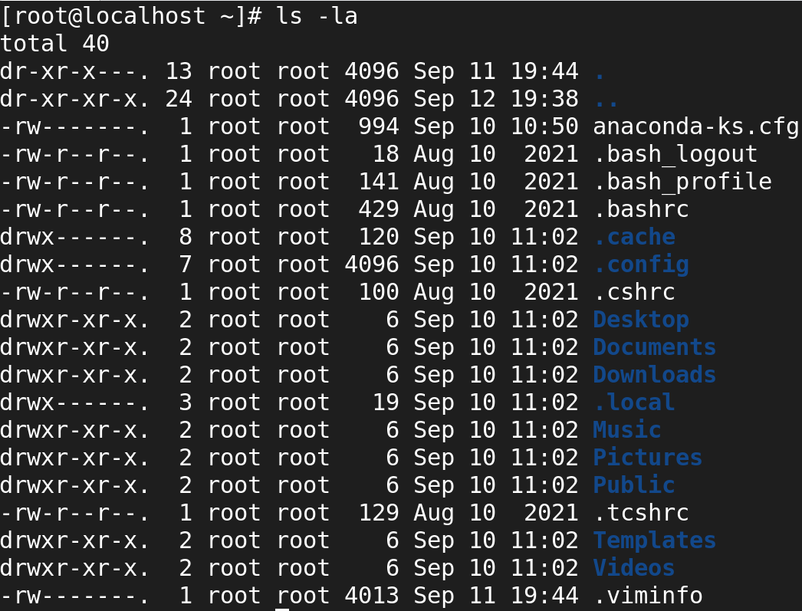

1. **How do you display the contents of a file named `example` in the terminal?**

**Cat** command is used to display the contents of the file in the terminal.

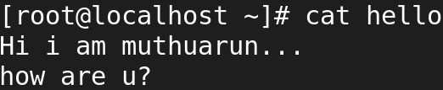

1. **Which command is used to copy a file named `file1` to a directory `/backup`?**

**cp** command is used to copy a file to a directory.

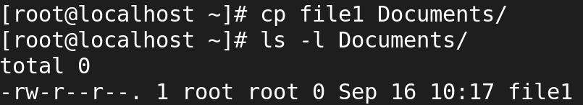

1. **What is the command to move a file named `data` from the `/home/user` directory to `/home/user/Documents`?**

**mv** used to move a file.

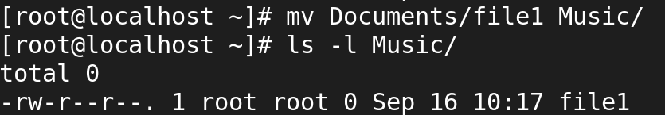

1. **How would you create an empty file called `logfile`?**

**touch** command is used to create an empty file.

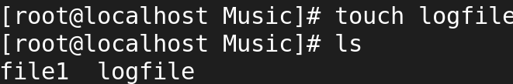

1. **What command do you use to delete a directory named `old_files` and its contents?**

* **rm -r** 🡪 command is used delete a directory and its content.
* **rmdir** 🡪 is used to delete a empty directory.
* **rm -rf** 🡪 used to delete a directory forcefully.

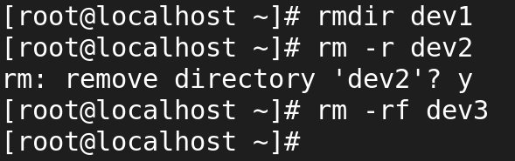

1. **How do you check your current working directory in the terminal?**

**pwd** is used to check the current working directory.

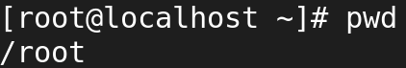

1. **Which command is used to view the last 10 lines of a file called `system.log`?**

**tail** is used to view the last 10 lines of a file.

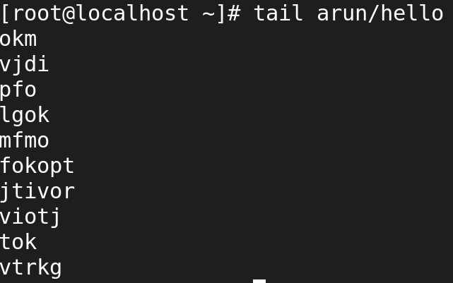

1. **How would you change the current shell session to the root user, provided you have the proper permissions?**

**logout or exit** is used to change the current shell session to the root user.

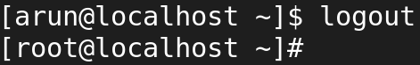

**‘vi’ Editor:**

1. **How do you open a file called ‘script’ in the ‘vi’ editor?**

vi command is used to open a file in vi editor.



1. **In the ‘vi’ editor, how do you enter insert mode to start editing a file?**

* i 🡪 insert the text
* I 🡪 insert the text in beginning of line
* a 🡪 adds the text after the current cursor position
* A 🡪 adds the text at the end of a line
* o 🡪 inserts the text one line below current cursor position
* O 🡪 inserts the text one line before current cursor position.

1. **Which command do you use in ‘vi’ to delete the current line?**

* **dd** command is used to delete the current line.

1. **How do you search for a word called `error` in ‘vi’?**

* **/word or ?word** is used to search a word in vi editor.

1. **If you want to save the changes and quit the ‘vi’ editor, what is the command for that?**

* **wq** is used to save and quit.

1. **How do you undo the last action in ‘vi’?**

* **u** is used undo the last action.

1. **In the `vi` editor, how do you move to the beginning of the file?**

* **gg** is used to move the beginning of the file.

1. **What command can you use to copy and paste a line in ‘vi’?**

* yy 🡪 to copy a line
* p 🡪 to paste copied line one time and paste the below the cursor
* P 🡪 paste the above the cursor

1. **How do you quit ‘vi’ without saving any changes?**

* **q** is used to quit without saving any changes.

1. **Explain how to enter visual mode in ‘vi’ to select text.**

* **V** is used enter the visual mode and select text.

**Basic File Permissions:**

1. **What command do you use to view the permissions of a file named ‘report’?**

* **ls -l** is used to view the permissions of the file.

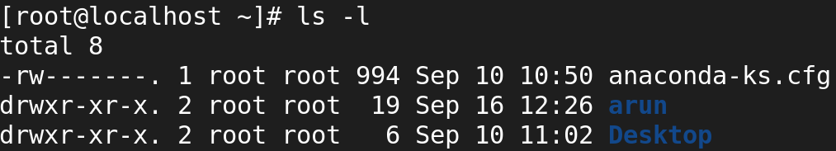

1. **Explain what the following file permission means: ‘-rwxr-xr--’?**

* The first character (-) indicates the type of file.
* A hyphen (-) means it is a regular file (If it were a directory, it would be d.)
* **Owner** (rwx): The owner has **read, write, and execute** permissions.
* **Group** (r-x): The group has **read and execute** permissions, but **no write** permission.
* **Others** (r--): Others have **read** permission but **no write and execute** permission.

1. **How would you change the permissions of a file called `test` to make it readable, writable, and executable by the owner, and readable and executable by the group and others?**

* **chmod 755 arun**

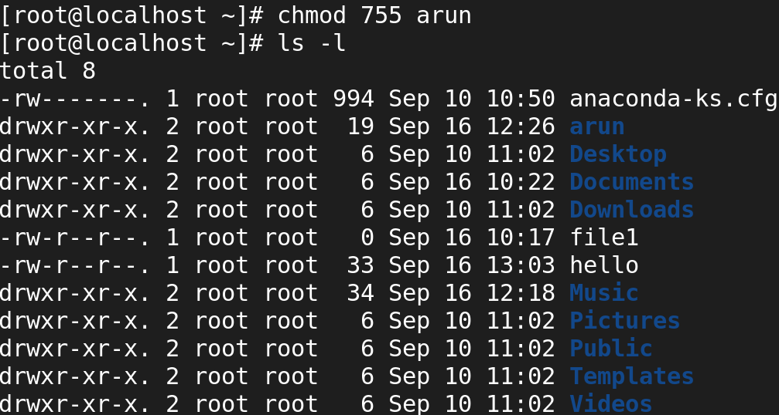

1. **What is the command to change the ownership of a file named `data` to a user called `john?**

* chown < owner > < files/directory >

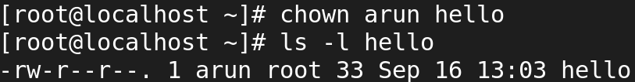

1. **If you want to remove execute permissions for a group on a file named `script.py`, what command would you use?**

* **chmod g-x script.py**
* **chmod:** Command to change file permissions.
* **g-x**: Removes (x) execute permissions for the group (g).

1. **What does the `chmod 755 filename` command do to the file's permissions?**

**chmod 755 filename**

* The owner can read, write, and execute the file.
* The group can read and execute the file.
* Others can also read and execute the file.

1. **How would you recursively change the permissions of all files and directories inside a directory called `project` to `755`?**

* chmod -R 755 project

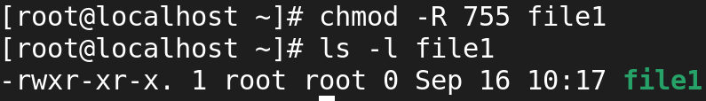

1. **How do you check the default file permissions (umask) for newly created files and directories?**

* **File 🡪** 666 – 022 = 644
* **Directories 🡪** 777 – 022 = 755

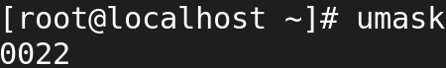

1. **What command can you use to set the owner of a file named `server.conf` to user `alice` and group `admins`?**

* chown < owner >: < group > < files/directory >

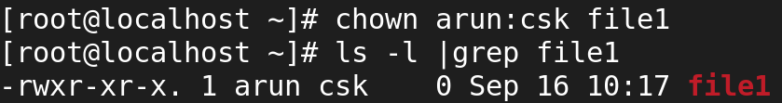

1. **Describe how to make a file `read-only` for everyone using a symbolic mode command**

* chmod a-wx file

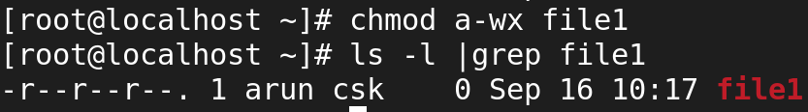

**User Management:**

1. **How do you add a new user called `student` in Linux?**

* userdd student



1. **What command would you use to delete a user named `testuser` along with their home directory?**

* userdel -r student



1. **How can you lock the account of a user named `jane` to prevent them from logging in?**

* passwd -l jane



1. **Which command would you use to change the password for a user named `bob`?**

* passwd bob

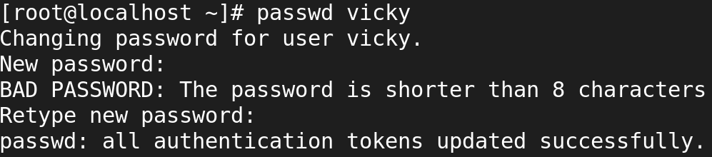

1. **What is the command to view all users on a Linux system?**

* cat /etc/passwd



1. **How do you list all the groups that a user called `developer` belongs to?**

* id developer



1. **Explain how you would add an existing user `jack` to a group called `devgroupp`?**

* usermod -aG devgroupp jack



1. **What command allows you to switch to another user’s account (without logging out of your current session)?**

* su – anotheruser

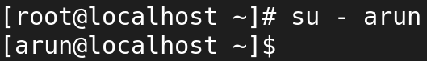

1. **How do you add a group called `team` in Linux?**

* groupadd team



1. **What is the purpose of the `/etc/passwd` file, and how is it structured?**

* **/etc/passwd** 🡪 This file stores essential information about user accounts.
* Username: The login name of the user.
* X: This placeholder indicates that the actual password is stored in /etc/shadow.
* UID: User ID (unique number for each user).
* GID: Group ID (primary group of the user).
* Comment: A comment or description about the user (usually the full name).
* home_directory: The path to the user’s home directory.
* shell: The default shell assigned to the user.

