LEVEL – 2

VB-Script Functions

- Abs

This returns only positive values

Dim a,b
a=-23.44
b=abs(a)
print b

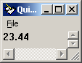

- Array

Collection of similar kinds of data. If we did not declare a variable as array, but it still contain an array using Array function.

Dim a
a=Array(23,33,34)
b=a(1)
print b

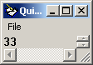

- Asc

This is used to return the ascii value of the first character of a word which is specified

Dim a
a=Asc("Hai") ‘Will return the ascii value of H
print a

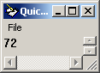

- Atn

Atn is the inverse trigonometric function of Tan, which takes an angle as its argument and returns the ratio of two sides of a right triangle

Dim pi
pi = 4 * Atn(1)
print pi

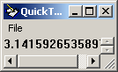

- Cbool

This will return TRUE if expression is not zero otherwise FALSE is returned.

Dim a
a=10
b=2
c=cbool(a=b)
print c

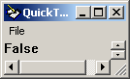

- Cbyte

Use CByte to force byte arithmetic in cases where currency, single-precision, double-precision, or integer arithmetic normally would occur.

Dim a
a=1068.345
c=cbyte(a)
print c

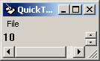

- Ccur

This will display only 4 values after the decimal .

Dim a
a=10.345343434
c=ccur(a)
print c

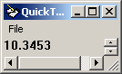

- Cdate

CDate recognizes date formats according to the locale setting of your system

Dim a
a="23 jan"
c=cdate(a)
print c

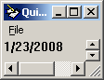

- Cdbl

Use the CDbl function to provide internationally aware conversions from any other data type to a Double subtype

Dim a
a="233334.342344"
c=cdBL(a*2*0.22)
print c

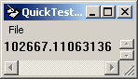

- Chr

This chr function will display the character code of the number specified

Dim a
a=chr("65")
print a

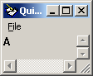

- Cint

Dim a
a=3230.545
c=cint(a)
print c

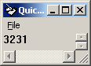

- Clng

Dim a
a=99999.99999
c=clng(a)
print c

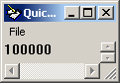

- Cos - Will display the cosine value of the number specified

Dim a
a=3/4
c=cos(a)
print c

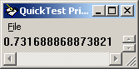

- Createobject

Used to create a spreadsheet file and insert values in to cells

Dim a
SystemUtil.Run "C:\Program Files\Microsoft Ofice\Office\EXCEL.EXE","","",""
set a=createobject("excel.sheet")
a.activesheet.cells(2,1).value="Hai Welcome"
a.saveas "F:\test\test.xls"
a.application.quit
Set a=nothing

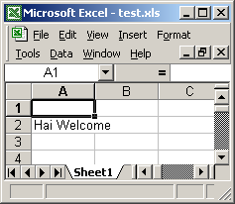

For creating text file
Dim a, b,c
Set a = CreateObject("Scripting.FileSystemObject")
Set b = a.CreateTextFile("F:\testfile.txt", True)
b.Writeline("Hai saravana")
b.Writeline("This is a test file")
SystemUtil.Run "F:\testfile.txt"

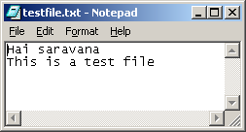

- Csng

Will display only 8 digits including decimals.

Dim a
a=126.345343434
c=csng(a)
print c

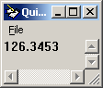

- Date

Will return the current date

Dim a
a=date
print a

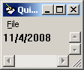

- DateAdd

Using this, we can add a day, week, month, year to the date specified.

Dim a
b="1 jan 2007"
a=dateadd("m", 1, b) ‘m is the month & 1 is adding 1 month
print a

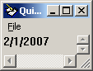

- DateDiff

Using this, we can find the difference b/w 2 dates which can be displayed in month, days, year

Dim a
c=date
b="20 oct 2009"
a = "day from today: " & DateDiff("d", c, b)
print a

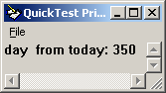

- Datepart

Using this, we can find the part of the day is in which week or month or year

Dim a
a = DatePart("ww", date)
print a

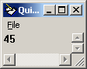

- Dateserial

a = DateSerial(1970, 1, 1) ' Returns January 1, 1970.
b = DateSerial(1990 - 10, 8 - 2, 1 - 1) ' Returns May 31, 1980.
print a
print b

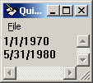

- Datevalue

Prints the date in the system date format

Dim a
a = DateValue("September 11, 1963")
print a

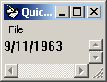

- Day

Prints the day

Dim a
a= Day("October 21, 1962")
print a

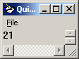

- Eval

Dim a
a=eval(b=c)
b=eval(12+1)
print a
print b

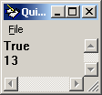

- exp

This is used to find the exponential value of the number

a=exp(0)
print a

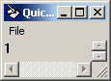

- filter

Used to filter the specified word started with some characters, which is stored in array.

Dim a
Dim b (3)
b(0) = "Sunday"
b(1) = "Monday"
b(2) = "Monday"
a = Filter(b, "Mon")
print a(0)
print a(1)

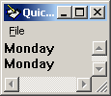

- FormatCurrency

Used to display the value in currency format (in $).

Dim a
a = FormatCurrency(13000)
print a

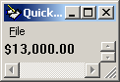

- FormatNumber

Used to display the decimal places as specified

Dim a
a=10.324334
c = FormatNumber(a,5) ' here 5 is mentioned to display after decimal
print c

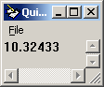

- FormatPercent

Returns an expression formatted as a percentage (multiplied by 100) with a trailing % character

Dim a
a = FormatPercent(212/3232)
print a

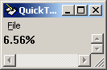

- SetLocale

- GetLocale

- GetObject

- Hex

Returns the hexadecimal value of the specified number

Dim a
a=hex(234)
b=hex(22)
print a
print b

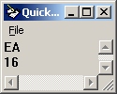

- Hour

Hour function is used to obtain the hour from the current time

Dim a, b
a = Now
c=Hour(a)
b = Hour("2.12 PM")
print a
print b
print c

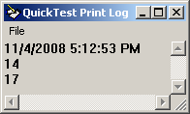

- Inputbox

This is used to get the input values from the user during runtime.

Dim a, b
a=int(inputbox("Enter the value: "))
b=a+a
print b
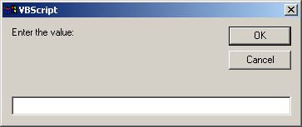

- Instr

This is used to find the position of a character in the specified word.

Dim a, b
a=instr(2, "Maintain condition", "n") ‘Here 2 is search start position and displays
print a first occurrence

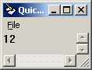

- InstrRev

This is used to find the position of a character in the specified word from reverse order

Dim a, b
a=instrrev( "Maintain condition", "t")
print a

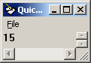

- Int, fix

The difference between Int and Fix is that if number is negative, Int returns the first negative integer less than or equal to number, whereas Fix returns the first negative integer greater than or equal to number. For example, Int converts -8.4 to -9, and Fix converts -8.4 to –8

MyNumber = Int(99.8) ' Returns 99.
MyNumber = Fix(99.2) ' Returns 99.
MyNumber = Int(-99.8) ' Returns -100.
MyNumber = Fix(-99.8) ' Returns -99.
MyNumber = Int(-99.2) ' Returns -100.
MyNumber = Fix(-99.2) ' Returns -99.

- Int, fix

IsArray returns True if the variable is an array; otherwise, it returns False

Dim a(3)
a(0)=12
a(1)=134
b=isarray(a)
print b

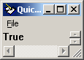

- Isdate

IsDate returns True if the expression is a date or can be converted to a valid date; otherwise, it returns False

Dim a
a="jan 23"
b=isdate(a)
print b

- Isempty

This is used to check the variable contain any values by displaying T or F

Dim a
a= empty
b=isempty(a)
print b
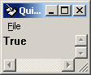

- Isnull

This is used to check the variable contain null values or not by displaying T or F

Dim a
a=null
b=isnull(a)
print b

- Isnumeric

IsNumeric returns True if the entire expression is recognized as a number; otherwise, it returns False

Dim a
a=isnumeric("122")
b=isnumeric("12sdf")
print a
print b

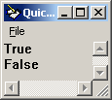

- Isobject

Isobject returns True if the entire expression is variable of Object subtype or a user-defined object; otherwise, it returns False

Dim MyInt, MyCheck, MyObject
Set MyObject = Me
MyCheck = IsObject(MyObject) ' Returns True.
MyCheck = IsObject(MyInt) 'Returns false
print MyCheck

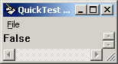

- Join

It is used to join the string of array

Dim a(5)
a(0)="Hai"
a(1)="Welcome"
a(2)="to year 2009"
b=join(a)
print b

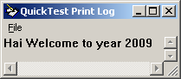

- Lbound

It is used to find the least bound of array, which will be always zero

Dim a
a=Array("hai", "saravanan", "How r u", "2334")
b=lbound(a)
print b

- Ubound

It is used to find the size of the array

Dim a
a=Array("hai", "saravanan", "How r u", "2334")
b=lbound(a)
print b
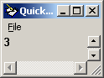

- Lcase

It is used to change the word case to lower

Dim a
a=Array("HAI", "SARAVANAN", "How r u", "2334")
b=lcase(a(1))
print b

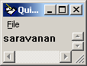

- Left

It is used to display the characters specified from left side of the word

Dim a
a=Array("HAI", "SARAVANAN", "How r u", "2334")
b=left(a(1), 3)
print b

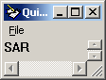

- Len

It is used to find the length of the string

Dim a
a=Array("HAI", "SARAVANAN", "How r u", "2334")
b=len(a(1))
print b

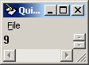

- LoadPicture

It is used to

- Log

It is used to find the natural logarithm of a number

Dim a
a=log(10)
print a

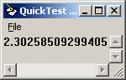

- Ltrim, Rtrim, Trim

It is used to return a string by avoiding the unwanted spaces in left, right or both side as per the syntax specified

Dim a
a=ltrim(" Hai Saravanan ")
b=rtrim(" Hai Saravanan ")
c=trim(" Hai Saravanan ")
print a
print b
print c

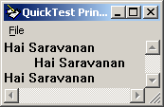

- Sgn

It returns the sign of the number specified. 1 for +ve, -1 for –ve and 0 for zero.

Dim a
a=sgn("-34")
print a

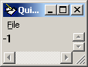

- Mid

It deletes the character from left and display the characters as specified nos

Dim a
a=mid("software engineer", 5, 13)
print a

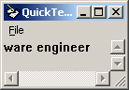

- Minute

It displays the minute

Dim a
a = Minute(now)
print a

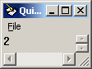

- Month

It displays the month

Dim a
a = Month("12 mar 2004")
print a

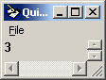

- MonthName

It displays the month name

Dim a
a = Monthname(12, true) ‘Here true is for abbreviate the month, default is false
print a

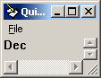

- Msgbox

It displays the output as a popup message

Dim a
a="Hai saravanan"
msgbox a, 3, "Output screen" ' 3 is for no of buttons to be displayed

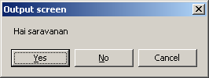

- Now

It displays the current date and time

Dim a
a=(now)
print a
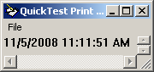

- Oct

It returns the octal value of a number.

Dim a
a=oct(123)
print a

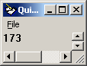

- Replace

It returns the octal value of a number.
Dim a
a=replace("saravanan", "a", "F")
print a

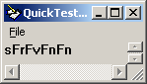

- RGB

- Right

It is used to display the characters specified to right side of the word

Dim a
a=right("saravanan", 5)
print a

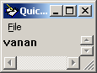

- Round

This will round the decimal values to the specified number

Dim a
a=round(23.27333, 2) ' 2 indicates the no should be displayed after decimal
print a

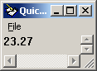

- – 68. ScriptEngine, ScriptEngineMajorversion, ScriptEngineMinorversion, ScriptEngineBuildVersion

This will return the scripting language and its version used.

Dim a(5)
a(0)=scriptengine
a(1)=scriptenginemajorversion
a(2)=scriptengineminorversion
a(3)=scriptenginebuildversion
print "Output is: " &a(0)&" "&a(1)&"."&a(2)&"."&a(3)

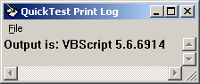

- Second

This will display the second specified in the time

Dim a
a=second(now)
print a

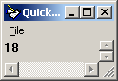

- Sin

This will display the sin value of the specified number.

Dim a
a=sin(90)
print a

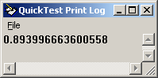

- Space

Returns a string consisting of the specified number of spaces

Dim a
a=("hai welcome" &space(4)&"To infics ")
print a

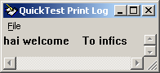

- Split

Used to remove unwanted character in the sentence

Dim a
a="HelloFSaravananFHai"
b=split(a,"F", -1)
c=join(b)
print c

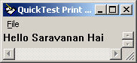

- Strcomp

Used to compare the two strings and returns the value

Dim a
a="hai"
b="sasa"
c=strcomp(a, b)
print c '-1 returns if str1<str2, 1 returns if str1>str2, 0 for str1=str2

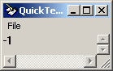

- String

Used to repeat the first character or number in a string for specified number of times

Dim a
a=string(12,"23")
b=string(15, "solution")
print a
print b

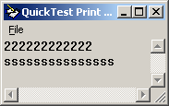

- Tan

Returns the tangent of an angle

Dim a
a=tan(45)
print a

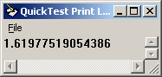

- Time

Returns the current system time

Dim a
a=time
print a

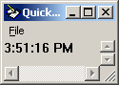

- Timer

Returns the execution time for a looping statement

Dim a
b=timer
For a=1 to 10
print "This is testing"
Next
c=timer
print b
print c

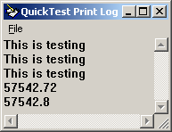

- Timeserial

a= TimeSerial(11 , -35, 23)
print a

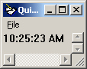
- Timevalue

a= TimeValue("14.24:34")
print a

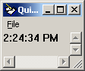

- TypeName

TypeName function is used to return information about a variable

Dim a
a=typename(20)
b=typename("sara")
c=typename(Null)
d=typename(array)
print a
print b
print c
print d

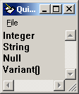

- Ucase

This will display the string in uppercase

Dim a
a=ucase("saravanan")
print a

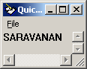

- Vartype

This will display the subtype of the variable. E.g. int, long, string, date etc which will be displayed in values

Dim a
a=vartype("saas")
print a

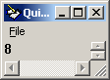

- WeekDay

This will display the weekday of the specified date in number.

Dim a
a=weekday("20 jan 2004")
print a

- WeekDayName

This will display the weekday name of the specified number

Dim a
a=weekdayname(6)
print a

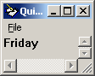

- Year

This will display the Year in the date specified
Dim a
a=year("20 jan 1983")
print a

