GOVERNMENT ART AND SCIENCE COLLEGE

SRIVILLIPUTHUR

# 1.INTRODUCTION:

Welcome to "Voyage Vista: Illuminating Insights from Uber Expeditionary Analysis with Tableau." Embark on a dynamic journey through a comprehensive analysis of Uber's extraordinary expeditions, illuminated by cutting-edge data visualization from Tableau. Discover the hidden patterns, trends, and impactful narratives that unfold as we delve into the heart of Uber's pioneering ventures. Join us as we unveil the transformative power of data in unraveling the complexities of modern-day exploration and innovation. Step into the world of "Voyage Vista" and witness the convergence of data, technology, and human ingenuity, revealing the untold stories that shape our ever-evolving global landscape.

# 1.1.OVERVIEW:

1. **Exploration of Uber's Expeditions:** Dive into an in-depth analysis of Uber's groundbreaking expeditions, highlighting the challenges, triumphs, and pivotal moments that have defined their journey.
2. **Data Visualization Excellence:** Utilize the powerful capabilities of Tableau to present complex data in an engaging and comprehensible manner, enabling a deeper understanding of Uber's expeditionary data.
3. **Unveiling Hidden Patterns and Trends:** Uncover hidden insights and patterns within Uber's expeditionary data, providing valuable insights into the decision-making processes and strategies employed by the company.
4. **Impact of Data in Modern Exploration:** Showcase the transformative power of data in shaping the course of modern exploration, highlighting its role in driving innovation, efficiency, and strategic decision-making within the realm of expeditions.
5. **Convergence of Technology and Human Ingenuity:** Explore the synergistic relationship between technological advancements and human ingenuity, illustrating how Uber's expeditions have been shaped by the innovative use of technology and human expertise.
6. **Global Relevance and Implications:** Illustrate the global relevance of Uber's expeditionary endeavors, showcasing how their insights and experiences have broader implications for the transportation industry and beyond.
7. **Lessons for Future Expeditions:** Extract valuable lessons and best practices from Uber's expeditionary analysis, providing insights that can guide future explorations and endeavors in various industries.

# 1.2.PURPOSE:

1. **Data-driven Exploration**: Showcase the power of data analytics in understanding the intricacies of Uber's expeditions, emphasizing the role of data in enabling informed decision-making and operational efficiency.
2. **Insightful Visualization**: Demonstrate the capabilities of Tableau in transforming complex data into visually compelling insights, making the analysis accessible and engaging for a wide audience.
3. **Unveiling Strategic Insights**: Identify key trends, patterns, and strategic insights derived from Uber's expeditionary data, providing valuable knowledge for the optimization of future operations and strategic planning.
4. **Promoting Innovation and Best Practices**: Highlight innovative approaches and best practices employed by Uber in its expeditionary endeavors, offering valuable lessons for other organizations seeking to enhance their exploration and operational strategies.
5. **Educational and Informative Purpose**: Educate stakeholders, industry professionals, and the broader public about the transformative impact of data analysis and visualization in the context of modern exploration and expeditionary activities.
6. **Inspiring Further Research and Analysis**: Encourage further research and analysis into the intersection of data analytics, technological advancements, and expeditionary operations, fostering a deeper understanding of the evolving landscape of modern-day exploration.

# 2.PROBLEM STATEMENT & DESIGN THINKING:

# 2.1.EMPATHY MAP:

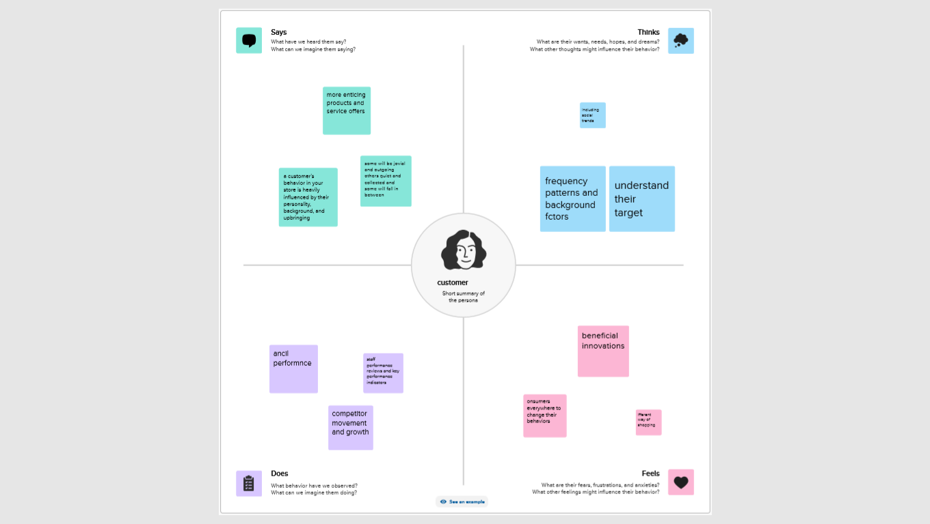

# 2.2.IDEATION AND BRAINSTORMING MAP:

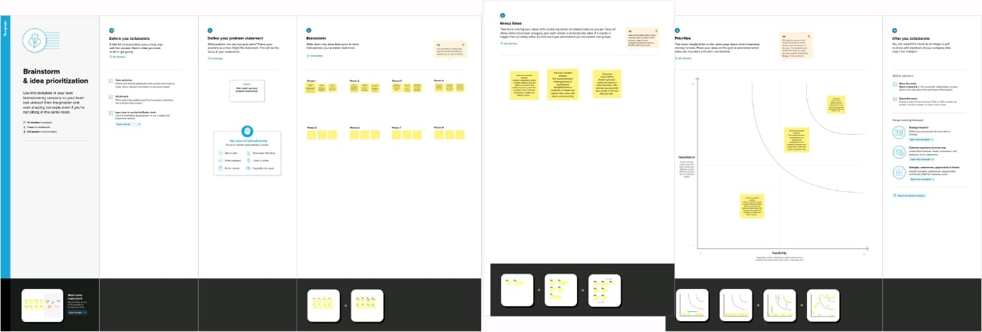

# 3.RESULT:

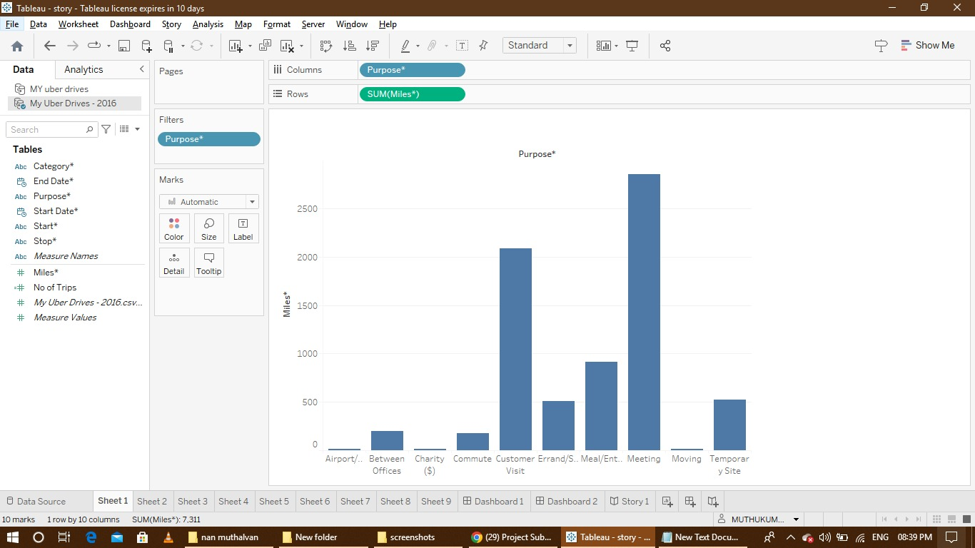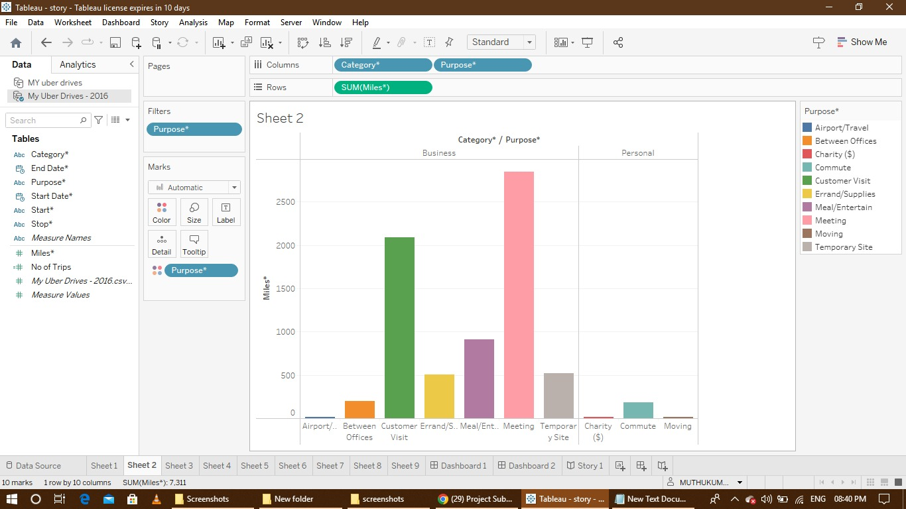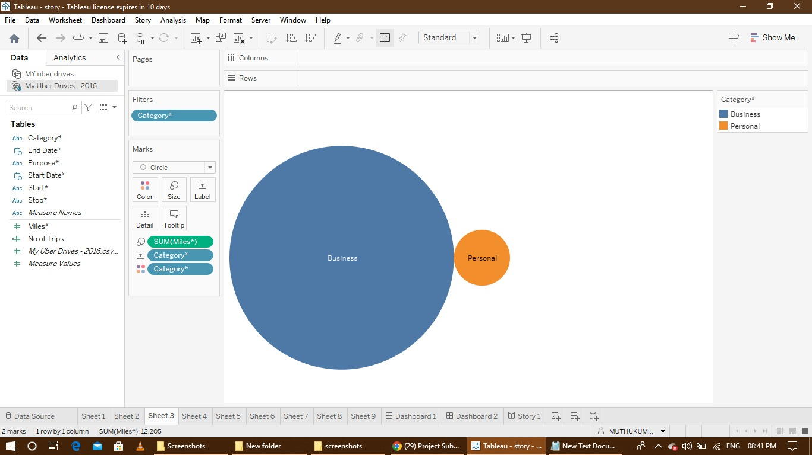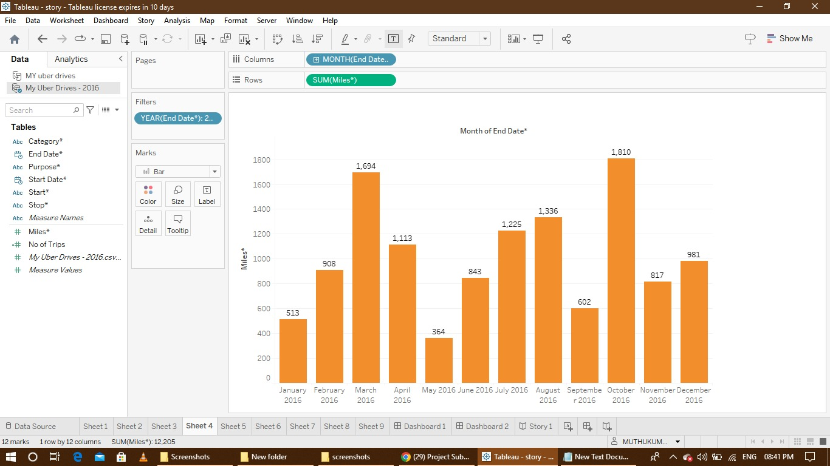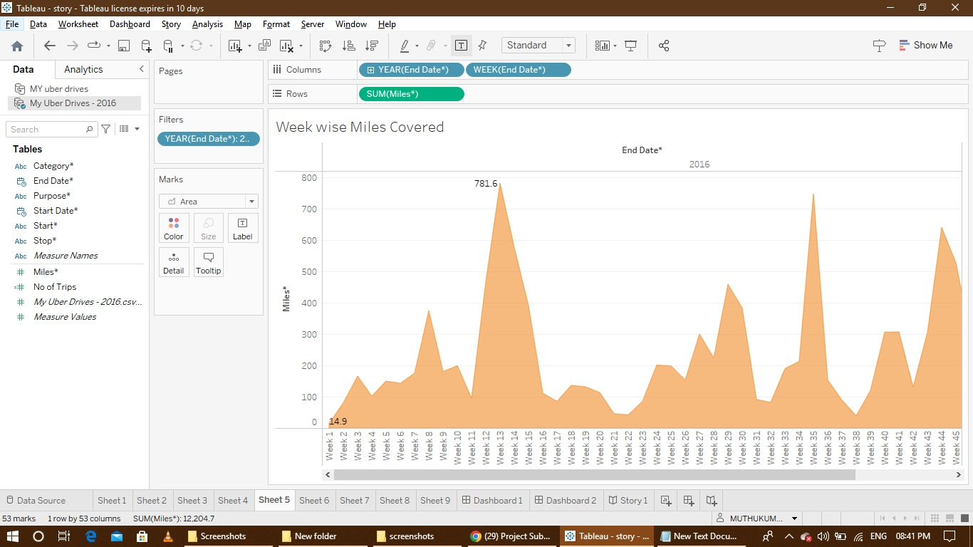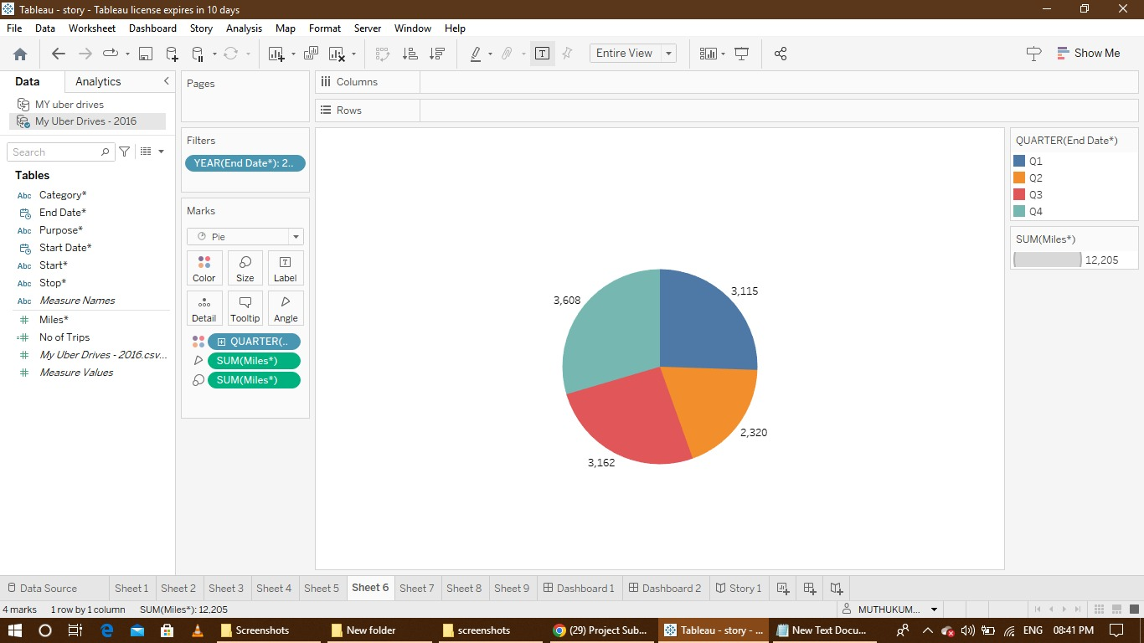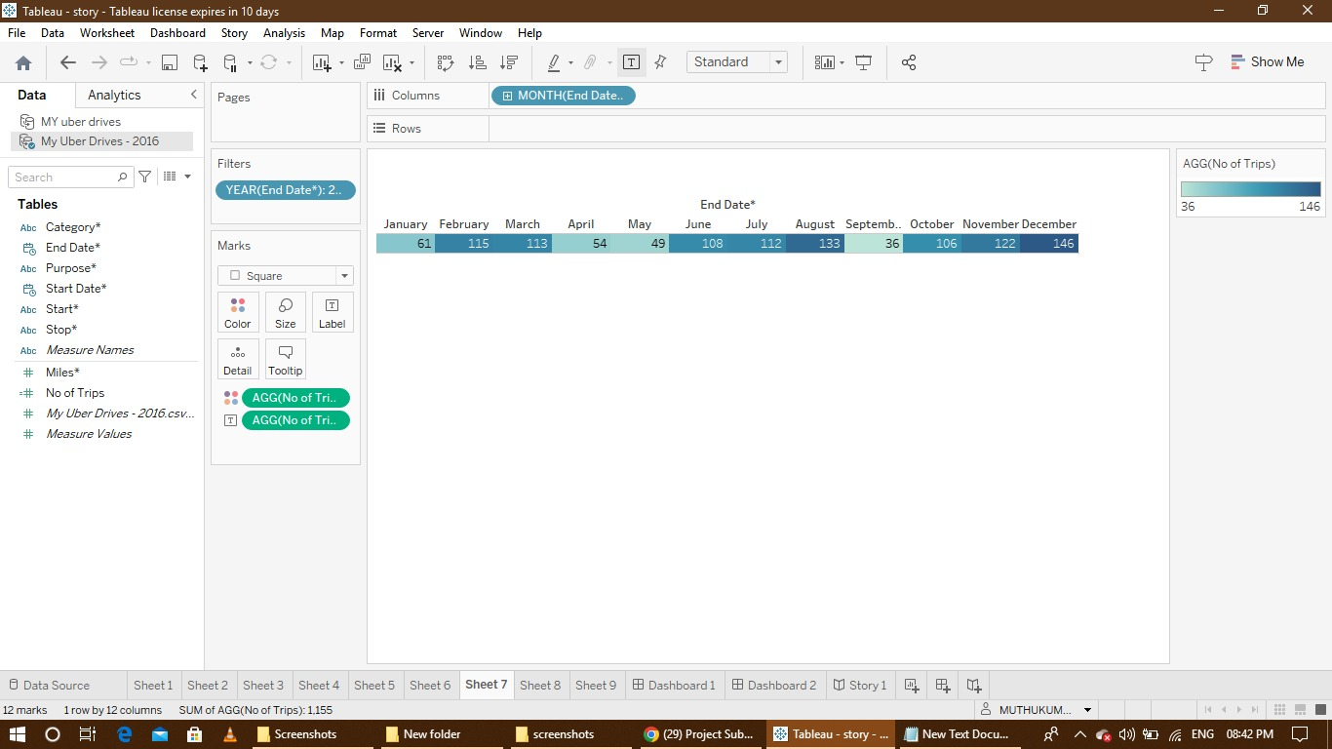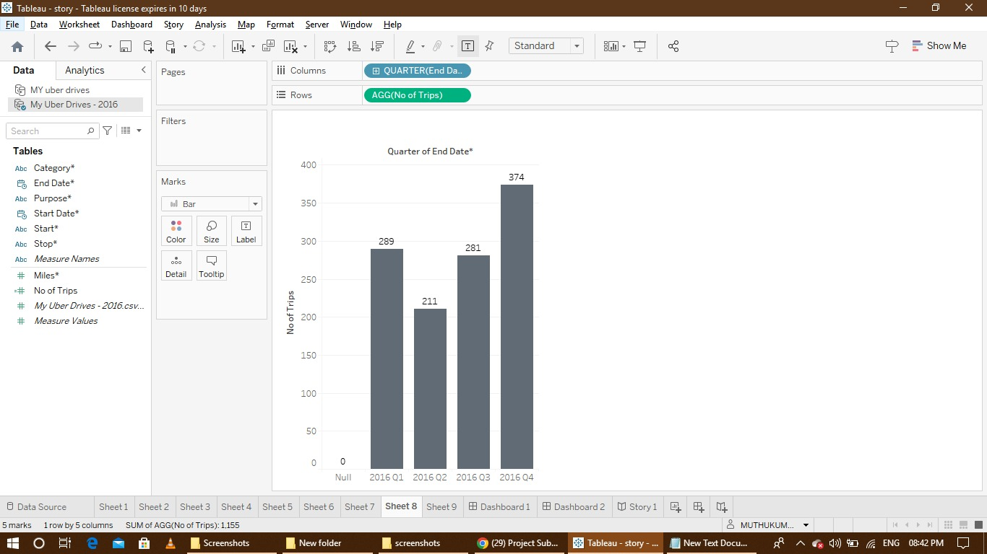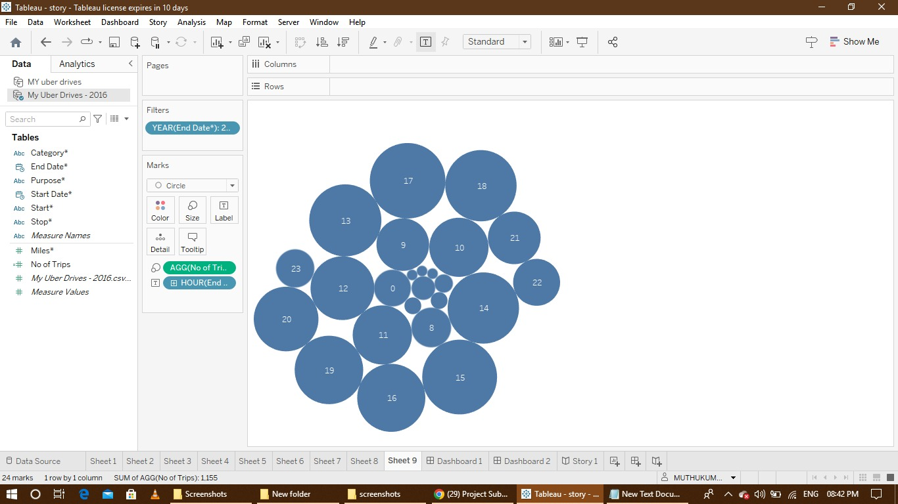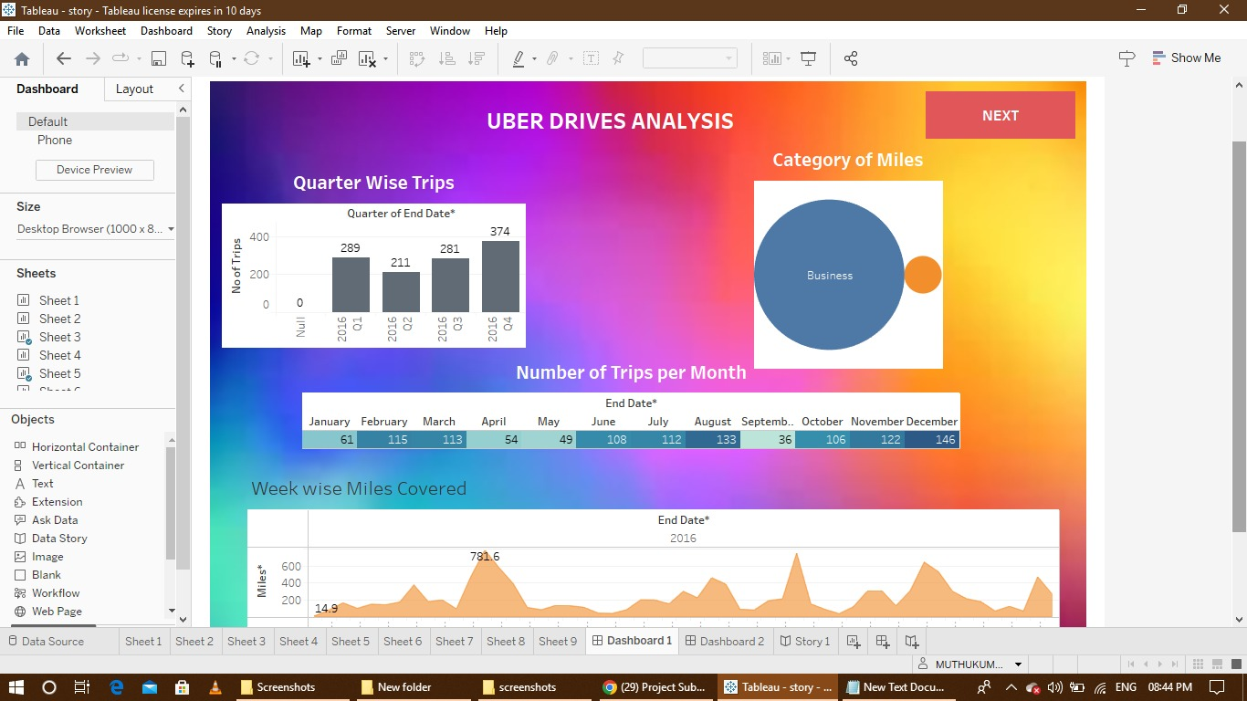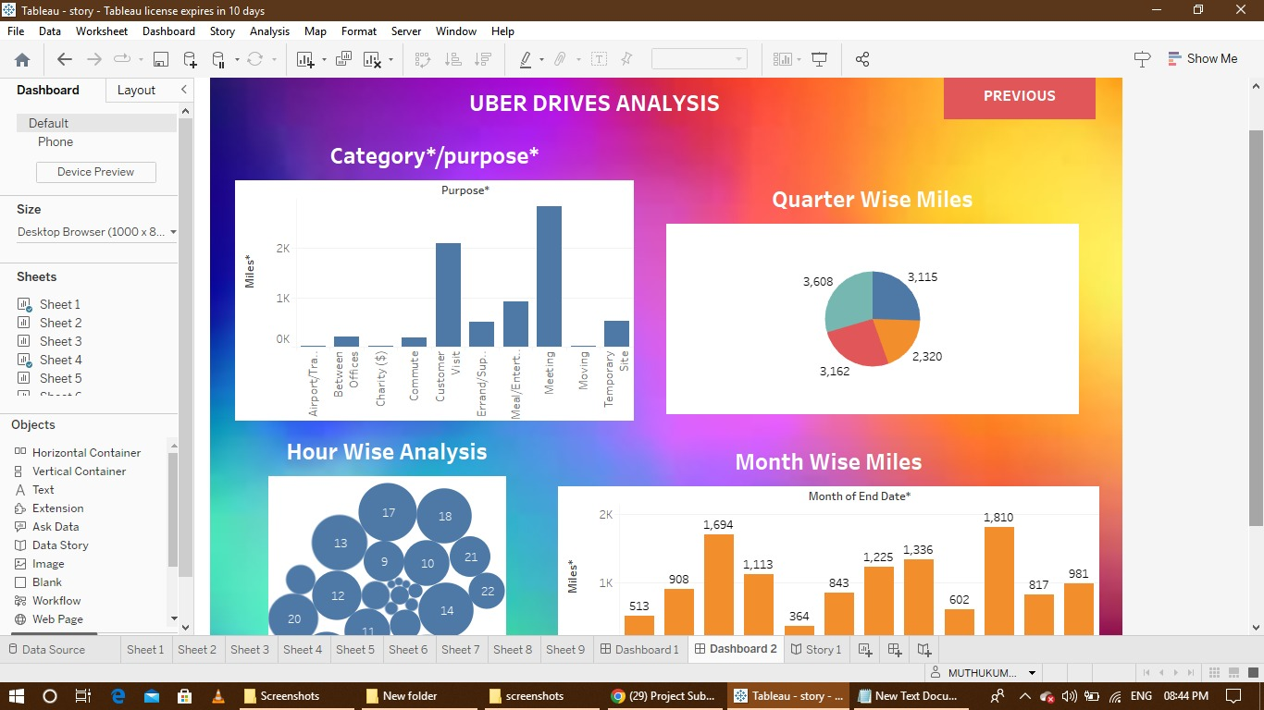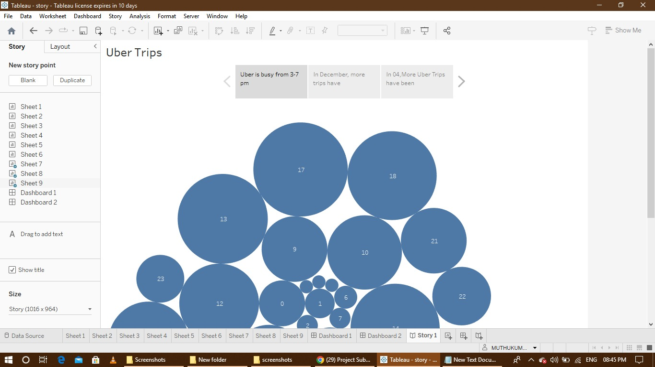

# 4.ADVANTAGES&DISADVANTAGES:

# advantages

1. **Enhanced Data Understanding:** Through the use of Tableau, the project can offer a comprehensive understanding of complex expeditionary data, making it accessible and easily comprehensible to a wide audience.
2. **Informed Decision-Making:** By uncovering valuable insights and trends, the project can facilitate better decision-making processes within Uber's expeditionary operations, leading to more efficient and effective strategies.
3. **Improved Visualization:** Utilizing Tableau's advanced visualization capabilities, the project can create engaging and visually appealing representations of data, facilitating a deeper understanding of Uber's expeditionary endeavors.
4. **Educational Impact:** "Voyage Vista" can serve as an educational resource, providing valuable insights into the role of data analysis and visualization in the context of modern-day exploration and expeditionary activities.

# Disadvantages:

1. **Complexity of Data Interpretation:** There might be challenges associated with interpreting and understanding complex data sets, potentially leading to misinterpretations or misunderstandings if not presented clearly.
2. **Data Privacy Concerns:** Depending on the nature of the data analyzed, there could be concerns related to data privacy and security, requiring careful handling and anonymization to protect sensitive information.
3. **Technical Limitations:** The use of advanced data visualization tools like Tableau might require a certain level of technical expertise, which could limit accessibility for individuals without the necessary skills or resources.
4. **Potential Bias in Analysis:** There is a risk of introducing bias into the analysis, especially if the data selection or interpretation process is not adequately controlled, potentially leading to skewed or inaccurate conclusions.

# 5.APPLICATIONS:

1. **Transportation Industry Optimization:** The insights derived from Uber's expeditionary analysis can be applied to optimize transportation operations, improving route planning, resource allocation, and overall efficiency within the transportation industry.
2. **Business Strategy Development:** The strategic insights provided by the analysis can aid businesses in developing effective strategies for expansion, market penetration, and service enhancement, drawing on the lessons learned from Uber's successful expeditionary endeavors.
3. **Data Visualization Education:** The project can serve as an educational tool for data visualization, helping students, professionals, and researchers understand the power of data visualization tools like Tableau in presenting complex data sets in an engaging and insightful manner.
4. **Technology and Innovation Research:** The project's exploration of the interplay between technology and expeditionary activities can inform further research and development in the fields of technology and innovation, inspiring the creation of new solutions and approaches for modern-day exploration.
5. **Operational Efficiency Enhancement:** The project's findings can be utilized to streamline operational processes and enhance overall efficiency within various industries, drawing on the best practices and innovative approaches identified through the analysis of Uber's expeditionary data.
6. **Policy Formulation and Regulation:** Insights from the project can contribute to the formulation of policies and regulations related to expeditionary operations and data analysis, ensuring the development of frameworks that promote responsible and ethical data usage within the context of modern exploration.

# 6.CONCLUSION:

In conclusion, "Voyage Vista: Illuminating Insights from Uber Expeditionary Analysis with Tableau" represents a pivotal exploration into the intersection of data analytics, technology, and modern-day expeditionary operations. Through the power of Tableau's advanced data visualization capabilities, this project has successfully shed light on the intricate dynamics and strategic nuances underlying Uber's pioneering expeditions. By uncovering hidden patterns, trends, and valuable insights, "Voyage Vista" has not only demonstrated the transformative potential of data in shaping the course of modern exploration but has also provided a comprehensive understanding of the strategic approaches and best practices employed by Uber.

The project's comprehensive analysis has far-reaching implications, spanning various industries and sectors, from transportation optimization to the advancement of data visualization education. By highlighting the convergence of data-driven insights and human ingenuity, "Voyage Vista" has underscored the importance of leveraging data to drive informed decision-making and operational efficiency in the context of modern exploration.

# 7.FUTURE SCOPE:

1. **Integration of Advanced AI and Machine Learning:** Incorporating advanced AI and machine learning algorithms to further analyze and predict patterns within Uber's expeditionary data, enabling more precise forecasting and decision-making.
2. **Expansion to Other Expeditionary Contexts:** Extending the analysis beyond Uber to encompass a broader spectrum of expeditionary contexts, including other transportation companies, logistics firms, and exploration-based enterprises, providing a comprehensive understanding of expeditionary operations across diverse industries.
3. **Real-time Data Analysis and Visualization:** Developing capabilities for real-time data analysis and visualization, allowing for immediate insights and decision-making in dynamic expeditionary scenarios, leading to more proactive and agile operational strategies.
4. **Collaborative Data Analysis Platforms:** Creating collaborative data analysis platforms that facilitate the sharing of insights and best practices among industry professionals and researchers, fostering a culture of collective learning and innovation within the expeditionary analysis community.
5. **Ethical and Sustainable Data Practices:** Emphasizing the integration of ethical and sustainable data practices within expeditionary analysis, ensuring the responsible use of data and the promotion of environmentally conscious expeditionary operations and strategies.
6. **Cross-disciplinary Research Initiatives:** Encouraging cross-disciplinary research initiatives that combine expertise from fields such as data science, environmental studies, and social sciences to provide a holistic understanding of the broader impacts of expeditionary operations on society and the environment.