* **INTRODUCTION:**
* ***Overview:***

Analysing housing prices in metropolitan areas of India involves a complex and multifaceted approach due to the diverse nature of the Indian real estate market.

It is a dynamic process that requires a combination of data analysis, domain knowledge and a keen understanding of economic and demographic factors.

* ***Purpose:***

The purpose is to provide valuable insights for potential home buyers, real estate agents, and investors. By leveraging historical sales data, property details, and location specific information, a predictive model can accurately estimate house prices.

* **PROBLEM DEFINING & DESIGN THINKINNG:**
* ***Empathy map***

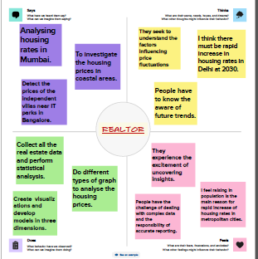

* ***Brainstorm Map***

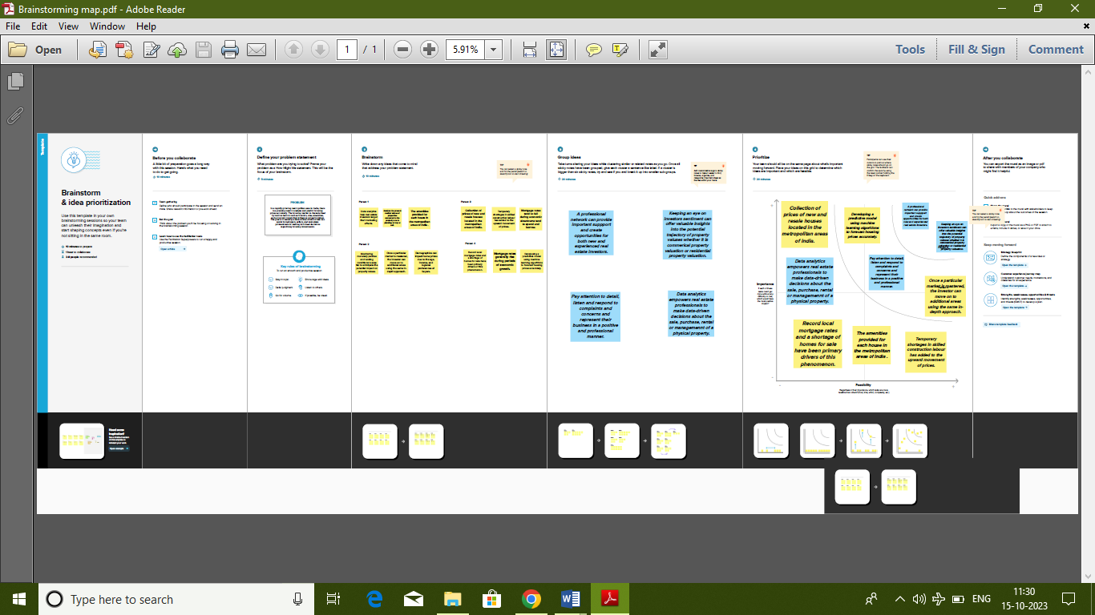

* **RESULT:**
* ***Screenshots:***

*Dashboard 1:*

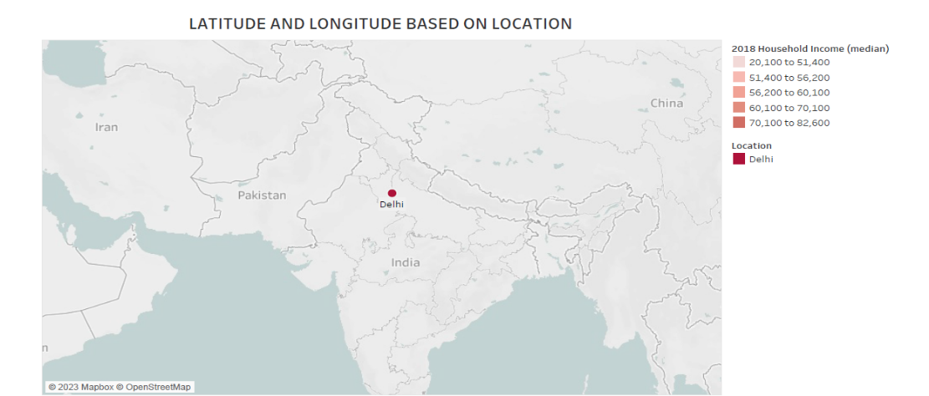

*Dashboard 2:*

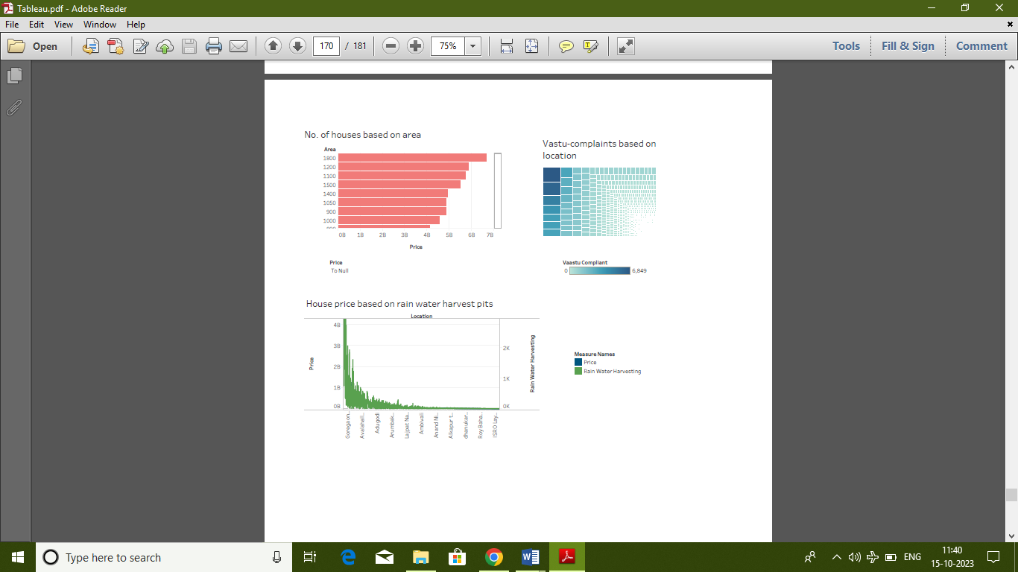

*Dashboard 3:*

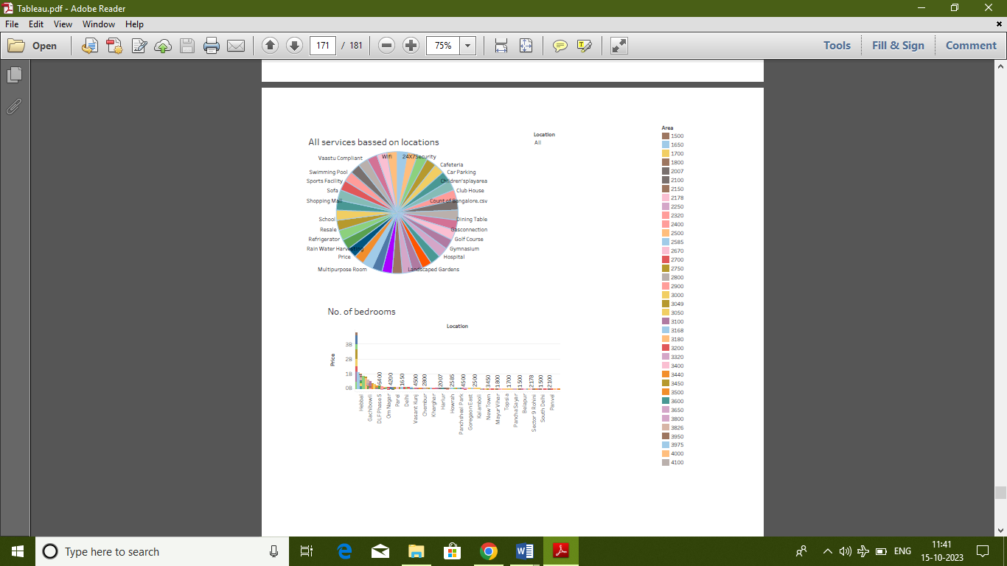

*Dashboard 4:*

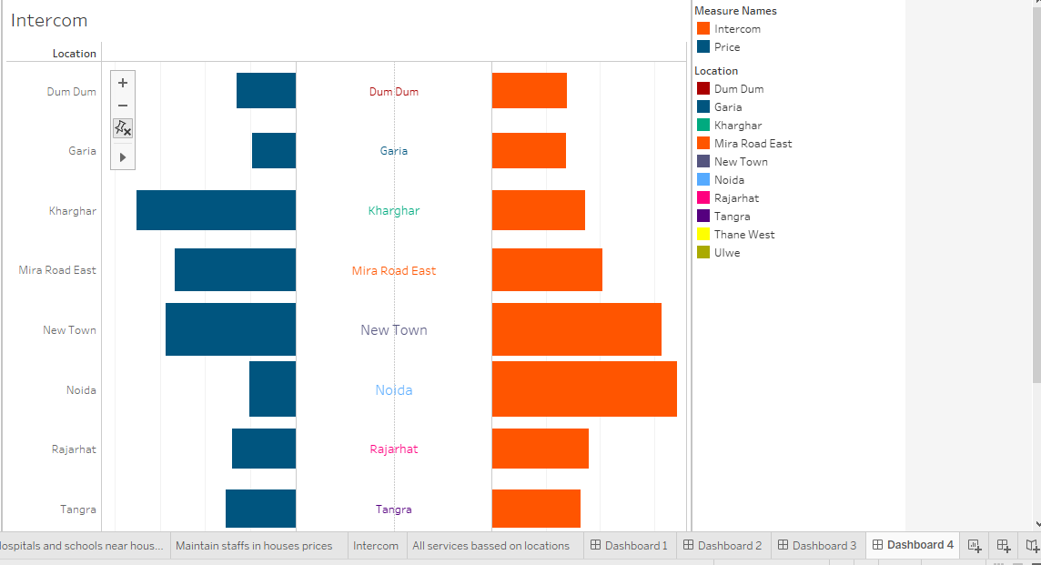

*Story:*

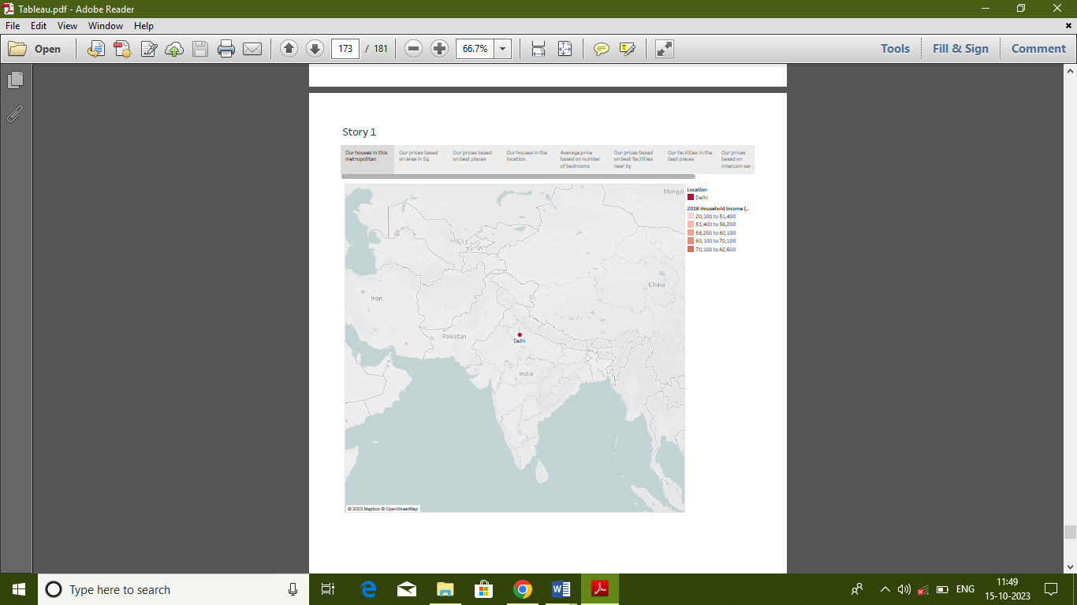

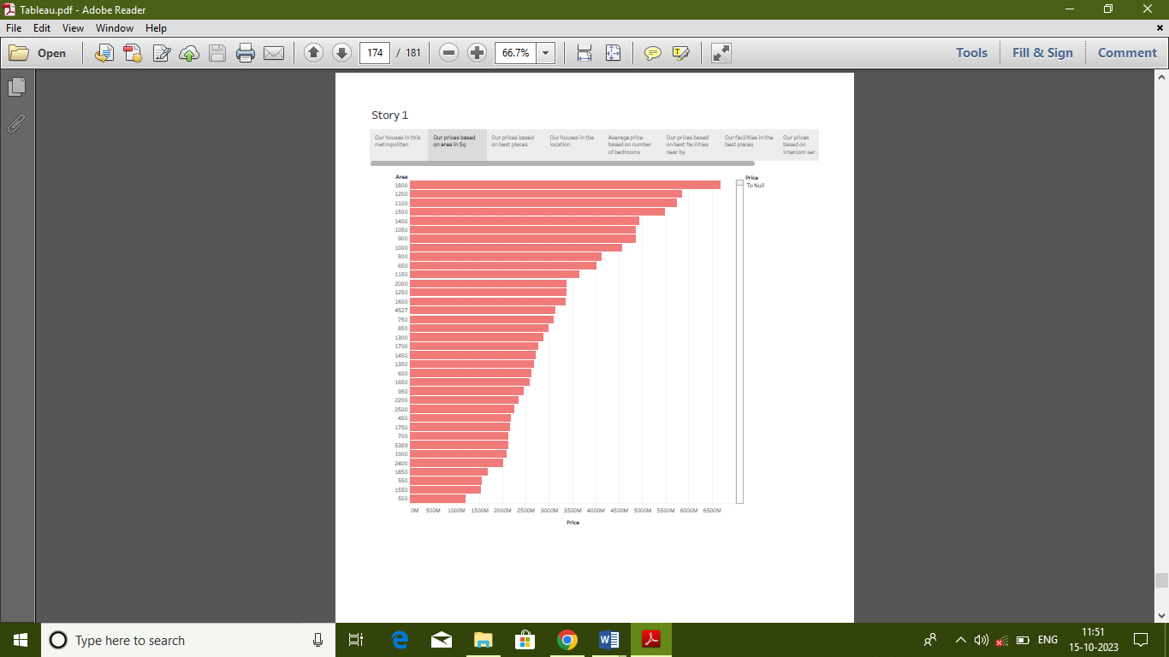

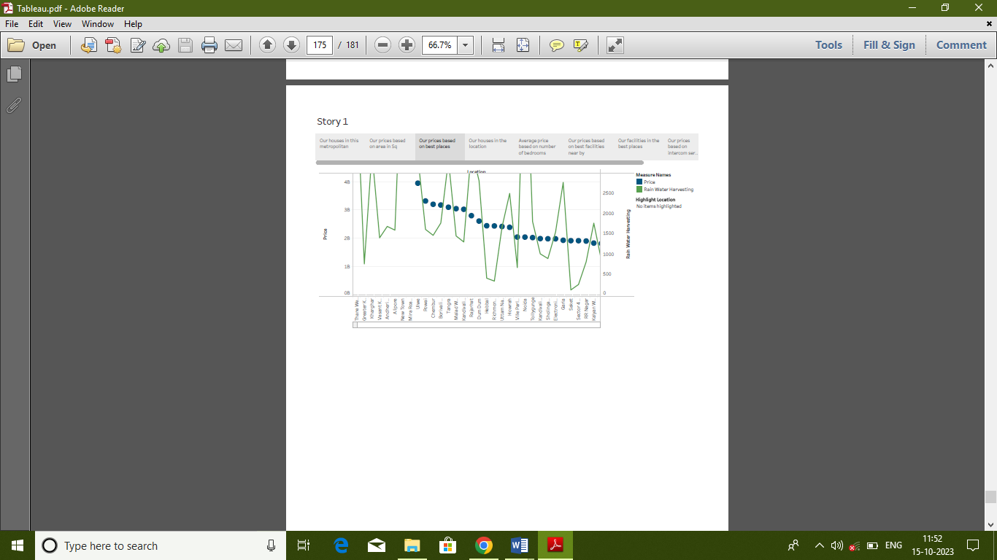



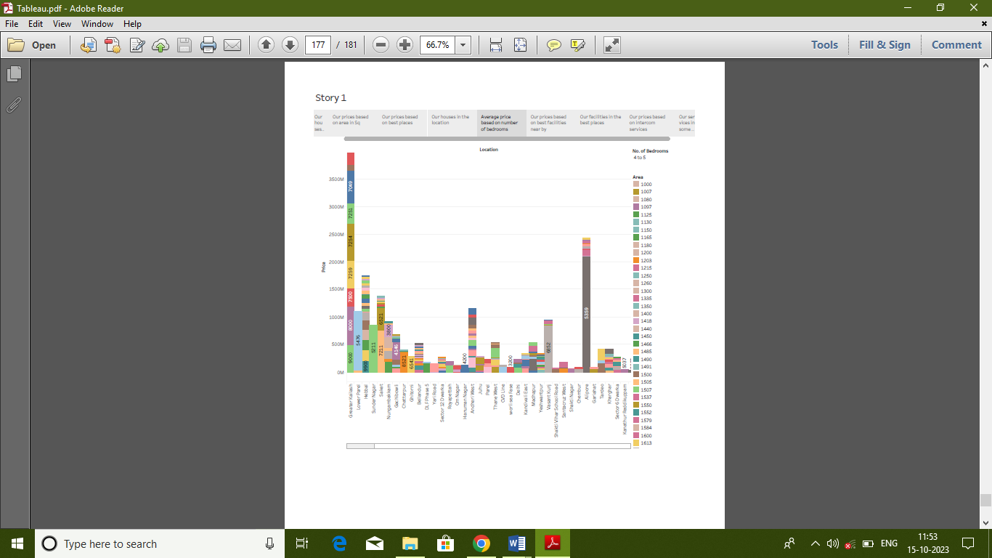

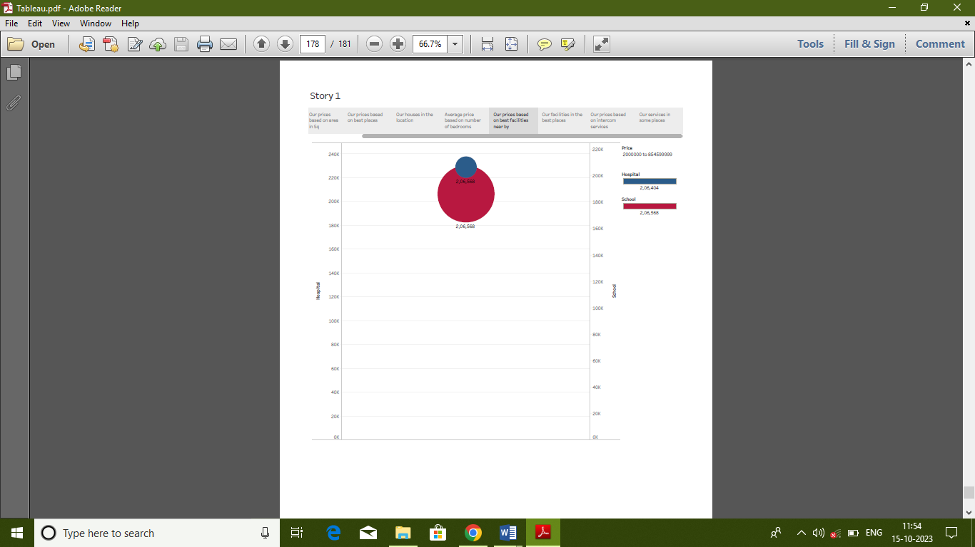

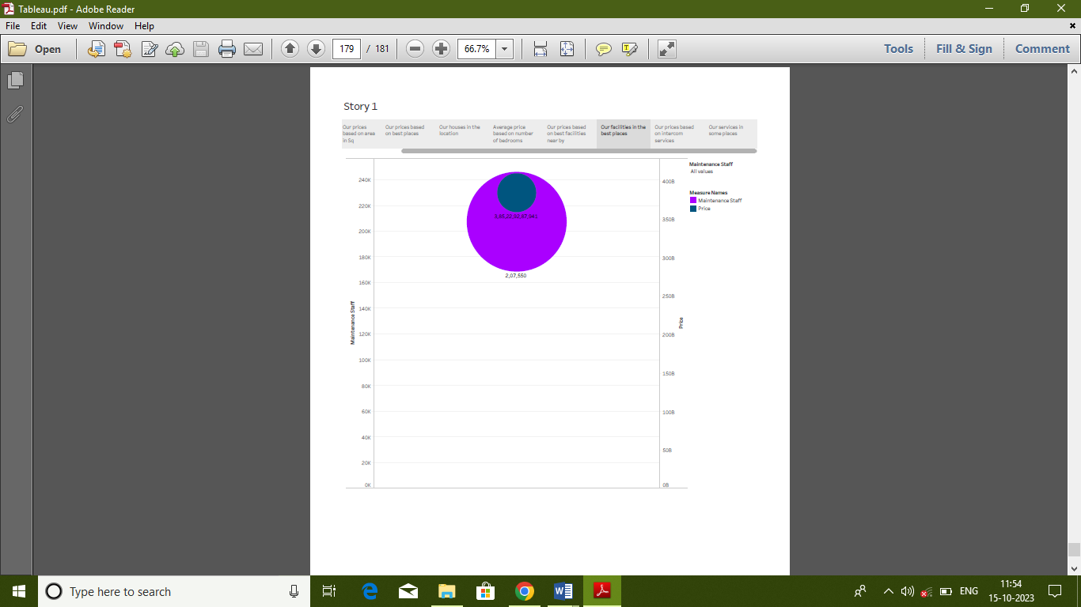

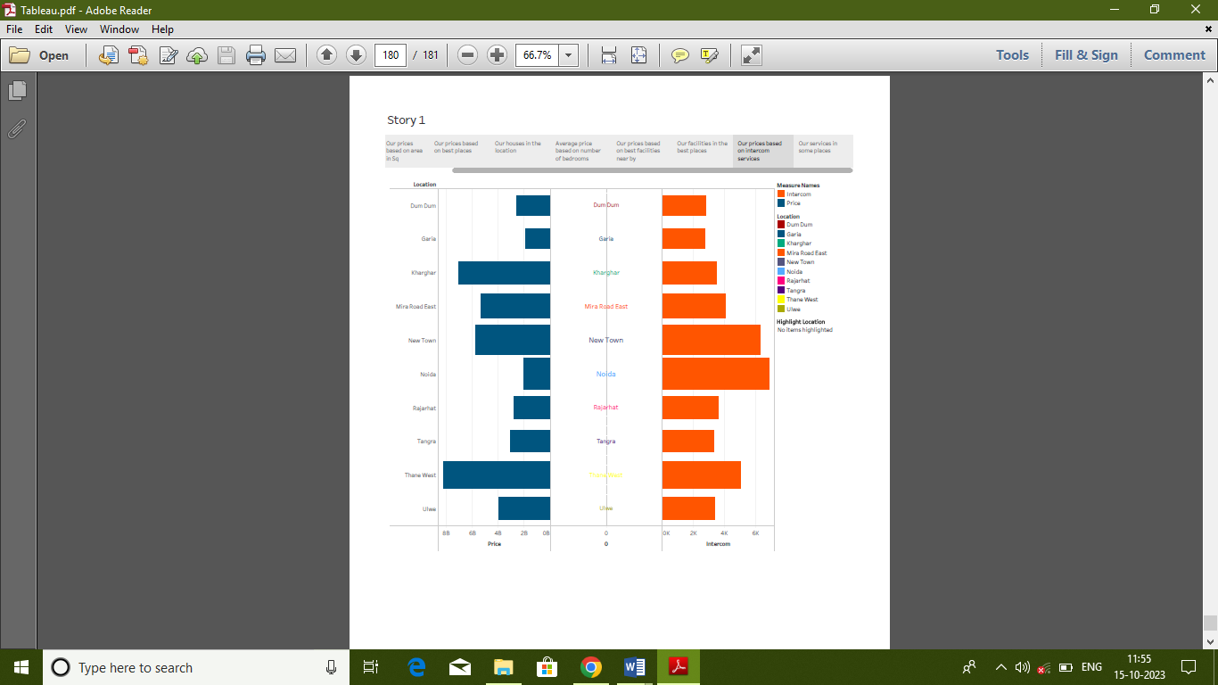

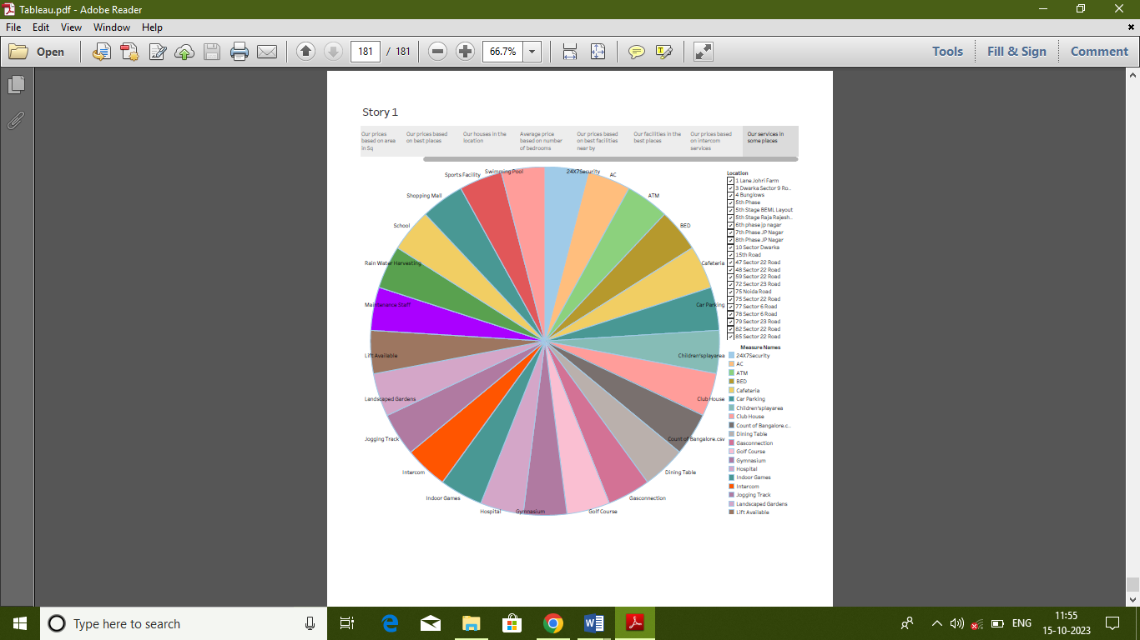

* **ADVANTAGES & DISADVANTAGES:**

Analysing housing prices can help stakeholders make informed decisions in the fast-paced real estate market. However, there are some disadvantages to analysing housing prices in metropolitan areas in India. For Instance, the data may not be accurate or up-to-date, which can lead to incorrect predictions. Additionally, the model may not account for external factors such ass economic downturns or natural disasters that can affect the housing market.

Despite these limitations, analysing housing prices can still be a useful tool for stakeholders looking to invest in real estate. It is important to keep in mind that this is just one of many factors that should be considered when making investment decisions.

* **APPLICATIONS:**

Analysing historical data can help identify patterns and trends in the housing market. This information can be used to predict future trends and make informed investment decisions. It also can help to identify properties that are undervalued or overvalued.

* **CONCLUSION:**

In conclusion, analysing housing prices is a multifaceted and crucial undertaking with various implications for individuals, businesses, policymakers, and society as a whole. The practice offers valuable insights into the dynamics of the real estate market, economic conditions and social impacts. In summary, it is a critical practice that serves various stakeholders. When conducted thoughtfully and with an understanding of the complexities involved, it can inform sound economic decisions, urban planning, and housing policies while contributing to a more transparent and equitable real estate market. However, it should be carried out with care, considering the potential risks and ethical consideration associated with the analysis.

* **FUTURE SCOPE:**

As technology advances, predictive models can become more accurate and reliable.

Predictive models can be integrated with other data sources such as demographic data, economic indicators, and environmental factors to provide a more comprehensive view of the housing market. It can be customised to meet the specific needs of different stakeholders such as home buyers, real estate agents, and investors.