FX Rates Load to PeopleSoft FSCM from Data in .txt File

**Abstract:**

This document discusses the custom PeopleSoft Application Engine run periodically to load exchange rates into PeopleSoft delivered Rate table and send the mail to Recipients.

**INFOSYS LIMITED**

**Bangalore**

|  |  |  |  |
| --- | --- | --- | --- |
| Document No. |  | Ver. Rev.: | **1.0** |
| Authored by: | |  | | --- | | **Muthumari Mariappan** | | Date: | **22-06-2022** |
| Reviewed by: | |  | | --- | | **Tapan Vakil** | | Date: |  |

**COPYRIGHT NOTICE**

©2021 Infosys Limited, Bangalore, India. All rights reserved. Infosys believes the information in this document is accurate as of its publication date; such information is subject to change without notice. Infosys acknowledges the proprietary rights of other companies to the trademarks, product names & such other intellectual property rights mentioned in this document. Except as expressly permitted, neither this document nor any part of it may be reproduced, stored in a retrieval system, or transmitted in any form or by any means, electronic, mechanical, printing, photocopying, recording or otherwise, without the prior permission of Infosys Limited and/or any named intellectual property rights holders under this document.

Infosys Limited

Hosur Road

Electronic City, 3rd Cross

Bangalore 560 100

India.

Telephone: (91) (80)28520 261-270

Fax: (91) (80) 8520 362

Website: <http://www.infosys.com>

**Table of Contents**

1. Problem Overview 3

2. Solution 3

**i. Code to read inbound csv file and insert the data into PeopleSoft delivered Rate table 4**

**ii. Code to Archive the .csv File 6**

**iii. Code to Send the Email 6**

**iv. Code to Handle the Errors 7**

3. Custom Objects 7

4. Highlights 7

1. **Problem Overview**

There was a business requirement to interface currency exchange rates received from external system in csv file format and load them into PeopleSoft FSCM on a periodical basis for different Exchange Rate Types. There is no PeopleSoft FSCM delivered process to receive exchange rate data in a .csv file format.

1. **Solution**

PeopleSoft FSCM custom Application Engine program was created to interface the exchange rates into PeopleSoft. A file layout has been created to read the .csv file received from external system, send email notification to specified recipients upon success or failure of the data interface custom program, archive the inbound csv file and generate a log file as per the file as per parameters specified on a user-maintained file parameters page.

1. **Code to read inbound csv file and insert the data into PeopleSoft delivered Rate table**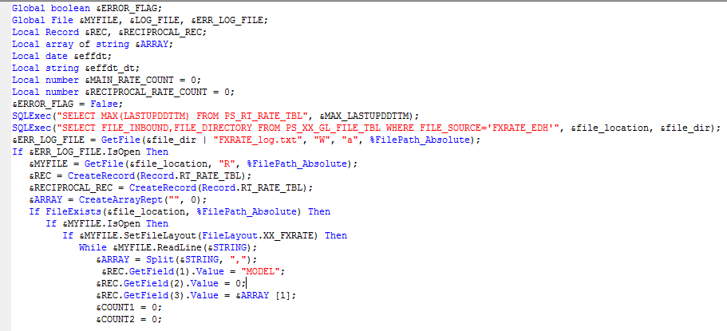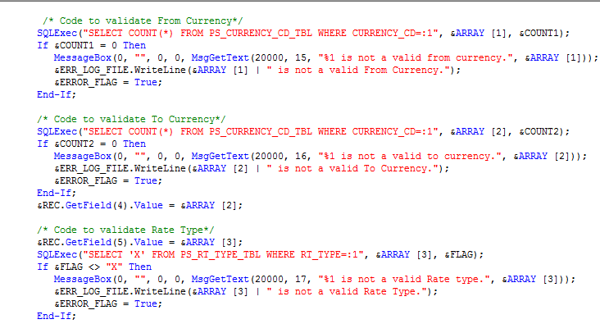

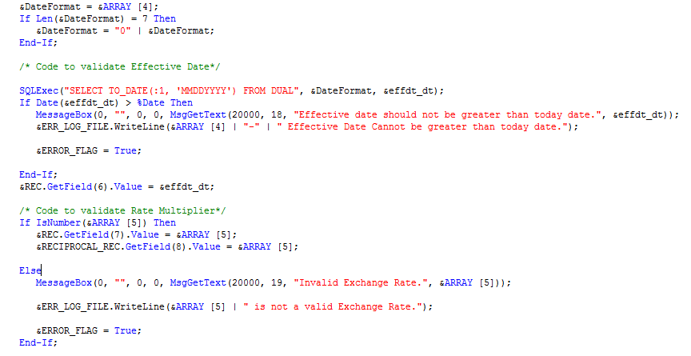

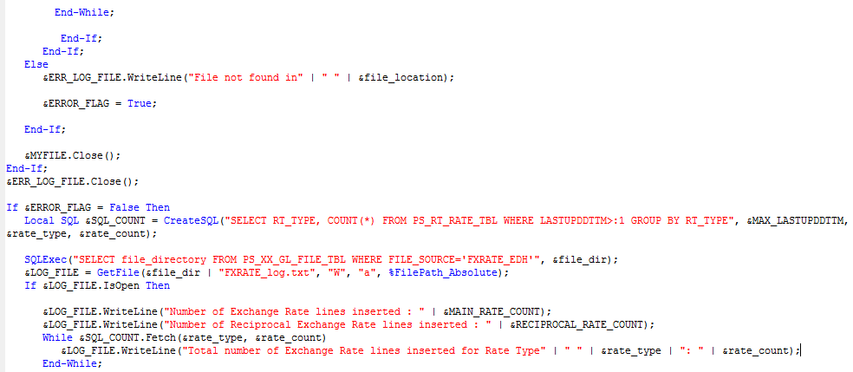



1. **Code to Archive the .csv File**

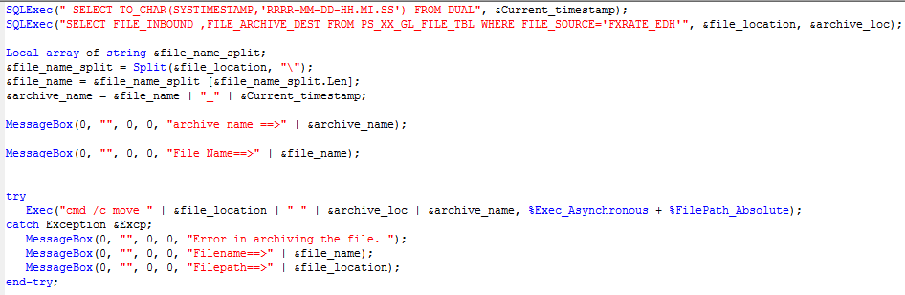

1. **Code to Send the Email**

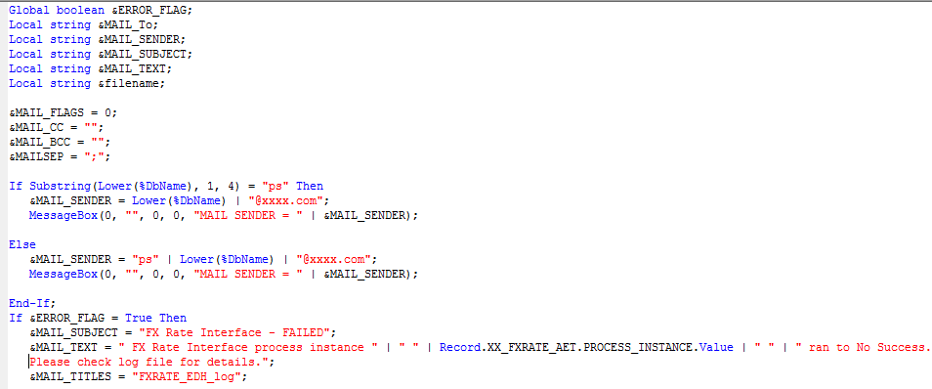

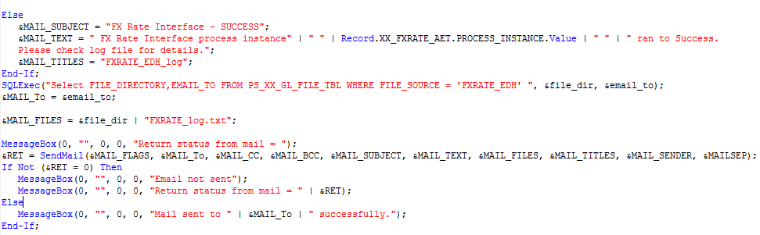

1. **Code to Handle the Errors**

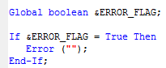

The code for error messages if any of the validations specified in 2(i) is included in the section of 2(i) itself.

1. **Custom Objects**

The following custom objects were created and used in the program:

* Table – PS_XX_GL_FILE_TBL.
* File layout – XX_FXRATE.
* Message sets:

|  |  |  |
| --- | --- | --- |
| **Message Set** | **Message Number** | **Message Description** |
| 20000 | 15 | Invalid From Currency |
| 20000 | 16 | Invalid To Currency |
| 20000 | 17 | Invalid Rate Type |
| 20000 | 18 | Invalid Effective Date |
| 20000 | 19 | Invalid Exchange Rate |

1. **Highlights**

* Reusable code
* Archival and Log file paths and Mail recipients are not hard coded but user input as program run control parameters.
* Archival file name contains date time stamp for logical storage and easy retrieval of files.
* Error messages are tailored based on type of error for easy understanding.
* Email message triggered to specified recipients after the process runs to Success / No Success