PROJECT DOCUMENTATION
Import Data Using Transform Maps
(Spreadsheet)
ServiceNow Data Import / Transform Map
Team ID: SWTID-2026-2567

Team Size | 4
Team Leader | Muthumathi S
Team Member | Pradeepa M
Team Member | Shobana S
Team Member | Varshini R

Team E-Mail IDs
Muthumathi S – rajiis2847@gmail.com
Pradeepa M – pradeepaambika30607@gmail.com
Shobana S – shobanaselvaraj008@gmail.com
Varshini R – varshini2007r@gmail.com@gmail.com

Contents
1. Introduction
2. Problem Statement and Proposed Solution
3. Source Spreadsheet and Data Structure
4. Implementation – Import Data Using Transform Maps
5. Field Mapping and Data Transformation
6. Testing and Validation
7. Benefits, Limitations and Future Enhancements
8. Conclusion
9. Key Learnings
Appendix A – Demonstrated Configuration Summary

1. Introduction

1.1 Project Overview
Importing employee data from a spreadsheet into ServiceNow is a common data-loading activity. A structured import process reduces repeated manual entry and provides a controlled way to move source data into a ServiceNow table. This project demonstrates the spreadsheet-to-ServiceNow import process using Load Data, an Import Set table, and a Transform Map.
The supplied spreadsheet contains employee information with the columns Employee ID, Name, Email, Department, and Location. The ServiceNow Load Data screen shown in the supplied screenshots uses an existing import-set table named “Employee Import [u_employee_import]” and accepts the spreadsheet as the import source.

1.2 Objective
- Prepare employee data in spreadsheet format for ServiceNow import.
- Use ServiceNow Load Data to upload the spreadsheet.
- Use an existing Import Set table to receive the imported source rows.
- Configure a Transform Map to map source fields to the target employee table.
- Transform and validate the imported records.
- Document the process using the supplied project screenshots.

1.3 Project Outcome
The project establishes a repeatable process for bringing spreadsheet data into ServiceNow. The screenshots demonstrate the source spreadsheet, the ServiceNow Load Data navigation, the Load Data form with the selected import table and spreadsheet, and a supporting Access Controls view.

1.4 Technologies and Components Used
Component | Purpose
Spreadsheet | Source file containing employee records.
ServiceNow Load Data | Loads spreadsheet rows into an Import Set table.
Import Set Table | Temporary/staging table used to hold imported source data.
Transform Map | Defines how source fields are mapped and transformed into target records.
Target Table | ServiceNow table that receives the transformed employee data.
Access Controls | Supporting configuration area for controlling record access where applicable.

2. Problem Statement and Proposed Solution

2.1 Problem Statement
Manual entry of employee information into ServiceNow can be slow and error-prone, especially when multiple records must be entered. Differences in spelling, email addresses, department names, or locations can also make the resulting data inconsistent.

2.2 Proposed Solution
The proposed solution is to prepare employee records in a spreadsheet, load the file into ServiceNow through Load Data, stage the rows in an Import Set table, and then use a Transform Map to map the source columns to the corresponding target fields. This provides a structured and repeatable import process.

2.3 Process Flow
- Prepare the employee spreadsheet with a header row.
- Open ServiceNow and navigate to Load Data.
- Select the existing Import Set table “Employee Import [u_employee_import]”.
- Choose the spreadsheet file and specify the sheet number and header row.
- Submit the Load Data request so the source rows are loaded into the Import Set.
- Open or create a Transform Map for the Import Set table.
- Map source fields such as Employee ID, Name, Email, Department, and Location to the target fields.
- Run the transform and review the resulting target records.
- Validate that the imported records contain the expected values.

2.4 Scope
- Spreadsheet preparation and source-data validation.
- ServiceNow Load Data configuration.
- Import Set staging.
- Transform Map field mapping and transformation.
- Basic validation of imported employee records.

2.5 Out of Scope
- External HR-system integration.
- Automated scheduled imports from a remote source.
- Complex scripted transformations not demonstrated in the supplied screenshots.
- Production data governance, archival, and enterprise identity synchronization.

3. Source Spreadsheet and Data Structure
The supplied spreadsheet screenshot shows a simple employee dataset. The first row contains the column headers and the following rows contain employee records. The visible columns are Employee ID, Name, Email, Department, and Location.

3.1 Spreadsheet Columns
Source Column | Example Value | Purpose
Employee ID | SB0001 | Unique employee identifier.
Name | user1 | Employee name or source-system user name.
Email | user1@gmail.com | Employee email address.
Department | Servicenow / Salesforce | Department or business function.
Location | Tamil nadu | Employee location.

3.2 Source Spreadsheet Screenshot
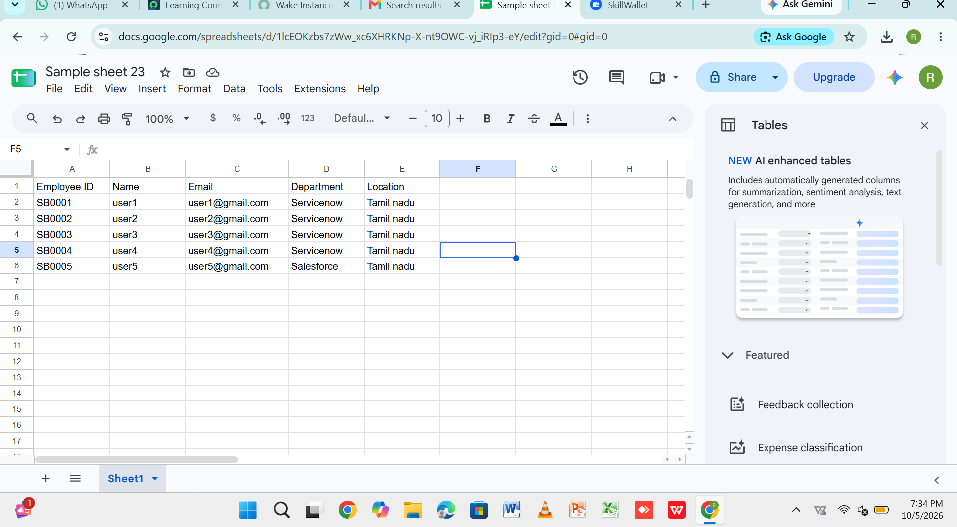
Figure 1. Source spreadsheet prepared for the ServiceNow import.
Observation: The sheet uses row 1 as the header row and contains employee records beneath it. This layout is suitable for a tabular import because each column represents a source field and each subsequent row represents one employee record.

4. Implementation – Import Data Using Transform Maps

4.1 Open Load Data in ServiceNow
- Sign in to the ServiceNow instance.
- Use the application navigator/search area and search for “Load Data”.
- Open the Load Data module under the appropriate import/data administration area.
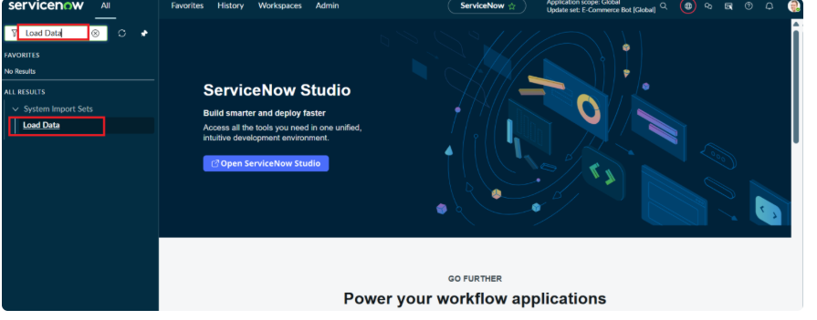
Figure 2. ServiceNow navigation showing the Load Data module.
Observation: The screenshot shows “Load Data” being located in the ServiceNow interface. This is the entry point for bringing spreadsheet data into an Import Set.

4.2 Configure the Load Data Form
- Choose Existing table when an Import Set table is already available.
- Select “Employee Import [u_employee_import]” as the Import Set table.
- Choose File as the source of the import.
- Select the spreadsheet file.
- Set Sheet number to 1 for the first worksheet.
- Set Header row to 1 because the first spreadsheet row contains the field names.
- Submit the form.
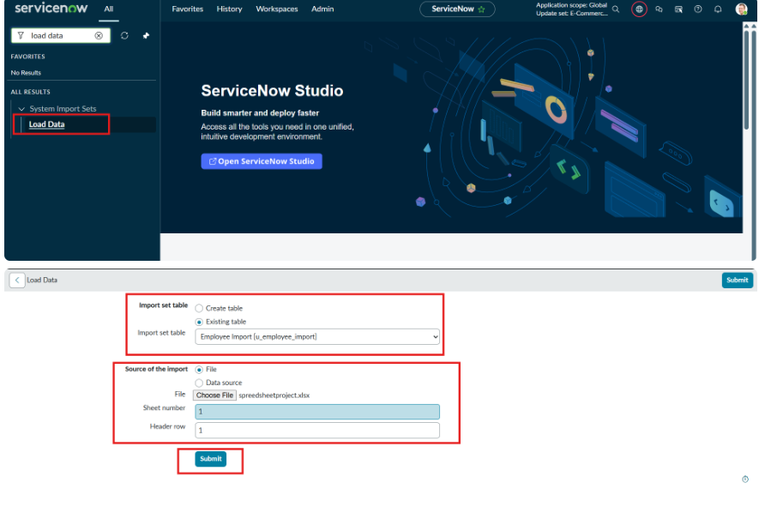
Figure 3. Load Data form configured with the Employee Import table and spreadsheet source.
Observation: The supplied screenshot shows Existing table selected, the Employee Import import-set table selected, File chosen as the source, and the sheet/header values set to 1.

4.3 Create or Open the Transform Map
- Open the Import Set / Transform Maps area in ServiceNow.
- Create a new Transform Map if one does not already exist for the Employee Import table.
- Select the Employee Import Import Set table as the source table.
- Select the intended employee target table.
- Define the field mappings between the source columns and target fields.
- If Employee ID is unique, use it as an appropriate coalesce/identification field when the target design requires update-versus-insert behavior.
- Save the Transform Map.
Important documentation note: the supplied screenshots show the spreadsheet and Load Data configuration, but they do not show the Transform Map field-mapping form itself. The mapping step above therefore describes the intended project implementation rather than claiming that an unseen mapping configuration is visible in the screenshots.

4.4 Run the Transform
- Open the completed Import Set run.
- Run the associated Transform Map.
- Review the transform result and any error or ignored rows.
- Open the target records and verify that the employee values were populated correctly.

4.5 Supporting Access Configuration
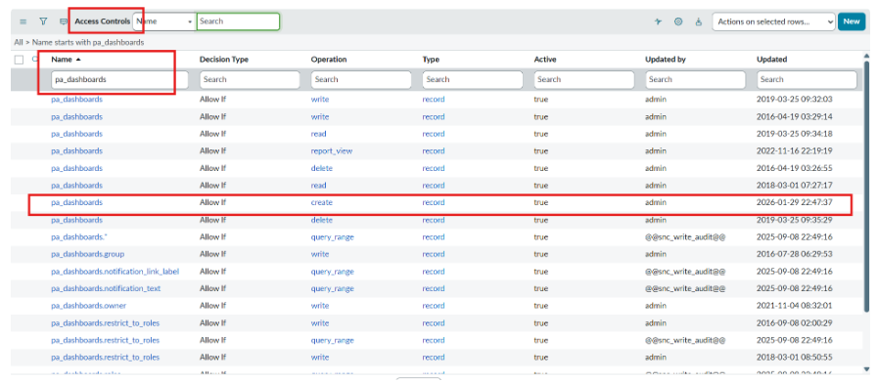
Figure 4. ServiceNow Access Controls view supplied as supporting configuration evidence.
Observation: This screenshot shows an Access Controls list and is included as supporting configuration evidence. It is not, by itself, evidence of the Transform Map field mappings. Access rules should be reviewed separately to ensure the intended users or roles can perform the required import and data operations.

5. Field Mapping and Data Transformation
The Transform Map is the key step that converts the staged spreadsheet data into the structure required by the target ServiceNow table. A straightforward mapping for the supplied spreadsheet can be documented as follows; the exact target field names should be verified against the target table used in the ServiceNow instance.
Source Field | Target Field | Transformation | Validation
Employee ID | Employee ID / unique identifier | Direct mapping | Check uniqueness and blanks
Name | Name | Direct mapping | Check that the value is present
Email | Email | Direct mapping | Check email format
Department | Department | Direct mapping or reference lookup | Check department value
Location | Location | Direct mapping or normalization | Check spelling/standard values

5.1 Data Validation Rules
- Employee ID should not be blank and should be unique where it is used as the identifying key.
- Email should contain a valid address format.
- Department and Location values should follow the naming conventions used by the target system.
- Unexpected blank or duplicate values should be reviewed before the transformed records are accepted.
- Transform errors should be investigated through the Import Set/transform results before re-running the import.

5.2 Insert versus Update Behavior
If the project requires repeated imports, the Transform Map can be designed to distinguish existing records from new records. A suitable unique source value, such as Employee ID, can be used as the coalesce field when the target-table design supports that approach. This helps prevent duplicate employee records during later imports.

6. Testing and Validation

6.1 Test Cases
Test | Expected Result | Evidence / Check | Status
T1 – Spreadsheet format | Headers and employee rows are present | Spreadsheet screenshot | Pass
T2 – Load Data setup | Employee Import table and file are selected | Load Data screenshot | Pass
T3 – Header/sheet selection | Sheet 1 and header row 1 are configured | Load Data screenshot | Pass
T4 – Transform mapping | Source fields map to intended target fields | Verify Transform Map in instance | To be verified
T5 – Transform result | Records are inserted/updated without unexpected errors | Review transform result and target table | To be verified

6.2 Validation Checklist
- Confirm the Import Set received the expected number of source rows.
- Confirm source columns were recognized correctly.
- Confirm the Transform Map is associated with the correct Import Set table and target table.
- Confirm the expected target records were inserted or updated.
- Check for transform errors, ignored rows, or duplicate records.
- Verify that access controls do not prevent the intended import/transform operation.

7. Benefits, Limitations and Future Enhancements

7.1 Benefits
- Reduces repetitive manual entry of employee records.
- Provides a consistent spreadsheet-to-ServiceNow data-loading process.
- Separates source staging from target record creation through the Import Set and Transform Map.
- Makes field mapping and transformation rules explicit and maintainable.
- Supports repeatable imports when source files follow the same structure.

7.2 Limitations of the Demonstrated Scope
- The supplied screenshots demonstrate spreadsheet preparation and Load Data configuration, but not the actual Transform Map field-mapping screen.
- The screenshots do not prove the final target-table transformation result.
- No external HR-system or scheduled integration is demonstrated.
- Complex data cleansing, reference lookups, and scripted transformations are outside the shown evidence.

7.3 Future Enhancements
- Add automated validation for email, Employee ID, Department, and Location.
- Use scheduled imports for recurring spreadsheet deliveries.
- Add transform scripts or reference lookups for standardized department and location values.
- Create import error reporting and notifications.
- Integrate the import process with an HR or identity-management source system.
- Add role-based controls and audit monitoring for import operations.

8. Conclusion
This project documents a practical ServiceNow approach for importing employee data from a spreadsheet using Load Data, an Import Set table, and a Transform Map. The supplied screenshots show the source spreadsheet and the ServiceNow Load Data setup, including the Employee Import table and file-selection configuration. The Transform Map provides the controlled mapping layer needed to move the staged source values into the intended target records.
The process can be extended with validation, scheduled imports, reference lookups, notifications, and integrations as the data-import requirement becomes more advanced.

9. Key Learnings
- How a spreadsheet can be structured for ServiceNow import.
- How Load Data is used to bring a file into an Import Set.
- Why an Import Set table is useful as a staging area.
- How a Transform Map controls source-to-target field mapping.
- How coalesce/unique-key design can help manage repeated imports.
- How to validate imported data and investigate transform errors.
- Why access controls should be considered when configuring import operations.

Appendix A – Demonstrated Configuration Summary
Configuration Item | Value / Evidence
Project | Import Data Using Transform Maps (Spreadsheet)
Team ID | SWTID-2026-2567
Team Size | 4
Source | Spreadsheet with Employee ID, Name, Email, Department, Location
Import method | ServiceNow Load Data
Import Set table | Employee Import [u_employee_import]
Sheet number | 1
Header row | 1
Transform layer | Transform Map
Supporting configuration | Access Controls screenshot supplied

End of Project Documentation

