Seasonal Agriculture Performance Analysis
VOIS AICTE Batch 1 (2026–2027) — Major Project Report
Prepared by: Muthumenen M
B.Tech — Artificial Intelligence and Data Science
Dhanalakshmi Srinivasan University, Tamil Nadu, India
Dataset: seasonal_agriculture_performance_dataset.xlsx | 4,000 farm records | 28 columns

1. Introduction
The dataset analyzed in this project represents agricultural activity across three cropping seasons (Kharif, Rabi and Zaid), eight Indian states, ten districts, eight crops and four irrigation methods. It records environmental conditions, resource usage, crop outcomes and economic performance for 4,000 individual farm records, providing an opportunity to study how agricultural performance changes across seasons and to identify meaningful, evidence-based patterns.

2. Problem Statement
Agricultural activities are influenced by seasonal variation in environmental conditions, farming practices, resource availability and market conditions, so performance may differ meaningfully between seasons. Raw agricultural data alone does not make these seasonal differences clear. This project analyzes the given dataset to investigate seasonal differences in agricultural performance by identifying patterns, trends, relationships and variations supported by the data.

3. Objectives
- Explore and understand the dataset structure and quality.
- Clean and prepare the data for analysis, documenting every treatment applied.
- Examine how agricultural performance varies across seasons.
- Identify important seasonal patterns, trends and relationships with environmental conditions.
- Compare relevant groups (crop, state, irrigation method) within seasons.
- Apply appropriate statistical tests (alpha = 0.05) and visualizations.
- Develop evidence-based conclusions and data-driven recommendations for seasonal planning.

4. Dataset Description
The cleaned dataset used for analysis contains 4,000 records and 28 columns (28 original columns plus 4 derived economic metrics). Categorical variables include State (8 values), District (10), Crop (8), Season (3: Kharif, Rabi, Zaid) and Irrigation Method (4). Numeric columns span environmental conditions, resource inputs, yield/production, and economic results.

5. Methodology
The analysis followed a standard data-analytics workflow: (1) initial inspection and data-quality audit, (2) documented cleaning and preprocessing, (3) exploratory data analysis, (4) the core seasonal performance comparison, (5) crop-wise and regional breakdowns, (6) environmental and resource-usage relationship analysis, (7) irrigation and economic performance analysis, (8) water-efficiency and disease/pest-risk analysis, (9) formal statistical testing at alpha = 0.05, (10) outlier/anomaly review, and (11) an advanced composite-scoring and regression exercise. Every figure and table in this report is generated directly from the cleaned dataset (`df_clean`) using the same code as the accompanying Jupyter Notebook, so the two are numerically consistent.

6. Data Preprocessing
The raw dataset had no duplicate rows and no formatting/whitespace issues in its categorical columns. Missing values were found only in three numeric columns: Rainfall_mm (48 records), Soil_Moisture_pct (40) and Yield_Tonnes_Ha (32) — together under 1.5% of the dataset. Rainfall and soil moisture were imputed using the median for their own Season group, since both vary strongly by season; yield was imputed using the median for its own Crop group, since yield varies by roughly two orders of magnitude between crops (notably Sugarcane).
Extreme values in Yield_Tonnes_Ha (up to 101 t/ha) were investigated rather than removed: 97.04% of the 304 flagged records are Sugarcane, a crop that genuinely yields far more per hectare than grains or pulses. These were retained as legitimate values. The Revenue − Total Cost = Profit identity was verified to hold exactly across all records, and the Revenue/Cost/Profit fields required no correction.
One data-quality characteristic worth noting: the District field does not map uniquely to a single State (several district names recur under more than one state), indicating State and District were populated independently rather than as a true geographic hierarchy. Regional analysis in this report is therefore presented at the State level.

7. Exploratory Data Analysis
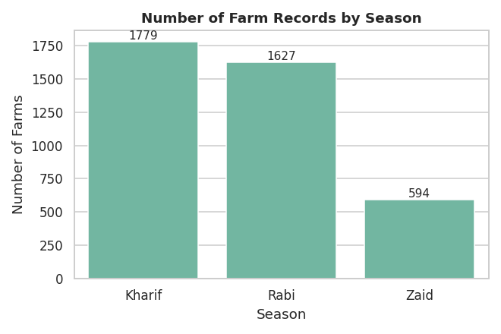
Kharif is the most represented season (44%), followed by Rabi (41%) and Zaid (15%) — consistent with Zaid being a shorter, irrigation-dependent cropping window in practice.
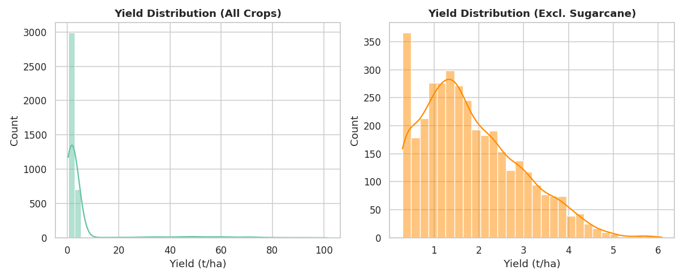
Yield and production are strongly right-skewed due to the Sugarcane crop group; once Sugarcane is excluded the remaining distribution is much closer to symmetric.

8. Seasonal Performance Analysis
The table below summarizes the core seasonal metrics computed from the cleaned dataset.
Metric | Kharif | Rabi | Zaid
Number of farms | 1779 | 1627 | 594
Avg. rainfall (mm) | 852 | 436 | 299
Avg. temperature (°C) | 28.45 | 23.49 | 31.04
Avg. humidity (%) | 71.81 | 57.89 | 52.01
Avg. yield (t/ha) | 5.63 | 5.1 | 4.64
Total production (t) | 82,388 | 67,499 | 23,098
Avg. profit (INR) | 178,915 | 87,689 | -24,805
Avg. water efficiency (t/1000m3) | 5.89 | 5.19 | 4.41
Avg. disease/pest risk (%) | 54.47 | 40.48 | 38.22

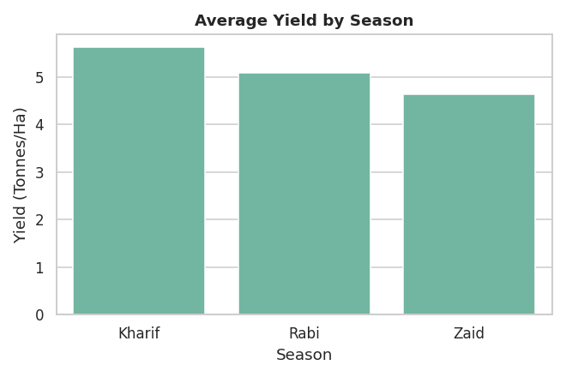
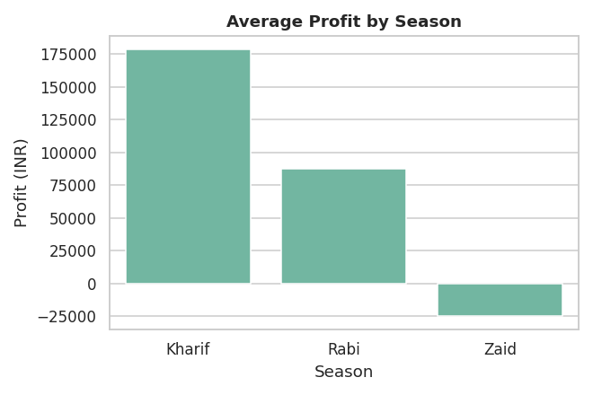

9. Crop-wise Seasonal Analysis
Sugarcane in Kharif is the single best-performing Season x Crop combination by average yield (53.46 t/ha); Pulses in Zaid is the lowest (0.66 t/ha). By average profit, Sugarcane in Kharif performs best (INR 10,00,791), while Rice in Zaid performs worst (INR -2,27,239).
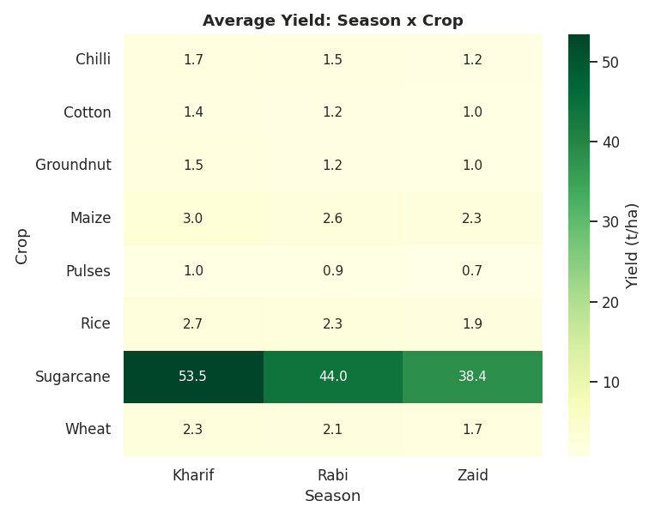
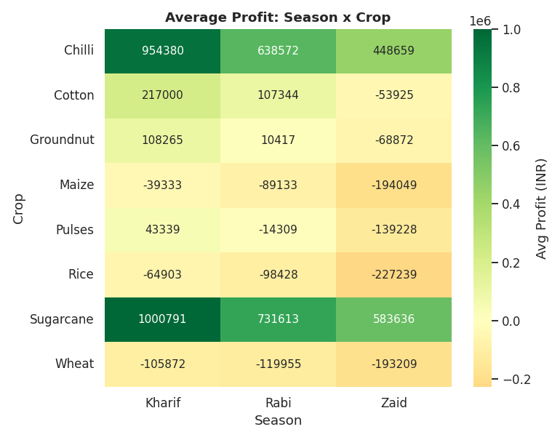

10. Regional Analysis
Because District does not map uniquely to State in this dataset, regional analysis is reported at the State level. Seasonal yield rankings are broadly consistent across states: Telangana shows the most consistent seasonal pattern (coefficient of variation 13.46%), while Maharashtra shows the least consistent pattern (41.93%).
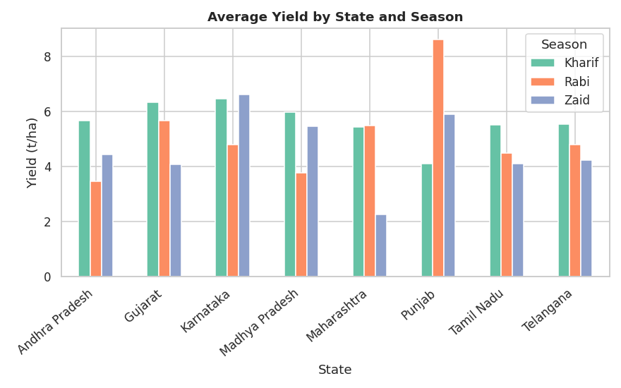

11. Environmental Analysis
Correlation coefficients between environmental variables and outcomes were generally weak in magnitude (mostly |r| < 0.2), meaning no single environmental variable strongly predicts yield or profit on its own — crop choice plays a much larger role (see Section 16). Correlation does not establish causation; these results describe association only.
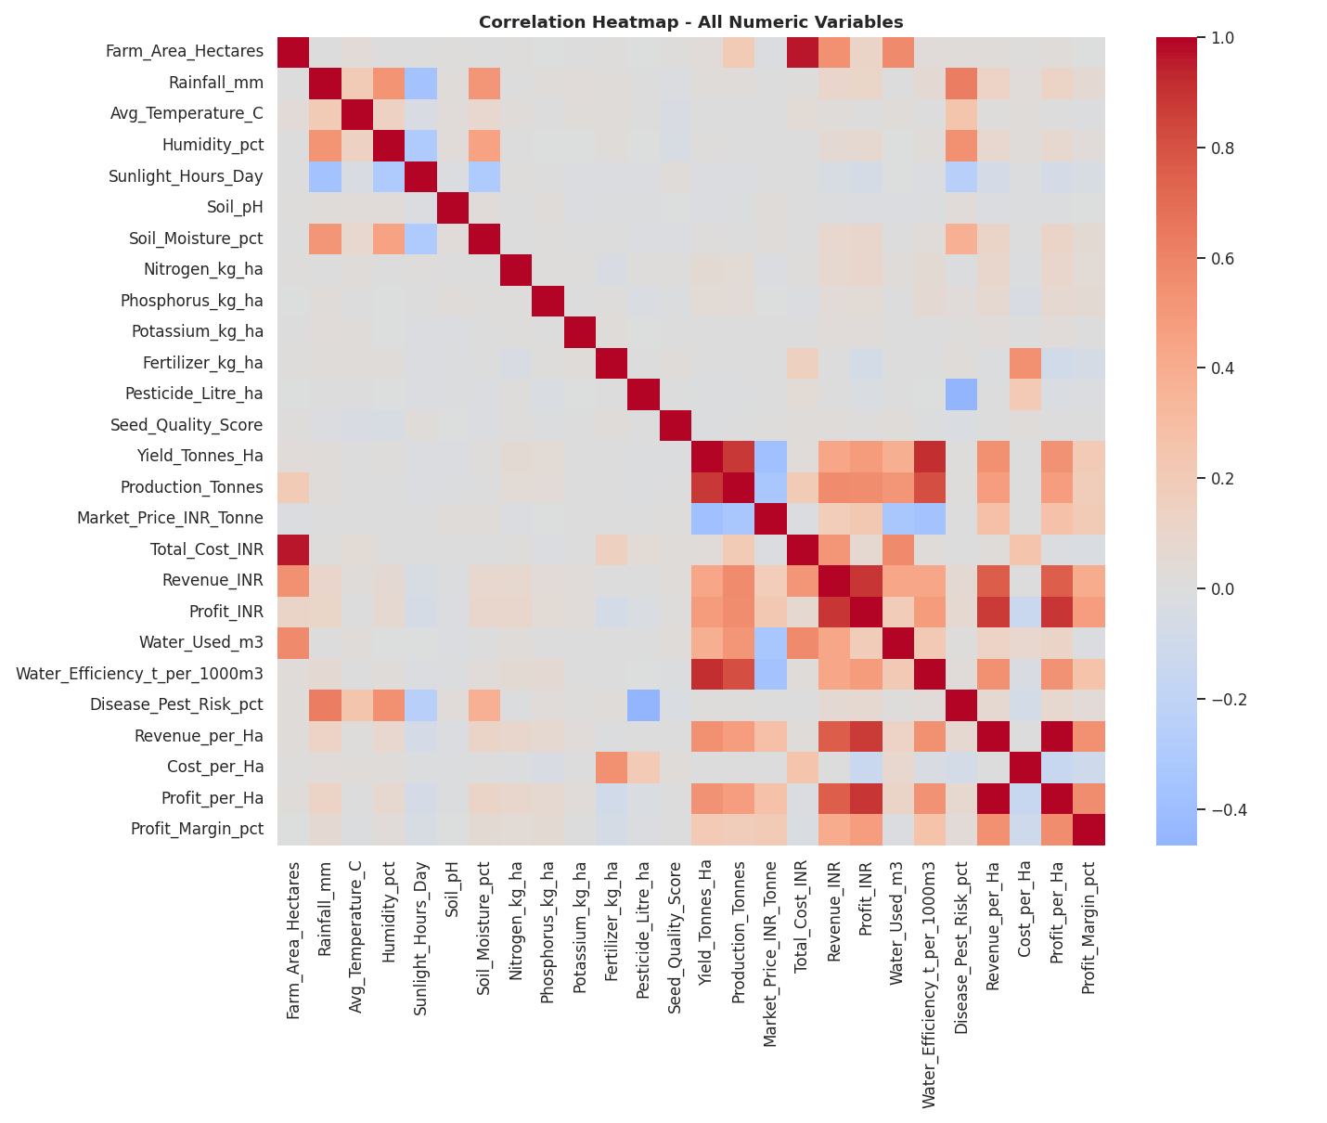
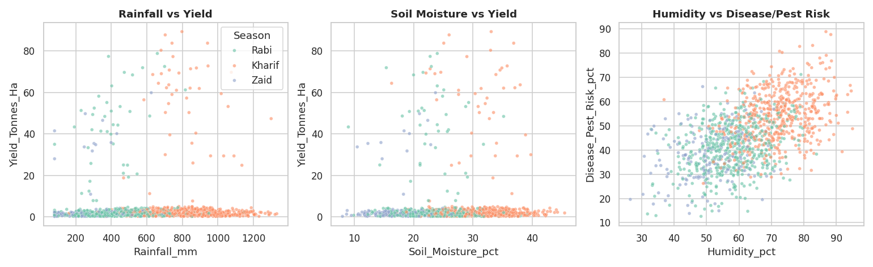

12. Resource Usage Analysis
Fertilizer, pesticide, and water usage were broadly similar across the three seasons, and none showed a strong correlation with yield, profit, or disease/pest risk — resource quantity alone is not a strong predictor of outcome in this dataset.

13. Irrigation Analysis
Irrigation Method | Farms | Avg. Yield (t/ha) | Avg. Profit (INR) | Avg. Water Efficiency | Avg. Disease Risk (%)
Drip | 915 | 6.68 | 219,626 | 6.27 | 45.79
Flood | 1310 | 4.86 | 73,354 | 3.44 | 46.6
Rainfed | 1041 | 4.6 | 79,050 | 7.56 | 46.49
Sprinkler | 734 | 5.16 | 91,121 | 4.67 | 46.48

A Kruskal-Wallis test found a statistically significant difference in water efficiency across irrigation methods (H = 573.863, p < 0.001). This is an observational association — irrigation choice may also reflect crop or regional water availability — not proof that switching methods alone causes the difference.
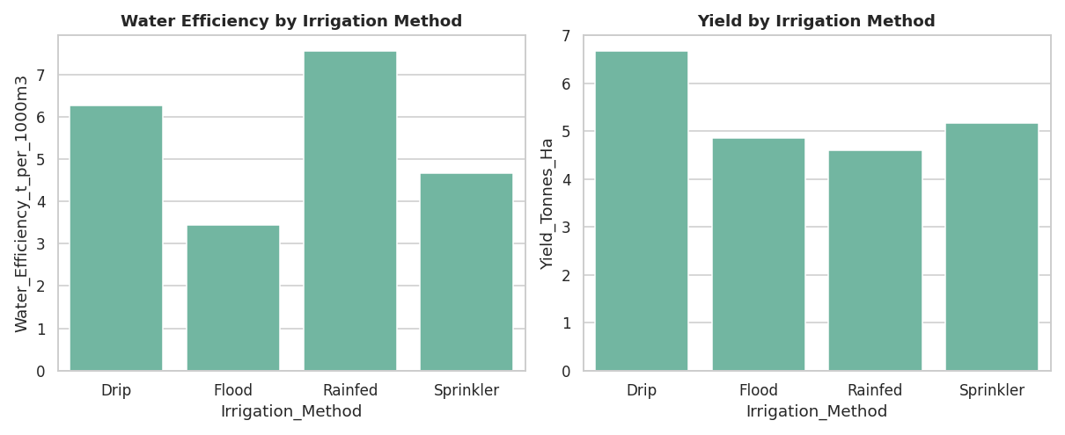

14. Economic Performance Analysis
Profit_per_Ha, Revenue_per_Ha and Cost_per_Ha are derived as the corresponding total divided by Farm_Area_Hectares; Profit_Margin_pct is Profit_INR / Revenue_INR x 100. The Revenue − Total Cost = Profit identity was verified to hold exactly for every record, so no reconciliation was needed.
Metric | Kharif | Rabi | Zaid
Avg. revenue (INR) | 710,719 | 601,526 | 519,172
Avg. cost (INR) | 531,804 | 513,837 | 543,977
Avg. profit (INR) | 178,915 | 87,689 | -24,805
Avg. profit per hectare (INR) | 21,882 | 10,362 | -2,637
Share of loss-making farms (%) | 42.21 | 51.14 | 64.48
Total profit (INR) | 318,289,158 | 142,670,768 | -14,734,066

Overall, 49.15% of all farm records operate at a loss. Zaid shows both the lowest average profit and the highest share of loss-making farms among the three seasons.
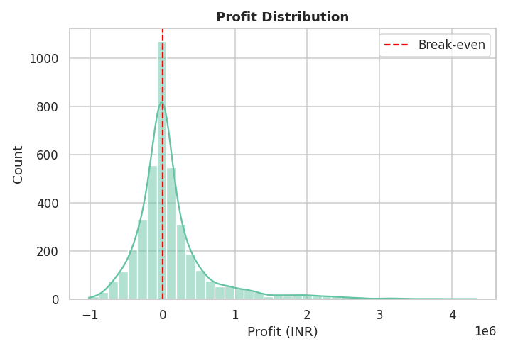

15. Water Efficiency Analysis
Average water efficiency by season: Kharif 5.89, Rabi 5.19, Zaid 4.41 (tonnes per 1000 m3). Sugarcane shows the highest water efficiency by crop, consistent with its much higher yield per hectare, even though it also uses more water in absolute terms.
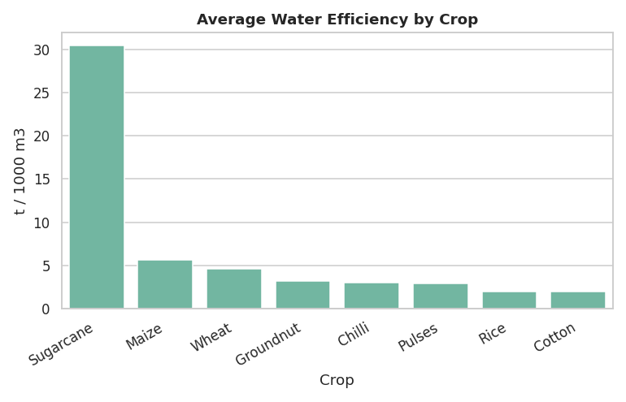

16. Disease and Pest Risk Analysis
Kharif shows the highest average disease/pest risk (54.47%), coinciding with its higher humidity. Humidity correlates more strongly with disease/pest risk than pesticide usage does — consistent with pesticide application being a response to anticipated risk rather than a simple driver of realized risk.
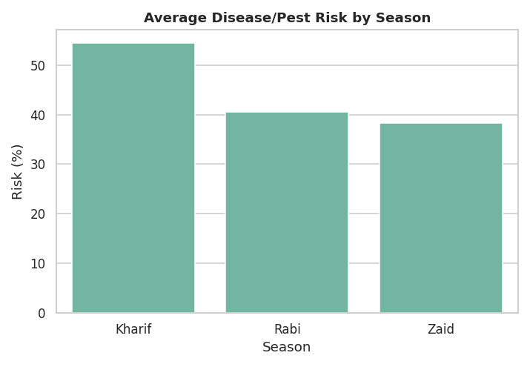

17. Statistical Analysis (alpha = 0.05)
Both one-way ANOVA and the non-parametric Kruskal-Wallis test were used to compare each outcome across seasons, since some outcomes (notably yield) are heavily right-skewed. Where the two disagree, Kruskal-Wallis is treated as the primary result because ANOVA's normality assumption is violated by the skew.
Metric | ANOVA p | Kruskal-Wallis p | Significant?
Yield_Tonnes_Ha | 0.2369 | < 0.001 | Yes
Profit_INR | < 0.001 | < 0.001 | Yes
Water_Efficiency_t_per_1000m3 | < 0.001 | < 0.001 | Yes
Disease_Pest_Risk_pct | < 0.001 | < 0.001 | Yes
Rainfall_mm | < 0.001 | < 0.001 | Yes

Chi-square tests found no statistically significant association between Season and Crop (p = 0.455) or between Season and Irrigation Method (p = 0.742) — crops and irrigation methods are distributed in broadly similar proportions across seasons, so the Season x Crop differences reported earlier reflect genuine performance differences rather than a shifting crop mix.

18. Outlier and Anomaly Analysis
Yield outliers identified via the IQR method are concentrated almost entirely in Sugarcane (97.04% of 304 flagged records), confirming these are legitimate crop-driven extremes rather than data-entry errors. No records were removed on this basis.
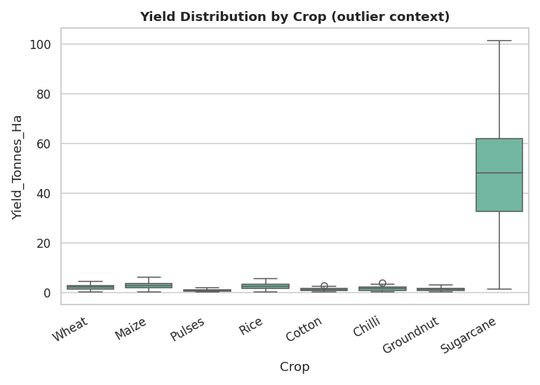

19. Advanced Analysis
A composite Seasonal Performance Score (weighted, min-max normalized combination of average yield, average profit, average water efficiency, and inverse disease risk) ranks the seasons as follows:
Season | Seasonal Performance Score
Kharif | 0.8
Rabi | 0.583
Zaid | 0.2

By crop profitability (profit per hectare), Sugarcane ranks highest (INR 97,170/ha) and Wheat ranks lowest (INR -15,969/ha).
A standardized linear regression of yield on rainfall, soil moisture, fertilizer, seed quality and temperature (excluding Sugarcane) achieved R-squared = 0.031 — confirming that these variables explain only a modest share of yield variation, and that crop choice is the dominant driver of yield in this dataset.
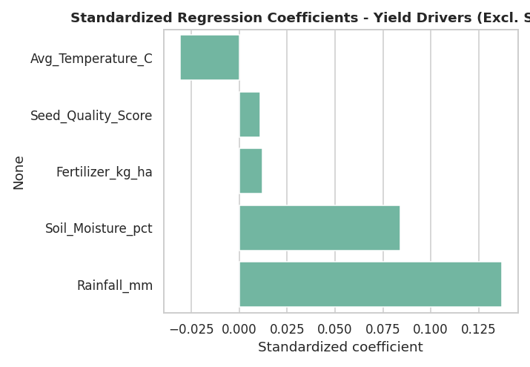

20. Key Findings
- Kharif recorded the highest average yield at 5.63 t/ha, versus 4.64 t/ha in Zaid.
- Kharif shows the highest average profit per farm (INR 1,78,915), compared with INR -24,805 in Zaid.
- Season has a statistically significant effect on yield, profit, water efficiency and disease/pest risk (Kruskal-Wallis, all p < 0.05), though effect sizes are modest.
- Irrigation method is significantly associated with water efficiency (p < 0.001); Rainfed and Drip methods show the highest average efficiency in this dataset.
- Kharif shows the highest average disease/pest risk (54.47%), coinciding with higher humidity.
- Sugarcane is the most profitable crop per hectare on average; Wheat is the least profitable.
- 97.04% of yield outliers are Sugarcane, confirming they are legitimate crop-driven extremes.
- 49.15% of all farm records operate at a loss overall, highest in Zaid.
- Season shows no significant association with Crop or Irrigation Method mix (both chi-square p > 0.05).
- A yield regression excluding Sugarcane achieves only R-squared = 0.031, showing crop choice dominates over environmental/resource variables.

21. Seasonal Comparison Summary
Metric | Kharif | Rabi | Zaid | Best Season
Avg. rainfall (mm) | 852 | 436 | 299 | Kharif
Avg. yield (t/ha) | 5.63 | 5.1 | 4.64 | Kharif
Avg. profit (INR) | 178,915 | 87,689 | -24,805 | Kharif
Avg. water efficiency | 5.89 | 5.19 | 4.41 | Kharif
Avg. disease/pest risk (%) | 54.47 | 40.48 | 38.22 | Kharif (highest risk)
Seasonal performance score | 0.8 | 0.583 | 0.2 | Kharif

22. Conclusions
Yield, profit, water efficiency and disease/pest risk all differ measurably and statistically significantly across Kharif, Rabi and Zaid. However, the size of these differences is generally modest once crop mix is accounted for, and crop choice remains the single largest driver of yield and profit outcomes in this dataset. Kharif — the monsoon season — combines the highest rainfall, highest average yield and highest average profit, but also the highest disease/pest risk, reflecting a genuine trade-off rather than one season being unambiguously "best" on every dimension. Zaid is the weakest season economically, with the highest share of loss-making farms. Environmental and resource-usage variables show only weak individual correlations with outcomes; crop selection, not small variations in weather or input levels, is the dominant factor behind performance differences in this dataset.

23. Recommendations
- Give crop-specific seasonal guidance using the Season x Crop tables (Section 9) rather than one blanket recommendation for 'the best season', since crop choice drives most of the outcome difference.
- Intensify disease/pest monitoring during Kharif, the season with the highest humidity and disease/pest risk, rather than applying uniform monitoring year-round.
- Review irrigation method choice against the water-efficiency comparison (Section 13) in water-constrained regions, since irrigation method is significantly associated with water efficiency.
- Prioritize cost review for the lowest-profit season-crop combinations identified in Section 9, since 49.15% of all records operate at a loss.
- Treat fertilizer/pesticide increases cautiously — resource usage correlates only weakly with yield, profit or reduced risk in this dataset, so input efficiency is a more defensible target than raw usage volume.

24. Limitations
- Observational, not experimental data — none of the relationships reported (e.g. rainfall-yield, humidity-disease risk) can be interpreted as causal.
- The State-District field does not form a true geographic hierarchy, so regional analysis is reported at the State level only.
- Crop mix differs somewhat across seasons; season-level averages partly reflect which crops are grown in that season (addressed via Season x Crop breakdowns).
- A single snapshot per farm per season — year-to-year variability within a season cannot be assessed.
- The yield regression's low R-squared indicates unobserved factors (exact practices, pest incidents, soil type beyond pH/moisture) likely matter more than what this dataset captures.
- Three numeric columns with under 1.5% missingness were median-imputed; this is a documented estimate, not an observed value, for those records.

25. Future Scope
- Extend the dataset to a multi-year panel to separate season effects from year-to-year weather variability.
- Collect a verified State-District geographic mapping to enable true district-level regional analysis.
- Capture additional agronomic variables (soil type, sowing date, pest incident records) to improve the explanatory power of yield models.
- Apply crop-specific regression or machine-learning models instead of a single pooled model, given how strongly yield scale differs by crop.

26. References
- Dataset: seasonal_agriculture_performance_dataset.xlsx (provided as part of the VOIS AICTE Batch 1 2026-2027 Major Project brief).
- Project brief: VOIS AICTE Batch1 2026-2027 - Major Project: Seasonal Agriculture Performance Analysis (provided PDF).
- Python libraries used: pandas, numpy, matplotlib, seaborn, scipy, scikit-learn.

