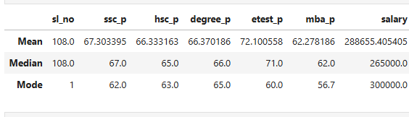

According to the data above, all students, from SL to MBA, perform on average, but only in the entrance exam do they score well, averaging 72%. I discovered an outlayer in the salary section, therefore I reported the mean of 288656, the median of 265000, and the mode of 300000.

