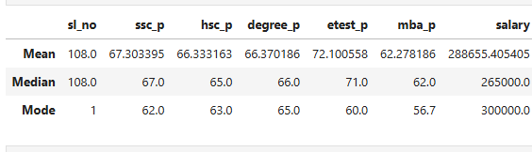

According to the data above, all students, from SL to MBA, perform on average, but only in the entrance exam do they score well, averaging 72%. I discovered an outlayer in the salary section, therefore I reported the mean of 288656, the median of 265000, and the mode of 300000.

Percentile
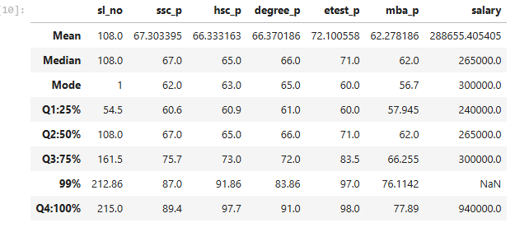

According to the data above, all students, from SL to MBA, performed in the percentile in SL. No, 25% to 50% was 53.5, 50 to 75 = 53, 75 to 99 = 51, and 99 to 100 = 1% on SL. The student got their marks by seeing this medial range performance, ssc_ p 25% to 50% was 05, 50 to 75 = 08, 75 to 99 = 12, 99 to 100 = 2%. On SSC_P the student got their marks by seeing this bellow avg performance, HSC_ 25% to 50% was 05, 50 to 75 = 08, 75 to 99 = 18, and 99 to 100 = 2%. On HSC_P, the student got their marks by seeing this below-average percentile, Degree_P 25% to 50% was 05, 50 to 75 = 06, 75 to 99 = 11, and 99 to 100 = 9%. In degree_P, the student got their marks by seeing this avg percentile degree. Etest 25% to 50% was 01, 50 to 75 = 07, 75 to 99 = 14, and 99 to 100 = 1% on Etest The student got their marks by seeing this avg percentile MBA_P25% to 50% was 04, 50 to 75 = 04, 75 to 99 = 10, and 99 to 100 = 1%. On MBA_p, the student got their marks by seeing this bellow avg percentile.

