Eye State Prediction Using EEG Signals (KNN)
A mini project report on EEG-based eye state classification

1. INTRODUCTION
Eye state, whether a person's eyes are open or closed, can be picked up from brain activity recorded through EEG. The brain regions near the back of the head, especially the occipital area, are closely tied to vision, so they react differently depending on whether the eyes are open or shut. This makes EEG a workable input for predicting eye state without needing a camera at inference time.
This project uses a publicly available EEG dataset recorded with the Emotiv EEG Neuroheadset. The recording ran for 117 seconds in one continuous session, with 14 electrode channels capturing brain activity. While the EEG was being recorded, a camera also recorded the subject's face, and the video was reviewed afterward to manually label each EEG sample as eye-open or eye-closed. In the dataset, the value 1 means eye-closed and 0 means eye-open. The goal of the project is to train a machine learning model, specifically K-Nearest Neighbors (KNN), that can classify the eye state directly from the 14 EEG channel readings.

1.1 ELECTRODE PLACEMENT
The Emotiv headset records from 14 electrodes positioned around the scalp, following the standard 10-20 placement system. Each electrode sits over a different region of the brain, and the regions are grouped as shown below:
- AF3, AF4 - Anterior frontal: attention and executive control
- F7, F3, F4, F8 - Frontal: cognition, emotion, motor planning
- FC5, FC6 - Fronto-central: decision-making, motor control
- T7, T8 - Temporal: auditory processing, memory
- P7, P8 - Parietal: sensory integration, spatial awareness
- O1, O2 - Occipital: visual cortex, the region most directly tied to eye state
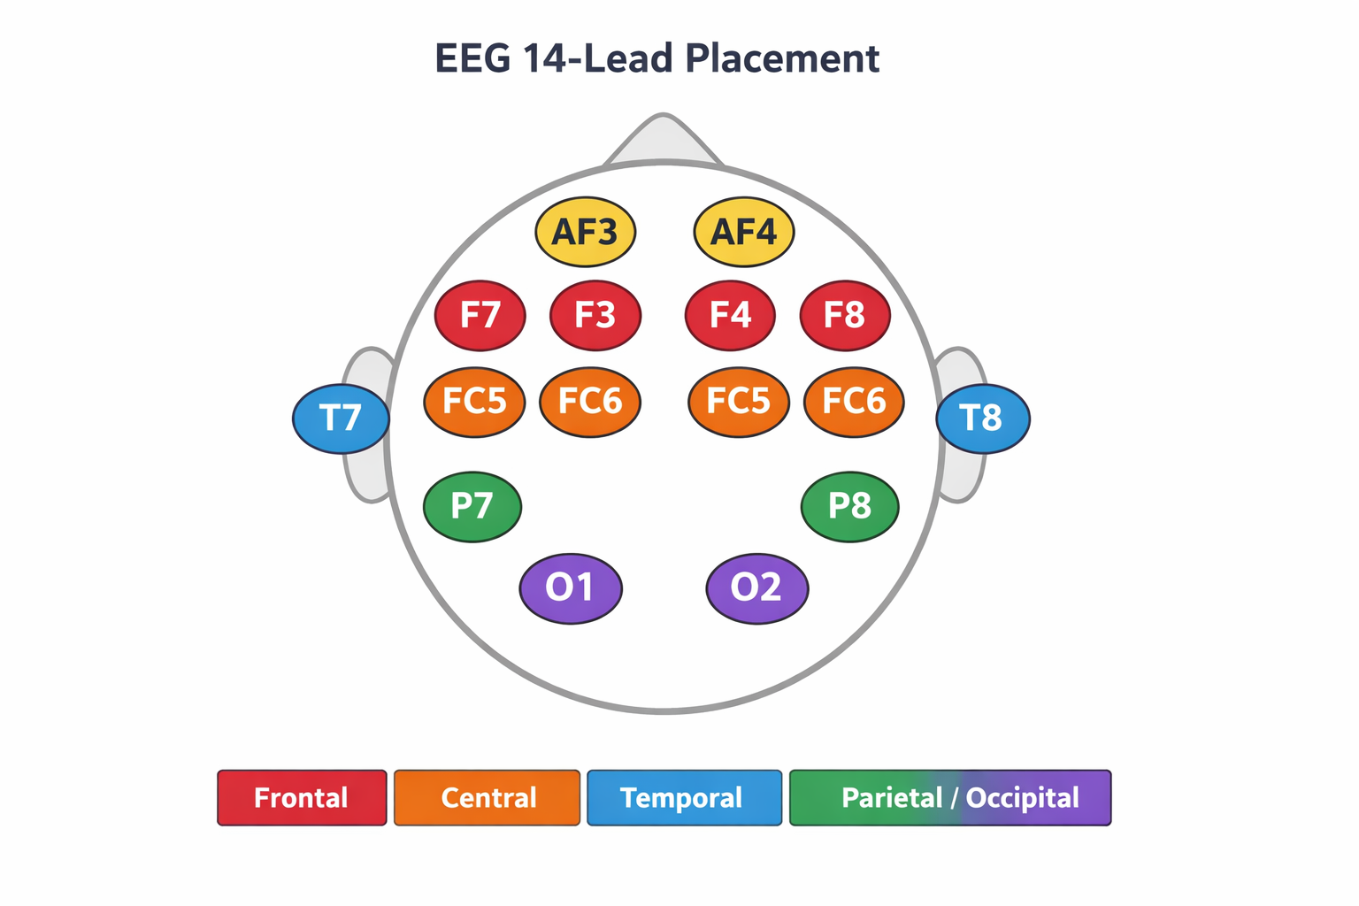
14-lead EEG electrode placement used in the dataset

2. EXPLORATORY DATA ANALYSIS
Before building any model, the data needs to be understood. The dataset has 14 EEG channel columns plus the target column ‘eyeDetection’, with close to 15,000 rows recorded in chronological order. A quick check showed no missing values, but a closer look at the value ranges told a different story.

2.1 BOXPLOTS - SPOTTING OUTLIERS
Boxplots revealed a few extreme outliers in most EEG channels. For example, AF3 typically stays below a few thousand, but one value exceeds 300,000, indicating sensor noise rather than genuine brain activity.
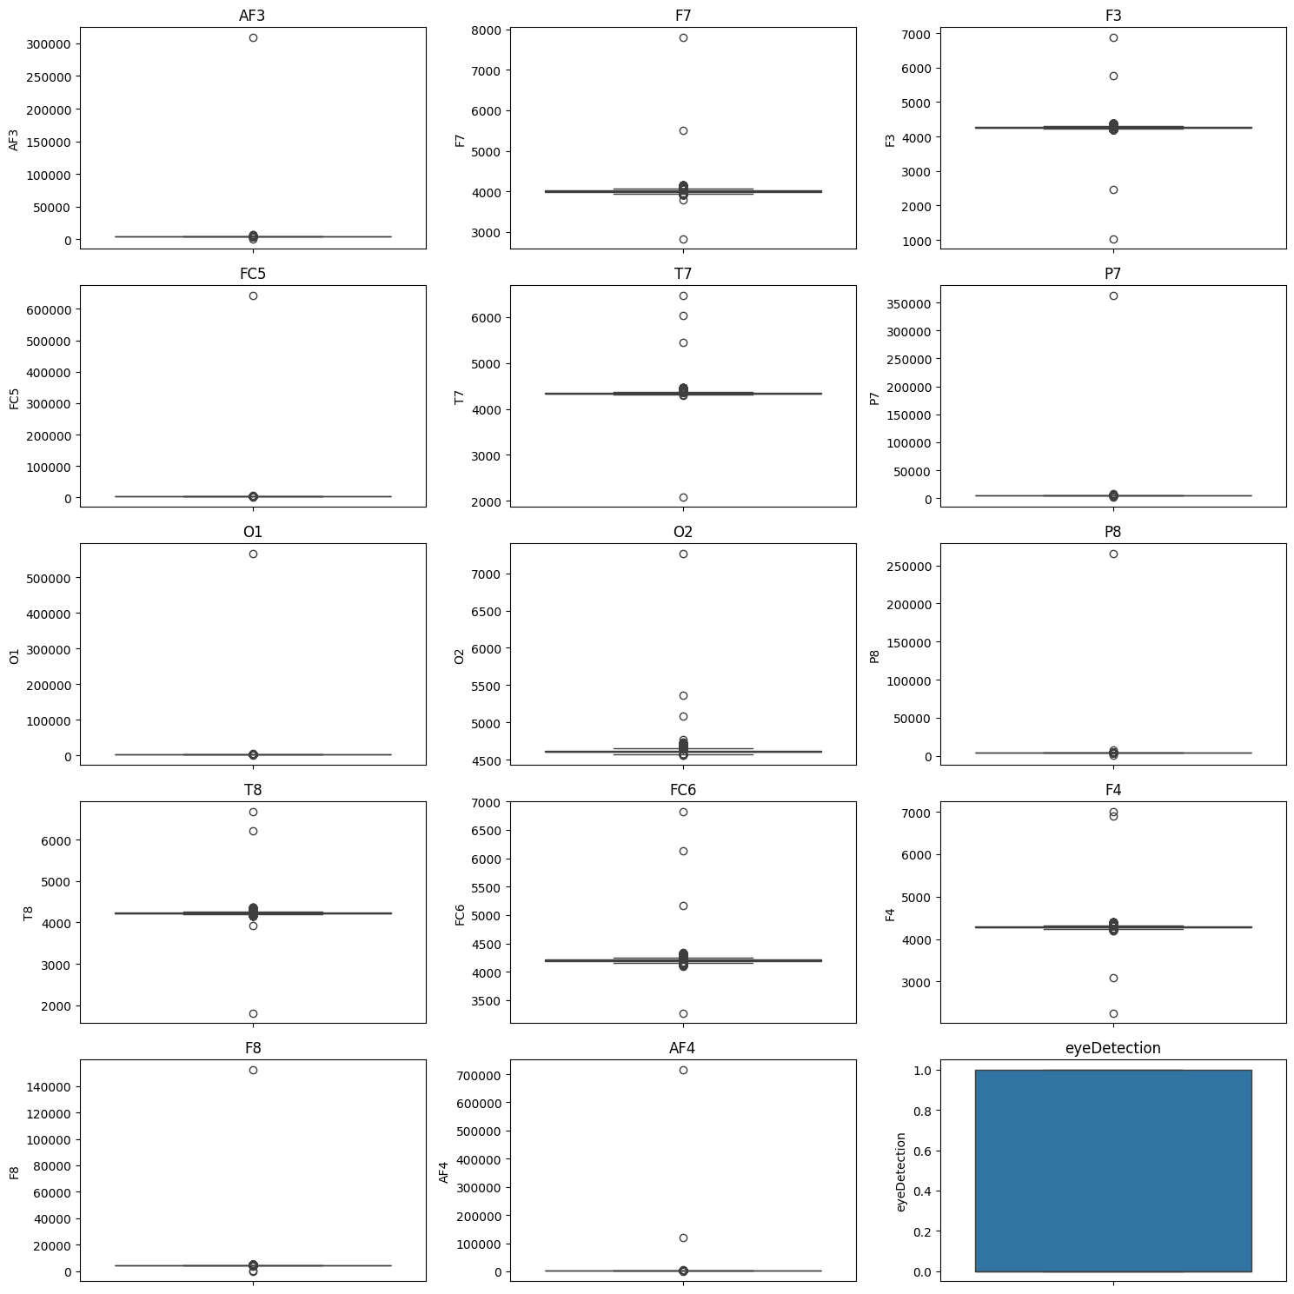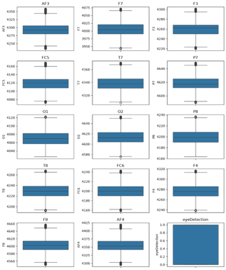
Boxplots of all 14 channels before outlier removal and Boxplots after IQR-based outlier removal

These extreme values are likely caused by recording artifacts such as powerline interference, subject movement, or poor electrode contact. Since only a small number of observations were affected, the IQR method was used to remove the outliers. After filtering, the EEG channels showed more realistic value ranges, and any rows containing null values were removed, resulting in a cleaner dataset for further analysis.

2.2 KDE PLOTS - DISTRIBUTION SHAPE
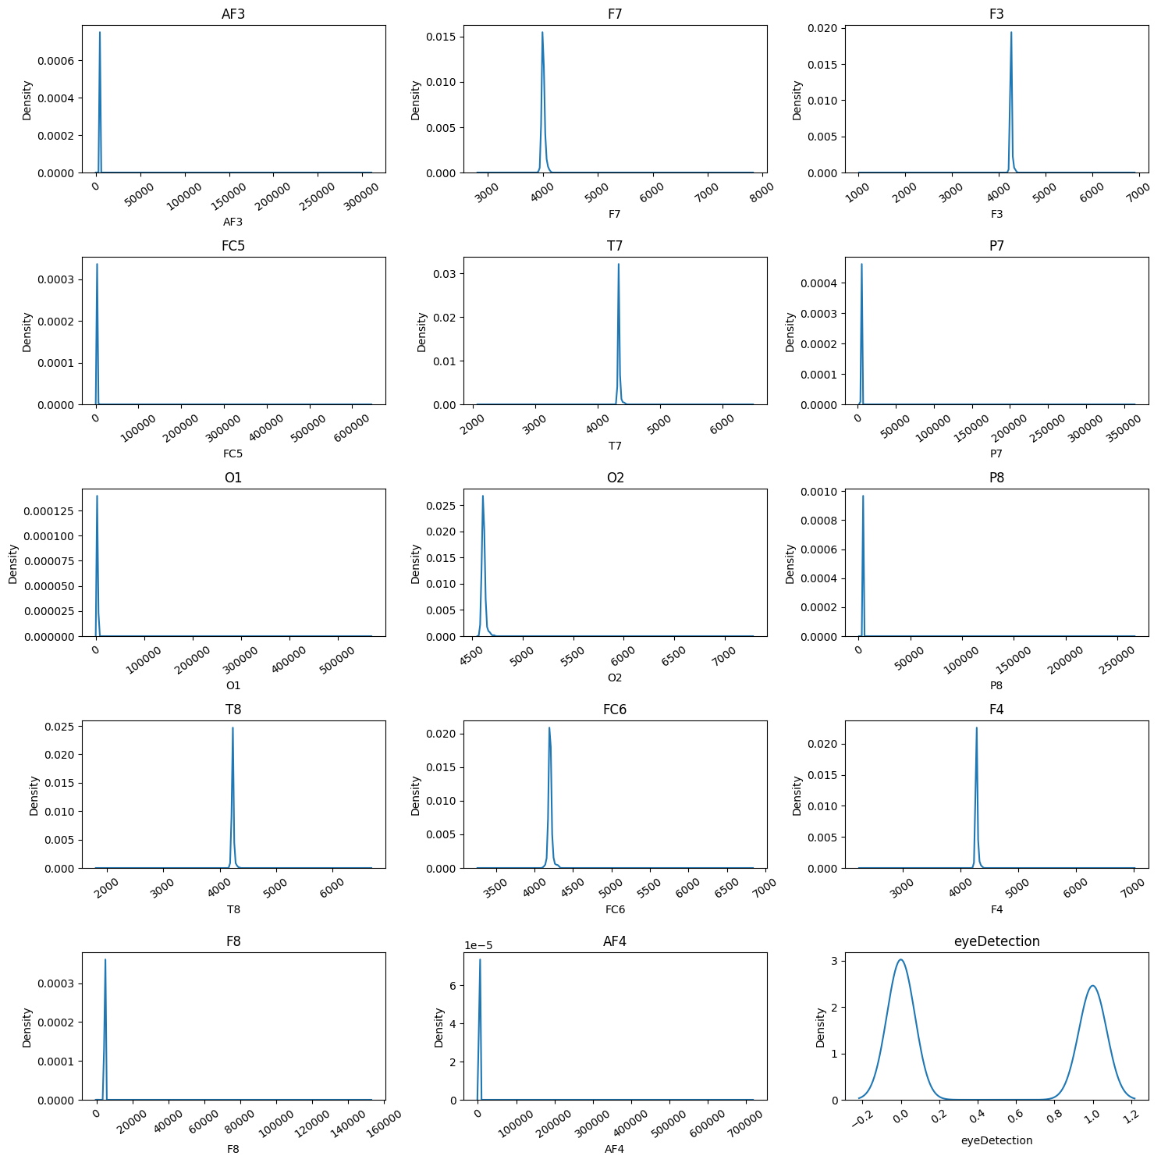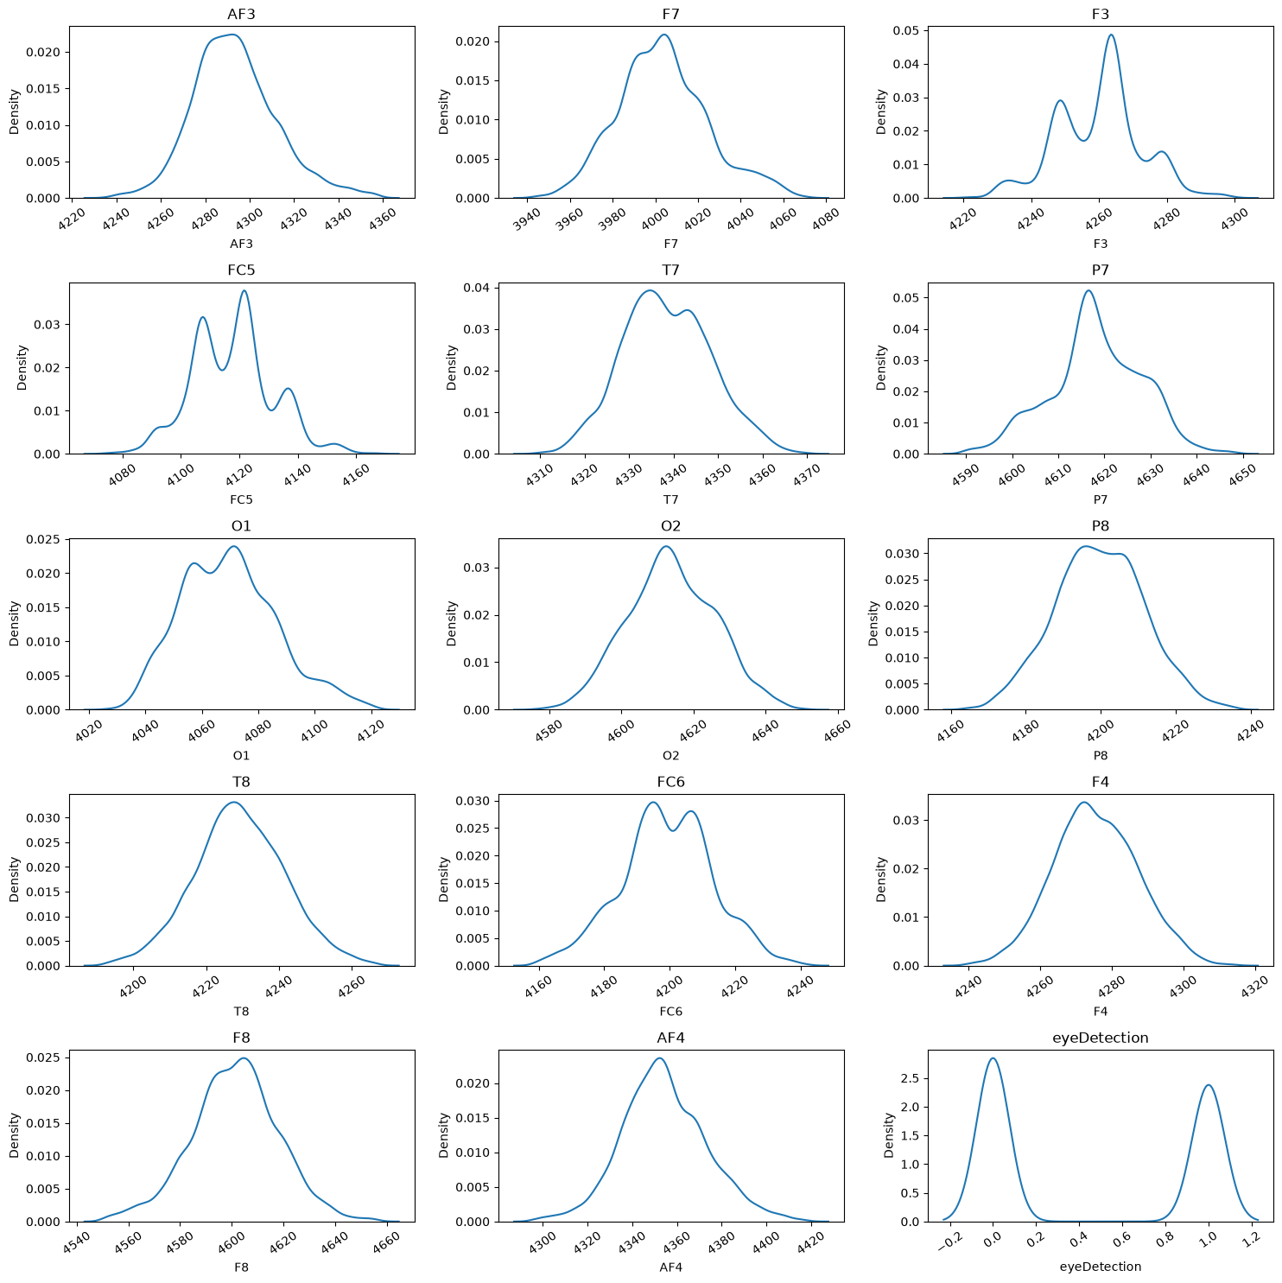
KDE plots before outlier removal, heavily skewed by extreme values and KDE plots after outlier removal, closer to a normal distribution

KDE plots showed that the EEG features were highly skewed before cleaning due to the presence of extreme outliers. After outlier removal, the distributions became much smoother and closer to a normal bell-shaped curve, making the data more suitable for model training.

2.3 PAIRPLOT - RELATIONSHIPS BETWEEN FEATURES
A pairplot was generated across all cleaned features to look at how channels relate to each other. Most pairs of channels are scattered fairly broadly across the plotting space, but some pairs, particularly channels positioned close together on the scalp, show a visible linear trend, which hints at redundancy between them.
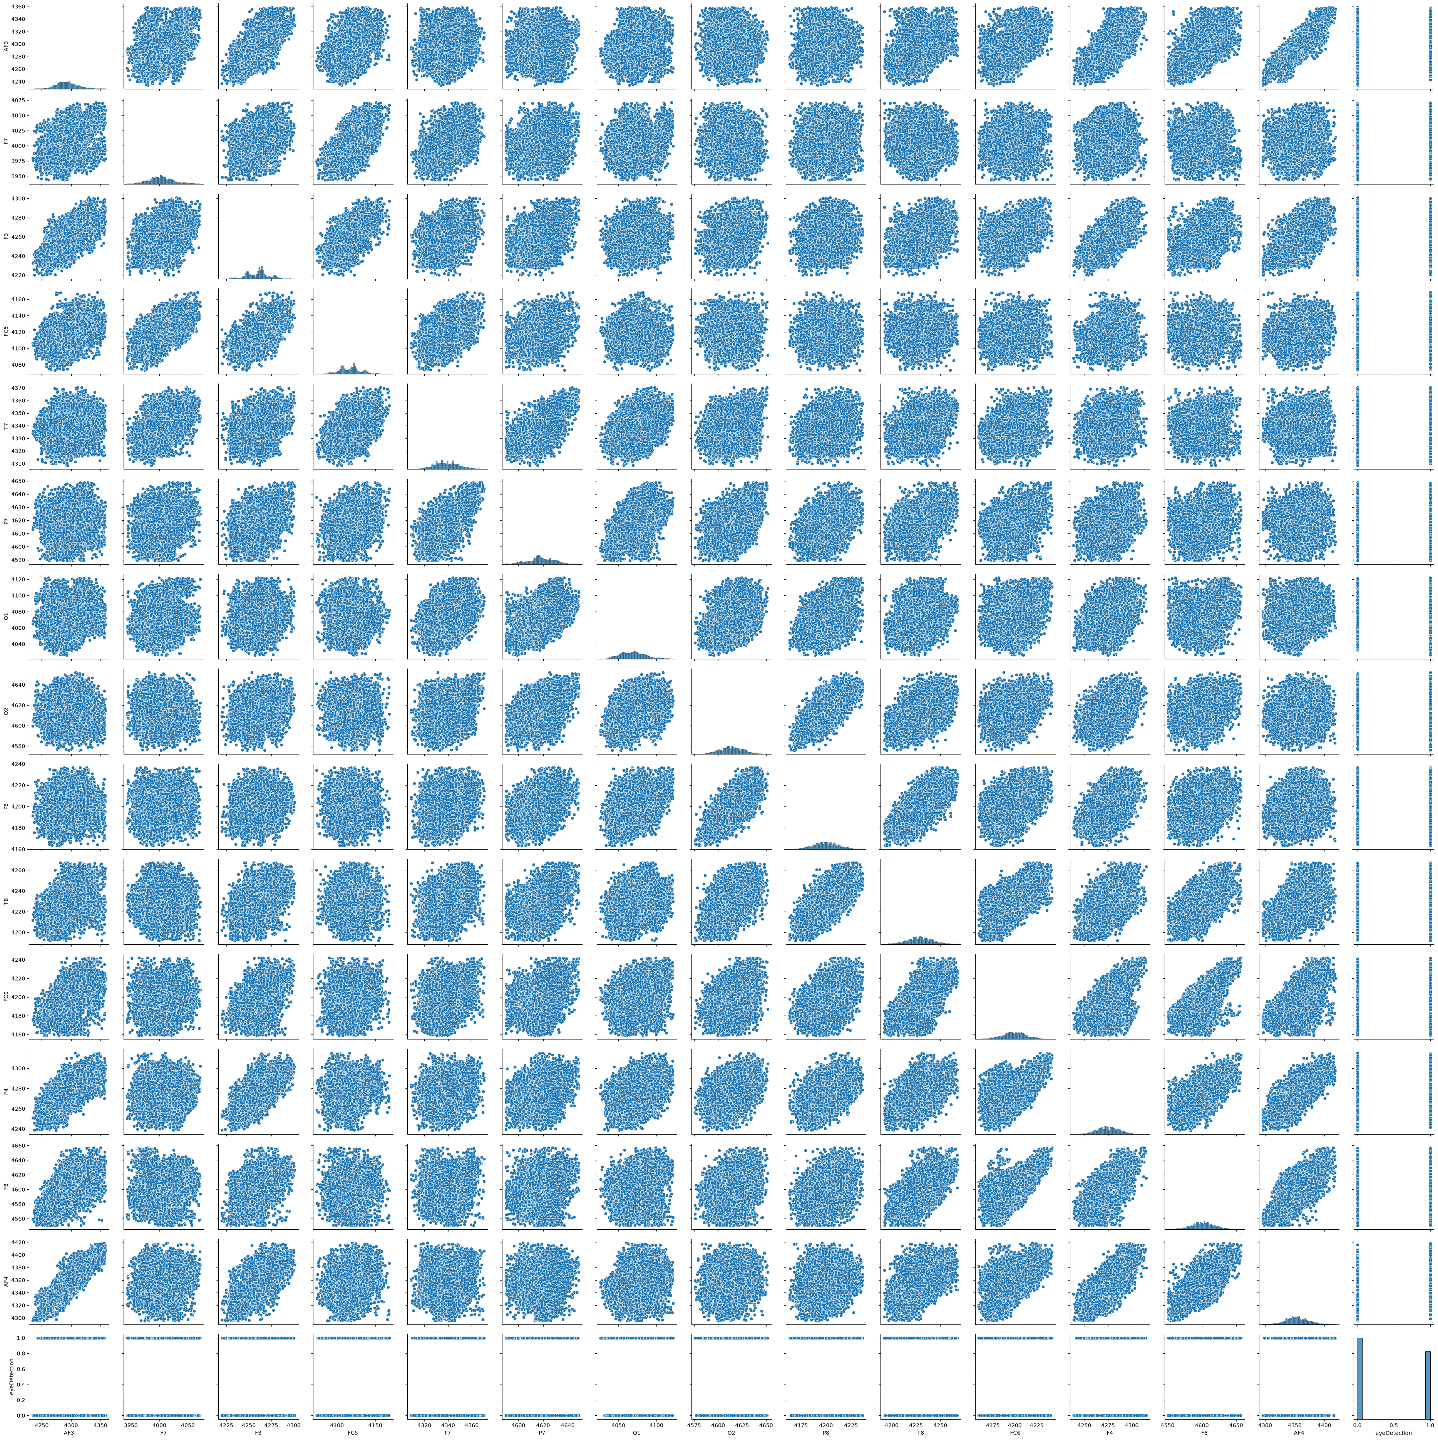
Pairwise scatter plots across all cleaned EEG channels

2.4 TARGET CLASS BALANCE
The target column, eyeDetection, was checked for class balance. The split came out to roughly 55% eye-closed (0) and 45% eye-open (1). Since neither class is heavily underrepresented, no resampling technique such as oversampling or undersampling was needed before training.
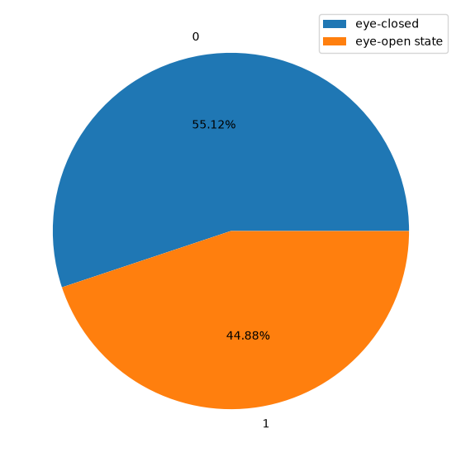
Class distribution of the eyeDetection target

3. FEATURE SELECTION
A correlation heatmap was used to identify highly correlated EEG channels that could introduce redundancy. Several feature pairs showed strong correlations, including O1–FC5, P8–AF3, F8–AF3, F8–P8, and AF4–P7. To reduce multicollinearity and simplify the model, the columns O1, P8, F8, and AF4 were removed, while FC5, AF3, and P7 were retained as they provided more distinct information.
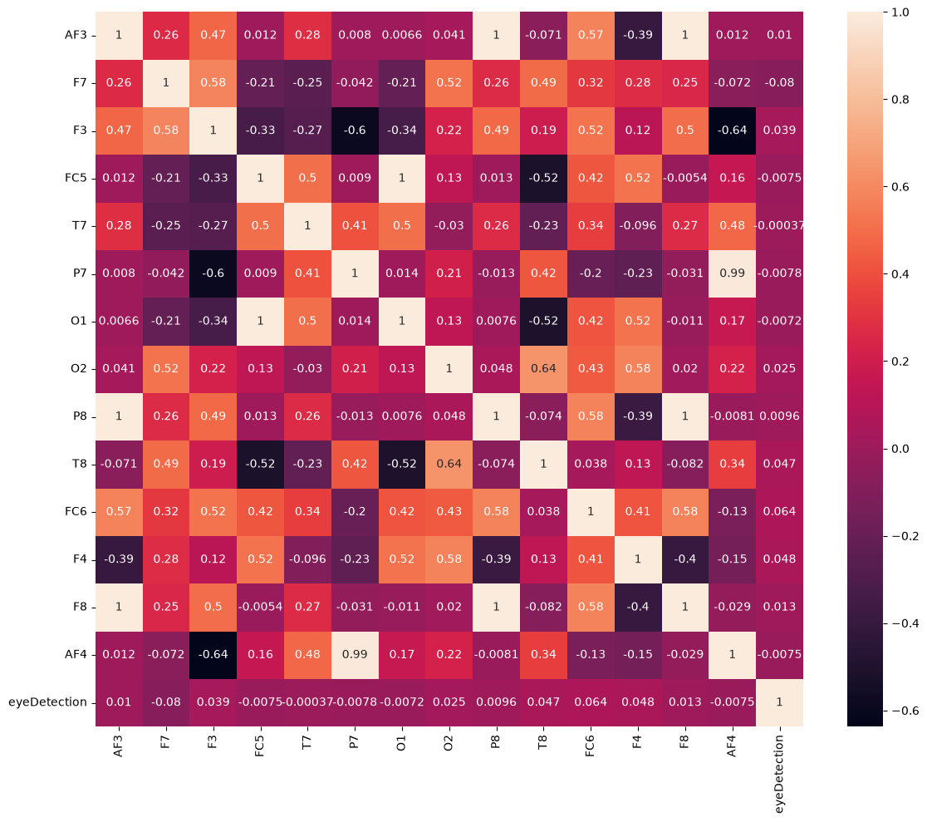
Correlation heatmap of all EEG channels and the target variable

4. MODEL DEVELOPMENT

4.1 TRAIN-TEST SPLIT AND SCALING
The cleaned and reduced dataset was split into training and testing sets, with 75% of the data used for training and 25% held out for testing. Because EEG channel values operate on different scales, StandardScaler was applied to standardize the features before feeding them into any model. The fitted scaler was saved as scaler.pkl so the exact same transformation can be reused later for new incoming data without refitting it.

4.2 COMPARING MULTIPLE MODELS

Several classification models were trained and evaluated, including Random Forest, Gradient Boosting, Logistic Regression, Decision Tree, XGBoost, SVC, and KNN. Their performance was compared using accuracy, precision, recall, and F1 score on the same train-test split.

Among all models, XGBoost and KNN achieved the best overall results. A detailed class-wise comparison of XGBoost, KNN, and SVC showed that KNN provided the most balanced performance across both eye-open and eye-closed classes. As a result, KNN was selected for hyperparameter tuning and the final model.

4.3 HYPERPARAMETER TUNING

GridSearchCV was used to tune the KNN model by testing different hyperparameters, including the number of neighbors, weighting method, distance metric, search algorithm, and leaf size using 3-fold cross-validation. The best configuration used 3 neighbors with distance-based weighting and Euclidean distance.

This tuning improved the model's performance from 90.79% to 91.19% accuracy and increased the F1 score from 89.89% to 90.37%, along with small gains in precision and recall, indicating better overall performance and generalization on unseen data.

4.4 SAVING THE MODEL
The final tuned KNN model was serialized and saved as knn_model.pkl using Python's pickle module, alongside the previously saved scaler.pkl. Together, these two pickle files let new EEG readings be scaled the same way the training data was scaled, and then classified by the trained KNN model, without retraining anything from scratch.

5. PROJECT WORKFLOW AND TOOLS

The workflow included loading the EEG dataset, performing exploratory data analysis, removing outliers with the IQR method, eliminating highly correlated features, scaling the data, evaluating multiple classification models, tuning the best-performing KNN model, and finally saving the trained model and scaler for future use.

5.1 VERSION CONTROL WITH GIT
The entire project, including the notebook, the EDA visualizations, and the supporting write-up, was version-controlled and pushed to GitHub. Using Git made it straightforward to track changes to the notebook as the analysis evolved, keep the project history organized, and share the work in a reproducible form rather than as a single static file.

5.2 CONTAINERIZING WITH DOCKER

To ensure consistent execution across different systems, the project was containerized using Docker. By packaging the environment, dependencies, and model files into a Docker image, the pipeline can run reliably on any machine without concerns about Python or library version conflicts. This allows anyone with Docker installed to run the prediction service easily without manually setting up the required environment.

5.3 DEPLOYMENT WITH FASTAPI

The trained KNN model was deployed as a web application using FastAPI and a simple HTML front end. The application includes a Home page, a Description page explaining the dataset and prediction process, and a Prediction page where users can enter 14 EEG channel values to predict whether the eyes are open or closed.

FastAPI handles the routing and backend logic, while the saved model and scaler are loaded from pickle files at startup for fast inference. Docker ensures the application can be deployed and run consistently across different environments. The complete source code is available in the GitHub repository.

6. CONCLUSION
This project followed a complete workflow for predicting eye state from EEG signals, including data cleaning, feature analysis, feature selection, and model comparison. After evaluating multiple algorithms, a tuned KNN model was chosen as the best performer, achieving about 91% accuracy with balanced precision and recall on unseen data.
To ensure reproducibility, Git was used for version control and Docker for environment management. The final solution combines the trained KNN model and fitted scaler into a lightweight pipeline, saved as pickle files, allowing eye-state predictions from EEG readings without retraining the model.

