muhtuprasanth

[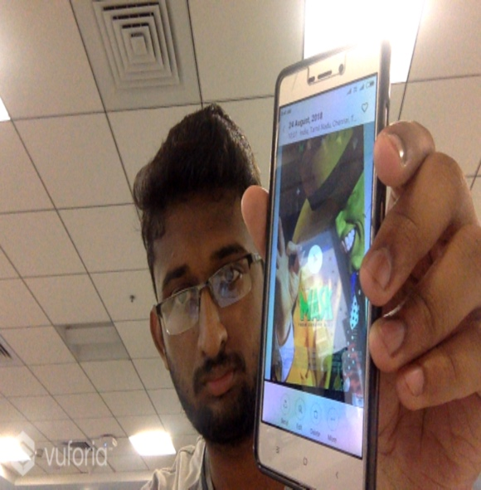](https://www.google.com/)