15. Add a background picture to a web page and write a HTML program for background repeat using CSS.
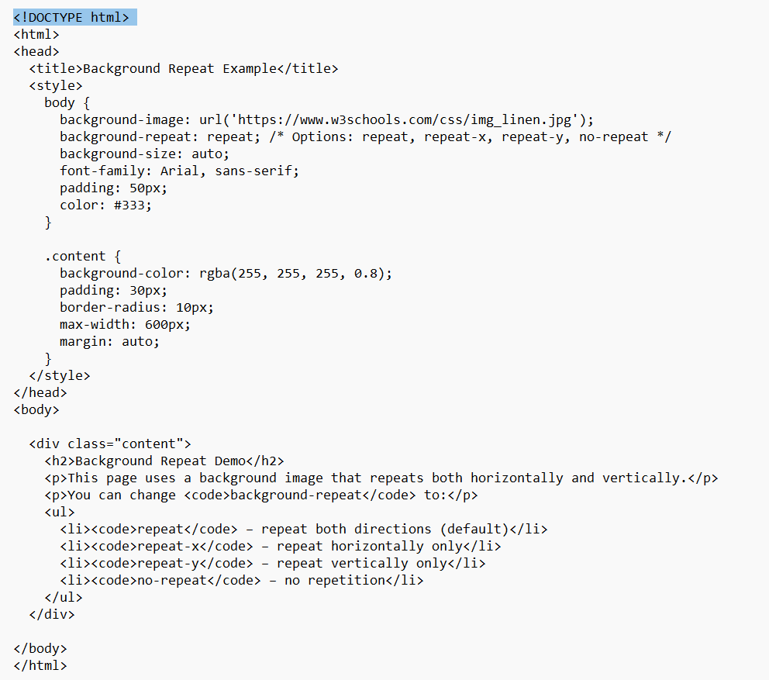
Output:
