2.Write a Java script program to get the numbers from the user and display only the nearest odd numbers.
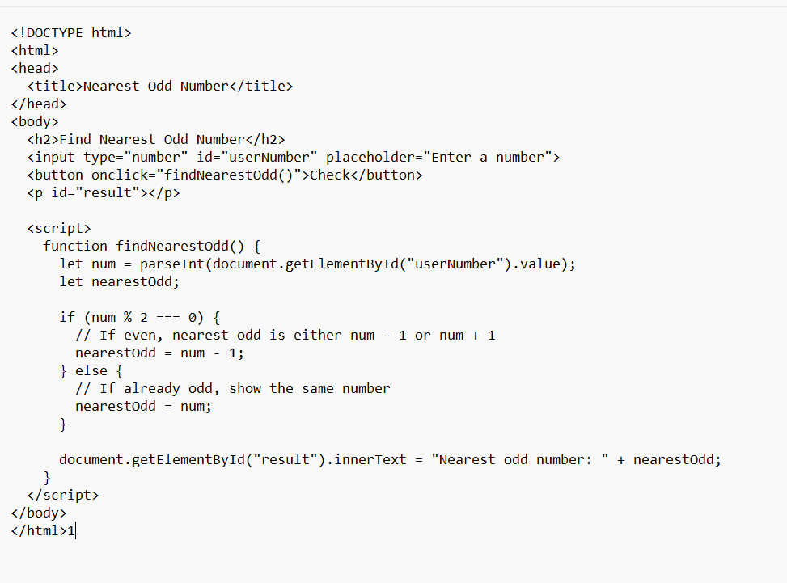
Output:
