22.Create a web page to embed the multimedia element with audio and video controls on it.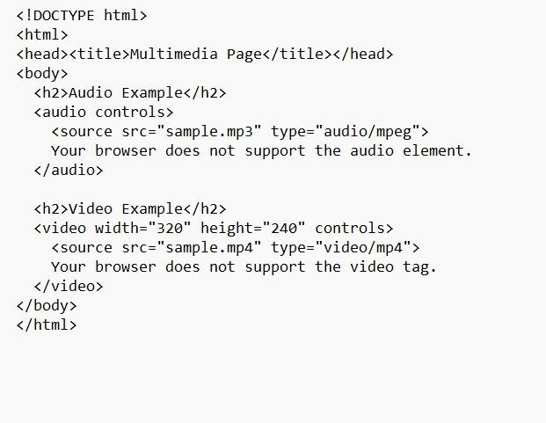

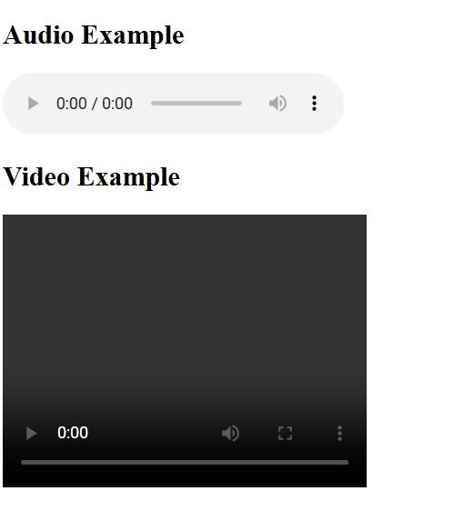
Output:

