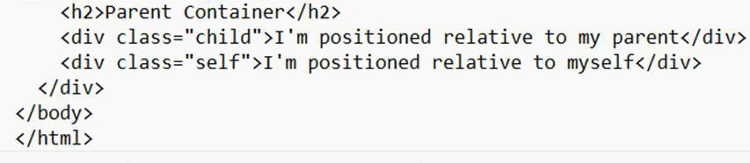
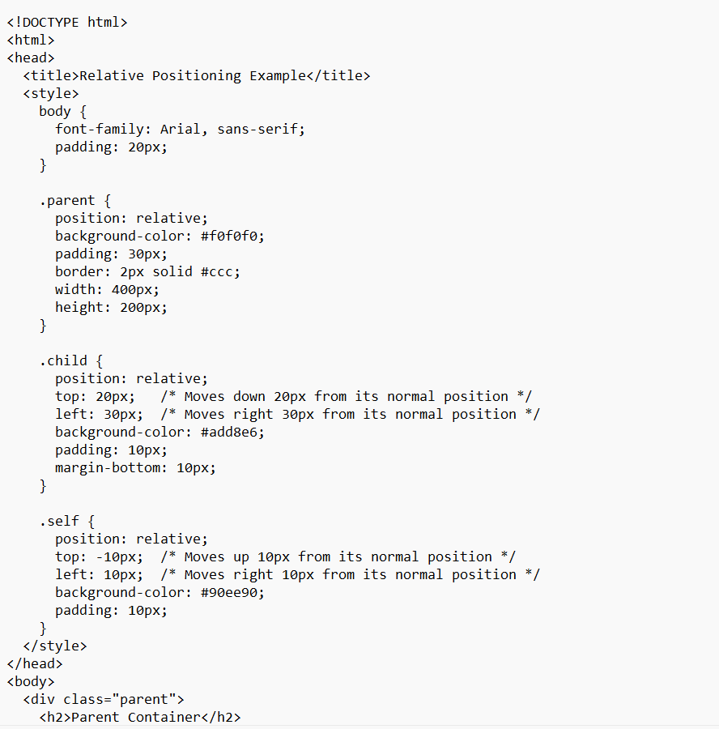
3.Create a HTML web page, change the position of the element relative to the parent element and relative to itself using relative positioning with a CSS file
Output:
