38. Create a registration form for student database management and display the collected document by using servlet program.
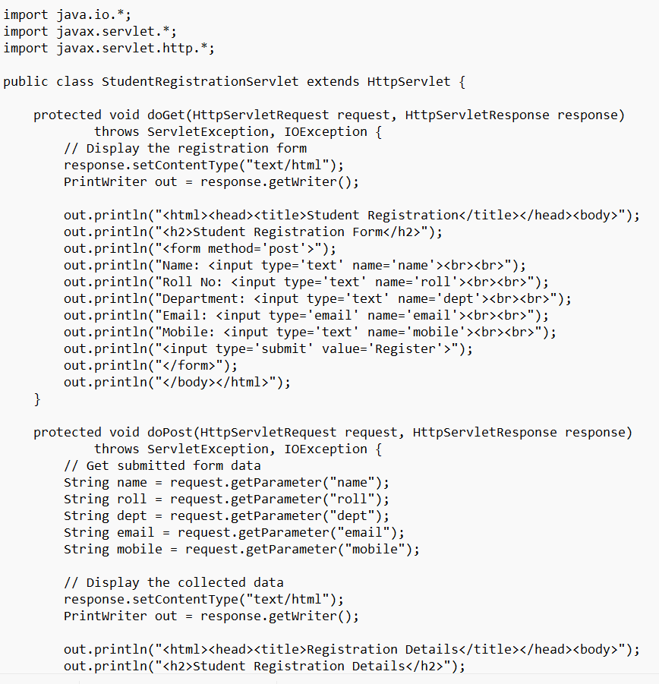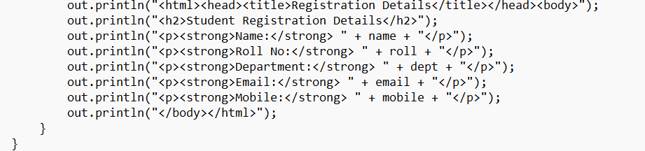

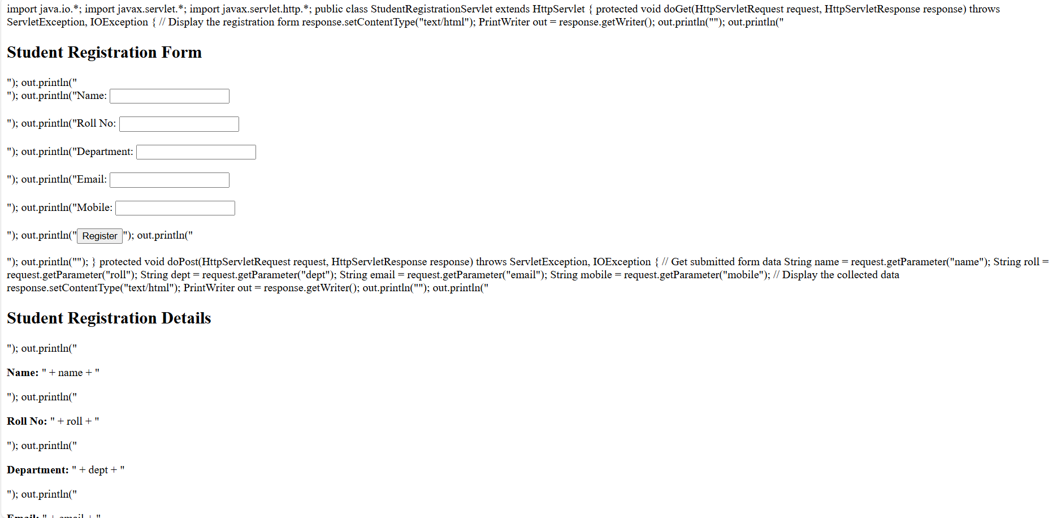
Output:

