7.Create a HTML web page, change the position of the element float to get two elements to float over each other using float positioning with a CSS file.

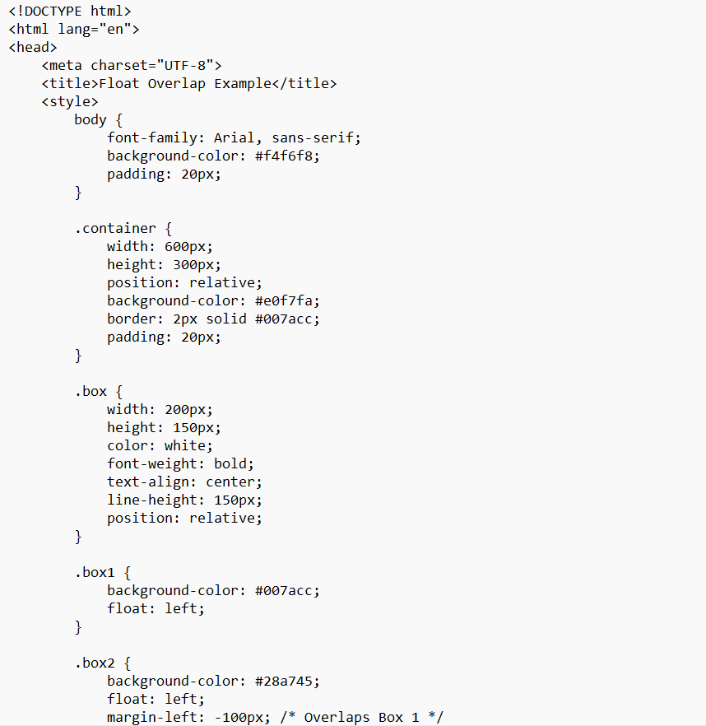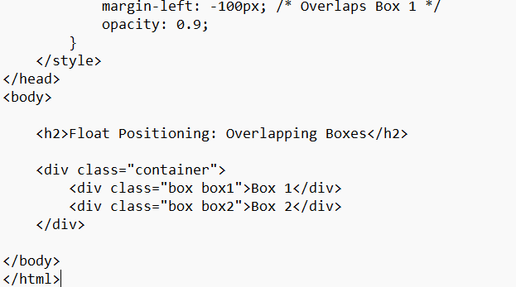

Output:
