9. Write a JavaScript program for Email validation. You can apply validation on the below
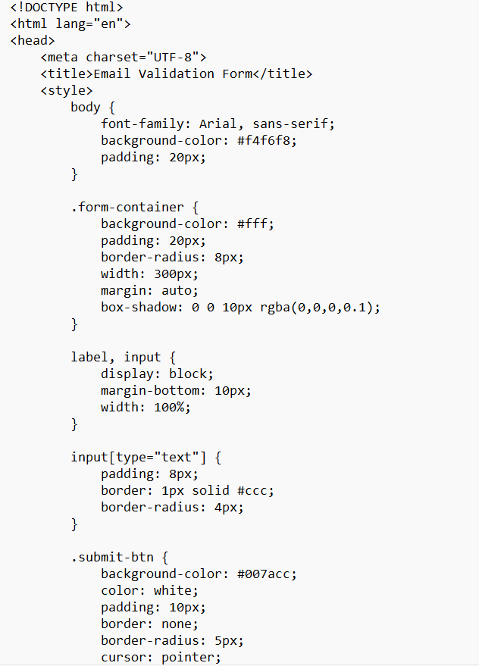
text questions to ensure they accept answers in a specific format.
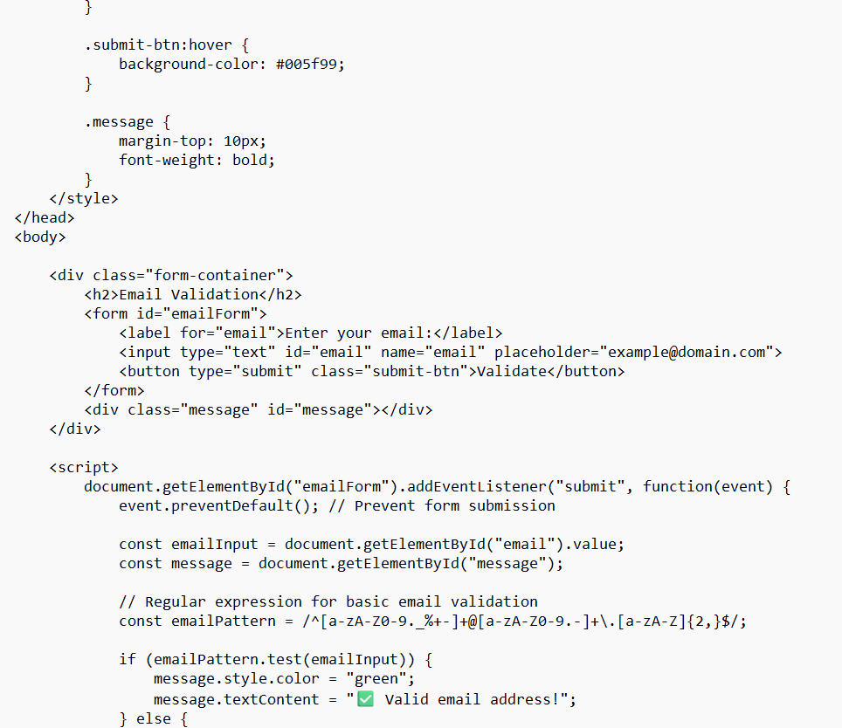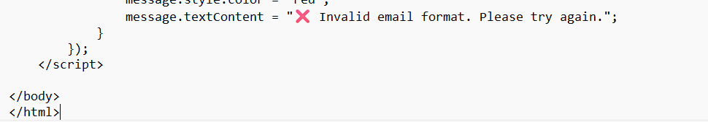
Output:
