Classification_Assignment 1
1.RandomForest:
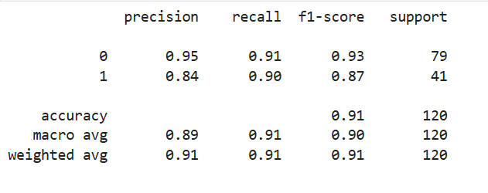
- What is the overall performance of the model in random forest?
Ans: 0.91
- What is the correct classification of not purchased?
Ans: 0.91
- What is the correct classification of purchased?
Ans: 0.90
- Out of all customers predicted as purchased, how many were actually purchased?
Ans: 0.95
- Out of all customers predicted as purchased, how many were actually not purchased?
- Ans: 0.84
- What is the overall balance between precision and recall in predicting purchased?
- Ans: 0.93
- What is the overall balance between precision and recall in predicting purchased?
- Ans: 0.87

2.Decision Tree:

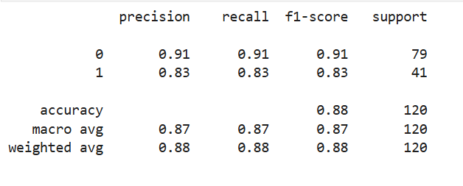
- What is the overall performance of the model in random forest?
Ans: 0.88
- What is the correct classification of not purchased?
Ans: 0.91
- What is the correct classification of purchased?
Ans: 0.83
- Out of all customers predicted as purchased, how many were actually purchased?
Ans: 0.91
- Out of all customers predicted as purchased, how many were actually not purchased?
Ans: 0.83
- What is the overall balance between precision and recall in predicting purchased?
- Ans: 0.91
- What is the overall balance between precision and recall in predicting purchased?
- Ans: 0.83

3.SVM:

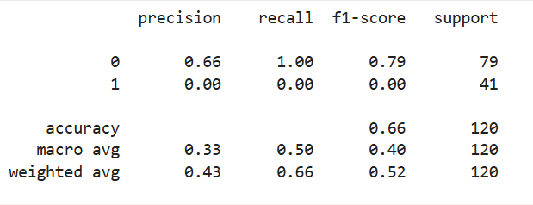

- What is the overall performance of the model in random forest?
Ans: 0.66
- What is the correct classification of not purchased?
Ans: 1.00
- What is the correct classification of purchased?
Ans: 0.00
- Out of all customers predicted as purchased, how many were actually purchased?
Ans: 0.66
- Out of all customers predicted as purchased, how many were actually not purchased?
Ans: 0.00
- What is the overall balance between precision and recall in predicting purchased?
- Ans: 0.79
- What is the overall balance between precision and recall in predicting purchased?
- Ans: 0.00

