**Dr. FINSTEIN**

**Health Application**

**A PROJECT REPORT**

***Submitted by***

**( THE BOYS )**

**YOGESHWARAN CHANDRAKASAN**

**GOKUL DHARMARAJAN**

**GOKULAKANNAN SELVAM**

**MUTHURAMAN MANICKAM**

**MARUDHU KANAGASABAI**

**SINGARAVELAN SEENUVASAN**

**ROSHINRAJ THANGASAMY**

**TABLE OF CONTENTS**

**CHAPTER NO.** **TITLE** **PAGE NO.**

1. **INTRODUCTION** **1**

**2.** **OBJECTIVES** **6**

**3.** **QUESTIONNAIRE** **3**

**4.** **FLOW CHART** **3**

**5.** **WIRE FRAME** **4**

**6.** **TECH STACKS** **5**

**7.** **CHECK LIST** **6**

**CHAPTER 1**

**INTRODUCTION**

The Importance of Health Monitoring:

* Begin by highlighting the importance of health monitoring in today's fast-paced world.
* Emphasize that many individuals tend to neglect their health due to busy lifestyles and other priorities.

The Consequences of Neglected Health:

* Neglecting health can lead to a myriad of health issues.
* Potential consequences such as increased risk of chronic diseases, reduced quality of life, and higher healthcare costs.

Introducing the Health Monitoring Application:

* Introduce your groundbreaking health monitoring application.
* Highlight that it aims to address the problem of health neglect and empower individuals to take charge of their well-being.

Empowering Users to Track Vital Health Details:

* This application enables users to track vital health details such as heart rate, blood pressure, sleep patterns, and physical activity.
* This tracking allows users to gain a comprehensive overview of their overall health status.

Providing Valuable Insights for Well-being:

* This application goes beyond mere tracking by providing users with valuable insights into their well-being.
* These insights are derived from analysing the tracked data and can help users identify areas for improvement.

Personalized Recommendations and Reminders:

* This application offers personalized recommendations based on users' health data.
* Explain that these recommendations can include lifestyle changes, exercise routines, dietary adjustments, and stress management techniques.
* Highlight that the application also provides reminders to help users stay consistent with their health goals.

Fostering a Proactive Approach to Health:

* Aim of the application to foster a proactive approach to health.
* By providing users with knowledge, insights, and motivation, the application encourages individuals to prioritize their well-being.

Bridging the Gap between Awareness and Action:

* Our application aims to bridge the gap between awareness and action in healthcare.
* It enables users to translate their health knowledge into meaningful changes and proactive decision-making.

Creating a Healthier Society:

* Conclude by expressing your vision of creating a healthier and more proactive society.
* Highlight the potential impact of your application in preventing health issues and promoting overall well-being.

**CHAPTER 2**

**OBJETIVES**

* Increase user awareness about the importance of monitoring vital health details.
* Educate users about the potential consequences of neglecting their health.
* Empower users to take an active role in monitoring and managing their own health.
* Provide users with personalized insights and recommendations for maintaining or improving their well-being.
* Facilitate early detection of health issues through regular tracking of vital health parameters.
* Prompt users to seek appropriate medical attention and preventive measures in a timely manner.
* Encourage users to adopt and maintain healthy habits related to physical activity, nutrition, sleep, and stress management.
* Provide personalized reminders and notifications to support users in developing sustainable lifestyle changes.
* Contribute to improving users' overall well-being by promoting preventive health measures and encouraging healthy lifestyle choices.
* Help users achieve their health goals and enhance their quality of life through proactive health management.

**CHAPTER 3**

**QUESTIONNAIRE**

* Purpose of the application
* Problem being addressed
* Target audience/Who will use the application
* For which screen is the application intended
* Preferred tech stack
* Existing applications (if any)
* Timeline for development
* Problem:
  + Monitoring employees' health
  + How to obtain vitals
  + How to display vitals
  + Collecting any previous medical reports
  + How to collect and maintain the reports
  + Providing suggestions for vital ranges
  + Availability of help desks
* Setting reminders:
  + For what purpose
  + How to set reminders
  + Duration for which reminders should be set

**CHAPTER 4**

**FLOW CHART**

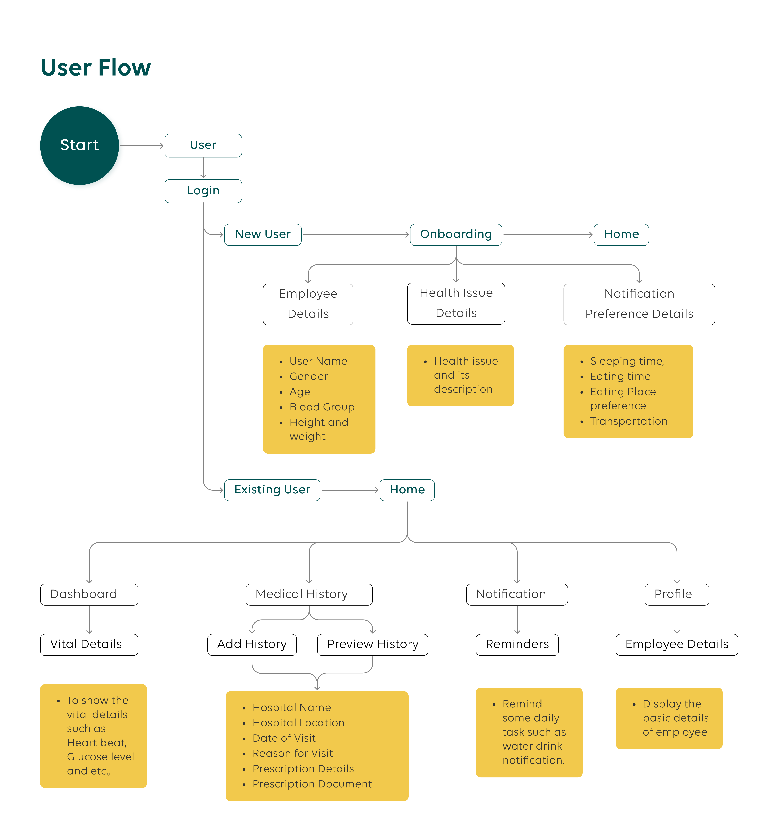

**CHAPTER 5**

**WIRE FRAME**

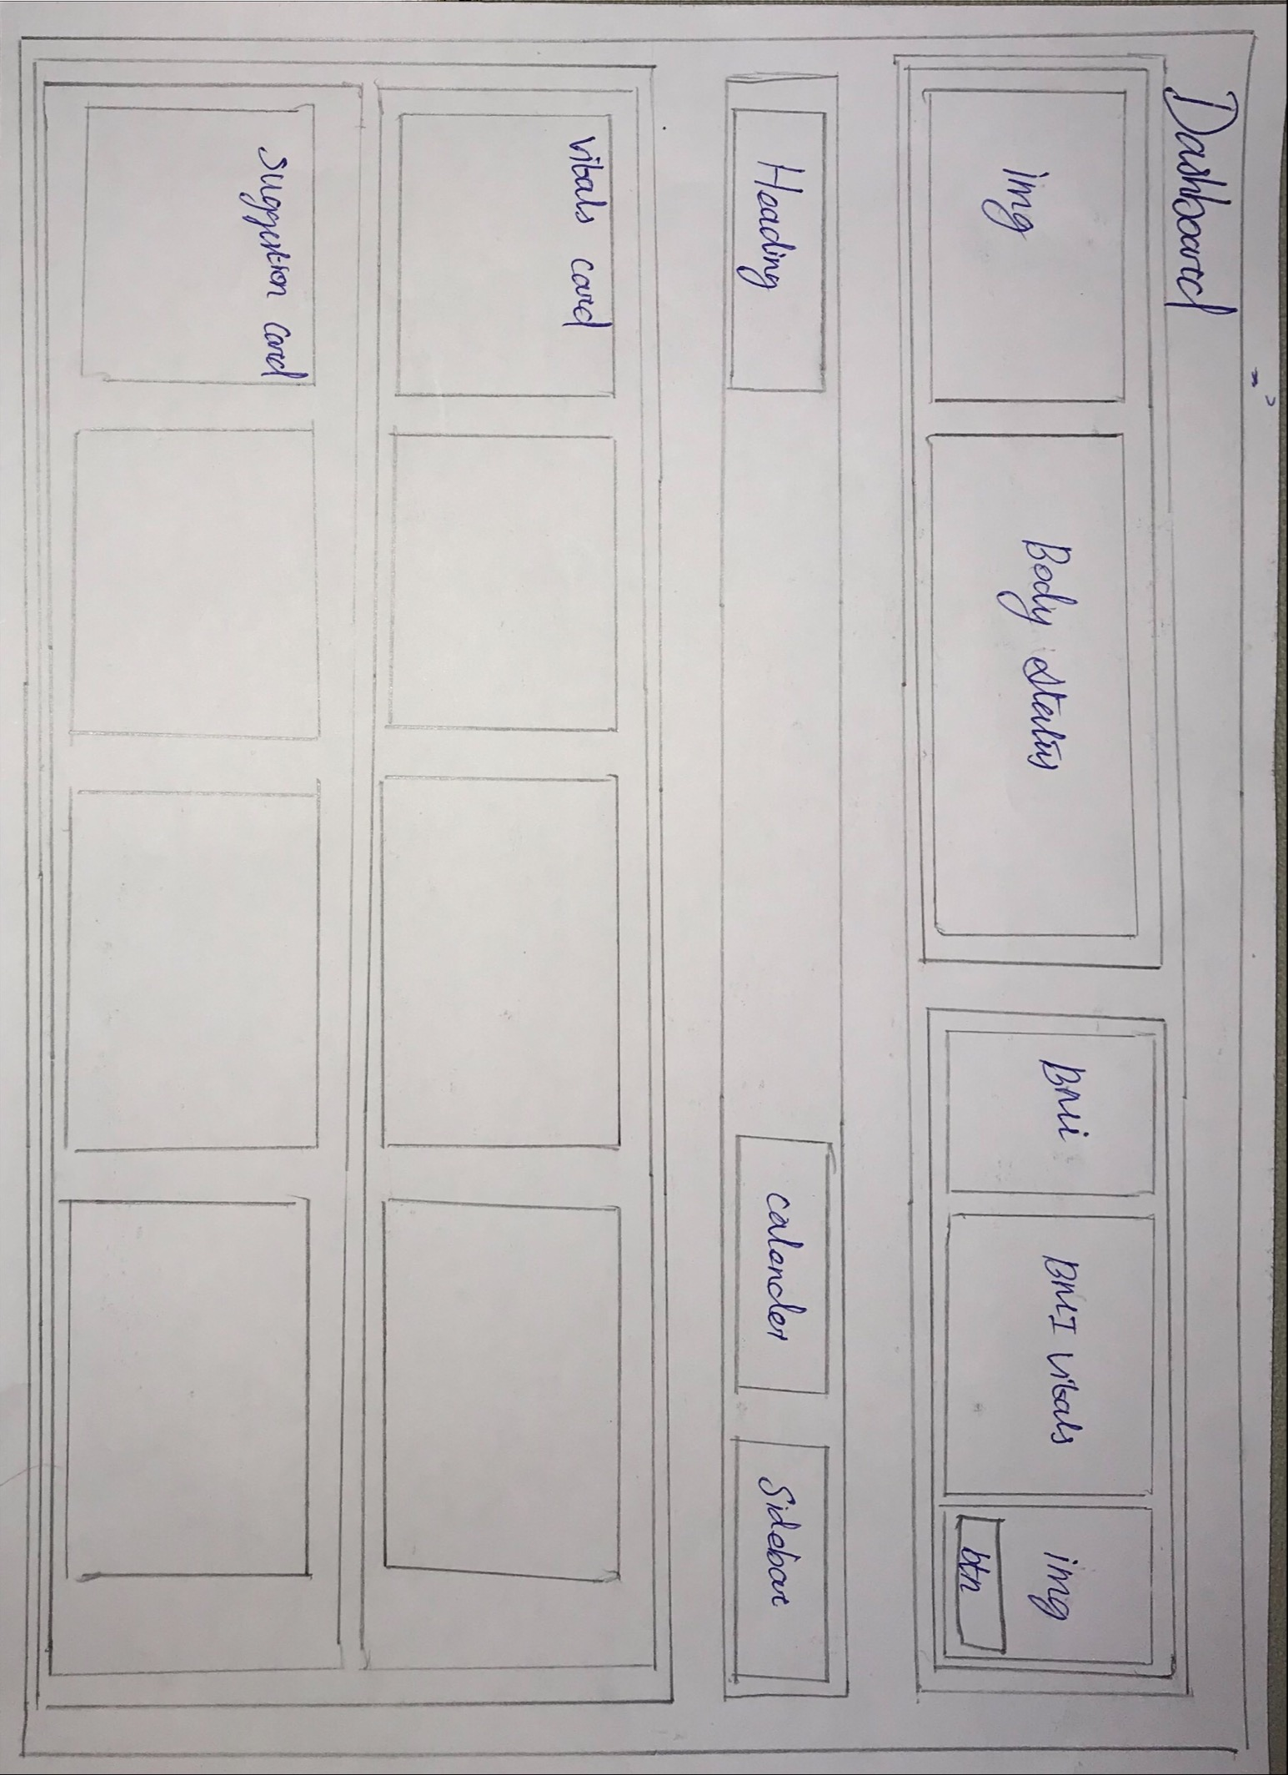

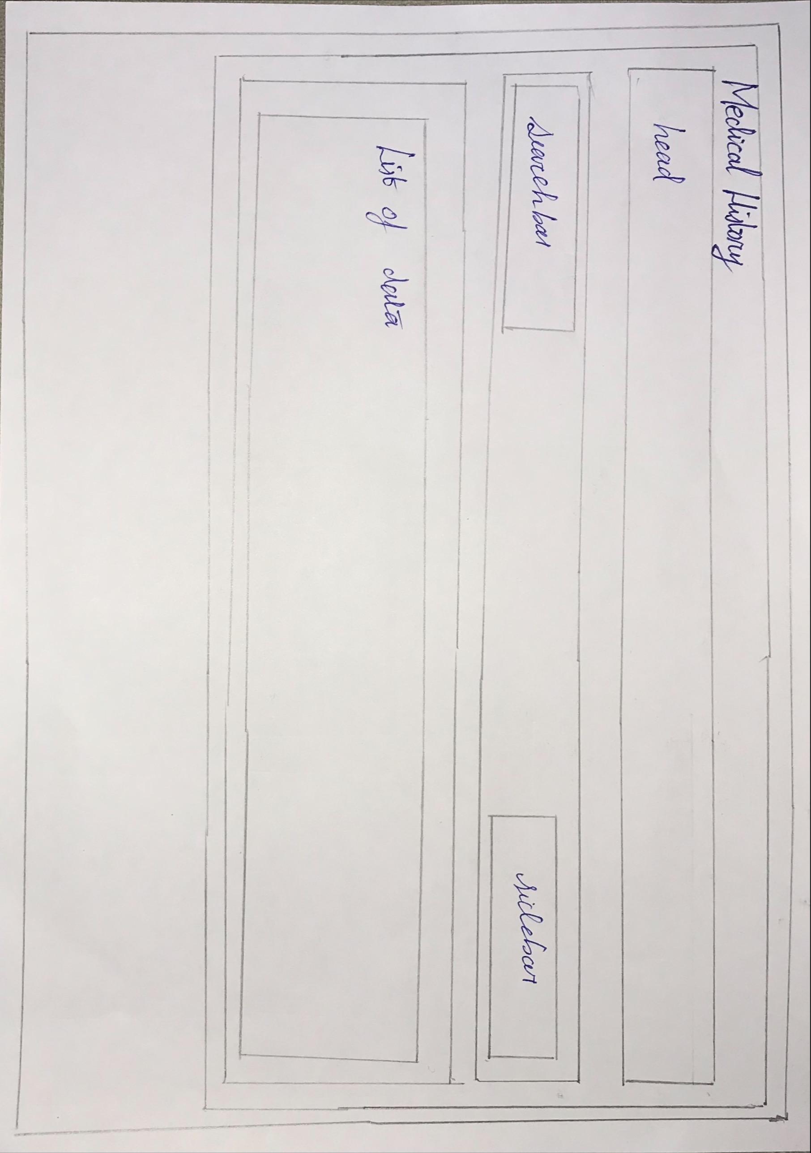

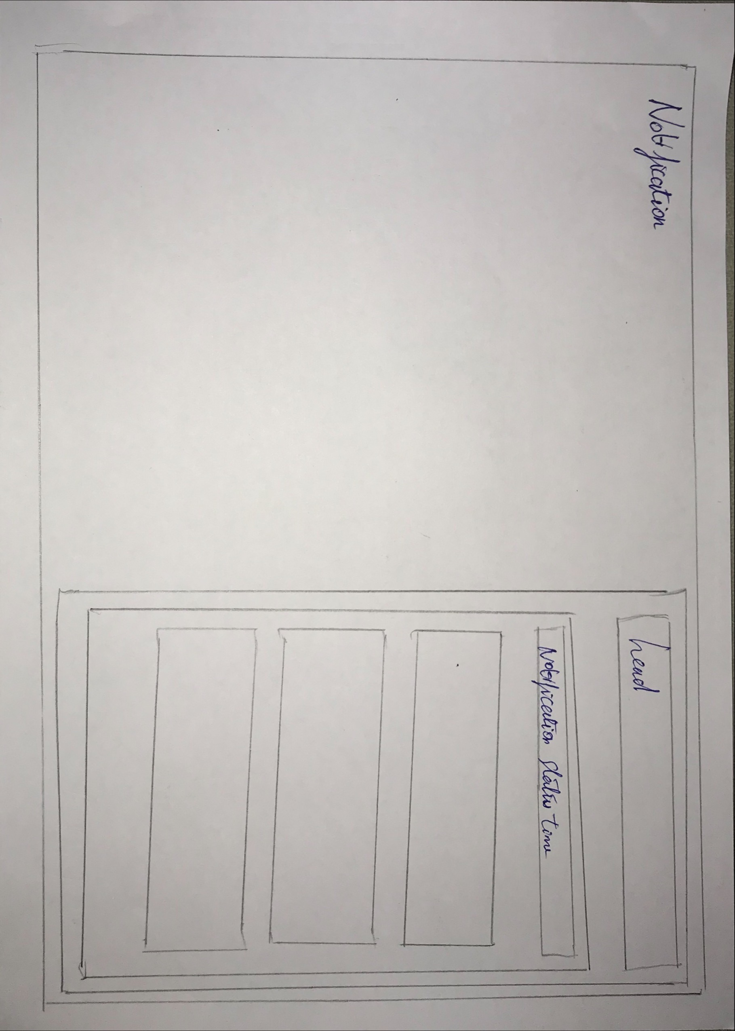

**CHAPTER 6**

**TECH STACKS**

Ui/Ux design:

Figma

frontend:

Angular

HTML/CSS

typescript

prime ng

backend:

Nest js

typescript

express

database:

MYSQL

notification:

firebase

tokens:

JWT token

code tool :

vs code

database tool:

mysql workbench

api check tool:

swagger

**CHAPTER 7**

**CHECK LIST**

* Install Angular, Nest, PrimeNG, TypeScript, Express, MySQL, Firebase, Swagger, VSCode, and JWT token.
* Create an Angular project and a Nest project.
* Create components for User, Medical History, Notification, Error, Alert Dialog Box, and Toast.
* Retrieve user details for login.
* Write an API call in Nest for the login functionality.
* Check if the user already exists.
* If the user exists, check if the user has completed the medical onboarding process.
* If the user hasn't completed the medical onboarding, redirect them to the onboarding page.
* If the user has completed the medical onboarding, redirect them to the home/dashboard page.
* Implement a side form to add vital details.
* Write an API call in Nest to add vital details.
* Create a card component to display vital information.
* Write an API call in Nest to retrieve the necessary details.
* Implement functionalities to bind the card details dynamically.
* Create a card component to show suggestions.
* Create components, forms, and functionalities for managing the user's medical history.
* Write an API call in Nest to retrieve the user's medical history.
* Create the notification component and implement its functionalities.
* Set up the necessary Firebase files.
* Connect your application to Firebase.
* Schedule notifications to be sent to the users