Product: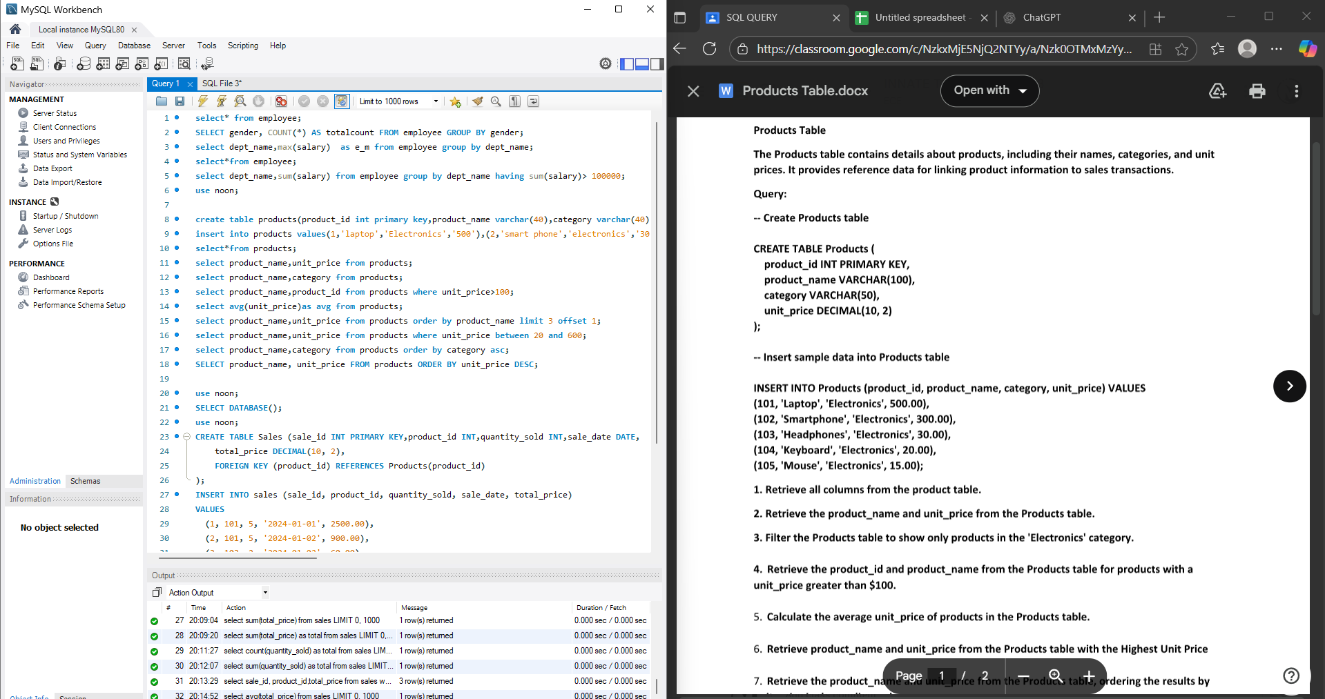

select* from employee;

SELECT gender, COUNT(*) AS totalcount FROM employee GROUP BY gender;

select dept_name,max(salary) as e_m from employee group by dept_name;

select*from employee;

select dept_name,sum(salary) from employee group by dept_name having sum(salary)> 100000;

use noon;

create table products(product_id int primary key,product_name varchar(40),category varchar(40),unit_price decimal(10,2));

insert into products values(1,'laptop','Electronics','500'),(2,'smart phone','electronics','300');

select*from products;

select product_name,unit_price from products;

select product_name,category from products;

select product_name,product_id from products where unit_price>100;

select avg(unit_price)as avg from products;

select product_name,unit_price from products order by product_name limit 3 offset 1;

select product_name,unit_price from products where unit_price between 20 and 600;

select product_name,category from products order by category asc;

SELECT product_name, unit_price FROM products ORDER BY unit_price DESC;

Sales: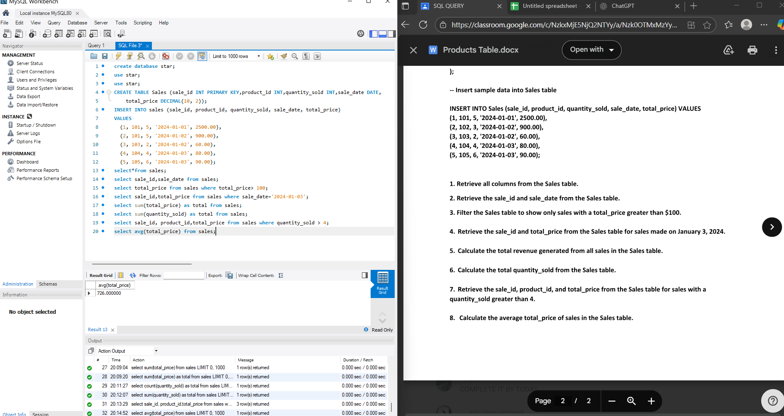

create database star;

use star;

use star;

CREATE TABLE Sales (sale_id INT PRIMARY KEY,product_id INT,quantity_sold INT,sale_date DATE,

total_price DECIMAL(10, 2));

INSERT INTO sales (sale_id, product_id, quantity_sold, sale_date, total_price)

VALUES

(1, 101, 5, '2024-01-01', 2500.00),

(2, 101, 5, '2024-01-02', 900.00),

(3, 103, 2, '2024-01-02', 60.00),

(4, 104, 4, '2024-01-03', 80.00),

(5, 105, 6, '2024-01-03', 90.00);

select*from sales;

select sale_id,sale_date from sales;

select total_price from sales where total_price> 100;

select sale_id,total_price from sales where sale_date='2024-01-03';

select sum(total_price) as total from sales;

select sum(quantity_sold) as total from sales;

select sale_id, product_id,total_price from sales where quantity_sold > 4;

select avg(total_price) from sales;