CHAPTER 3:
REQUIREMENTS AND ANALYSIS
This phase of this project dissertation gives an overview of requirements and analysis. We will be describing the problem definition of the project that we will achieve from the project and all the hardware requirements for the project. We will also give all the details of conceptual diagrams through which it became easy to know about the requirements that were to be undertaken while developing this website. The Problem Definition, Requirements, Specification, Planning and Scheduling, Hardware Requirement, Software Requirements, and Conceptual Models will be covered in this Chapter.
3.1 Problem Definition
n a world where individuals are increasingly active on various online platforms, the need for a consolidated method to share multiple links has become essential. Traditional methods of sharing links can be cluttered and inefficient, especially on platforms with strict character limits like Instagram or Twitter. The Social Media Link Platform solves this issue by providing a single URL that consolidates all other important links, making sharing efficient and simple.
Key challenges include:
- Developing a user-friendly interface.
- Ensuring smooth user registration and login functionality.
- Implementing customizable profile pages.
- Securing user data and links.
3.2 Requirements Specification
Functional Requirements:
- User Registration and Authentication:
  - Users should be able to sign up, log in, and manage their profiles.
- Link Management:
  - Users can add, update, delete, and reorder their links.
- Customizable Profile Page:
  - Users can customize their profile page with a profile picture, background color, or theme.
- Profile URL:
  - A unique shareable URL is generated for each user to share their page.

Non-Functional Requirements:
- Performance:
  - The platform should load pages quickly and efficiently.
- Scalability:
  - The platform should handle a growing number of users and links as it scales.
- Security:
  - Ensure secure authentication using JWT.
  - Use HTTPS to encrypt data in transit.
3.3 Planning and Scheduling
Planning and scheduling are essential parts of event management. They help to ensure that events run smoothly and efficiently. Planning involves creating a roadmap for event, including setting goals, identifying target audiences, and developing a budget. Scheduling involves breaking down event into manageable tasks and assigning them to individuals or teams. It also involves setting deadlines and tracking progress.
Event management can be a valuable tool for planning and scheduling events. They can help to:
● Create and manage your event schedule
● Assign tasks and responsibilities
● Track progress and deadlines
● Communicate with team members and stakeholders
● Share documents and resources
● Register attendees and guests
● Sell tickets and collect payments
● Manage logistics and operations
3.3.1 Analyze event data and reports Gantt Chart
A Gantt chart is a commonly used graphical depiction of a project schedule. It’s a type of bar chart showing the start and finish dates of a project's elements such as resources, planning and dependencies. The Gantt chart is the most widely used chart in project management. These charts are useful in planning a project and defining the sequence of tasks that require completion. In most instances, the chart is displayed as a horizontal bar chart.
Horizontal bars of different lengths represent the project timeline, which can include task sequences, duration, and the start and end dates for each task. The horizontal bar also shows how much of a task requires completion. A Gantt chart helps in scheduling, managing, and monitoring specific tasks and resources in a project. The chart shows the project timeline, which includes scheduled and completed work over a period. The Gantt chart aids project managers in communicating project status or plans and also helps ensure the project remains on track.
⮚ As it's a bar chart format, it’s possible to check progress with a quick glance. We can easily see the following details:
● A visual display of the whole project
● Timelines and deadlines of all tasks
● Relationships and dependencies between the various activities
● Project phases
⮚ When researching Gantt chart software for your project management needs, be sure that it has these capabilities:
● Defining and updating milestones in your project.
● Linking tasks according to predefined or customizable dependencies.
● Collaborating on a dynamic project plan.
● Share files in the form of text, images videos or notes summarizing tasks.
● Monitor progress of each task against the planned one.

Gantt Chart Table
Tasks | Start Date | End Date | Duration
Selection of Project | 18-06-2023 | 25-06-2023 | 7
Hardware Specification | 26-06-2023 | 30-06-2023 | 4
Preliminary Investigation | 01-07-2023 | 21-07-2023 | 20
Requirement and System  Analysis | 22-07-2023 | 05-08-2023 | 14
Feasibility Study | 06-08-2023 | 26-08-2023 | 20
Planning and Scheduling | 27-08-2023 | 23-09-2023 | 27
Conceptual Model Design | 24-09-2023 | 12-10-2023 | 18
System Design | 13-10-2023 | 04-11-2023 | 22
Coding and Implementation | 05-11-2023 | 15-12-2023 | 40
Testing | 16-12-2023 | 04-01-2024 | 19
Deployment | 05-01-2024 | 18-01-2024 | 13

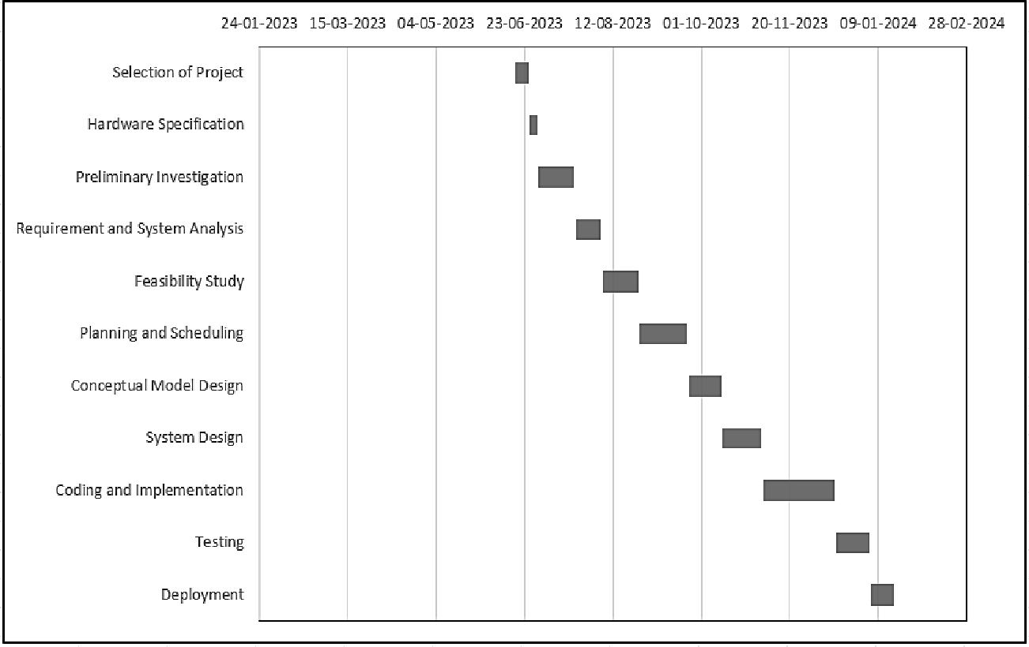

GANTT CHART
      - Advantages of Gantt Chart:
  - Project managers can better allocate resources effectively by viewing the start and end date of each task and identifying conflicts in resources and scheduling.
  - Gantt charts provide team members with a clear and visual representation of a project and its schedule, helping everyone with project schedule management.
  - Track the progress of multiple tasks and compare them against the planned schedule to identify potential delays or bottlenecks and improve time management.
  - Task ownership is more apparent as team members are assigned tasks and know their responsibilities and deadlines.
  - Project managers can identify potential risks and create measures accordingly by visualizing task dependencies and critical paths.
  - Gantt charts facilitate communication with team members, clients, and stakeholders and help manage expectations while providing a clear overview of project progress.

PERT Chart
The Program Evaluation and Review Technique (PERT) is a statistical tool used in project management, which was designed to analyze and represent the tasks involved in completing a given project. PERT, or Project/Program Evaluation Review Technique, accounts for inevitable changes that occur in a project‘s schedule that impact the project finish. The technique was initially developed by the Navy in the 1950s for the Polaris submarine project. Today, PERT charts are used by teams across industries looking to plan and execute their projects more effectively. The complexity of our PERT chart is driven by the number of project
milestones along your critical path and the estimated time set to complete each task.

PERT or the Program Evaluation and Review Technique is a method that analyzes the time required to complete each task and its associated dependencies, and to determine the minimum amount of time required to complete a certain project.

      - The process takes into consideration three different time estimates:
  - Optimistic Time (To): The minimum amount of time required to complete the project, assuming everything goes better than expected.
  - Pessimistic Time (Tp): The maximum time required to complete the task, assuming things go wrong.
  - Most Likely Time (Tm): The most likely amount of time required to complete the tasks, assuming everything goes alright.
(Estimating duration this way allows managers to calculate a more realistic project schedule.)

“PERT charts are an excellent training tool for a project controls person to truly understand the underpinnings of a schedule,” says PMFocus’s Patterson.
- Therearefourkeycomponents that set PERT charts apart:

  - Each node on your PERT chart diagram represents a specific milestone.
  - Milestone tasks are connected with arrows like a flowchart.
  - The arrows represent the sequence of tasks and each task’s dependencies to prevent bottlenecks.
  - Each milestone and tasks are time-bound to a set deadline.

Peart Chart Template includes following features:
  - Numbered nodes:

These are the numbered boxes in the PERT chart. Each node represents an event or milestone in the project, completion of one stage, or a series of tasks needed to move the project forward.

Directional (or concurrent) arrows:

The arrows on a PERT chart represent the tasks or activities that need to be completed before the team can move on to the next event or phase in the project.The task between nodes 1 and 2 is a directional or concurrent arrow in the mockup above. This indicates the task must be completed in the sequence indicated. Project managers use directional arrows to schedule activities that have dependencies.

Divergent arrows:

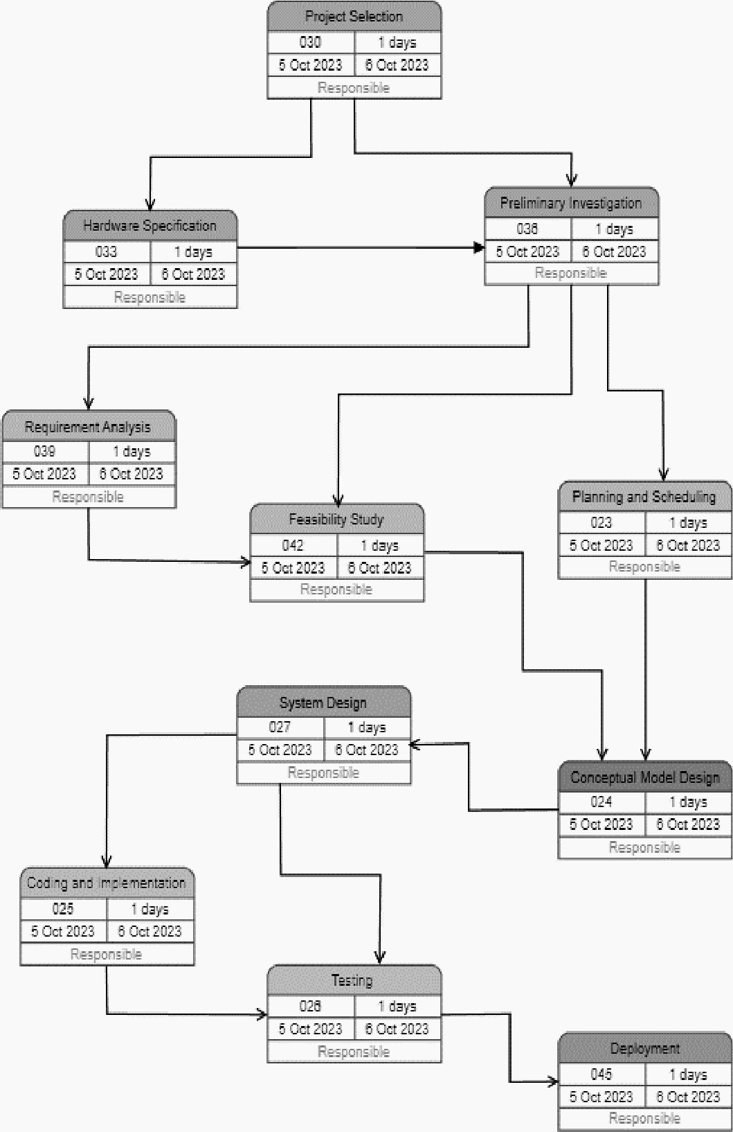
These arrows represent tasks that a team may work on simultaneously or in any sequence they choose because they do not have dependencies. In the mockup here, you can see an example of this after node 2, for example. The team may work first on the activities leading to node 3 or node 4, or they may choose to complete them simultaneously.

PERT CHART

      - Advantages of PERT Chart:
  - The project manager may easily schedule project activities with the aid of the PERT system. This method is used more frequently in complex, large-scale project work.
  - The critical path will be clearly displayed using the PERT approach. The crucial path is the path that contains tasks that cannot, under any circumstances, be put off.
  - The PERT networks' activity and events are examined. Both of these are examined separately and jointly. This will paint a picture of the project's likely completion and the budget.
  - The several construction organization departments will supply the data for the PERT operations. The departments are well integrated, which will aid in enhancing the project team's capacity for planning and decision-making.

  - Software and Hardware Requirements
Software Requirements:
- Frontend: HTML5, CSS3, JavaScript, React.js (optional).
- Backend: Node.js, Express.js, MongoDB.
- Authentication: JWT for login sessions.
- Version Control: Git and GitHub for version tracking.
Hardware Requirements:
- Minimum 4 GB RAM for development environment.
- 500 GB HDD/SSD for storage.
- Modern computer with a multicore processor.

Preliminary Product Description

The first step in the system development life cycle is the preliminary investigation to determine the feasibility of the system. The purpose of the preliminary investigation is to evaluate project requests. It is not a design study nor does it include the collection of details to describe the business system in all respect. Rather, it is the collecting of information that helps committee members to evaluate the merits of the project request and make an informed judgment about the feasibility of the proposed project.

Modules Table

Name | Data Type | Size
module_id | Number | 14
module_name | Text | 100
description | Text | 255
is_active | Text | 5
created_at | Text | 14
updated_at | Text | 14

3.6Conceptual Models
A conceptual model is a simplified representation of a system or process that helps us understand its key elements and their interactions. It focuses on the essential aspects and relationships, leaving out unnecessary details.
Here's some brief information about conceptual models: Purpose:
- To facilitate understanding and communication about a complex system.
- To guide decision-making and problem-solving.
- To predict behavior and identify potential issues.
- To document and share knowledge about a system. Components:
- Entities: The key objects or actors involved in the system.
- Attributes: The properties or characteristics of entities.
- Relationships: The connections and interactions between entities.
- Rules and constraints: The limitations and conditions that govern the system. Types of Conceptual Models:
- Object-oriented models: Focus on entities and their relationships.
- Process-oriented models: Focus on the flow of activities and decisions.
- Event-driven models: Focus on how events trigger changes in the system.
- Data-driven models: Focus on the structure and organization of data. Benefits of Using Conceptual Models:
- Improved understanding: Provides a clear and concise view of the system.
- Increased efficiency: Helps identify and eliminate inefficiencies.
- Enhanced communication: Creates a common language for stakeholders.
- Reduced risk: Helps identify and mitigate potential problems.
- Better decision-making: Provides a basis for making informed decisions. Examples of Conceptual Models:
- Business process models
- Data flow diagrams
- Entity-relationship diagrams
- System flowcharts
- UML diagrams

Flowchart Diagram
A flowchart is a diagram that depicts a process, system or computer algorithm. They are widely used in multiple fields to document, study, plan, improve and communicate often complex processes in clear, easy-to-understand diagrams. It’s a powerful tool that can be used in multiple fields for planning, visualizing, documenting, and improving processes.
A flow chart is a graphical or symbolic representation of a process. Each step in the process is represented by a different symbol and contains a short description of the process step. The flow chart symbols are linked together with arrows showing the process flow direction. A flowchart is a picture of the separate steps of a process in sequential order.
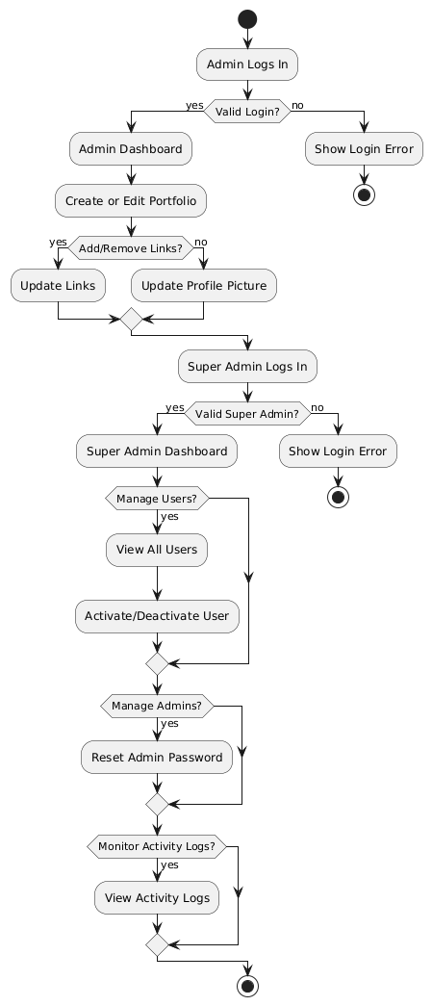

ER Diagram
Entity Relationship consist of information required for each entity or data object as well as it shows relationship among the object also and it is graphical representation of entities and their relationship to each other also. It shows the construction of information or data in terms of tables. It includes the entities, attributes and relationship between the entities. ER-modeling is a data modeling method used in software engineering to produce a conceptual data model of an information system.
There are following types of relations exist between the object:

      - One-to-One Relationship
      - One-to-Many Relationship
      - Many-to-Many Relationship
  - Reasons for using ER diagrams:
- Helps you to define terms related to entity relationship modeling.
- Provide a preview of how all your tables should connect, what fields are going to be on each table.
- Helps to describe entities, attributes, relationships.
- ER diagrams are translatable into relational tables which allows you to build databases quickly
- ER diagrams can be used by database designers as a blueprint for implementing data in specific software applications
- The database designer gains a better understanding of the information to be contained in the database with the help of ERP diagram.
- ERD Diagram allows you to communicate with the logical structure of the database to users.

Entity Relationship Diagram
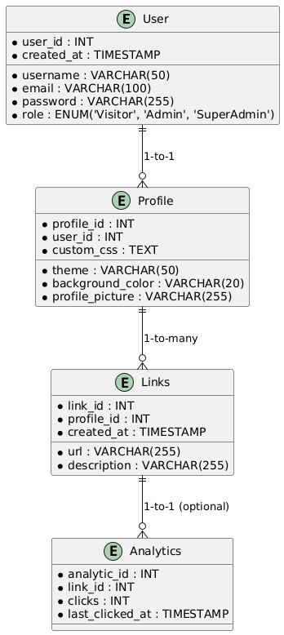

Chapter 4
SYSTEM DESIGN
4.1 Basic Modules
- User Management:
  - Registration: Users can sign up by providing email, username, and password.
  - Login: Users can securely log in with JWT-based authentication.
  - Profile Management: Users can update their profile picture, theme, and other settings.
- Link Management:
  - Users can add, delete, and reorder the links they wish to showcase on their profile.
  - Links are associated with users, ensuring they are displayed only on the correct profile.
- URL Generation:
  - Upon registration, each user is assigned a unique, shareable URL that links to their customized profile page.

4.2 Data Design

Data design refers to the process of organizing, structuring, and managing data in a way that makes it efficient and valuable for specific use cases. It involves various aspects, including:

Defining Data Requirements and Objectives:
  - Identifying the purpose and intended use of the data.
  - Determining the types of data needed to achieve your objectives.
  - Defining the level of data quality and consistency required.

Data Modeling:
  - Choosing a suitable data model, such as relational, dimensional, or NoSQL.
  - Designing the schema, which defines the structure of the data, including tables, columns, and relationships.
  - Ensuring data integrity and consistency through normalization and other techniques.

Data Governance and Security:
  - Establishing policies and procedures for data access, control, and ownership.
  - Implementing security measures to protect data from unauthorized access, modification, and loss.
  - Defining data retention and disposal policies.

Data Quality Management:
  - Developing processes for ensuring data accuracy, completeness, and timeliness.
  - Identifying and correcting data errors and inconsistencies.
  - Monitoring data quality metrics and taking corrective actions when necessary.

Data Integration and Interoperability:
- Enabling different systems and applications to share and exchange data seamlessly.
- Establishing common data standards and definitions to ensure consistency.
- Utilizing data integration tools and technologies for efficient data exchange. Effective data design is crucial for several reasons:
- Improved data accessibility and usability: Properly designed data is easier to access, understand, and analyze.
- Enhanced decision-making: Data-driven decisions are more informed and likely to be successful.
- Increased efficiency and productivity: Well-organized data reduces time spent searching for and managing information
- Reduced costs: Efficient data management helps save on storage, processing, and analysis costs.
- Improved regulatory compliance: Data design plays a vital role in complying with various data privacy and security regulations.
Overall, data design is a critical aspect of managing and utilizing information effectively. By investing in good data design practices, organizations can maximize the value of their data and achieve their desired objectives.

1.1.1 Schema Design
Database Schema design refers to a structure that represents relationships among data and defines how information is stored in a database. Without a proper schema, it is easy to drift away from the objective considering the scale of big data projects. As schema also represents the relationship among tables, different databases have different schema designs to support varying business requirements. Besides ensuring effective business data communication to database users and internal stakeholders, schema design could also ensure data safety and security by incorporating security measures like authentication and access control into your database.

Basically a schema design is a blueprint for organizing and structuring data within a database. It defines the entities (data objects), their attributes (data properties), and the relationships between them.

Here's a quick overview of schema design:

Key components:
  - Entities: Represent real-world objects or concepts relevant to the data system (e.g., customers, products, orders).
  - Attributes: Define the characteristics of each entity (e.g., customer name, product price, order date).
  - Relationships: Specify the connections between entities (e.g., a customer can place multiple orders).

Types of schema designs:
  - Relational: Data is organized in tables with rows representing entities and columns representing attributes. Relationships are established through foreign keys.
  - Dimensional: Optimized for data analysis, with tables containing facts (measurements) and dimensions (categories).
  - NoSQL: Flexible schema design for unstructured or semi-structured data, often used for large datasets.

Benefits of a well-designed schema:
  - Data accuracy and consistency: Ensures data integrity through normalization and data validation techniques.
  - Efficient data access and retrieval: Facilitates faster search and retrieval of specific data points.
  - Improved data analysis and reporting: Provides a foundation for building effective data analysis and reporting tools.
  - Enhanced application performance: Optimizes database performance by minimizing unnecessary data processing.
  - Reduced data redundancy: Eliminates unnecessary data duplication, saving storage space and improving efficiency.
Important considerations for schema design:
  - Data requirements: Identify the specific data needs and objectives of the system.
  - Performance and scalability: Design the schema to handle current and future data volumes efficiently.
  - Security and privacy: Implement security measures to protect sensitive data.
  - Flexibility and adaptability: Design the schema to accommodate future changes and expansions.

Tools and techniques:
  - Entity-Relationship diagrams (ERDs): Visualize entities, attributes, and relationships.
  - Data modeling tools: Software applications that assist in designing and managing schemas.
  - Normalization techniques: Reduce data redundancy and improve data integrity.
By understanding the fundamentals of schema design, y ou can create a solid foundation for your database, ensuring data integrity, efficiency, and flexibility

