Tour Booking System Project statement
Project name: Tour Booking System
Technologies used:
- Java SDK 11
- Spring boot, spring data JPA
- Spring cloud
- JSP/Thymeleaf
- Mariadb/MySQL Database

Abstract:
The Tour Booking System is an application which allows users to book their holidays and other trips to book online. The requirements are given below:

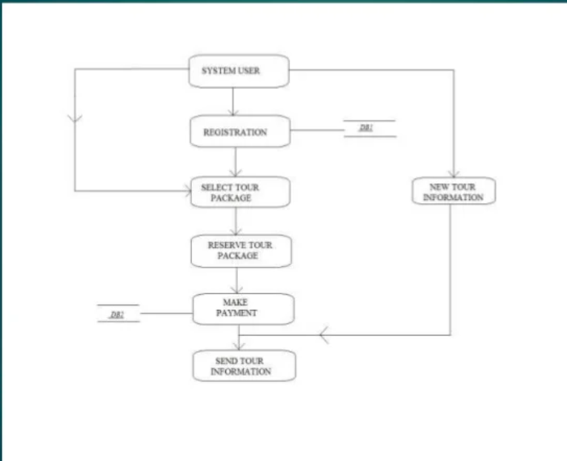

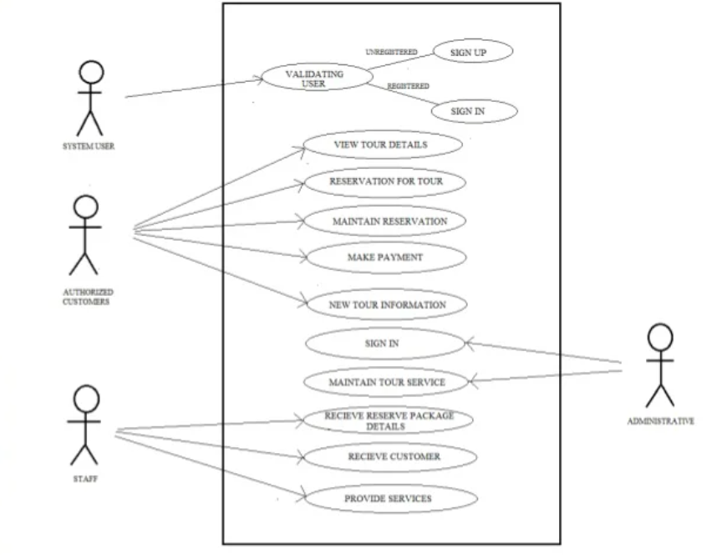

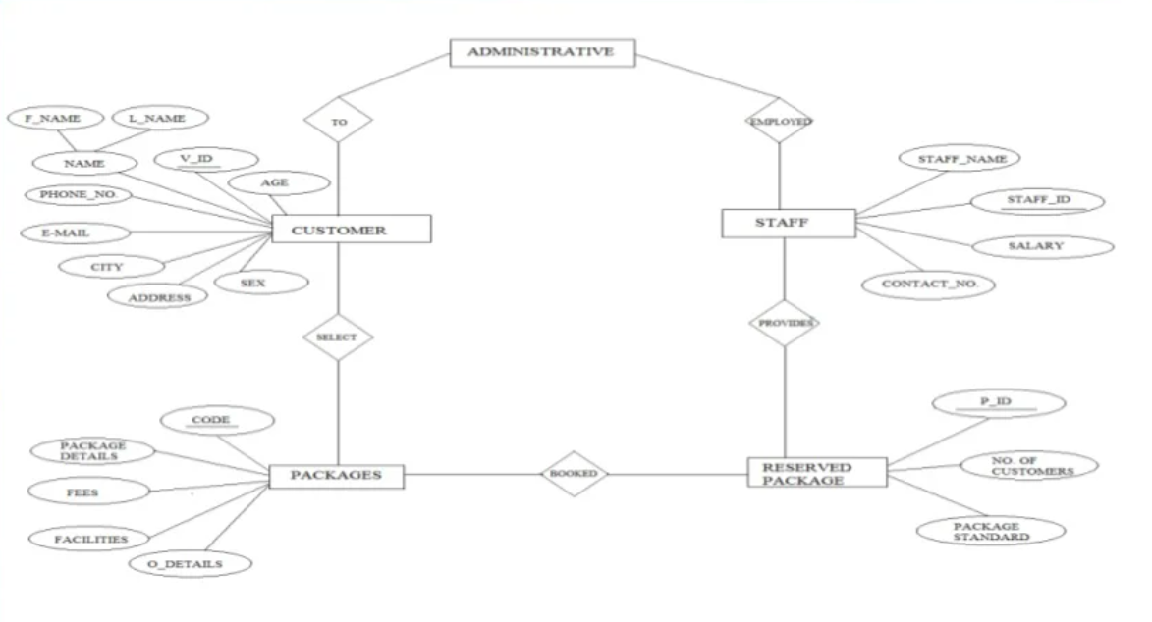

You are required to create an application using microservices architecture following the given diagrams.

Other Requirements:
- Microservices loose coupling need to be maintained as far as possible.
- All interactions from client happen through the API Gateway.
- Request to microservices from the API Gateway are Load Balanced.
- The microservices register their availability through the Eureka Server.
- Micrometer/Prometheus/Grafana should be used for monitoring services.
- Testcases (Unit tests and Integration Tests) must be written.
- The UI should be created using JSP/Thymeleaf.
You must follow the below given guidelines:
- Follow Good Coding Practice
- Data Validation at the persistence layer is a must
- Logging for the services must be written using SLF4J and file based logging
- Follow Naming conventions
- Code readability must be maintained
- Test coverage should be 80% min (include reports)
- Check Code quality using SonarQube
- Build and Delivery should be done using Jenkins
- Dockerize all the microservices
- Deploy your applications on Amazon EC2
- Provide Data Flow and ER Diagrams
- Project Documentation
- Table Schema

