**TUGAS MODUL PRAKTIKUM 6**

**Untuk Memenuhi Tugas**

**Mata Kuliah Praktikum Analisis Algoritma**



**Disusun oleh :**

**Mutia Karimah 140810170002**

**Felia Sri Indriyani 140810170018**

**Ilham Muharam 140810170046**

**Ikbal Antoni 140810170054**

**TEKNIK INFORMATIKA**

**FAKULTAS MATEMATIKA DAN ILMU PENGETAHUAN ALAM UNIVERSITAS PADJADJARAN**

**2019**

1. Dengan menggunakan undirected graph dan adjacency matrix berikut, buatlah koding programnya menggunakan bahasa C++.

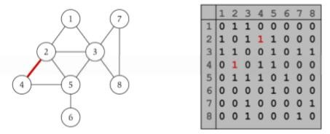

Jawab : Program :

/*

* C++ Program to Implement Adjacency Matrix

*/

#include <iostream>

#include <cstdlib>

using namespace std;

#define MAX 20

/*

* Class untuk Adjacency Matrix

*/

class AdjacencyMatrix

{

private:

int n;

int **adj;

bool *visited;

public:

AdjacencyMatrix(int n)

{

this->n = n;

visited = new bool [n];

adj = new int* [n];

for (int i = 0; i < n; i++)

{

adj[i] = new int [n];

for(int j = 0; j < n; j++)

{

adj[i][j] = 0;

}

}

}

/*

* Menambahkan edge ke graf

*/

void add_edge(int origin, int destin)

{

if( origin > n || destin > n || origin < 0 || destin < 0)

{

}

else

{

}

}

/*

cout<<"Invalid edge!\n";

adj[origin - 1][destin - 1] = 1;

* Mencetak graf

*/

void display()

{

int i,j;

for(i = 0;i < n;i++)

}

};

/*

* Main

*/

{

for(j = 0; j < n; j++)

cout<<adj[i][j]<<" ";

cout<<endl;

}

int main()

{

int nodes, max_edges, origin, destin; cout<<"Enter number of nodes: "; cin>>nodes;

AdjacencyMatrix am(nodes);

max_edges = nodes * (nodes - 1);

for (int i = 0; i < max_edges; i++)

{

cout<<"Enter edge (-1 -1 to exit): ";

cin>>origin>>destin;

if((origin == -1) && (destin == -1))

break;

am.add_edge(origin, destin);

}

am.display();

return 0;

}

Screenshot :

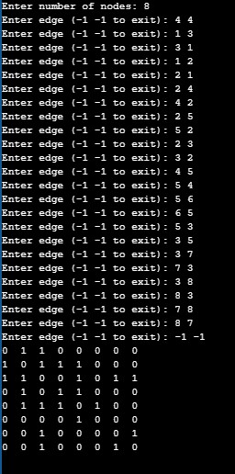

2. Dengan menggunakan undirected graph dan representasi adjacency list, buatlah koding programnya menggunakan bahasa C++.

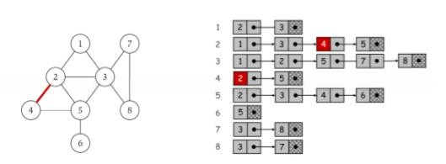

Jawab : Program :

/*

* C++ Program to Implement Adjacency List

*/

#include <iostream>

#include <cstdlib>

using namespace std;

/*

* Adjacency List Node

*/

struct AdjListNode

{

int dest;

struct AdjListNode* next;

};

/*

* Adjacency List

*/

struct AdjList

{

struct AdjListNode *head;

};

/*

* Class Graph

*/

class Graph

{

private:

int V;

struct AdjList* array;

public:

Graph(int V)

{

this->V = V;

array = new AdjList [V];

for (int i = 0; i < V; ++i)

array[i].head = NULL;

}

/*

* Creating New Adjacency List Node

*/

AdjListNode* newAdjListNode(int dest)

{

AdjListNode* newNode = new AdjListNode;

newNode->dest = dest; newNode->next = NULL; return newNode;

}

/*

* Adding Edge to Graph

*/

void addEdge(int src, int dest)

{

AdjListNode* newNode = newAdjListNode(dest); newNode->next = array[src].head; array[src].head = newNode;

newNode = newAdjListNode(src);

newNode->next = array[dest].head;

array[dest].head = newNode;

}

/*

* Print the graph

*/

void printGraph()

{

int v;

for (v = 1; v <= V; ++v)

{

AdjListNode* pCrawl = array[v].head;

cout<<"\n Adjacency list of vertex "<<v<<"\n head ";

while (pCrawl)

{

cout<<"-> "<<pCrawl->dest;

pCrawl = pCrawl->next;

}

cout<<endl;

}

}

};

/*

* Main

*/

int main()

{

Graph gh(8); gh.addEdge(1, 2); gh.addEdge(1, 3);

gh.addEdge(2, 4);

gh.addEdge(2, 5);

gh.addEdge(2, 3);

gh.addEdge(3, 7); gh.addEdge(3, 8); gh.addEdge(4, 5); gh.addEdge(5, 3); gh.addEdge(5, 6); gh.addEdge(7, 8);

// print the adjacency list representation of the above graph

gh.printGraph();

return 0;

}

Screenshot :

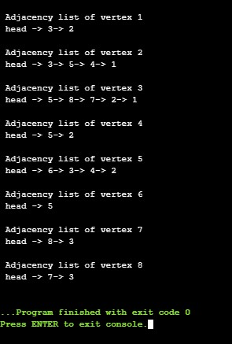

3. Buatlah program Breadth First Search dari algoritma BFS yang telah diberikan. Kemudian uji coba program Anda dengan menginputkan undirected graph sehingga menghasilkan tree BFS. Hitung dan berikan secara asimptotik berapa kompleksitas waktunya dalam Big-Θ!

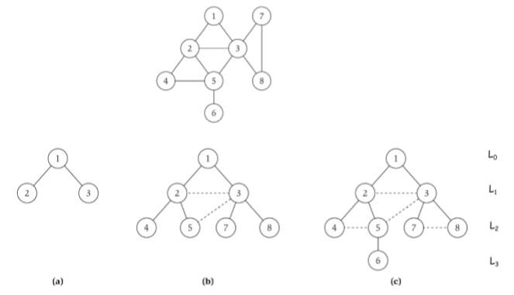

Jawab : Program :

// Program to print BFS traversal from a given

// source vertex. BFS(int s) traverses vertices

// reachable from s.

#include<iostream>

#include <list>

using namespace std;

// This class represents a directed graph using

// adjacency list representation class Graph

{

int V; // No. of vertices

// Pointer to an array containing adjacency

// lists list<int> *adj;

public:

Graph(int V); // Constructor

// function to add an edge to graph void addEdge(int v, int w);

// prints BFS traversal from a given source s void BFS(int s);

};

Graph::Graph(int V)

{

this->V = V;

adj = new list<int>[V];

}

void Graph::addEdge(int v, int w)

{

adj[v].push_back(w); // Add w to v’s list.

}

void Graph::BFS(int s)

{

// Mark all the vertices as not visited bool *visited = new bool[V];

for(int i = 0; i < V; i++)

visited[i] = false;

// Create a queue for BFS

list<int> queue;

// Mark the current node as visited and enqueue it visited[s] = true;

queue.push_back(s);

// 'i' will be used to get all adjacent

// vertices of a vertex list<int>::iterator i;

while(!queue.empty())

{

// Dequeue a vertex from queue and print it s = queue.front();

cout << s << " ";

queue.pop_front();

// Get all adjacent vertices of the dequeued

// vertex s. If a adjacent has not been visited,

// then mark it visited and enqueue it

for (i = adj[s].begin(); i != adj[s].end(); ++i)

{

if (!visited[*i])

{

visited[*i] = true;

queue.push_back(*i);

}

}

}

}

// Driver program to test methods of graph class int main()

{

// Create a graph given in the above diagram

Graph g(8); g.addEdge(1, 2); g.addEdge(1, 3);

g.addEdge(2, 4);

g.addEdge(2, 5); g.addEdge(2, 3); g.addEdge(3, 7); g.addEdge(3, 8); g.addEdge(4, 5); g.addEdge(5, 3); g.addEdge(5, 6); g.addEdge(7, 8);

cout << "Following is Breadth First Traversal "

<< "(starting from vertex 1) \n";

g.BFS(1);

return 0;

}

Screenshot :

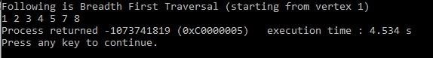

Karena Big-O dari BFS adalah O(V+E) dimana V itu jumlah vector dan E itu adalah jumlah edges maka Big-O = O(n) dimana n = v+e

Maka dari itu Big-Ө nya adalah Ө(n).

4. Buatlah program Depth First Search dari algoritma DFS yang telah diberikan. Kemudian uji coba program Anda dengan menginputkan undirected graph sehingga menghasilkan tree DFS. Hitung dan berikan secara asimptotik berapa kompleksitas waktunya dalam Big-Θ!

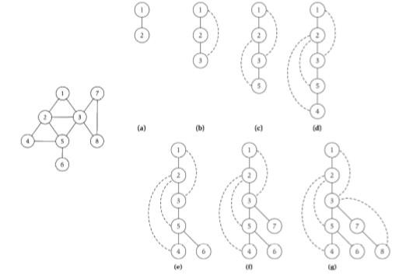

Jawab : Program :

#include<iostream>

#include<list>

using namespace std;

// Graph class merepresentasikan graf berarah menggunakan representasi adjacency list

class Graph

{

int V; // No. simpul

// Pointer ke array yang memiliki adjacency lists list<int> *adj;

// Fungsi rekursif yang digunakan DFS

void DFSUtil(int v, bool visited[]);

public:

Graph(int V); // Constructor

// fungsi untuk menambah tepian ke graf void addEdge(int v, int w);

// DFS traversal dari simpul yang terjangkau dari v void DFS(int v);

};

Graph::Graph(int V)

{

this->V = V;

adj = new list<int>[V];

}

void Graph::addEdge(int v, int w)

{

adj[v].push_back(w); // Menambah w ke list v.

}

void Graph::DFSUtil(int v, bool visited[])

{

// Menandakan node bersangkutan sudah dikunjungi lalu cetak visited[v] = true;

cout << v << " ";

// Ulang simpul berdekatan ke node ini list<int>::iterator i;

for (i = adj[v].begin(); i != adj[v].end(); ++i)

if (!visited[*i]) DFSUtil(*i, visited);

}

// DFS traversal dari simpul terjangkau dari v.

// Menggunakan rekursif DFSUtil()

void Graph::DFS(int v)

{

// Menandakan semua simpul belum dikunjungi bool *visited = new bool[V];

for (int i = 0; i < V; i++)

visited[i] = false;

// Memanggil fungsi rekursif pembantu untuk mencetak DFS

traversal

DFSUtil(v, visited);

}

int main()

{

// Membuat graf di diagram

Graph g(8); g.addEdge(1, 2); g.addEdge(1, 3); g.addEdge(2, 5); g.addEdge(2, 4); g.addEdge(5, 6); g.addEdge(3, 7); g.addEdge(3, 8); g.addEdge(7, 8);

cout << "Depth First Traversal"

g.DFS(1);

return 0;

}

" (dimulai dari node 1) \n";

Screenshot :

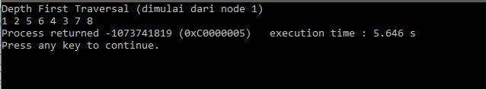

Kompleksitas waktu : O(V+E)O(V+E), saat diimplementasikan menggunakan *adjacency list*.