ECE 661: Homework #1  
Linear Model, Back Propagation and Building a CNN

Student NetID: wh162

1. True/False Questions
   1. Problem 1.1: True, the set of the weight was trained under different guesses and thus there’s no guarantee that the exact same set of weight can be found even if we control all the conditions.
   2. Problem 1.2: False, Latency is the delay time that takes for the data to go through the mode, so it’s positively relative to our processor.
   3. Problem 1.3: True, the gradient will no vanish even when , making the model to be able to know what’s the gradient.
   4. Problem 1.4: True, convolution layer has less parameters compare to FC.
   5. Problem 1.5: True.
2. Adalines
   1. Problem 2.1: Logic AND function

|  |  |  |  |
| --- | --- | --- | --- |
| x1 | x2 | s | y |
| -1 | -1 | -5 | -1 |
| -1 | +1 | -3 | -1 |
| +1 | -1 | -1 | -1 |
| +1 | +1 | +1 | +1 |

* 1. Problem 2.2: w0 = -1, w1 = -1, w2 = -1

|  |  |  |  |
| --- | --- | --- | --- |
| x1 | x2 | s | y |
| -1 | -1 | -1 | +1 |
| -1 | +1 | -1 | -1 |
| +1 | -1 | -1 | -1 |
| +1 | +1 | -3 | -1 |

* 1. Problem 2.3: w0 = 0, w1 = 1, w2 = 1, w3 = 1

|  |  |  |  |  |
| --- | --- | --- | --- | --- |
| X1 | X2 | X3 | s | y |
| -1 | -1 | -1 | -3 | -1 |
| -1 | -1 | +1 | -1 | -1 |
| -1 | +1 | -1 | -1 | -1 |
| -1 | +1 | +1 | +1 | +1 |
| +1 | -1 | -1 | -1 | -1 |
| +1 | -1 | +1 | +1 | +1 |
| +1 | +1 | -1 | +1 | +1 |
| +1 | +1 | +1 | +3 | +1 |

* 1. Problem 2.4: w20 = -2, w21 = 2, w22 = -1

|  |  |  |  |
| --- | --- | --- | --- |
| x1 | x2 | s | y |
| -1 | -1 | -3 | -1 |
| -1 | +1 | +1 | +1 |
| +1 | -1 | +1 | +1 |
| +1 | +1 | -1 | -1 |

1. Back Propagation
   1. Problem 3.1:

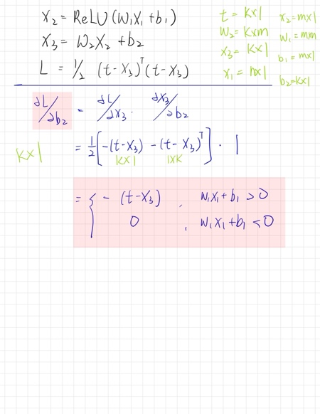

* 1. Text, letter

     Description automatically generatedProblem 3.2:

1. 2D Convolution:
   1. Problem 4.1:

* 1. Problem 4.2: After the shifting of the 3x3 kernel, we can see that not only did the “1” numbers decreased, but also its neighbor was added to some degree of noise. If this kernel were applied to an image, the result would be that the edge will be dilate and the image would turn vague.

1. Lab: LMS Algorithms:
   1. Problem 5.1: W* = [[1.0006781][1.00061145][-2.00031968]] , MSE = 5.03995157e-05
   2. Chart

      Description automatically generatedText

      Description automatically generatedProblem 5.2:
   3. Chart

      Description automatically generatedChart, surface chart

      Description automatically generatedProblem 5**.**3: (a) (b)
   4. Problem 5.4:
2. Lab: Simple NN
   1. (a)

* 1. Table

     Description automatically generated (b)

1. Lab3
   1. 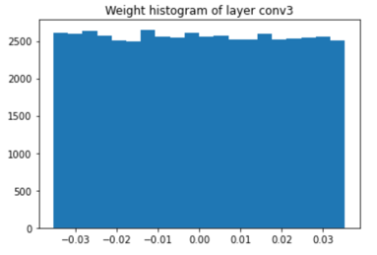Chart, histogram

      Description automatically generatedChart, histogram

      Description automatically generatedChart, histogram

      Description automatically generatedChart, histogram

      Description automatically generatedBonus
   2. Chart, histogram

      Description automatically generatedChart, histogram

      Description automatically generatedChart, histogram

      Description automatically generatedChart, histogram

      Description automatically generatedChart, histogram

      Description automatically generatedBonus
   3. Bonus

by initializing the weights to zero, we can see that the gradient is in a stable 0 for all the layers in the CNN model.