CHAPTER 4: SYSTEM DESIGN AND IMPLEMENTATION

4.1 Introduction
System design is a critical phase in the software development life cycle where the system requirements gathered during analysis are transformed into a structured and implementable model. The goal of this stage is to provide a clear blueprint that guides developers in creating a system that fulfills all functional and non functional requirements effectively.
In the context of this project the hospital management system design focuses on developing an integrated digital platform that streamlines hospital operations such as patient registration, appointment scheduling, doctor management and report generation.
This design ensures seamless interaction between administrators, doctors and patients through a user friendly web interface. The hospital management system aims to enhance efficiency, reduce paperwork, improve data accuracy and support decision making within the healthcare environment.

4.2 Data Design
The data design stage defines how data is stored, organized and accessed within the system. It establishes the logical and physical structure of the database to ensure efficient data retrieval, integrity and security. The hospital management system relies on a MySQL relational database that allows easy querying, indexing and relationship management among entities.

4.2.1 Internal Software Data Structure
Internal data structures are used to store data temporarily during program execution. These include PHP arrays, variables and associative arrays used to hold form input, temporary session data or query results before committing them to the database. For example when a doctor adds a new patient the details are first stored in temporary variables and validated before insertion into the database.
The following internal data elements are used to ensure this. $_SESSION variables. They store logged in user details such as the user id, role, and name. $_POST and $_GET arrays. They capture user inputs and form submissions and finally associative arrays which hold database query results for display in tables. These structures enhance flexibility, ensure modular programming and reduce redundancy.

4.2.2 Global Data Structure
Global data structures are shared across multiple modules of the system. In the hospital management system shared data includes user authentication information such as session IDs and roles. Database connection objects which is stored in the db_connect.php file for centralized access and global configurations like time zones (Africa/Nairobi), date formats and path references. This structure ensures consistent and synchronized access to data across all modules which include patient, doctor and admin module.

4.2.3 Temporary Data Structure
Temporary data structures store short lived data during operations such as searches or updates. For instance when searching for patients or appointments results are temporarily stored in memory arrays. Form submissions such as prescriptions or appointments use temporary variables before database insertion. Session based notifications like “Patient added successfully” are stored temporarily and cleared after display. These structures enhance speed and usability without compromising data integrity.

4.2.4 Database Description
The database is the backbone of the system designed using a relational model with primary and foreign keys ensuring referential integrity. The main entities include an admin table that stores the admins credentials and profile information like name, email and age. Doctors table that consists of doctor details like their name, department, email, phone number and date of birth. There is also a patients table that records patient details including personal information like date of birth their email, contact information and assigned doctor. Appointments table which tracks appointments between doctors and patients with field for date, time, status and description of the booked appointment or reason behind the patient booking an appointment. Medical records which stores each patients medical history, diagnosis and treatment notes. Finally there is the prescription table that records prescribed drugs, dosage and duration for each patient.

4.2.5 Entity Relationship Diagram
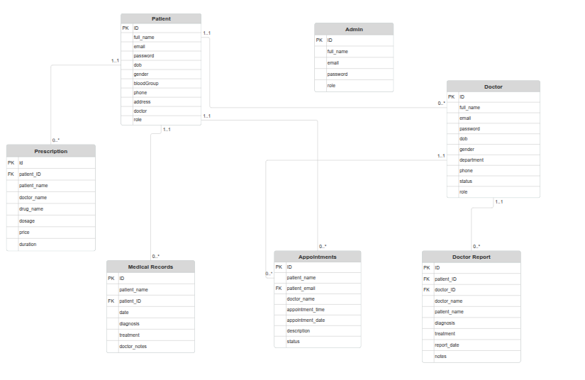

4.3 Architectural and Component Level Design

4.3.1 System Structure
The hospital management system follows a three tier architecture namely the presentation layer. This is the frontend designed using HTML, CSS and JavaScript. This layer handles user interactions and displays data fetched from the backend. The second layer is the application layer our backend which is built with PHP this layer contains all the business logic such as authentication, data validation and appointment scheduling. finally we have the data layer which is the database is managed using MySQL it stores and retrieves data securely through SQL queries.
This layered design enhances modularity making maintenance and updates easier.

4.3.2 Architecture Diagram
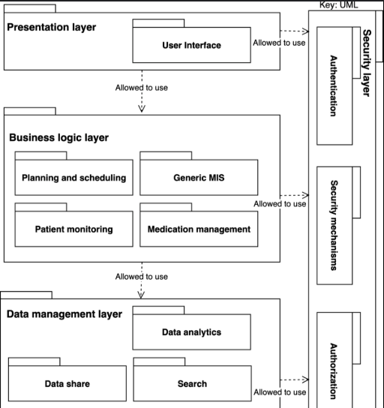

4.3.3 Component Description

4.3.3.1 Admin Module

The Admin Module serves as the core control center of the entire hospital management system. It is responsible for managing both doctor and patient accounts ensuring that the system remains organized and up to date. The administrator has full privileges to create, read, update and delete user accounts for doctors and patients ensuring that only authorized personnel and valid patients are part of the system.
Additionally, this module oversees all appointments within the system. The admin can monitor appointment requests made by patients and track their progress whether they have been accepted, declined or completed by the respective doctors. This oversight enhances transparency and accountability in hospital operations.
Another key feature of the admin module is its ability to manage and review medical reports through the reports dashboard. The administrator can view how many patients each doctor has attended to which helps in analyzing doctor performance and balancing workloads.

4.3.3.2 Doctor Module
The doctor module is designed to streamline the daily activities of healthcare practitioners. It allows doctors to manage their patients efficiently, record medical diagnoses and prescribe treatments digitally. This module eliminates manual paperwork enabling doctors to access and update patient information instantly.
The module also includes a real time data visualization feature that presents charts and summaries of patient visits. These graphical representations help doctors track their performance, monitor the number of patients seen over time and assess workload patterns.
Additionally, the module provides options for viewing, printing and updating medical records, giving doctors the flexibility to generate prescription reports or share records during patient consultations. This integration of digital record keeping and analytics promotes efficiency, accuracy and better patient care.

4.3.3.3 Patient Module
The Patient Module focuses on improving the overall patient experience within the hospital management system. It provides patients with access to their personal health information in a secure and user friendly interface. Through this module patients can view their upcoming and past appointments ensuring they stay informed and can plan accordingly.
Patients can also access their prescriptions and medical history which helps them keep track of their treatment progress. This transparency fosters trust between patients and healthcare providers as individuals can review details of their diagnoses and prescribed medications anytime.
In addition to viewing records the patient module allows patients to interact with doctors through appointment bookings. Patients can schedule consultations based on doctor availability reducing waiting times and improving service delivery. This communication channel ensures efficient coordination between patients and medical staff promoting better healthcare outcomes.

4.4 User Interface Design

4.4.1 Description of the User Interface
The hospital management system interface is designed with simplicity and usability in mind. Each user category admin, doctor or patient has a dashboard that presents only relevant information. The layout follows a consistent theme with a sidebar navigation panel a top bar for quick actions, and responsive tables for data display.

4.4.2 Screen Images
4.4.2.1 Admin Dashboard
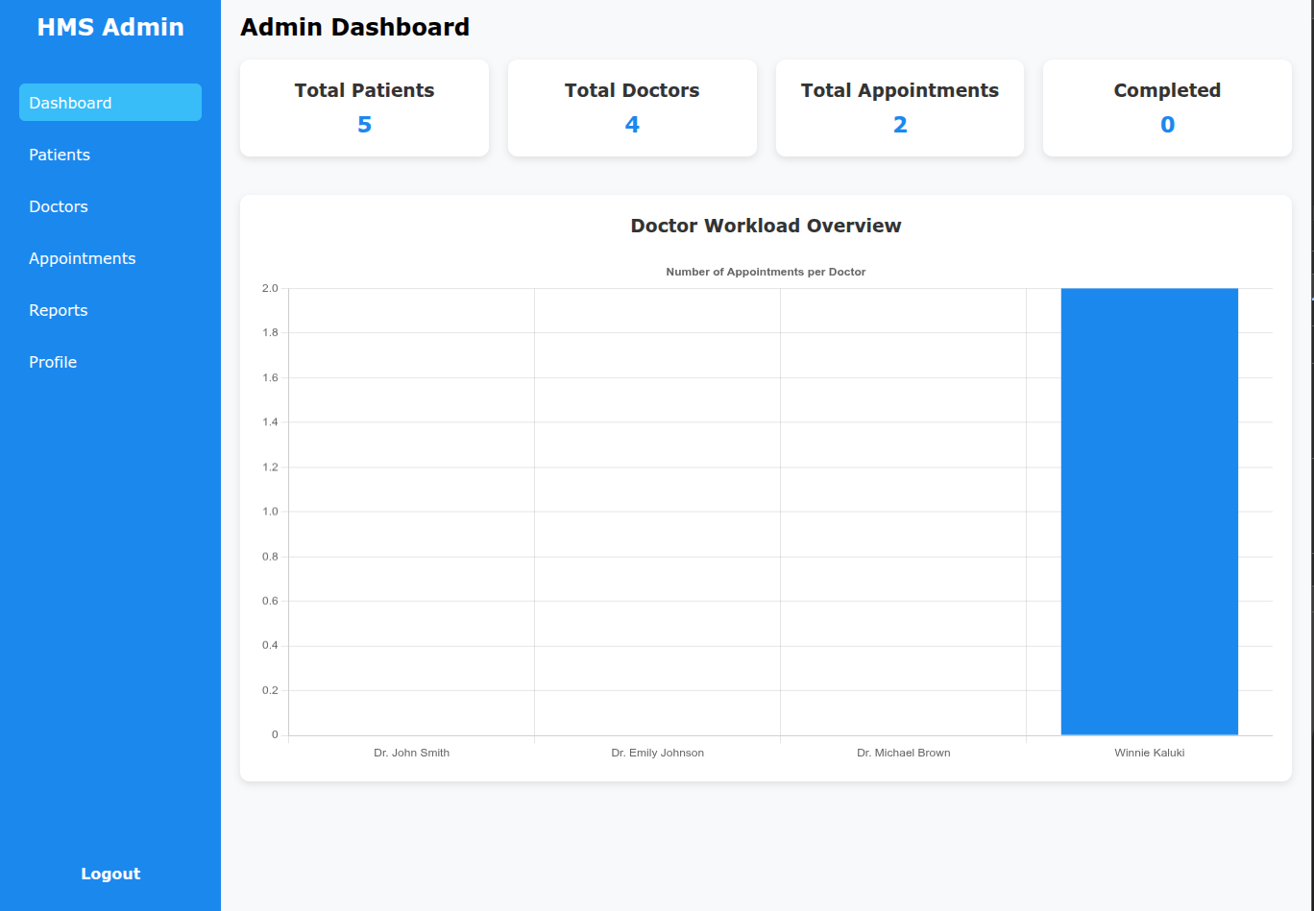Figure 1: admin dashboard
4.4.2.2 Doctor Dashboard:
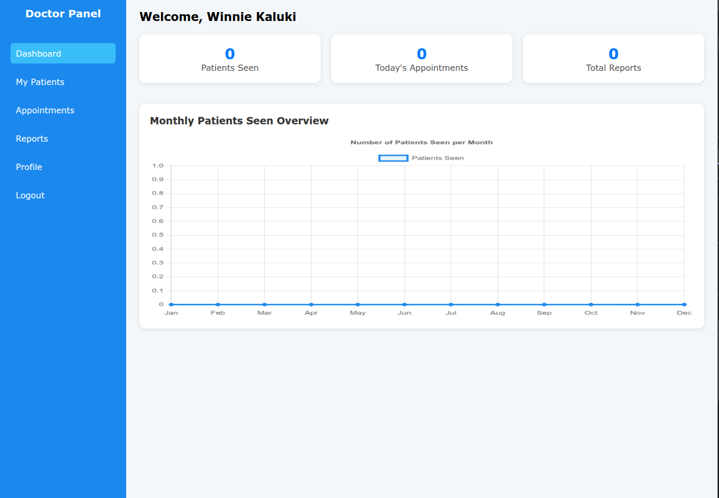Figure 2: doctor dashboard
4.2.2.3 Patient Dashboard
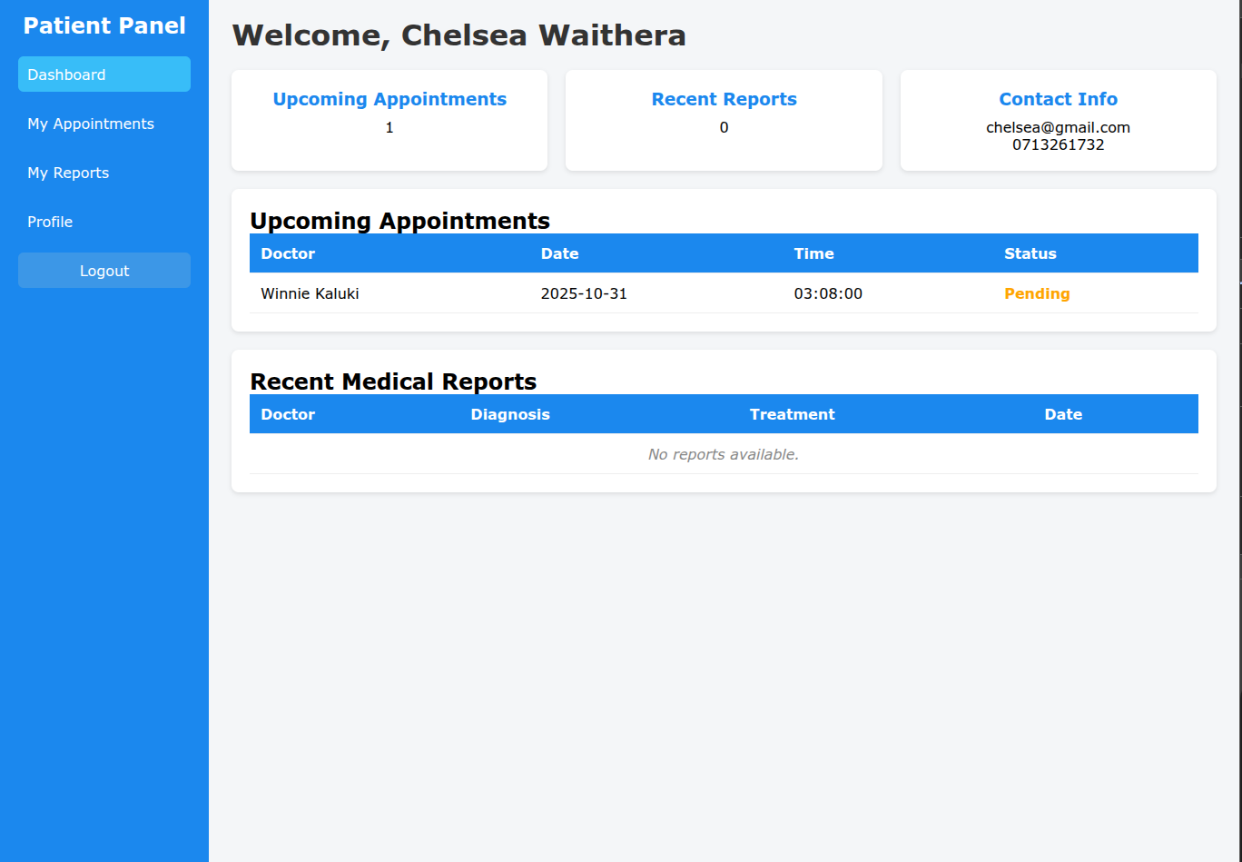Figure 3: patient dashboard

4.4.3 Objects and Actions
In the hospital management system several user interface objects facilitate interaction between the user and the system. Each object serves a specific purpose in executing functions, collecting data or navigating between different modules. The most common objects include buttons, forms and navigation links.
Buttons are interactive elements that trigger specific actions such as adding, editing, deleting or viewing details. For example in the doctor module buttons like add prescription or view patient details allow doctors to perform tasks quickly and efficiently. Similarly the admin uses buttons to approve appointments or manage user accounts.
Forms are crucial for capturing input data throughout the system. They are designed to collect user information during patient registration, record medical details and handle appointment scheduling. The forms ensure that all data entered is validated and stored securely in the database reducing human errors and improving data accuracy.
Navigation links enable smooth movement between various system sections. They connect users to different pages such as the dashboard, reports, appointment lists and profiles. This structure ensures a user friendly experience where both patients and doctors can easily access the features they need without confusion.

4.4.4 Interface Design Rules
The following design standards were adopted. Consistency. A uniform color scheme and typography was applied throughout the system. Responsiveness. The interface adapts to various screen sizes ensuring accessibility on desktops and tablets. Clarity. Labels and placeholders are clearly defined to guide user input. Validation. All forms include frontend and backend validation to prevent errors.

4.4.5 Components Available
Key user interface components include a side navigation panel that will enable a user navigate though the system. Search bar and filter tools that reduces time wasting while looking for records or a user. Interactive charts powered by Chart.js which provide a visual representation on a users performance and pop up alerts for success and error notifications

4.5 Restrictions, Limitations and Constraints

4.5.1 Regulatory and Compliance Constraints
The system complies with local data protection and confidentiality guidelines under the Kenya Data Protection Act (2019). Patient information is secured through encrypted connections and role based access control.

4.5.2 Technical Constraints
The HMS is hosted on an Apache server running PHP and MySQL. Internet connectivity is required for remote access and performance may depend on hosting bandwidth and server response time.

4.5.3 Budgetary and Resource Constraints
Since this system is being developed as a university project financial resources were limited. Free and open source tools such as XAMPP, Visual Studio Code and MySQL Workbench were used to minimize costs.

4.5.4 Time Constraints
Development was carried out within a limited academic timeframe, restricting the implementation of advanced features such as SMS notifications and AI based diagnosis support.

4.5.5 User Adoption and Training Constraints
End users particularly hospital staff require basic computer literacy training to use the system effectively.

4.5.6 Integration Constraints
Integration with third party systems such as pharmacy inventory or laboratory modules is not yet implemented but can be added in future versions.

